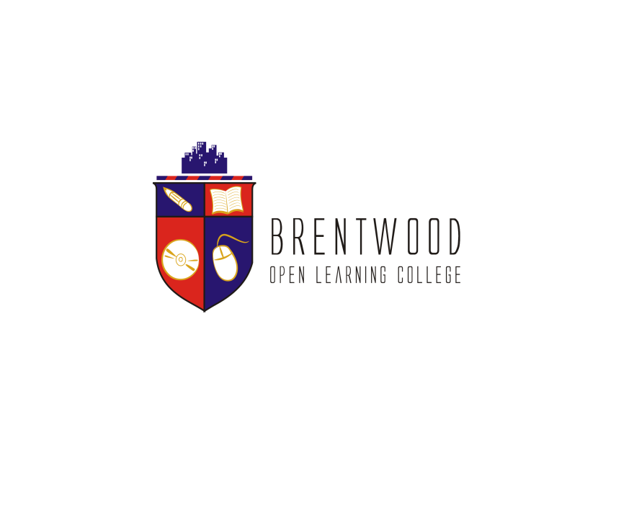
Assignment Cover Sheet

Student Name: | Urfan Khan
Student Number: | 6329
Course: | Getting your product together
Assignment NO: | 3

Marking Criteria:
We expect the learners to write minimum one well expressed point in three lines against each allocated mark. This means one needs to write 15 lines with 5 well expressed points to get high grades for a 5 marks question.
For high grades use examples and illustrations where appropriate.
Please insert your completed assignment ( in word format) here:

- What is inventory management? Outline its various forms.
inventory management is a very important function that determines the health of the supply chain as well as the impacts the financial health of the balance sheet. Every organization constantly strives to maintain optimum inventory to be able to meet its requirements and avoid over or under inventory that can impact the financial figures.
Inventory is always dynamic. Inventory management requires constant and careful evaluation of external and internal factors and control through planning and review. Most of the organizations have a separate department or job function called inventory planners who continuously monitor, control and review inventory and interface with production, procurement and finance departments.
Inventory of materials occurs at various stages and departments of an organization. A manufacturing organization holds inventory of raw materials and consumables required for production. It also holds inventory of semi-finished goods at various stages in the plant with various departments. Finished goods inventory is held at plant, FG Stores, distribution centers etc. Further both raw materials and finished goods those that are in transit at various locations also form a part of inventory depending upon who owns the inventory at the particular juncture. Finished goods inventory is held by the organization at various stocking points or with dealers and stockiest until it reaches the market and end customers.
Besides Raw materials and finished goods, organizations also hold inventories of spare parts to service the products. Defective products, defective parts and scrap also forms a part of inventory as long as these items are inventoried in the books of the company and have economic value.
- Why is inventory maintained?
Having an accurate valuation of inventory is important because the reported amount of inventory will affect 1) the cost of goods sold, gross profit, and net income on the income statement, and 2) the amount of current assets, working capital, total assets, and stockholders' or owner's equity reported on the balance sheet. In fact, an incorrect inventory valuation will cause two income statements to be incorrect. The reason is the ending inventory of one accounting period will automatically become the beginning inventory in the subsequent accounting period.

- How do quality control processes help a business grow?
Quality control is essential to building a successful business that delivers products that meet or exceed customers’ expectations. It also forms the basis of an efficient business that minimizes waste and operates at high levels of productivity. A quality control system based on a recognized standard, such as ISO 9001 published by the International Organization for Standardization, provides a strong foundation for achieving a wide range of marketing and operational benefits.

- Why is a visual identity important for a business?
An integral part of visual identity, it gives you the opportunity to differentiate yourself from competitors. In order to remain uniform in its communication, it is necessary to follow graphic standards. Effective graphic standards are crucial for a company wishing to maintain consistency in their graphic identity

- What is branding?
The process involved in creating a unique name and image for a product in the consumers' mind, mainly through advertising campaigns with a consistent theme. Branding aims to establish a significant and differentiated presence in the market that attracts and retains loyal customers.

- Discuss various types of visual identity you are aware of.

Visual identity is the use of visual communication to establish a unique and recognizable identity for an organization or brand in a crowded market. The following are common types of visual identity.

Logos & Names
Logos and brand names are a primary type of visual identity that typically appear on all of a firm's products and communications.

Colors
A set of corporate or brand colors. Commonly incorporated into everything that a firm does including seemingly obscure things such as the interiors of offices and templates for internal documents.

Slogans
Textual elements of a firm's visual identity usually in the form of brief slogans such as a mission statement.

Personalities & Characters
Personalities and characters such as a company founder, mascot or celebrity representative in advertising.

Trade Dress
The characteristic look and feel of products, services and packaging.

User Interfaces
User interfaces such as web sites.

Environments
Environments include physical and non-physical locations where people spend time such as a office, retail shop, showroom, restaurant, green space, interior of an aircraft or virtual environment in a game. For example, a restaurant may establish a unique decor as part of its visual identity.

Uniforms
The uniforms worn by employees.

Experiences
Looking at visual identity as an experience such as a film as opposed to static elements such as an image.

Student Statement:

By submitting this assignment, I confirm that this is my own work.

Student Signature |  | Date

For Tutor / Assessor Use Only
Total Marks
Marks Obtained
Percentage / Grade

