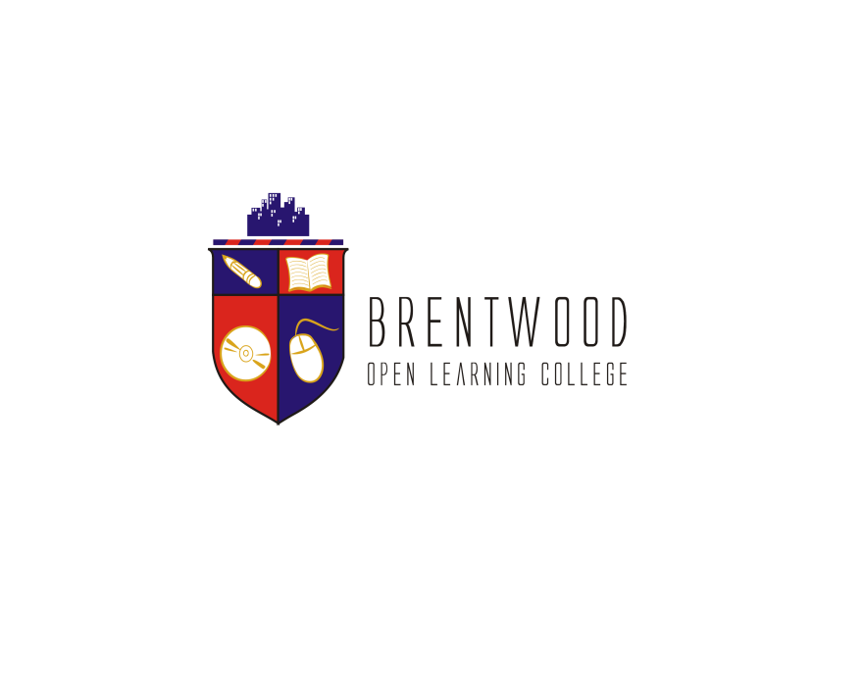
Assignment Cover Sheet

Student Name: | Saleema Choudrey
Student Number: | 1240
Course: | Fashion Designing
Assignment NO: | Unit 5 Elements of Design

Unit 5
Elements of Design

  - What is meant by ‘weight and hand’ in textile industry?

Texture is an element in Fashion that describes the fabric by sensory feelings. By weigh it describes how heavy or light the fabric is and by hand it describes the feeling of the fabric.
It could be soft, silky, rough, bulky, shiny, etc.

  - Name the warm colors. How best these can be used in dress designing?

Warm Colors:
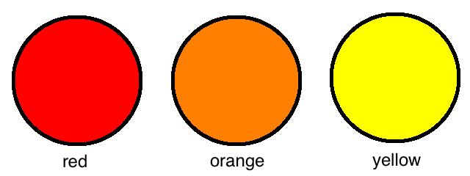

Red is the color of fire and blood, so it is associated with energy, war, danger, strength, power, determination as well as passion, desire, and love. The color red is worn as a symbol of a virgin for brides in countries like India, Pakistan, and Bangladesh etc.

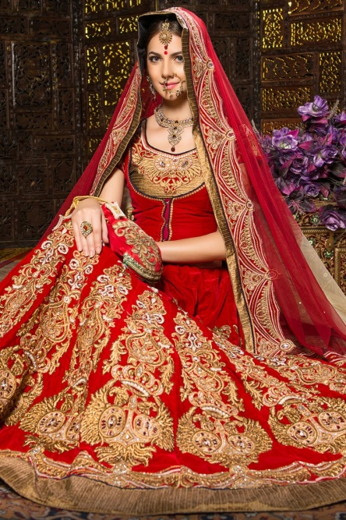
Indian Bride

Orange combines the energy of red and the happiness of yellow. It is related with joy, sunshine, and the tropics. Orange represents enthusiasm, fascination, happiness, creativity, determination, attraction, success, encouragement, and stimulation. Orange is worn in Holland as a National Day color or it can be worn as a symbol for pumpkin on Halloween. Some religions wear Orange for example Sikhs.

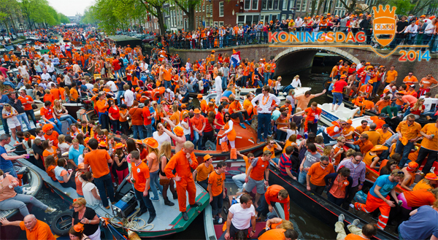
Kingsday in Amsterdam Holland 2014. Wearing Orange.

Yellow is the color of sunshine. It's associated with joy, happiness, intellect, and energy.
Yellow produces a warming effect, arouses cheerfulness, stimulates mental activity, and generates muscle energy. The color yellow doesn’t suit everybody. People wear yellow in the summer time to feel fresh in the hot weather. Yellow is also a warning color mixed with black. Like life safety guard wear yellow jackets. Or bicyclers wear yellow to attract attention from traffic

. 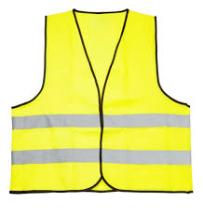
Yellow Safety Jacket

  - Why it is important for a designer to consider the scale of a pattern, when using patterned fabric in dress designing?

It is important to adjust the scale of a pattern to the design. A large print should be kept simple according to the pattern. For a detailed pattern it would be ideal to use plain fabric.

  - What is the difference between conventional design and geometric design?

Conventional designs are more traditional an example of an art Is based on history, tradition or moments of life. Geometric designs are designs that are done with the use of straights lines and shapes. An example of Geometric designs is an art piece that’s made using square, circles, oval etc.

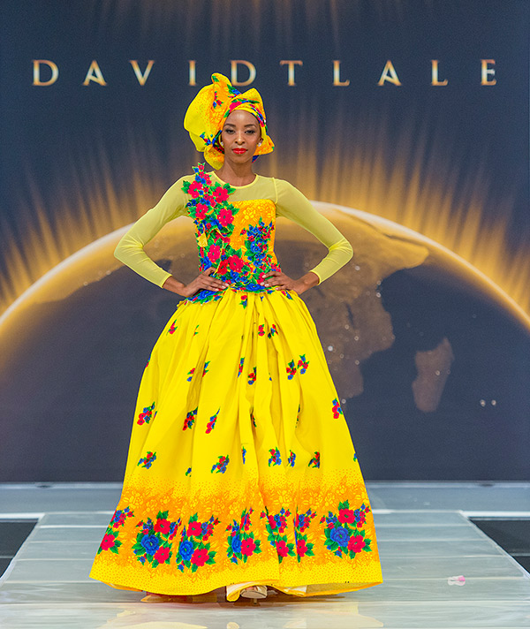
Sample of conventional design

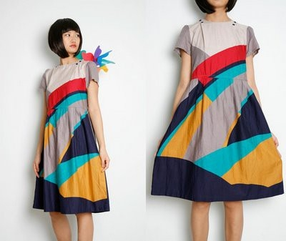
Sample of Geometric design

2. Define the term color dimension:

Color dimensions means that Colors are divided in 3 aspects. Hue, Value and Intensity (saturation).

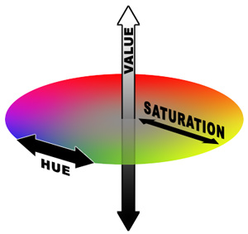
Sample of Color Dimension

Explain the following terms;

Hue: Hue shows which color is mixed with another color to get a particular color.

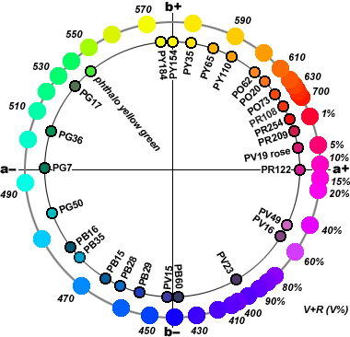
Sample of Hue

Value: The value measures lightness and darkness in a color. This is done by using white or black to measure the value.

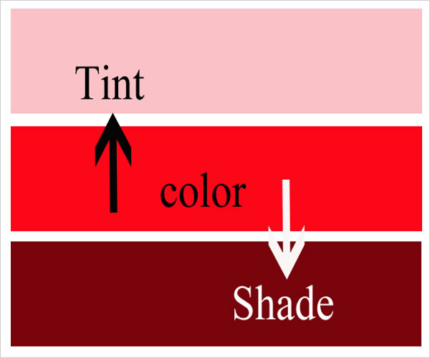
Sample of Value

Intensity: Brightness or dullness of colors.

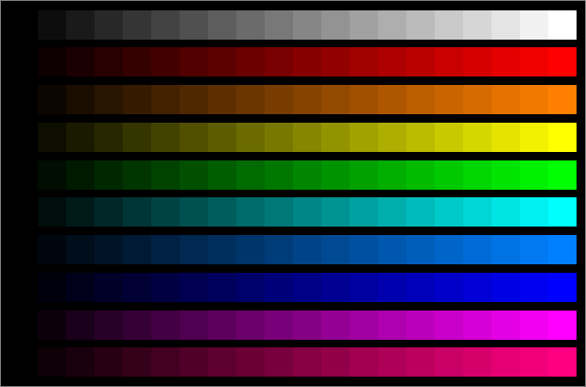
Sample of Intensity

3. Write short note on the following:

Basic Shapes in dress designing

Triangle: Triangle shapes dresses are fitted from the bodice and wide from the skirt.
(A-Line) Triangle dresses are suitable for any body shape.

Inverted triangle: the key to dressing is to add more volume to the hips when choosing a dress for this shape. Suitable for women with heavy bustier and smaller hips.

Oval: Feminine draped dresses. Ideal for evening gowns. Suitable for heavier body shapes.

Square: Loose fitting, straight cut dresses. Boxy jackets. Ideal for thin figures.

Round: ball gowns, puffy sleeves, tulle skirt to create a Cinderella look. ideal for thin figure and young ladies.

Hourglass: wide shoulders, smaller waist, wide hips, full skirt fitting over the hips. Ideal dress for tall and thin ladies.

Combination: any fashion silhouette can be used and combined to get the ideal figure dress.
According to the latest trends and figure.

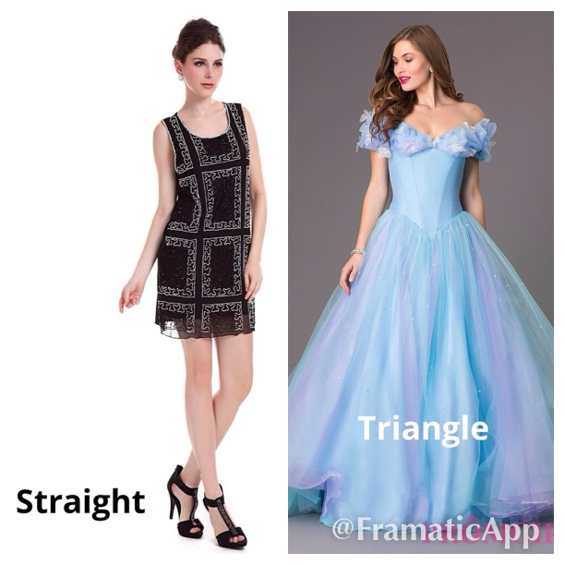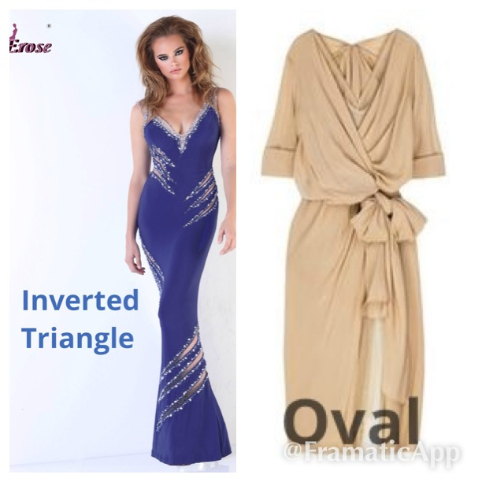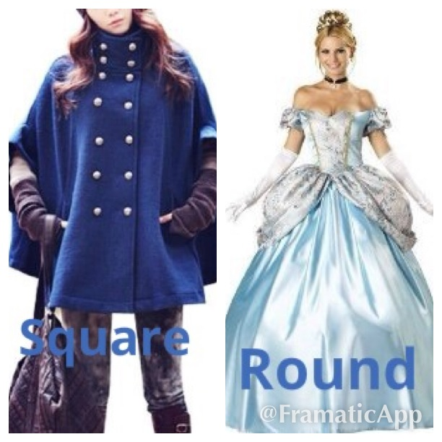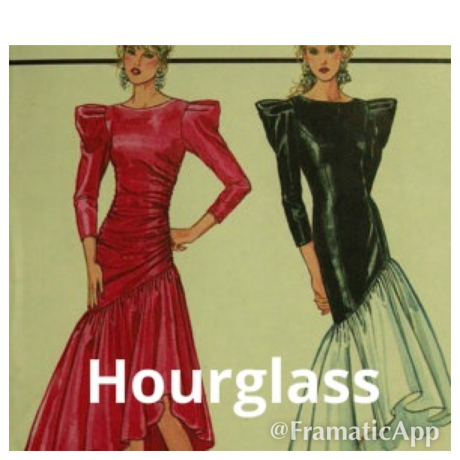

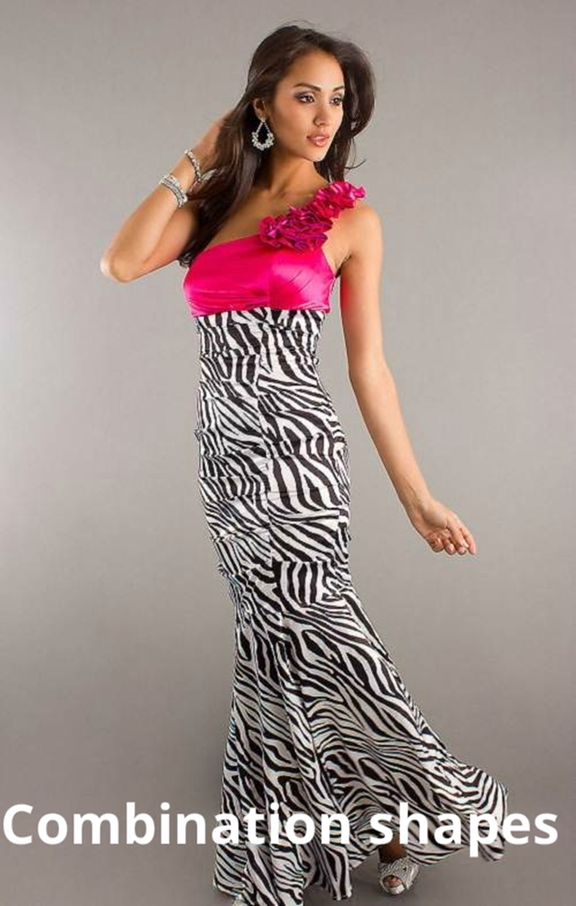

Project

- Look through costume books for pictures of an historic dress. Using these inspirations, design a garment using the line, shapes, colours and details from the historic garment in a new combination for our lifestyle

Cleopatra Jumpsuit

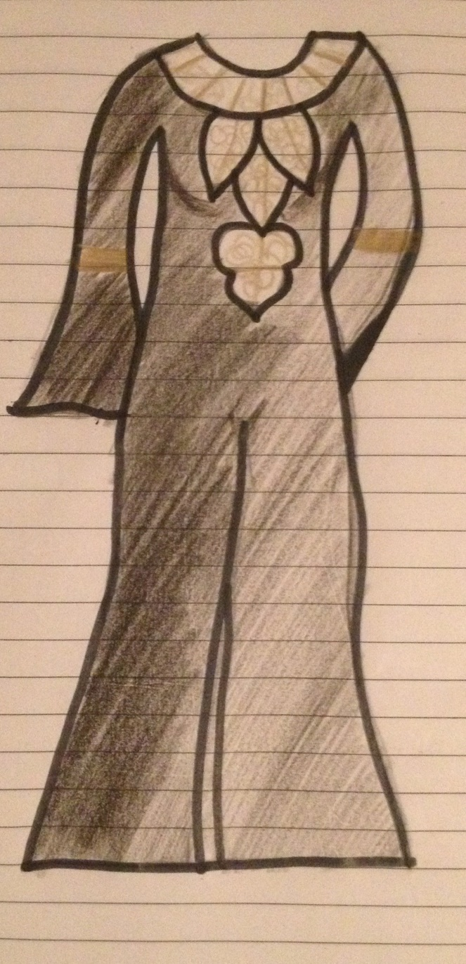

This dress design is inspired by Cleopatra’s historic costumes. Cleopatra’s Neck design with bell sleeves and fitted waistline. Jumpsuit today’s fashion in black silky, shiny fabric. Triangle dress shape, perfect for anybody.

References

https://www.google.co.uk/search?q=yellow+dress&rlz=1C1CHWA_enGB611GB611&espv=2&biw=1366&bih=643&source=lnms&tbm=isch&sa=X&ei=g7I-Vb69JM-P7AbY8oHwCQ&ved=0CAcQ_AUoAg#tbm=isch&q=koningsdag+&imgrc=3YM22dXqnKqjGM%253A%3BvpAwGVuBQwqXAM%3Bhttp%253A%252F%252Fwww.oranjewinkel.nl%252Fuploads%252Fkoningsdag-amsterdam-2014.jpg%3Bhttp%253A%252F%252Fwww.oranjewinkel.nl%252Fnieuws%252Fkoningsdag-2014%252F%3B600%3B329

http://speckyboy.com/2010/04/22/understanding-and-the-meaning-of-color-within-design/

http://www.handprint.com/HP/WCL/color18a.html

http://www.daviddeen.com/imprint/issue25/issue25.html

http://www.elle.co.za/david-tlale-bridal/

http://indulgy.com/post/n8AJB23CV1/geometric-pattern-dress

https://www.google.co.uk/search?q=cleopatra&biw=1366&bih=643&source=lnms&tbm=isch&sa=X&ei=1d1PVdPBOqit7gbllYG4BA&ved=0CAYQ_AUoAQ#tbm=isch&q=cleopatra+costume&revid=704589158

http://www.google.co.uk/imgres?imgurl=http://i1136.photobucket.com/albums/n481/ottois/Franco/48459.jpg&imgrefurl=http://www.ebay.co.uk/itm/BLACK-ADULT-WOMEN-LADY-CLEOPATRA-EGYPTIAN-QUEEN-OF-THE-NILE-COSTUMES-48459-/360749460292&h=1024&w=707&tbnid=MMeUZcANWjs_lM:&zoom=1&docid=Be0BClbWf2ksWM&ei=3N1PVa6LJ-bX7Aa8pICADA&tbm=isch&ved=0CEIQMygOMA4

Student Statement:

By submitting this assignment, I confirm that this is my own work.

Student Signature | Saleema Choudrey | Date | 10 May 2015

For Tutor / Assessor Use Only
Total Marks
Marks Obtained
Percentage / Grade

