
Assignment Cover Sheet

Student Name: | Omnia Rafiq
Student Number: | 1343
Course: | Diploma in interior Design
Assignment NO: | 8

Student Statement:

By submitting this assignment, I confirm that this is my own work.

Student Signature | Omnia Rafiq | Date | 29-1-2015

For Tutor / Assessor Use Only
Total Marks
Marks Obtained
Percentage / Grade

Q.1.i. What is the best way of mixing patterns?
Simply it depends upon the relationship between density and scale. Scale is how big or small a pattern element is on the wall paper or on the fabric. This especially has to do with its size. The scale of a large flower is greater than a small rose bud.
While, Density is how tightly grouped together the elements of the pattern are. A rose bud pattern on an open solid colored back ground would be less dense than the larger intertwining pattern which shows little, in any background.
Here are some rules we must take into consideration when choosing and mixing patterns :

- First we should consider factors such as scale, color, tone and content when choosing pattern.
- Experiment with mixing and matching: try Stripes and checks, stars and stripes.
- Choose two dominant patterns of the same scale and you will find that they fight each other for your attention.
- As general rule the best results are achieved by arranging for the largest areas (walls floors, curtains) to take on the largest scale patterns and the smaller items correspondingly smaller patterns.
- Always view pattern from distance from which it will be viewed in a room. By holding the sample at a suitable distance from a mirror you will get the right effect.
- Curtain sample patterns are best viewed with some light behind them rather than facing the light. This will give a good idea of how the material will appear when hung at a window.
- When using several patterns in one room make sure that they are linked. Choose patterns with colors, themes, motifs or textures in common.
- We can also develop our own patterns, picking up motifs from other elements in a room. For example, we can trace patterns form china to use a guide for embroidering table linen, or cut out elements from a printed fabric to use to make appliqué designs.
- The simplest way to mix patterns is to choose a decorative pattern first, then co-ordinate a plain or semi-plain fabric or a stripe in a different scale, all in same color palette. You can then use combinations of all these fabrics for the window treatment, upholstered furniture and cushions. Consider using a checked fabric for sofa and then overlaying it with cushions in different combinations of patterns, for example stripes and checks foe a Floral with a small gingham check.

Combine white plus a coloured pattern Let neutral colours become your base when using large prints
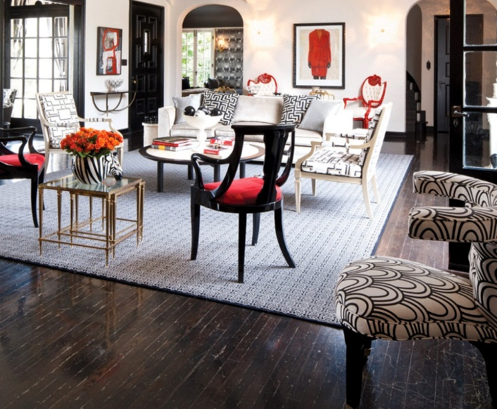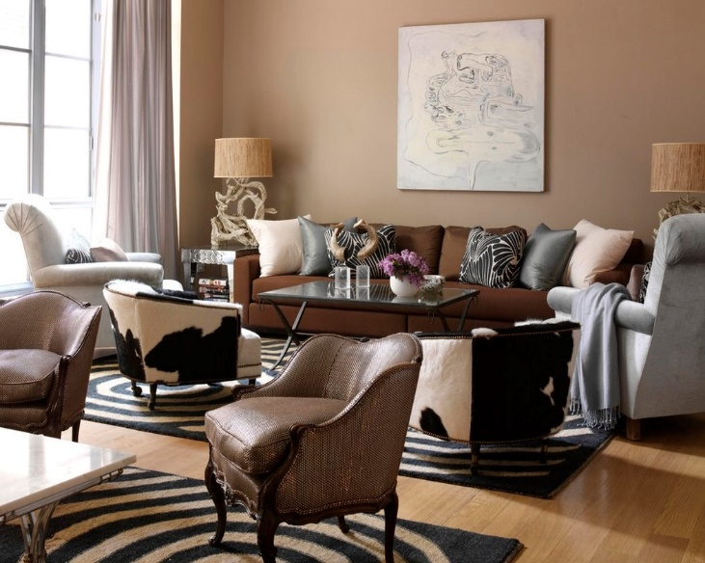

Don’t shy away from bold colours and prints Tone on tone colour helps prints neutralize your space
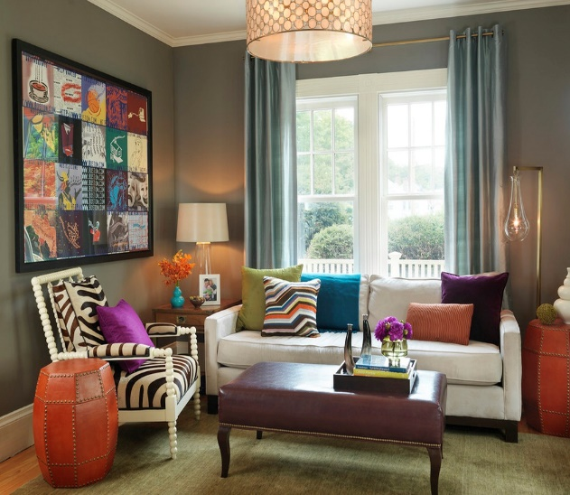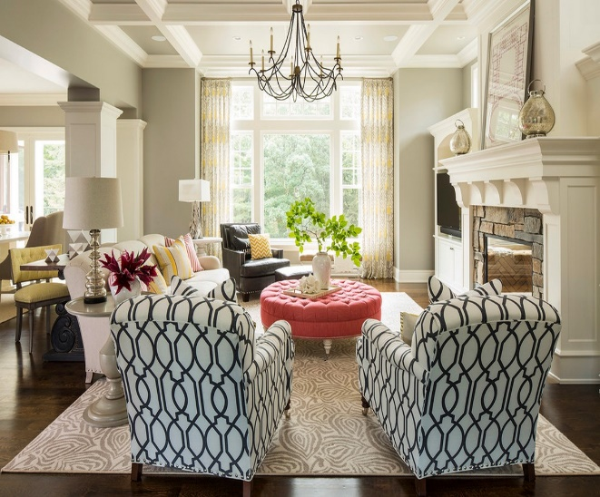

Q.1.ii. What is the density of a pattern?

Density is how tightly grouped together the elements of the pattern are. A rose bud pattern on an open solid coloured back ground would be less dense than the larger intertwining pattern which shows little, in any background.
Different Patterns with different densities
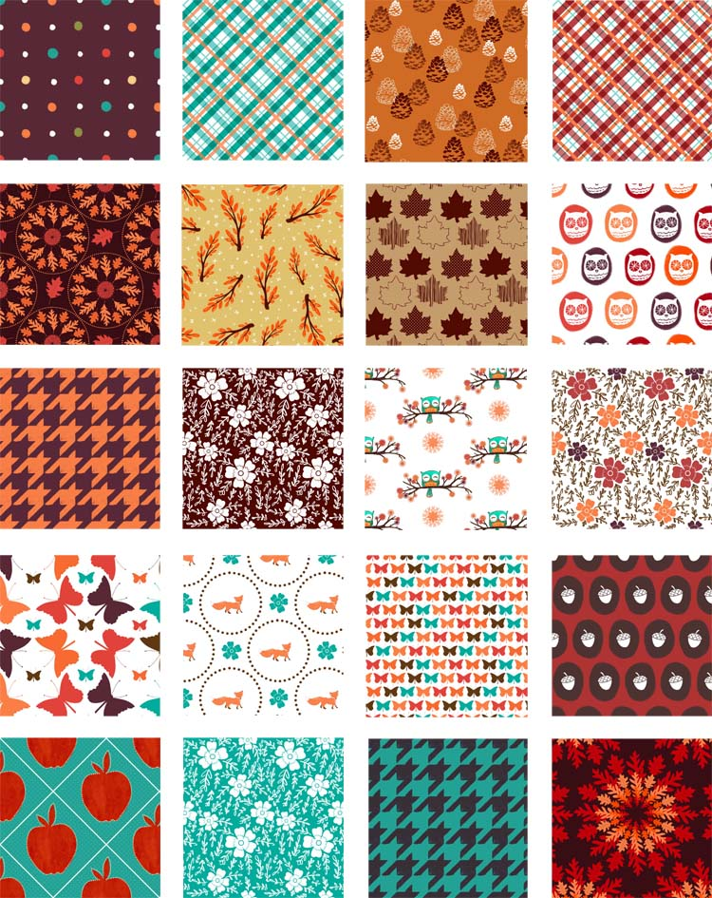

Q.1.iii. If you are to wall paper a room with a vertical stripe pattern would the ceilings Appear lower or higher?
This type of geometric pattern (stripes) is decorative yet it can also serve the purpose of deceiving the eye. It is also a space manipulation tool.Vertical stripes make a surface appear taller. Traditionally, vertical stripes have been the common way to go. They create the illusion of height thus making ceilings appear higher than they truly are. A tone-on-tone colour scheme (like cream with white, or a matte and glossy version of the same colour) creates a soft look that is classic and beautiful. As colours become more contrasted the look gets more powerful.
Horizontal stripes are a little more edgy and modern than vertical stripes. They make rooms feel wider and can elongate spaces. Horizontal stripes are also often considered more playful – when used in a variety of colours and widths, they feel bold, fun, and fresh.

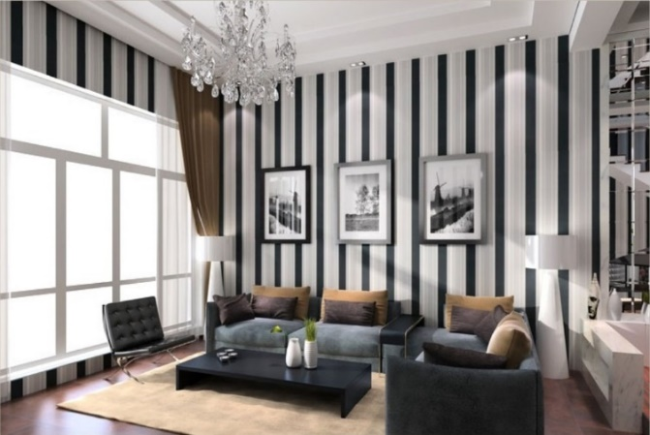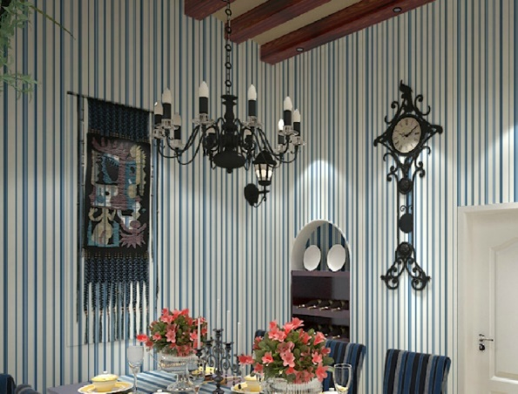
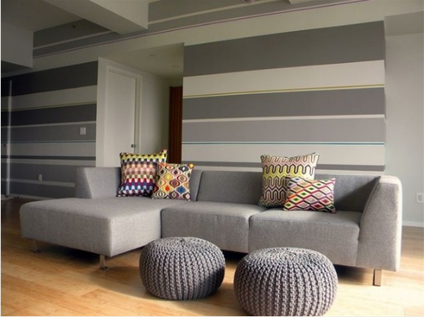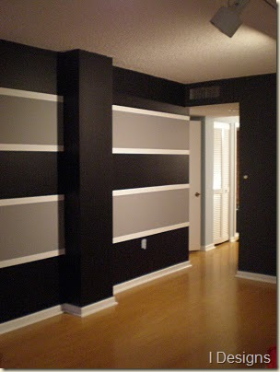

Tips for Decorating with Stripes
- Avoid using colors that clash. Stripes are graphic enough on their own to create impact, so it's important to use colors that either contrast, or come from the same color family (depending on what look you're going for). Clashing colors like orange and purple or red and pink will look cluttered and distracting rather than graphic and punchy.
- Use strong colors in small areas. If you're afraid to commit to a large space, a foyer or a powder room is a great place to experiment. People tend not to stay long in these spaces so the look doesn't become tiresome or overwhelming.
- Be sure to counteract stripes with less busy design elements. If you have striped walls, solid furnishings are probably the way to go. If you have striped throw pillows, add a couple of solids and dainty floral between them. The effect is cohesive, but it also gives your eyes a place to rest.
- When decorating with stripes consider the size of the room. The larger the room, the wider the stripes should be (when used on walls). Thin stripes can look too cluttered in a large room, while wide stripes can lose their impact in a small space.
- Subtle techniques like alternating flat and glossy stripes can add perceived depth and dimension to a room without being overly bold or confrontational. They are elegant and classic and work well in traditional spaces.
- Mixing wide and skinny horizontal stripes work really well on the walls of rec rooms and children's rooms. They create a very playful look.
- Floors are terrific places to include stripes. Striped area rugs add a great graphic element. If you don't want a large area covered, try a runner, a doormat, or layer a small area rug over another existing rug.
- If you're nervous about decorating with stripes, start small. Including a striped vase, lampshade, or other decorative element can be a super way to introduce the pattern into a room.
- Stripes have been described as the "neutral" of the pattern world. They can be incorporated into any style or size of room. They can be used in large doses or small, and they can work with just about anything. If you want to add some pattern to a room but you're unsure of where to start, stripes are always a safe bet.

Q.1.iv. How can textural depth be created in a design scheme?
Texture is a key element for making a space interesting and inviting. Textural depth can be created by mixing items of different texture in a design scheme. Texture can bring a touch of luxury, substance and interest, to an otherwise, nicely done, but flat and boring home decorating scheme. Here are some tips to be taken into consideration when using different textures in a design scheme :
- Use plenty of texture if you are decorating in one color - especially white. White without soft texture added, can look sparse and clinical. Add some texture and it is quickly transformed into a luxurious and loveable, interior decorating scheme.
- Shiny or glossy textures, like tiles, gloss paint, mirrors, glass furniture, chrome, lacquered dark wood, silk and satin, tend to lend a sophisticated feel to your interior design scheme.
- Shiny surfaces reflect light back into the room, making the room feel lighter and bigger.
- But, we should be aware that using too many glossy textures can make the scheme feel a little cold and clinical.
- Rough or soft textures, like natural or unfinished wood, many fabrics like chenille, hessian, linen, faux fur, fluffy cushions and rugs, natural stone and brick - bring added interest to a room.
- Rough textures are often suited to a more casual, rustic or country feel in an interior design scheme.
- Rough textures, can bring warmth and a cozy atmosphere to your home decorating. But, take care - too many rough textures can overcrowd and overwhelm, when decorating small spaces.
- Rough and smooth textures look great combined together - as well as with each other.

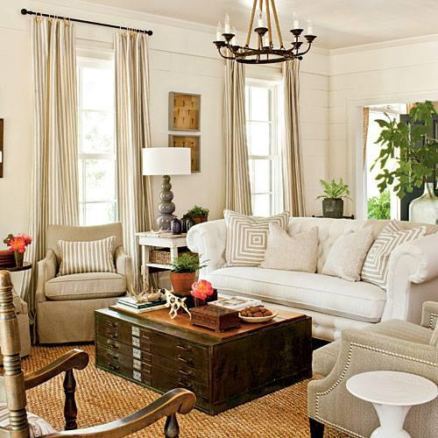In this room design, texture is added to an already light colored room by the design in the pillows, window treatments and the rug.
Additional depth is created by using complimentary wood tones in a darker color to ground the room and bring out the neutral colors, making the room feel inviting. Adding design elements with a pop of color makes the room complete and this entire design is pulled together. Simple accessories can by changed seasonally to create a completely different look and feel as well.

Q.1.v. ‘Texture in fabrics emphasize mood in a room’. Explain with examples.
Texture in fabrics can create and emphasize mood. It gets rid of the two-dimensional look often found in carefully structured one colour themes or minimalist rooms. Unfortunately, these rooms can feel soulless – no matter how expensive or well crafted. A grand dining room is synonymous velvet, brocade, parsley and taffeta, whereas a romantic bedroom brings to mind voile, light weight cotton and ribbon trims. Texture can be used to create the smart town house look of smooth linen, and suede. Every fabric you choose has textural significance, so be aware of how you can use this to add another layer of interest to a room. This applies not only to foundation fabrics but also to smaller items-denim cushions embellished with wooden buttons are the prefect addition to a relaxed family room, for example, whereas cashmere ones trimmed with satin look sensational on a leather club chair. Textured fabrics can create warmth, set the tone, style and even use of a room. A grand dining room often needs rich velvets, brocades, paisley and taffeta to bring it to life while a romantic bedroom wants softer voiles, pique, lightweight cotton and ribbon trims.
There are hundreds of different fabrics, each with its own textural qualities. How you use them is up to you, but if you take advantage of their distinctive features, you’ll get the look you want, using less, more relaxed and less contrived. This applies not only to foundation fabrics but also smaller or detailed fabrics. Each additional fabric you choose with its characteristics creates a new layer of interest for your eyes to take in and appreciate.
Different textures examples that show their effect on the mood of a room
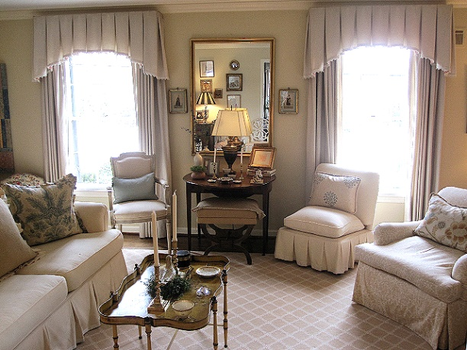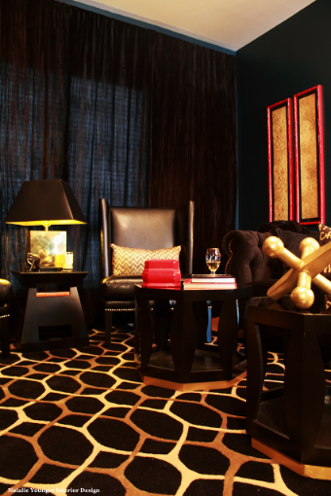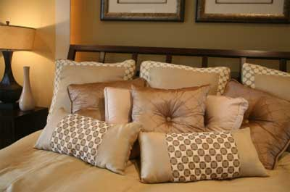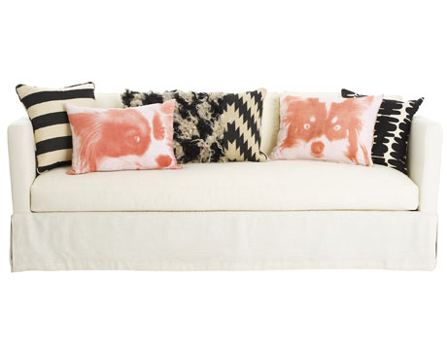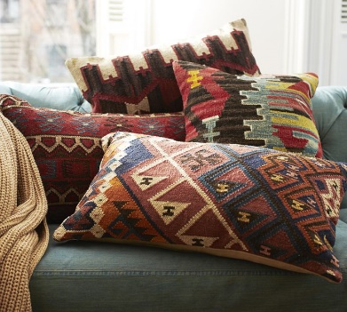

Q.1.vi. Sometimes the same color appears different in different types of light. What in
Your opinion could be the reason behind this?
Surface textures also affect the way we perceive a color – many textures absorb light, some reflect it; others filter and diffuse light. Sometimes the same color can appear quite different, depending on the way the surface reacts to light. It is another reason why you need to look at the fabrics, paints samples under the lighting conditions in which they will actually be seen. Many people think of texture as a purely raised, rough or sculptured surface. Actually all surfaces have a texture, even if perfectly smooth and bland, such as plastered walls that have been painted with matt emulsion paint. This texture absorbs light slightly, making a color look weaker. The same color on a shiny surface, such as gloss paint, silk fabric, glazed tiles, will look brighter and stronger, as the light is bounced back. The rough textures of exposed brick or stone walls, planks of wood, natural flooring and coarsely woven textiles absorb light, and therefore make the color appear darker, richer or in some cases duller. Light diffusing textures such as sheer muslin, voile fabrics, allow the light to pass through, making the color appear softer and more delicate. Heavily
Textured items can create very interesting effects.

Because of their uneven surface, light is reflected, absorbed and reflected differently across resulting in varying values of color. You can use this in a room where you want to add an extra visual element.
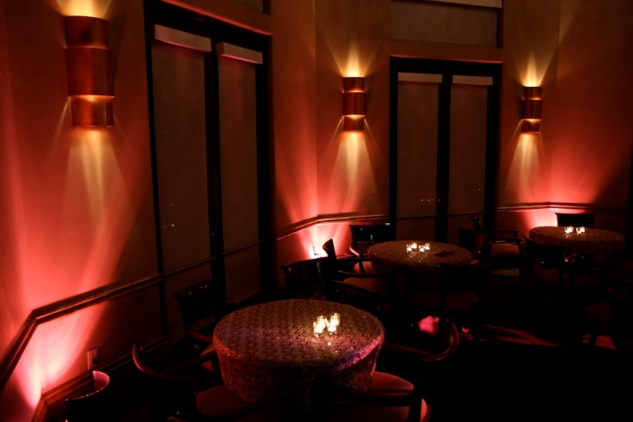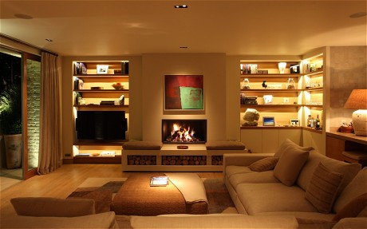

Q.1.vii. “Texture can work like color to bring surfaces forward or can give the impression That they are further away”.
Generally visual texture can be perceived as warm or cool, similar to colour. For example a glass table would evoke cool qualities because of its clear smoothness when compared to a cross- section tree trunk that is playing The role of a unique end table. Mixing warm and cool textures in a space can make it more sophisticated. The eye is drawn from one detail to another. Focusing texture to one side of the temperature spectrum can create a sense of
Harmony.Texture can also work like color to bring surfaces forward or can give the impression that they are further away. For example the shiny and silky textures - glass, brass and chrome- seem to come to you; whereas the rougher, soft and light absorbing textures- velvet, tweed and jute – do the opposite and seem to move apart. As a result the color of highly glazed ceramic tiles stand out much more than the same color on a bath towel.

Cool and warm textures mix
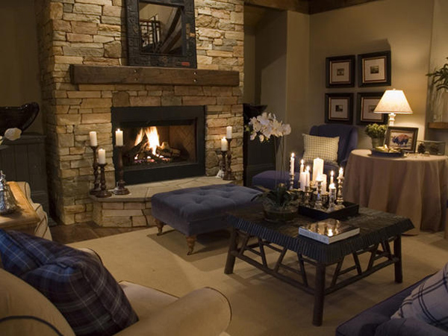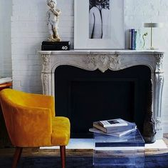
Silky texture Glass gives the feeling of larger space Jute makes the area look smaller
