
-+–
Assignment Cover Sheet

Student Name: | Sara Spiers
Student Number: | 1486
Course: | Diploma in Wedding Planning (Level 4)
Assignment NO: | 7

Marking Criteria:
We expect the learners to write minimum one well expressed point in three lines against each allocated mark. This means one needs to write 15 lines with 5 well expressed points to get high grades for a 5 marks question.
For high grades use examples and illustrations where appropriate.
Please insert your completed assignment ( in word format) here:

- i. Briefly discuss the history of the white wedding gown
White wedding gowns were first seen in the 1400’s when Anne of Brittany wore white as a symbol of her purity, as opposed to the traditional colour of blue. It wasn’t until Queen Victoria’s wedding in 1840 when white gowns became popular. At that time, red was a common colour choice for brides (Time, 2015), but the trend set by Queen Victoria is still true to this day. It’s thought that white also symbolised wealth, due to the expense of white materials such as lace, and therefore, the bride’s social standing. However, white wasn’t always regarded in this way. It was considered to be a colour of mourning in the mid 19th century (Schultz, 2014) and it was Queen Victoria’s choice of dress that signified a change in perception of the colour.

Today, white is the most common colour of gown with a small percentage of modern brides choosing alternative colours. White materials have also become cheaper and easier to source which may also be a factor in its popularity

ii. What are the important elements to be considered when deciding upon the wedding gown?
The choosing of the wedding gown is thought to be one of the biggest decisions a bride has to make as gowns come in a variety of cuts and styles to fit different body shapes, lengths, materials and even colours. The most important decision is choosing one that suits the bride and her personal taste, however, there are other considerations.

Different dress styles can set the overall tone of the day. For example, materials such as silk, satin and lace give a classic feel, and a coloured dress gives a more modern feel. Furthermore, the bride may want the dress to tie in with the theme of the event so she may choose a colour that fits with this or chooses wedding accessories that form part of the dress to match this.

A bride might also choose their dress to reflect the season in which the wedding is being held, the location of the wedding such as a beach, certain religions or cultures, or even a family tradition where a dress is passed down the generations.

iii. Which type of wedding gowns are usually worn on the traditional type of weddings?
Cinderella gowns and ball gowns are the two types of dresses usually worn in traditional weddings. The Cinderella gown, as its name suggests, is a princess style gown with its classic style of being tight fitted at the waist with a flared skirt, and Ball gowns are typically made with a hoop or petticoats to form the full skirt. Both styles also have embellishments such as beading or stones. Both gowns were typically the most popular gown for brides to wear, however, A line gowns – similar to ball gowns - are increasingly popular as they are a more subtle gown for those who prefer a simpler style.

iv. How are the modern wedding gowns different from those of the past?
Modern gowns are much simpler than the traditional gowns. Most dresses have little embellishments, allowing the bride to choose her own accessories to fit with her style and the theme of the wedding. As previously mentioned, white fabrics used to be rare and expensive, however, these are now more readily available. Lace, silk, chiffon, satin and tulle are just some of the fabrics available to modern brides and not just in white, but a variety of colours. As well as a larger choice of fabric and a larger choice of colours, there are also a larger variety of styles including princess, mermaid, peplum, sheath and empire, and a variety of necklines including strapless, sweetheart, halter, v neck and one-shoulder.

- “The wedding gown should match the overall theme and style of the wedding.” Discuss
The theme of a wedding is about ensuring all elements fit together to create a seamless flow to the event. These elements include but are not limited to the decoration, linen, centerpieces, flowers, favours and most importantly, the wedding attire. When all of these fit together within the theme, it gives the wedding a nice fluidity that makes it seem like a well organised affair. If the bride decides on a dress in a different style or colour, this can change the theme altogether or make the theme look haphazard and unorganized. A dress that looks out of place can alter the overall appearance of the wedding and distract from the theme the couple wish to convey. For example, traditional weddings call for a traditional style of dress such as the Cinderella gown or ball gown, as previously mentioned. However, with such a wide variety of wedding themes, it is difficult finding a dress to match. The more modern styles of gowns are simpler and can fit with many different themes. They are also highly versatile as they have fewer embellishments and can be customized to the bride’s own specifications. In order to avoid unnecessary conflict, it’s vital to first have a theme in place before choosing a dress.

Activity
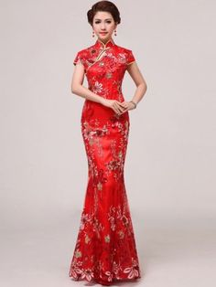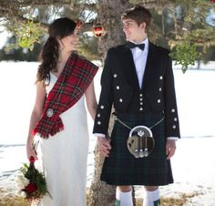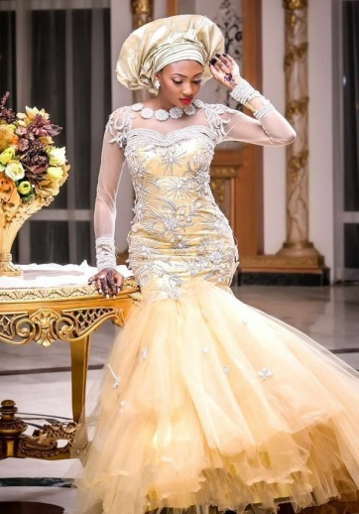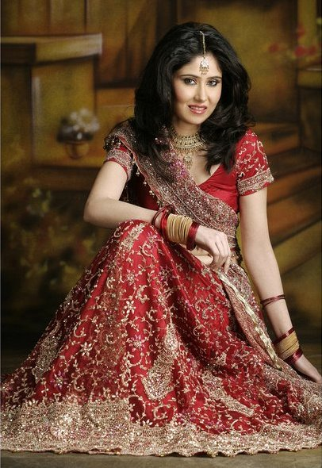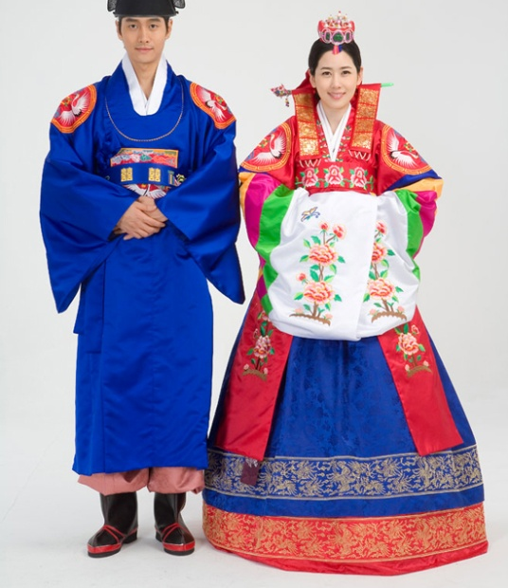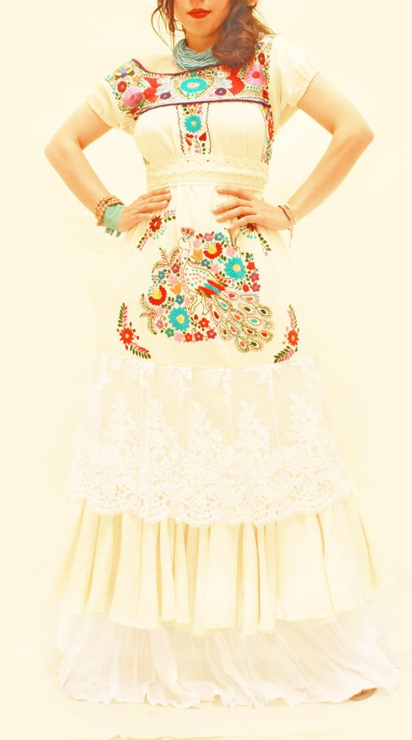

References
Time. (2015). The White Dress That Changed Wedding History Forever. Available URL: http://time.com/3698249/white-weddings/. Last accessed 28 Dec 2015.

Student Statement:

By submitting this assignment, I confirm that this is my own work.

Student Signature | Sara Spiers | Date | 29/12/15

For Tutor / Assessor Use Only
Total Marks
Marks Obtained
Percentage / Grade

