
Assignment Cover Sheet

Student Name: | Martin Selley
Student Number: | 1328
Course: | Safety In The Workplace
Assignment NO: | 3

Marking Criteria:
We expect the learners to write minimum one well expressed point in three lines against each allocated mark. This means one needs to write 15 lines with 5 well expressed points to get high grades for a 5 marks question.
For high grades use examples and illustrations where appropriate.
Question 1.I - Which of these businesses should be concerned about safety?
a. Insurance company
b. Manufacturing company
c. Medical transcriptionists that work from home
d. All of the above

Answer - The answer is ‘d. All of the above’. It makes no difference what type of business you run; or where your employees are working from, safety is a concern. We all encounter hazards in our daily home & working lives’, some hazards are more visible than others, some have measures in place to reduce the hazard to such an extent that we don’t notice it any more.

Question 1.II - Resolving a hazard using personal protective equipment means…
a. Changing the way workers perform tasks to make it safer
b. Adding safety elements into the design of the hazard (such as stairway railings)
c. Requiring the employee to do something to reduce the hazard

Answer - ‘Resolving a hazard using personal protective equipment means ‘Requiring the employee to do something to reduce the hazard’ The method(s) utilized may be as simple as wearing eye protection or gloves; or more complex such as wearing heated or cooled clothing when working in hot/cold environments. There are many ways in which a hazard can be resolved by the employee doing something to reduce the hazard; it all depends on what hazards are identified, and what potential mitigations are available.

Question 1.III - True or False: Hazard resolution methods can be combined.

Answer - Hazard resolution methods can be combined, therefore the answer is true. It may be that the only sure way of minimizing the risk from the hazard is to combine different elements of Engineering Controls, Work Practices & Personal Protective Equipment to best protect the employee and the company. The ultimate aim being to modify/adapt the task so that becomes safe to execute.

Question 2 - Which Hazard resolving methods have been identified by OSHA. Explain each with examples.

Answer - The three main methods identified by OSHA for Resolving Hazards are: Engineering Controls
Working practices
Personal Protective Equipment

Examples of the above methods are detailed below.

Engineering Controls – probably the most important, and a way to control hazards at the source. Examples range from simple barriers, signs, choosing different chemicals, installing guards around machinery etc.
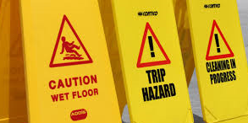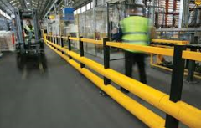

Working practices – these are typically utilised once Engineering Controls have been applied but hazards still exist. Working practices look at changing the way tasks are performed or supervised. Examples could be producing standard operating procedures, monitoring/supervising the task, specific task related training, rotating employees off task after a pre-determined interval etc.

Personal Protective Equipment – Typically the ‘last line of defence’; should the Engineering Controls and Working Practices be in place, and the task still requires the use of Personal Protective Equipment (PPE) then if it fails there is nothing to further protect the employee from the hazard. The types of Personal Protective Equipment available are numerous, and cater for a wide range of hazards. Examples include basic PPE such as Hard hats, gloves, coveralls & safety boots. Other types of PPE include breathing apparatus, hearing protection, goggles and shields, reflective work wear, fall arrestors etc.
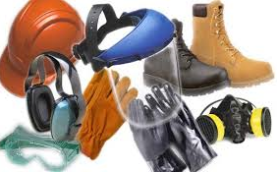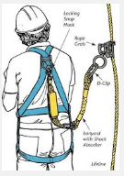

Student Statement:

By submitting this assignment, I confirm that this is my own work.

Student Signature | Martin Selley | Date | 04-JUN-2015

For Tutor / Assessor Use Only
Total Marks
Marks Obtained
Percentage / Grade

