
Youssef
Assignment Cover Sheet

Student Name: | Gehan Aly Youssef
Student Number: | 1092
Course: | Interior Design Diploma
Assignment NO: | Module 8

Student Statement:

By submitting this assignment, I confirm that this is my own work.

Student Signature | Gehan Youssef | Date | 1/1/2014

For Tutor / Assessor Use Only
Total Marks
Marks Obtained
Percentage / Grade

Name: Gehan Aly Youssef
Student no.: 1092
Assessment no.: Module 8
Course Name: Interior Design Diploma
Address: Beverly Hills Compound, Build. No. 89,Square 1,El Sheik Zayed, 6 October, Giza,Cairo,Egypt
Page no.: 1

Q.1. Short Questions:

- What is the best way of mixing patterns?

The best way of mixing pattern is the best relationship between density and scale so when the scale of the pattern is appropriate whether big or small with the density of the pattern on the material itself so for example if we choose a specific pattern let's say a drawing like a leaf so if it has large scale on a beige cloth for example I think it should be less dense than a small scale leaf also when colour differ scale and density differs.
There is another relationship in mixing patterns it could be by using 2 0r 3 types of patterns on same room or even coach with same colour as sometimes we use floral pattern pillow with another plan pillow put on a striped pattern coach but all used in same colour let's say velvet crimson coach or a floral one with plan and striped pillows
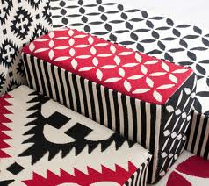

- What is the density of a pattern?

Density of a pattern is how much this pattern is used on the material or the amount of the drawing that is used is it too much or very little for example if we have a heart that is drawn so if we have 5 repeated in a meter so this is dense but if we have this heart repeated 15 time

Name: Gehan Aly Youssef
Student no.: 1092
Assessment no.: Module 8
Page no.: 2
in a meter so this will be denser so here density of 15 is more than density of 5.

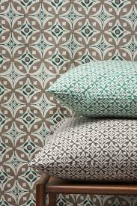

- If you are to wall paper a room with a vertical stripe pattern would the ceilings appear lower or higher?

If there is a wall paper I'm going to use in a room with vertical stripe pattern the ceiling would appear higher as vertical stripes make the wall appear taller but the horizontal stripes make the wall appear wider so when we have a low ceiling we can use vertical stripes and when we have a small room horizontal stripes will be a good solution for space to look bigger.
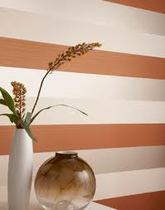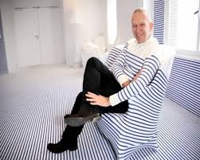

Name: Gehan Aly Youssef
Student no.: 1092
Assessment no.: Module 8
Page no.: 3

- How can textural depth be created in a design scheme?

Textural depth can be created in a design scheme by mixing different items having different textures together this can appear very obviously when using monochromatic scheme as texture here have a great Varity as using a texture for painting and other one for sofas and chairs like mixing for example cotton with jute or shiny glass with wood rough surfaces with smooth ones we can put wallpaper with ordinary painting which gives us different textures or combine rocks surfaces with plain wall all this give us a depth in the scene as when use only one or 2 textures it make the theme looks boring and with no depth as eye wants to move from one scene to another seeing rooms details to make the room looks richer also the texture of draperies is very important and accessories as it complete the picture of the room to make it more powerful.
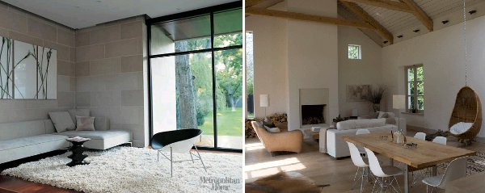

- ‘Texture in fabrics emphasize mood in a room’. Explain with examples.

Using different textures in fabrics give a specific mood in a room specifically when choosing a certain fabrics to combine together in same room to give us a cozy or warm or rich effect for example in reception we mainly use velvet , brocade, silk, taffeta, embroider cloth, Orbison, chanellie. As these textures together give a reception a chic luxury look, while living rooms it better to use cotton, linen,

Name: Gehan Aly Youssef
Student no.: 1092
Assessment no.: Module 8
Page no.: 4

denim, leather fabrics to give comfort cozy look. As bedrooms it's better to use voile, silk or satin and light cottons .

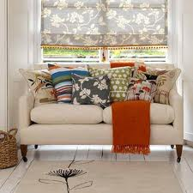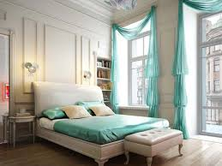

- Sometimes the same colour appears different in different types of light. What in your opinion could be the reason behind this?

The reason behind that that different textures are different in there degree of absorbing light and therefore reflecting colours so there are some textures absorb light like rough surfaces like stones bricks other surfaces reflect colour like soft surfaces like glass or tiles and there is a third type that filter and diffuse light like voile that’s why we need to look to the colour on this texture in place that it actually will be used in it as the amount of light there differ .
Also that make a conclusion that same colour differ totally from one texture or surface than another as same colour on a ceramic tile differs than on a plastered wall differs than on a silky or linen drapery .
So here for example same colour in different textures:

Name: Gehan Aly Youssef
Student no.: 1092
Assessment no.: Module 8
Page no.: 5

We use baby blue in different textures so it looks different.

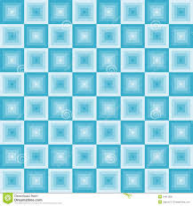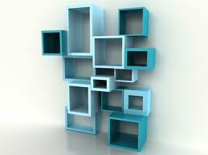
Wall paper Wood paint

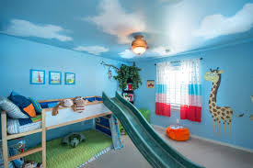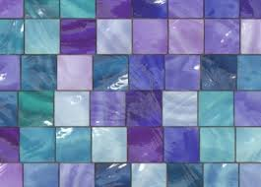
Wall paint Glass tiles sheets

- “Texture can work like colour to bring surfaces forward or can give the impression that they are further away”. Explain

Yes texture like colour they can bring surfaces forward like silk , glass, brass, stainless, glossy , ceramic textures all these textures bring colour to you and make it shiny as it reflects colour other textures or surfaces move away or take apart from you as velvet , stone, bricks, wooden, cotton surfaces that absorb colour so that’s why same colour on silk cloth seems brighter , shiny coming to you than same colour on linen cloth that absorb colour make it darker and move it away from you.

Name: Gehan Aly Youssef
Student no.: 1092
Assessment no.: Module 8 Page no.: 6

Here are 2 examples which show the relationship between texture and its effect in the feeling of the surface as it works like colour in reflecting or absorbing light.

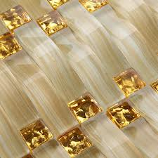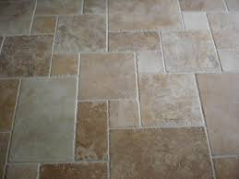
Glass tiles Matt stony tiles

Activities

Activity 1
Shop around and bring back various samples of different materials like brick, tiles, matting or fabrics like silk, chenille, voile. Experiment with them and try out various contrasts.

After experimenting them I have found that :
- Brick has a very rough texture and it absorb light and colour and move it away from you .
- Tiles they have smooth surface which reflects colours and light so colour here come to you and looks bright.
- Matting can be rough or smooth but they absorb light and colour which make it looks darker and not shining.
- Fabrics:
- Silk: it's very soft fabric and it reflects colour and make it very shiny.
- Chenille : it's heavy fabric and absorb colour which make it looks darker and more rich.
- Voile: it's a transparent fabric so colour is distributed when pass through it so it looks pale.

Name: Gehan Aly Youssef
Student no.: 1092
Assessment no.: Module 8
Page no.:7

Activity 2
Observe different types of fabrics in artificial and natural lights of varying strengths. Write down the outcomes of your observation. Attach the pieces of fabrics with your written observation.

I'll show you different types of fabrics that I have experiment them:

First: linen embroidered cloth

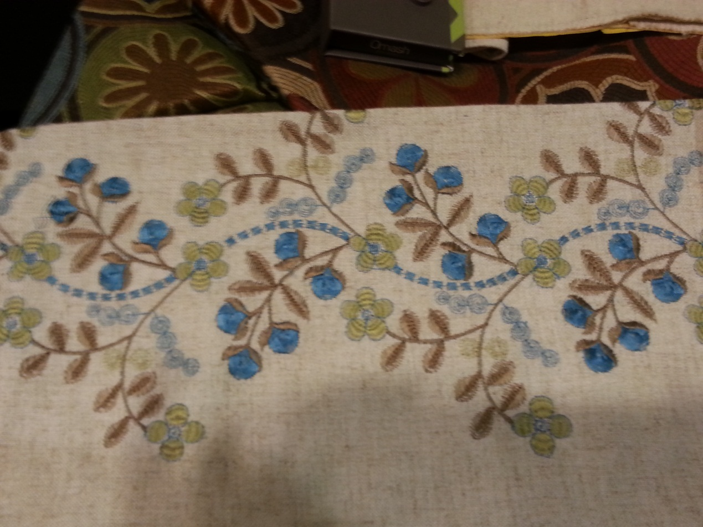

Here is a fabric made from linen and it's embroidered this fabric absorbs color, color looks darker and it's not shiny but embroidered lines look more shiny in both natural and artificial light. Linen cloth in sun may look much lighter than in artificial light it can be a little bit transparent.

Name: Gehan Aly Youssef
Student no.: 1092
Assessment no.: Module 8
Page no.:8

Second: chenille cloth both stripped and plain.

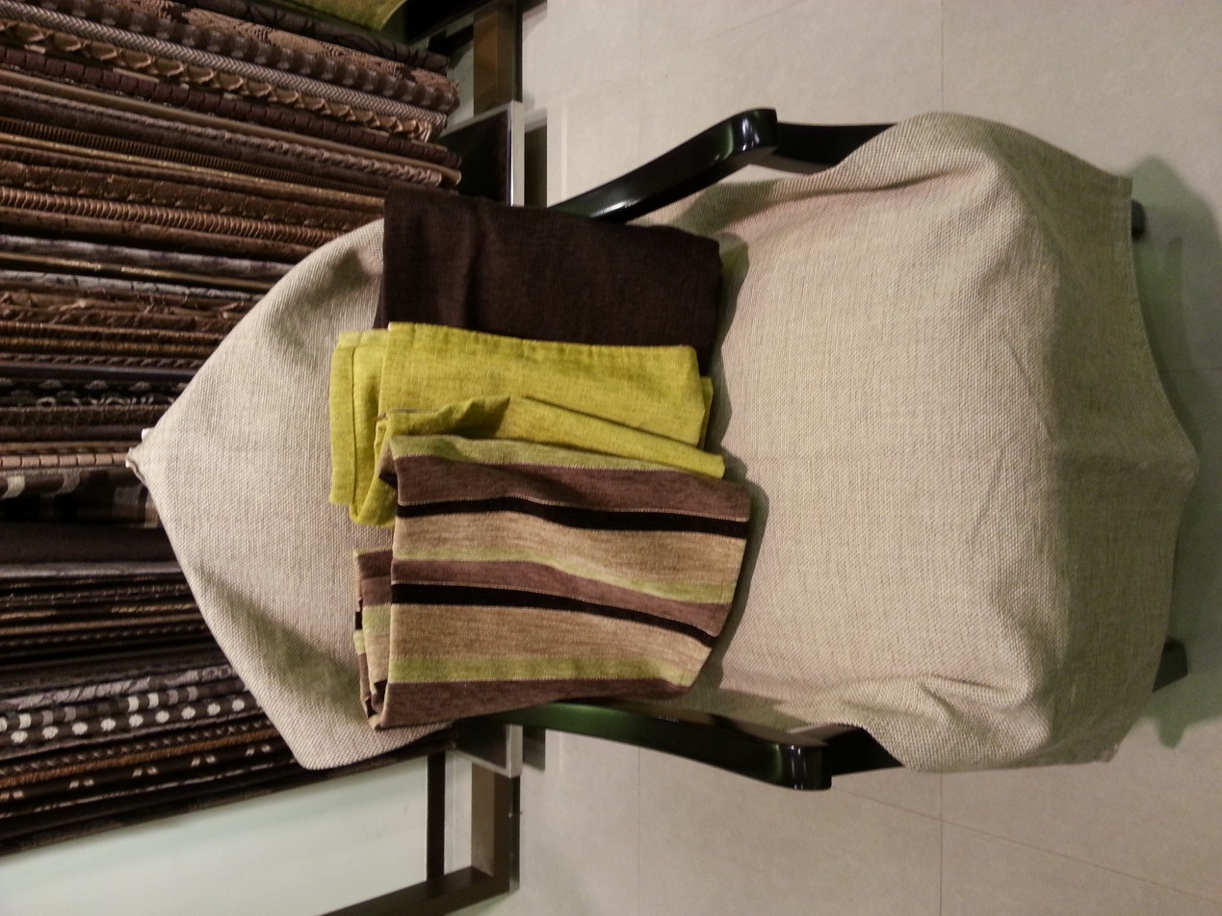

I've experiment this type of cloth it's soft but very heavy and absorbs light very much which make colour darker and more rich also in natural and artificial light it look same except that in sun light it looks more shiny.

Name: Gehan Aly Youssef
Student no.: 1092
Assessment no.: Module 8
Page no.:9

Third cloth: cotton + synthetic fabric

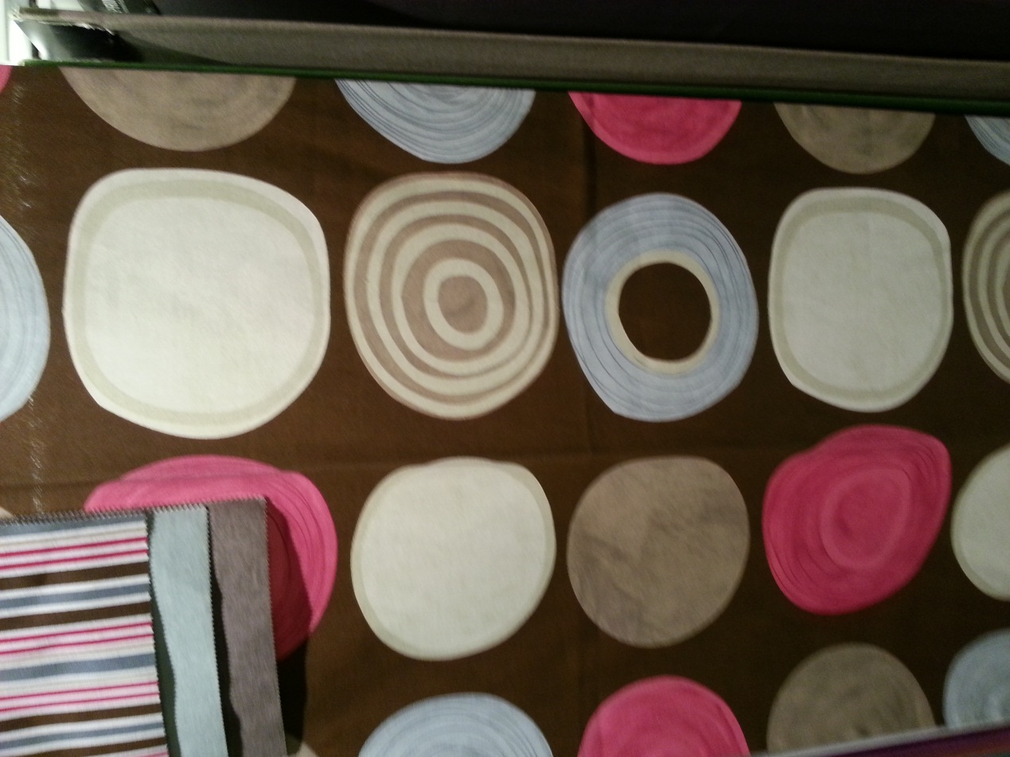

This cloth I've experiment it and it also absorb colour it seems to move colour away from you also it doesn't differ from sun light or artificial light as in both cases it's dark absorbing light .

