
Assignment Cover Sheet

Student Name: | Annur Zara Liyana Othman
Student Number: | 1227
Course: | Diploma in Fashion Design
Assignment NO: | 7

Student Statement:

By submitting this assignment, I confirm that this is my own work.

Student Signature | 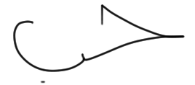 | Date | 20th June 2014

For Tutor / Assessor Use Only
Total Marks
Marks Obtained
Percentage / Grade

Dress Designing Essentials

Assessment 7 Total Marks: 30
Q: 1: Give short answers to the following questions:
a) Which type of materials should be chosen for the dress of a thin person? And when choosing a stripy print which type of stripes would you recommend for the dress of a thin person?

How the figure type of wearer is really important aspect to pay attention in dress designing. There are certain rules that designers have to follow in other to make the garment look good on the body. When the garment sold in the store, designer will not be there to explain which one is perfect for the consumer body, so the consumer at least should know what look good on them. Still, as the person who know better in this field, designer play an important role in dressmaking.
For a thin person, most people used to think whatever material of the fabric its going to fit their figure. Easy math, its because they are thin. This is slightly not right because choosing a good garment for a thin figure could be tricky. For thin person, choosing materials, which do not cling to the figure and remember what has been said about shiny materials increasing the appearance of size. The other material that suite this type of figure are materials that stand out somewhat from the figure, and the loose garment that make from easy material.
Stripy print is very popular in fashion. However the figure, at least once they will wear a stripy print garment. For a thin figure, the horizontal stripy print is the best to make them look a little bit full. It doesn’t have to be a straight horizontal line only; it can be a curve, jagged, zigzag line as well. Wearing a straight vertical line makes a thin body look even thinner.
Here are the examples;
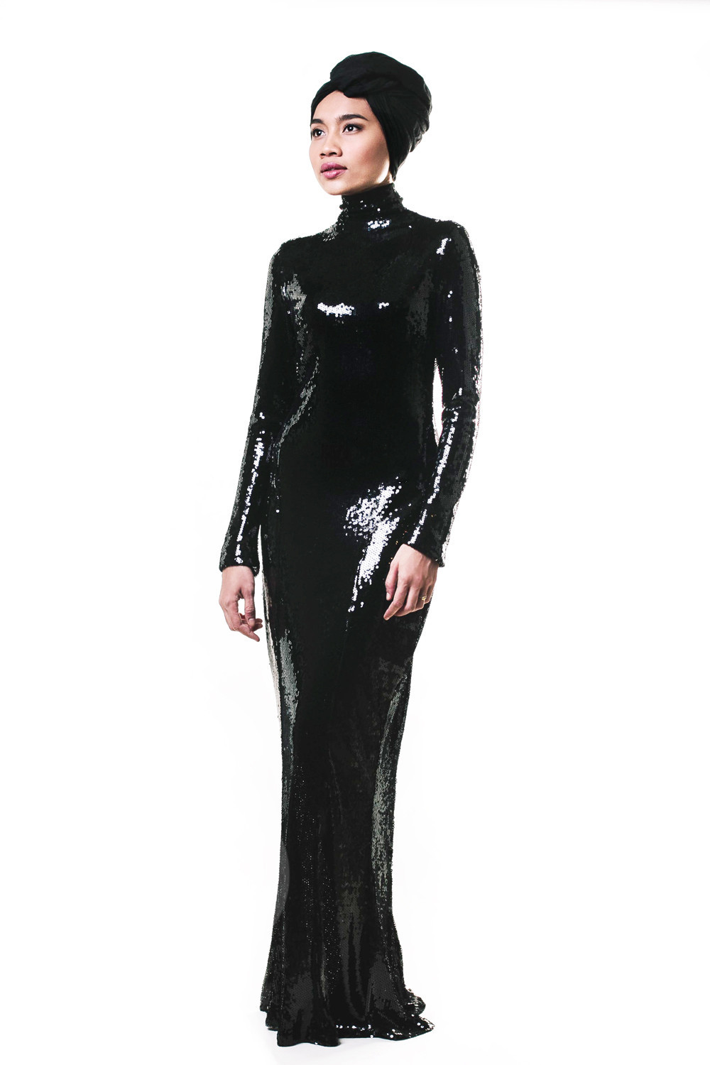
Example of a shiny fabric made into a long dress make a thin figure look beautiful in shape.
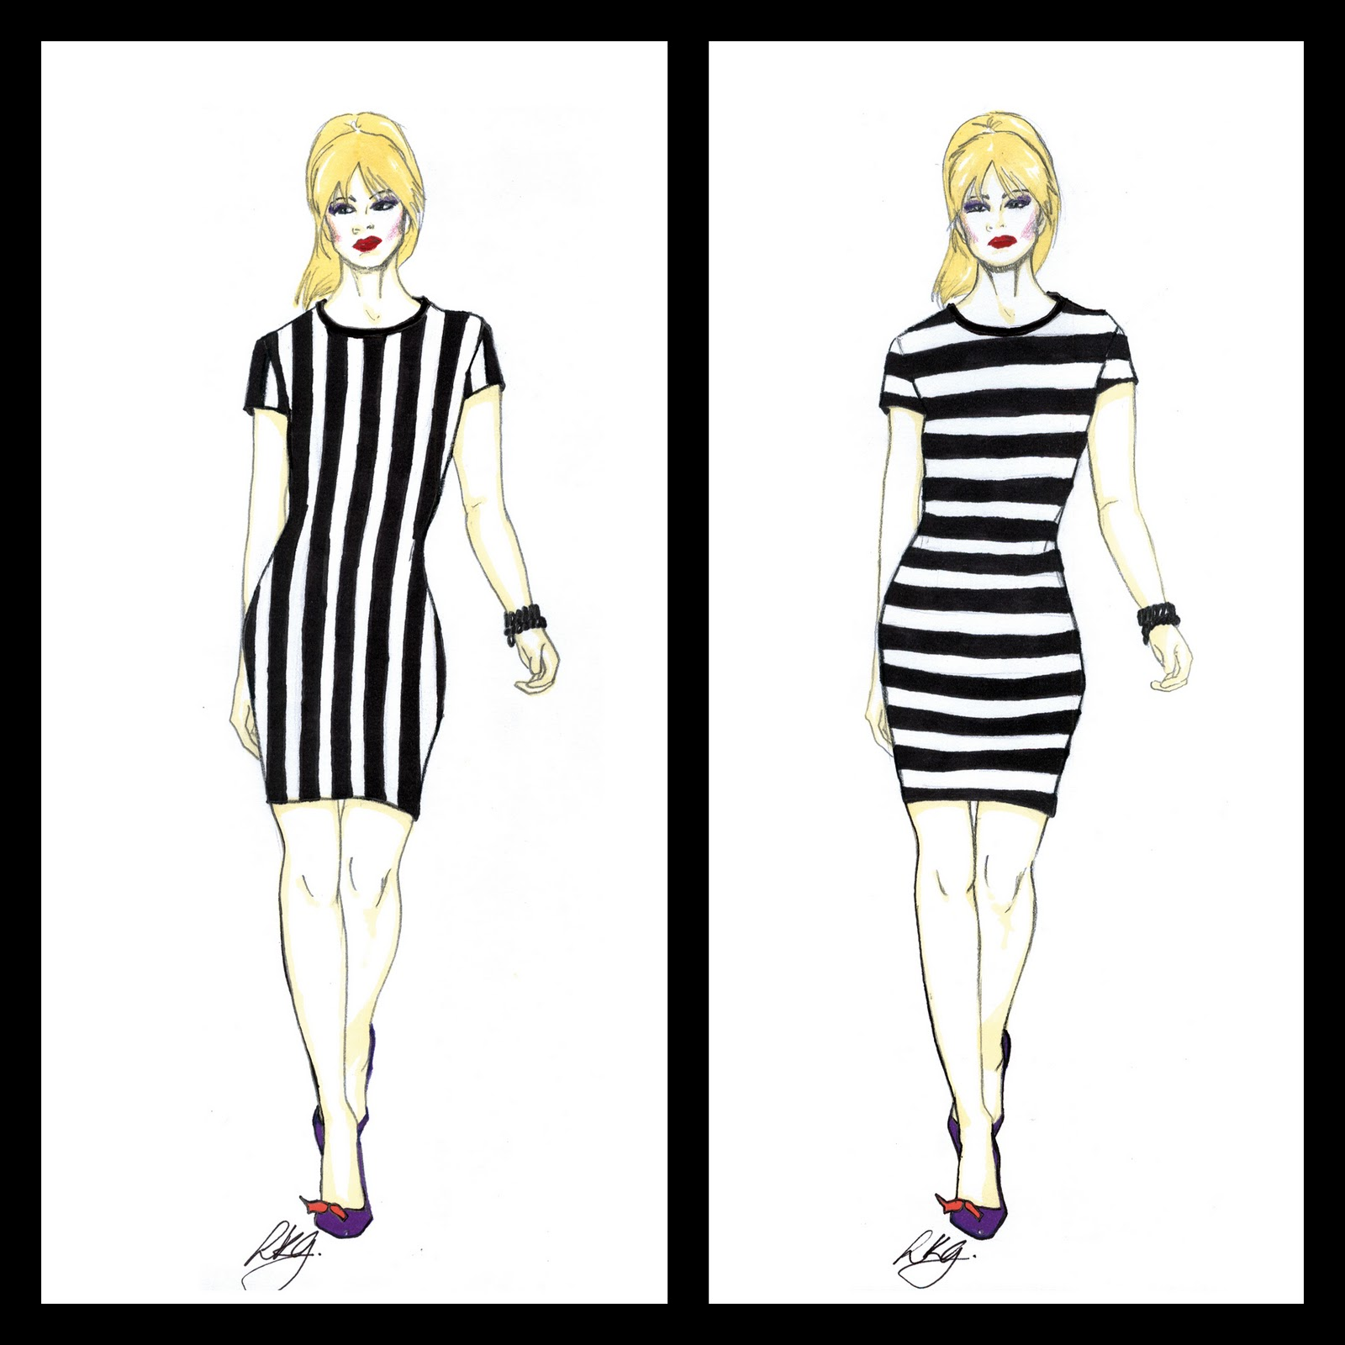
Examples of stripy print on thin figure. Left is Vertical stripe and right is horizontal stripe

b) How would you design a dress for a person with large waist and hips? Which designing techniques would you apply?
Design a garment for the person that has a large waist and hips is a little bit tricky and there are few things that designer have to pay close attention in order to make the wearer look fine. For the bottom part of the garment, the material should be not from a shiny material. Soft and dull surface of material are absolutely better than a shiny surface.
The bottom part should not too tight and close to the body neither to loose since only waist and hip are big. The design can based on the emphasis up and down the centre front of the dress, oblique lines from hem to waist that end slightly at one side of the centre front. From the waistline, narrow belt placed slightly below natural waistline and it should be not too outstanding. Because the waist and hip it selves are big, its really important to not use a huge amount of fullness in the skirt. The skirt should be flared slightly from the hips. In other words, the design should be less in the fullness start from the waist. Also the colour can’t be too bright because the brighter the colour, the bigger it will be look.
There are few design that not suitable for this type of figure; A one-piece which is belt less dress hanging straight from the shoulders, pockets at the hip line, horizontal lines on the skirt placed near the hip line, skirt that too short and too tight or even a very full skirt, skirts that are narrowest at the hem and a tight, closely fitted waist. All these design will look the waist and hip even bigger.

Overall, for this type of figure perhaps design can be heavier in the upper part, which start from the waistline and up. In order to make the whole garment look fair and stable on the figure, the emphasis should be in the upper part of the garment and keep simple and natural at the bottom part.

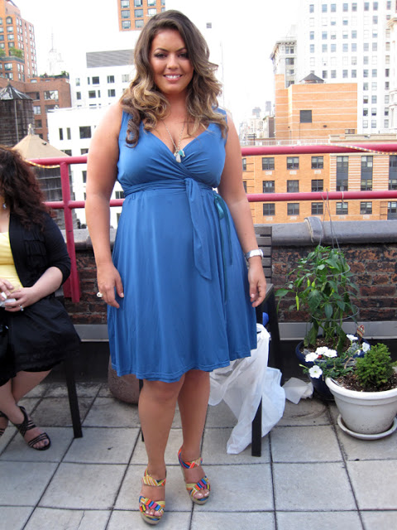

Example of a dress on the large waist and hip figure.

c) 'A person with stout figure must never try wearing a dress which is too tight for him/her'. Discuss

For a stout figure, choosing a very match and suitable garment is sometimes very hard because most of the ready-to-wear garments are made for a normal type of figure. Since the major problem is the size, so its really important not to shown closely the one and only weakness. The emphasis should not be from the tightness of the garment. It should make it simple and comfortable. Soft materials with a dull rather than a shiny surface are suitable for this type of figure. Garments that have a vertical movement is the best because it can make eyes travel up and down rather than a horizontal movement which make eyes goes across the dress.
The whole garment style should not make from a heavy and extreme material of shape. The garment like fur coat should be thin and light. The space between lines also should be in natural look and not to busy. Wearing a too short, too long, and tight sleeves are always a wrong choices for this figure. For the neckline, v-neck is a forever choice in order to make the emphasis became narrower.
There are a few things to follow in order to make a very good garment for a stout figure. For the colour, it’s going to be great to wear one colour no matter the design look. Either full to the ankle or divide by two. The material should not be to clingy and use the dull colour In the large area. The black or dark tones silhouette and the silhouette that not break too much can be count as a perfect look. For the play safe garment, it’s really good to keep the traditional lines rather than extreme curves and angles. This figure look great in the vertical stripy print garment.
Meanwhile there are few styles that don’t suit this figure. Such as, the heavy fabric. Too stiff, clingy and shiny fabric should be avoided. It’s a very bad idea id the stout figure wearing a garment that too tight for them. Its going to make the whole look uncomfortable. Either wearing or outlook. It will make the emphasis of the garment on the not very good body curves. But, in order to hide the body curves, the garment should not be too loose until it look super heavy and not in shape at all.
Overall, choosing a right garment for a stout body its not to hard if we know the right thing to wear. Wearing a too tight garment is not good neither wearing a very loose garment.

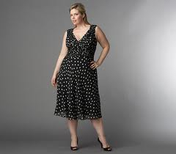

Example of a perfect dress for a stout figure.

d) How would you design a dress for a person with round shoulders so this problem is least noticeable?
Having a round shoulders definitely not a problem because there are few aspects that we can follow in order to make the whole garment look good in the wearer. We can pay more attention in the shoulder and sleeves part. The sleeve should be set-in sleeve. The shoulder seam placed about one-half inch back of the normal shoulder line can hide the roundness of the original shoulder. Collars that will appear to straighten the curve of the back. Either have the collar long enough to hang loose from the neck to below the highest point of the curve, or have it short enough to fill in the space between the neck and the beginning of the curve. Then build out the waistline by having the waist full and loose in order to fill in below the prominent curve.
Anything that defines your shoulders such as pert puffed sleeves, shoulder pads, crisp fabrics, and large, square collars will straighten out your shoulder line. Avoid using a free sleeve line. For example kimono and raglan sleeves. These style going to give a rounder look in the shoulder. The collar design also important to make the shoulder look more stiff and pretty. Avoid using collars that end at the curve of the back as well as collarless dresses that are tight at the waistline.
For the head part avoid wearing a hat with a long dropping brim in back that forms a continuous line between the crown and the curve of the shoulders.

In conclusion pay more attention in the shoulder to sleeve line and the collar to waist in order make round shoulder least noticeable.

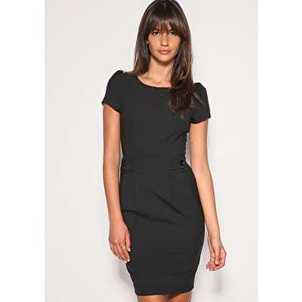
Example of a simple dress that have a puffed sleeve.

Q: 2: Activity
Make a collage of the pictures from a magazine, people wearing dresses unsuitable for their figures. For each picture explain how this could have been designed correctly for that person’s figure. (10)

Picture 1
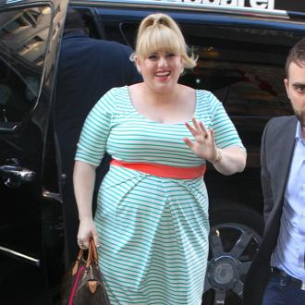
Stripe printed garment is always beautiful. Unless you wear it wrong. The picture above show a stout figure on horizontal stripe dress. Although it look cute because the colour is so fresh but still it made the figure look even bigger. This person wearing this cloth also have large bust. It covers well and gave a comfortable look but the orange line under the bust line seriously failed. The line is in different colour with the whole garment. Its look like a high waistline. Its even crooked and folded in on the wearer body. The emphasis of this dress is a orange waistline. It make eye travel through the body in horizontally which is make the wearer look wider.
For this type of figure, vertical stripe line is very recommended because it make eye travel all the way up and down. This can make the body look thinner. And for the waistline, it should not be an obvious waistline like shown in the picture. Also the colour of waistline should be in the same tone or colour as the whole garment. Using the darker colour will give an effect of slenderness but, since the original dress colour is s cute and sweet, it might be able to be accepted if the stripe is in vertical way.
Picture 2
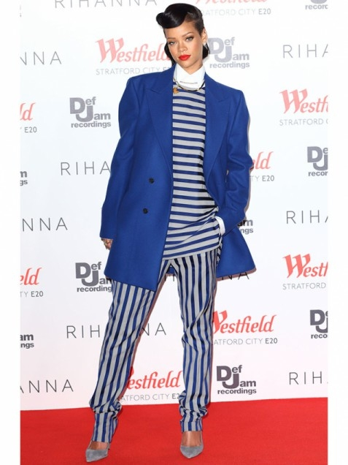
Having normal figure is a gift because there are plenty of styles you can put on. But still, you should be careful in order to look right. As shown in the picture above, the wearer wearing a blue tone in the whole garment. Stripe shirt and pant look not very bad much. And create quite good interesting look by using a different way of line in the design. Fore the pant, the vertical stripe look good and it makes the bottom part look slimmer. The shirt part is a worrisome. The shirt is in a horizontal stripe, which is not so bad for this kind of figure. But, it mixes up with a huge shape of jacket. The shoulder is longer than the wearer shoulder size and its look saggy. It’s pretty long in length. The shirt is on horizontal line, which gave a wider look plus the very wide size of the jacket.
This whole garment look so unstable. The upper part look messy and too saggy in addition the wearer face is small. For this figure, the stripe line direction is free to apply just the jacket size need to be fit well to the body. It give a very neat look at the same time can create a professional look. The shoulder should be in the right place and the sleeves length should be just okay with the wearer hand arm length and size.

Picture 3
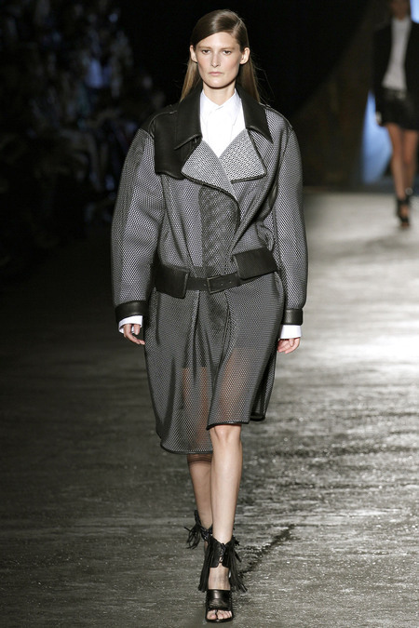
For this garment, the outer jacket look so baggy especially at the shoulder area. The upper part of the body look heavy. The usage of leather gives a heavy and hard look. The collar fold is too big for this wearer body. The sleeve is so big and even longer than what it should be. The leather belt set in loose gave a boring look. It not right in the waist and the width is big. In addition, out of nowhere a transparent and soft material made the bottom part of this garment. It’s not really right against the hard garment that used in the upper part. It’s look heavy in only upper part.
For this figure, the jacket should be a little bit fit to the body. Its okay to have a loose sleeves but not the extra long shoulder edges. The material should be match each other well in order to create a harmony look. The belt going to good if the body part or this garment reduces in size a little bit.

Picture 5
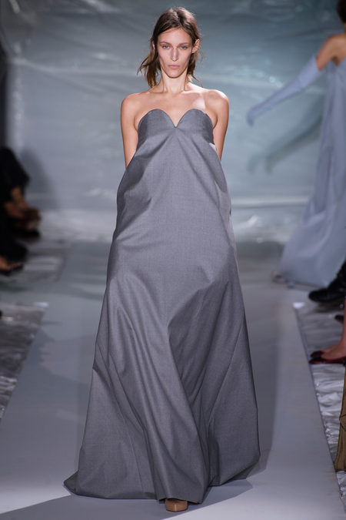
This figure is so beautiful in shape and this garment show nothing with it. Its so plain and huge. Its well shaped in upper part aspecially the neckline. But when our eye travel down, it give a big shock. Its pale in colour and the garment is open wide in the skirt part. It even has the pockets. Since the material is so stiff, so the whole garment look unfriendly and cold.
For this garment, its really great if the bottom part be a little narrower . The garment also should be a little bit soft. The colour was okay, but since the wearer is slim so its must be great if the colour in the bright tones. In order to look more interesting, this garment should have a waistline either in the middle or under the bust or even near the hip. If not, just make a litte shape for the waist part.

Reference
Information: BOLC unit 7 notes, Fashion website, Fashion blog, Fashion magazine online and offline.
Images: Google images, Fashion website, Certain fashion brand website, Fashion blog.

