Kyle Pentland
1605
Assignment 3
Diploma in Environmental Management

Page 1
Q1.
Shifting cultivation: A simple system of unsustainable farming in which the forest is slashed and burned or cut down to make room for crop planting. These fields are cultivated for only one to four years due to heavy rainfall leaching out the important nutrients from the exposed, deforested soil. The topsoil containing these nutrients is washed away/eroded, exhausting soil fertility. With crop productivity gone, the field is abandoned and the farmers move on to clear a new area of forest.
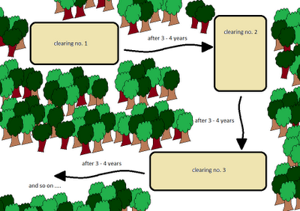
Development projects: Damming causes massive areas of land to not only be destroyed at the sight of the project, but large areas of forest are cleared at the start of planning when roads, railways and river ports are built. Dammed forests become pockets of islands. Species adapted to the river ecosystem are decimated, as are populations in the lowlands that flood. Larger vertebrates like howler monkeys survive but due to poor swimming skills live out their lives isolated, unable to breed.

Page 2

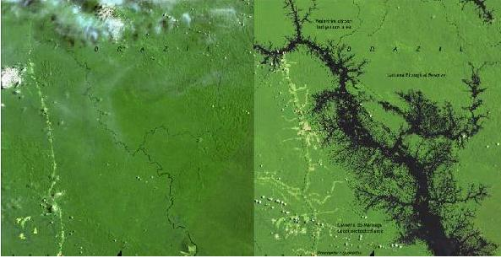
The Balbina dam, Brazil in 1986.
Firewood: Within poorer developing nations, people living near forest need firewood to satisfy their own energy demands, as they cannot afford electricity due to poverty and lack of employment. Larger households are more likely to use firewood as “the associated economic burden of increasing family size affects households’ ability to switch to cleaner fuels”. Within the continent of Africa alone, an estimated 90 percent of the entire population uses firewood for cooking; in sub-Saharan Africa, firewood and brush supply nearly 52 percent of all energy sources.
Commercial Industry: Much of the world’s wood based products are sourced from tropical forests. Indonesia supplies a third of all producer-country exports of tropical timber, second only to Malaysia. It is also the world's leading exporter of pulp, paper, and furniture sourced from tropical forest timber. Plywood accounted for half of Indonesia’s timber export. Nearly half of this was destined for Japan. Indonesia has lost nearly three-quarters of its tropical forest. A quarter of this loss was directly due to the demand for its timber from native forests.

Page 3

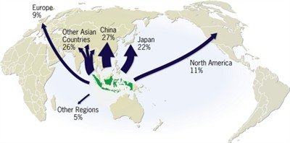
Colonisation: Governments and international aid agencies believed for some time that by encouraging colonisation and trans-migration schemes into rainforest areas, they could reduce the burden of the poverty felt by the people of the financially poorer countries. It has since become obvious that these efforts have failed, hurting the indigenous people and the environment. In Indonesia, the Transmigrasi Program, which begun in 1974, is believed to be “the greatest cause of forest loss in Indonesia”, directly causing an average annual loss of 200,000 hectares.
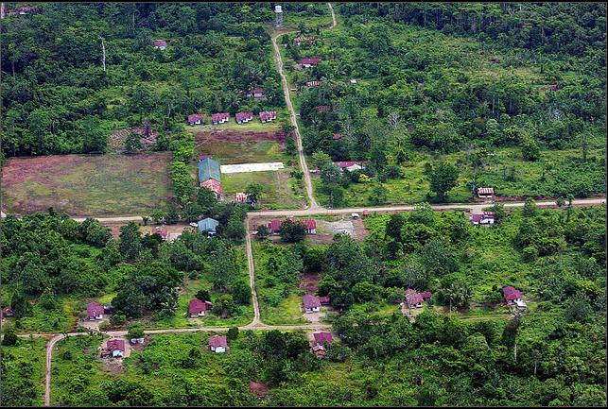

Page 4
Q2:
Overgrazing: Some farmers do not know how to use the land effectively. Letting their livestock graze continuously and recklessly, essentially stripping the land of everything that it has before moving on to another plot of land. With the vegetation consumed all is left is bare, exposed land. By stripping the soil of its nutrients, desertification becomes more and more of a reality for the area that is being used for farming. In Northern China excessive grazing causes 29.4% of its total desertification.
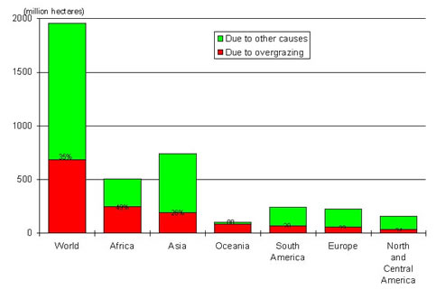
Soil salinisation: In irrigated lands, where underground water reservoirs are often polluted, evaporation brings mineral salts to the surface, resulting in high salinity. This renders the soil unsuitable for crops which cannot withstand these high levels of salt concentrations. Similarly, vegetation cover may not be given enough time to re-establish itself during intensive grazing periods or when grazing activities affect plots that have already been cultivated.

Page 5
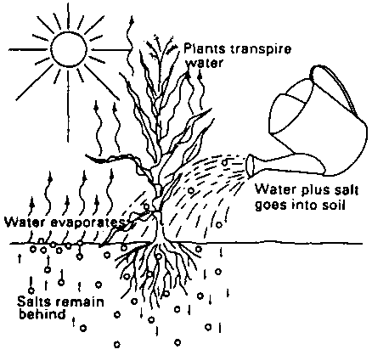
Excessive mining: Extensive mining and misuse of chemicals cause destructive, toxicological and chemical pollution to land and water resources. With the poor application techniques and inefficient use, large portions of the chemicals do not reach their targets and the residue contaminate land, water and air. These chemicals can also be leached into drainage system causing pollution of surface and ground waters. Gold mining in Peru has increased 400% from 1999 to 2012.
Famine and poverty: While this may be initially thought of as something that occurs post desertification, it is something that too can be a cause of it. Poverty and famine encourages poor land-use practices and short term food production at the cost of long-term production. The predictable effect of these practices is declining food production and an increase in the level of poverty. Eventually the land collapses completely and turns to what is more or less desert, able only to support population sizes considerably lower than those that were there before.

Page 6
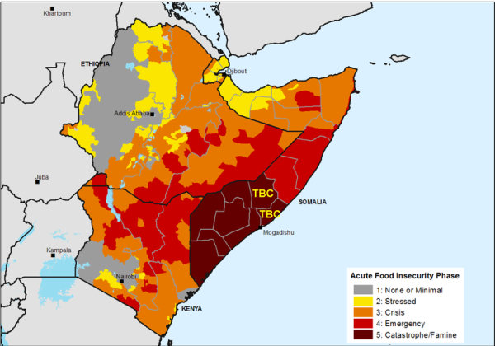
Areas of famine Somalia, 1997
Human Apathy: Losing an average of 400,000 hectares of land annually through forest clearing, Tanzania has failed to protect and conserve its environment and achieve sustainable development. Reasons for the failure to combat environmental destruction are many and complicated. However environmentalists singled out widespread public ignorance of the role of environment in national life as the major cause of desertification. Among the major weaknesses is the lack of resolve and commitment on the part of the government to protect the environment.
Q 3:
The Convention on Biological Diversity was created and adopted by governments at the 1992 Earth Summit to meet current needs and ensuring a living planet for the future. The main goals are: the conservation of biodiversity, the sustainability of its components, and the fair and equitable sharing of benefits from genetic resources.

Page 7
The African Convention on the Conservation of Nature and Natural Resources is a continent-wide agreement signed in 1968 which covers quantitative and qualitative management of resources, activities damaging to the environment and cooperation between nations.
The World Conservation Union (ICUN) is the world’s largest conservation organisation. Its mission is to influence and assist societies in the world to conserve the integrity and diversity of nature and to ensure that use of its resources is equitable and ecologically sustainable.
The International Convention for the Protection on Birds realises the danger of extermination which threatens certain species of birds and is concerned with the numerical decrease in other species, particularly migratory species. Its purpose is to protect birds in their wild state and environment.
World Resources Institute (WRI) is a global research organisation that spans more than 50 countries. Their work focuses on six critical issues at the intersection of environment and development: energy, climate, food, forests, water, and cities and transport.
World Wide Fund for Nature (WWF) founded in 1961, pursues three global objectives: "saving endangered species, protecting endangered habitats, and addressing global threats such as toxic pollution, over-fishing and climate change." The organization conducts campaigns in more than 100 countries worldwide.
International Convention for the Regulation of Whaling was signed in 1946. It has a legally binding Schedule which includes catch limits. These provisions can be amended. It monitors Cetacean diseases, chemical pollution and habitat degradation.
UNESCO programme on Man and biosphere is an inter-governmental programme. It aims to improve the relationship between people and their environmental surroundings through science. It promotes innovative approaches to sustainable development and environmental sustainability.
Page 8
Convention on the Conservation of Migratory Species of Wild Animals (CMS) signed in 1979. The CMS is the only global and UN-based intergovernmental organisation established exclusively for the conservation and management of terrestrial, aquatic and avian migratory species throughout their range.

