Assignment Cover sheet

Name: Saleema Choudrey
Student Number: 1240

Course: Diploma in Fashion Design

Principles of Fashion
Unit 2

  - What is FAD?
FAD means “Short lived fashion trend that comes out on the fashion aspect all of a sudden and die out as quickly as they appear. From makeup, jewellery, handbags to shoes, jeans and dresses and many styles that just make a permanent appearance. Fad fashion is also very expensive not everyone can afford it. It’s the society that’s responsible for how long the Fad fashion exist.

Sample of fad fashion:
Designer Logo bags
Every fashionable consumer was after a logo bag from top designers like Louis Vuitton and Gucci. These logo bags were a must have for every fashionable consumer for their wardrobe. Not everyone can afford these bags.

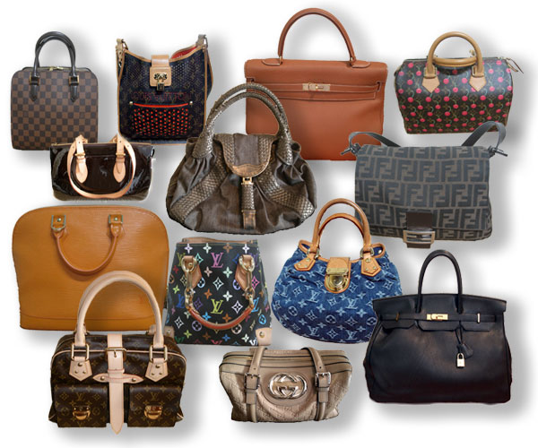
http://www.mymagicmix.com/wp-content/uploads/2013/03/purses.jpg

  - Define the term “ Fashion Forecasting”
Fashion forecasters analyse colours, style, materials, fabrics, cut that will be presented in the future in the fashion industry. They have to plan 2 years ahead and sell it to fashion retailers. Fashion forecasters know what will sell well in the fashion industry. Internet is a big source for fashion forecasters they get all the information online as well as their work is done through the media like, television, magazines, newspaper, shows, which includes:
- Market research
- Consumer research
- Surveys
- Consumer focus group
- In-store informal interviews
- Shopping
- Sales records
- Evaluating the collection
- Fashion trends
- Trend for target market

  - How would you differentiate Fashion forecasting from Trend forecasting?
The difference between fashion forecasting and trend forecasting is that fashion forecasters focus on upcoming styles. Fashion forecasters try to sell branded products to fashion retailers, attract customers through the media, they do researches online to sell their products to fashion retailers
While trend forecasters focuses on automobiles, medicine, food and beverages, literature, and home furnishings.
Trend forecasting is a difficult and yet the best way to keep on track of sales.

  - What is meant by fashion trends?

A “trend “means the acceptance of a “new” design. The new designs are mostly copied from the past fashion. It occurs only when the public accepts it. It last for about five months.

Usually the fashion remains the same but the material/ designs/silhouettes changes.

Sample of fashion trend:

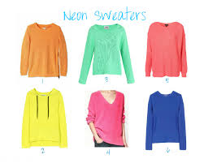
http://www.fashioncaramel.com/2011/12/neon-sweaters-and-great-affordable-neon.html

- Outline the basic practical considerations that a customer takes into account when selecting fashion garments and accessories.
Criteria Consumer use in fashion selection

Elements of fashion

Manufacturers and consumers need to consider the criteria use in fashion selection. Before buying a fashion item the consumer goes through practical consideration.

The fashion element for the buyer as well for the consumer is simply the same. The only difference is that these elements are seen by the purchaser instead of the creator.

Colour is a first impression to buyers when selecting a fashion item. Consumer look at the colour if it suits them if they like it or not.
That will be their first judgement to the fashion item.
And depending on that the buyer might regret it.

Texture plays a role when selecting a product. Sensuous appeal develops in the consumer.

Style is a fashion element that defines a fashion item.
Including the line, silhouettes and details.

Consumers fashion awareness affects the opinion on the current fashion. Their judgement makes a difference to what’s fashionable.

Practical Consideration

- Price
Price is the most important fashion element when selecting a fashion item for the average consumer. Not everyone can afford designer branded fashion items.

- Fit
Standard sizing are set by The Department of Commerce. Consumers prefer to fit and make sure their size before purchasing the item. Still is it possible that the sizes might not fit perfect on the buyer. So there will be chances the buyer might regret again not to purchase the item.

- Appropriateness
Fashion items should be suitable for each specific occasion.
For example: Age appropriateness. Consumer should select a garment according to their age.

- Brand
Brands are recognition for products that are produced by businesses. Advertising directs consumers which brand to choose. Some consumers buy only the brands they recognize.

2. What is the difference between fashion and style?

Fashion is about dressing according to what’s fashionable. Style is more about being yourself. Fashion is currently a trend it could be anything like makeup, accessories, shoes, clothes. They are made popular by the media, fashion houses, model, actors and actresses.
Fashion stays in for years and trends last up to five months.

Fashion | Style
Trousers | High waist
Skirts | peplum
Jeans/Denim | Various colours
Dresses | Flower prints/Animal print
jumper | Oversized
Basics | Neon

Style
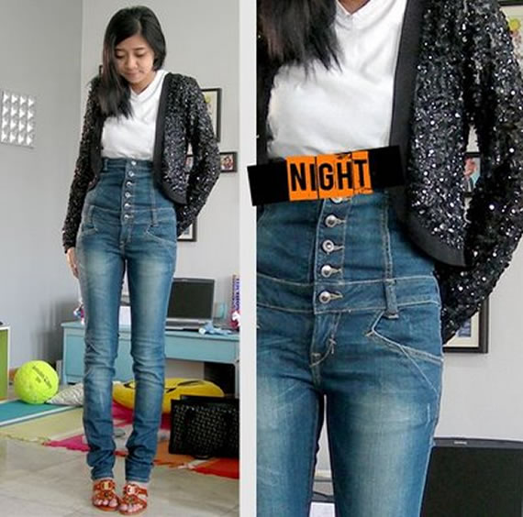
Highwaisted trousers Jeans

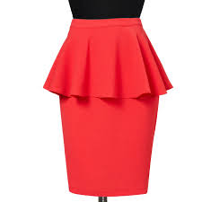
Peplum skirt

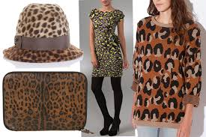
Animal printed fashion items
Fashion
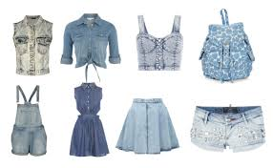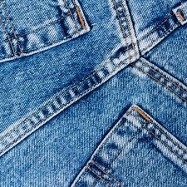
Denim

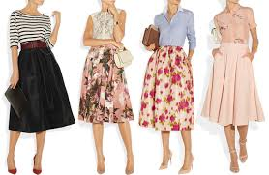
Skirt
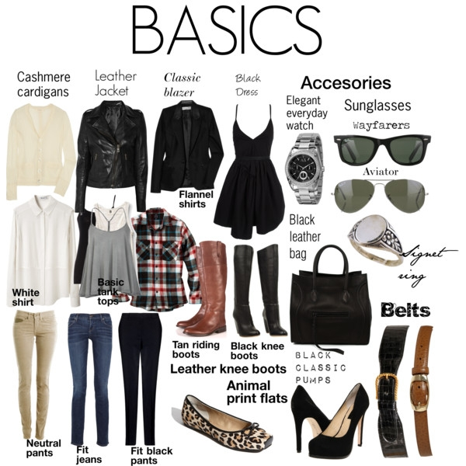
Basics
Reference:

http://google.com
www.pinkvilla.com
www.vogue.co.uk/fashion/trends
www.bing.com
http://fabulouslydisheveled.com
http://facebook.com

