
Assignment Cover Sheet

Student Name: | JOSHUA GWASHAVANHU
Student Number: | 1614
Course: | PROJECT MANAGEMENT
Assignment NO: | 2

Marking Criteria:
We expect the learners to write minimum one well expressed point in three lines against each allocated mark. This means one needs to write 15 lines with 5 well expressed points to get high grades for a 5 marks question.
For high grades use examples and illustrations where appropriate.
ASSIGNMENT 2

Answers to the Following Questions:
1. What are priority quadrants?
The Priority Matrix is a simple diagramming technique that helps one to choose which activities to prioritize (and which ones to drop) if one want to make the most out of his/her time and opportunities.
e.g.

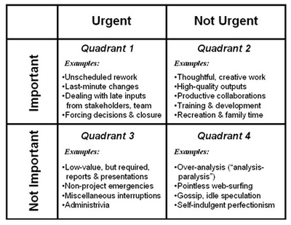
Quadrant 1 (Urgently and Important)
- Rework (Revise) something that was not planned.
- Dealing with Last minute changes based on inputs from stakeholders/sponsors
- Negotiating with someone who is refusing to make a decision that is holding up the entire project.

Quadrant 2 activities (Not Urgent, but Important)
These are kinds of things done be team leader and his or her team, they are likely to spend most of their time doing. These include engaging in thoughtful, creative work to develop high-quality project deliverables. And these include productive collaborations with project stakeholders. e.g. personal growth and renewal that comes from training and development activities or simply spending time in recreation and with family.

Quadrant 3 activities (Urgent, but Not Important)
These are kinds of things that typically are imposed by someone outside the project. These include unnecessary presentations e.g. dealing with excessive demands for reports, organizational emergencies outside the project, and all manner of interruptions.

Quadrant 4 activities (Not urgent and Not Important)
These are simply anything that wastes time and produce nothing of value, these activities that can suck time from overly-conscientious professionals in any field, all of us can fall victim to such time wasters e.g. pointless web surfing, gossip, or idle speculations and rumors.

1b) How do these matrix help in selecting projects?

A prioritization matrix supports structured decision-making in the following ways:
• Helps prioritize complex or unclear issues when there are multiple criteria for determining importance
• Provides a quick and easy, yet consistent, method for evaluating options
• Takes some of the emotion out of the process
• Quantifies the decision with numeric rankings
• Is adaptable for many priority-setting needs e.g. projects, services & personal
• When used with a group of people, it facilitates reaching agreement on priorities and key issues

2. What is SPIRIT?
a) Spirit is a smart way of setting goals using the following steps:
S- Specific
P- Present tense or becoming present
I –“I” Statements
R- Reach High: Aim for the Starts and Land in the Sky!
I – Ignites Emotion
T- Time and Deadline

2b) How it is used for setting goals?
Specific
Successfully ensure and clearly clarify your goal which makes it simple to evaluate success of a project using the calculation of time, cost, resources and desired outcome.

Present tense or becoming present
Writing goals in either present tense or becoming tense makes it feel real and believable and it makes one to believe that it can be accomplished.
e.g.
I have managed to create a project management software
or
I am working around the clock on my new project management software

“I” Statements

“I” statements create a sense of ownership and responsibility for your goals and it also tells the inner person that the goals set are achievable and they are yours you have the final say to them.

Reach High: Aim for the Starts and Land in the Sky!

Aims and goals should always be out of this world without any limit though real, it pushes one to accomplish the unthinkable.

Ignites Emotion

Goal setting always include creating goals that ignite a ton of passion within and which are also achievable.

Time and Deadline

The deadline should be clear and the goal can be achieved during the given space of time.

Student Statement:

By submitting this assignment, I confirm that this is my own work.

Student Signature | Joshua Gwashavanhu | Date | 20/01/2016

For Tutor / Assessor Use Only
Total Marks
Marks Obtained
Percentage / Grade

