
Assignment Cover Sheet

Student Name: | Laurel Huxham
Student Number: | 1648
Course: | Certificate in International Project Management
Assignment NO: | 02

Marking Criteria:
We expect the learners to write minimum one well expressed point in three lines against each allocated mark. This means one needs to write 15 lines with 5 well expressed points to get high grades for a 5 marks question.
For high grades use examples and illustrations where appropriate.

Please insert your completed assignment ( in word format) here:

2.1 - What is meant by ‘Project Deliverables’?
Product deliverables are the products or services produced as a result of the project. The product deliverables are often things that need to be handed over to the end users (internal or external to the organisation) such as a report or a building. Once the deliverable has been handed over the project or project phase is then complete. For example a project my team are working on is looking at the CCTV Hub on two sites and merging them into one. The deliverable will be a fully working CCTV Hub at one location with all the kit needed for it to work effectively. Once the Hub is complete this can be handed over to the end users.

2.2 – What is the purpose of determining a project’s goals and objectives?
Goals and Objectives help to identify what the overall aim of the project is, how and when it will be achieved. Goals and objectives help to break down the project in to smaller achievable tasks. These smaller tasks can break down in to resource, finance and duration to ensure a successful planning stage and overall outcome of a project. Once all of the goals and objectives are achieved the project will be finished. An example would be that I am currently working on a project that is at planning stage, before we can continue to the execution stage the projects Business case needs to be signed off by the TDA. Goals should be SMART:
S – Specific
M – Measurable
A – Accurate
R - Realistic
T – Timed

Some examples of goals and objectives to get us to sign off would be:
- Meet with end users and establish/design the floor plan incorporating their needs/requirements (Objective)
- Meet with the design team and get the 1/50’s and 1/100’s signed off (Objective)
- Tender the works (Objective)
- Send the Full Business Case to the TDA by the 1st August.

2.3 – What is the project planning phase about? Which plans are made at this stage?
The project planning phase is the second phase in the project lifecycle. These plans are produced to ensure all aspects of the project are managed (resource, time, cost, quality, risks and issues). Having detailed plans helps to have overall control of the project ensuring that is finished on time and within budget. Various documents and diagrams are created to show how the project will be run guiding the team through the execution and closing stages of the project. In these documents problems can be identified and solutions put in place to overcome them. Good detailed plans help to ensure the success of the project, they highlight progress measures, goals and objectives.

The Project Plan
The project plan is the most important document to the project. This document is used to define the project scope and show how the project team will deliver this. The project Plan needs to answer the following:
- Why – What is the purpose of the project? Is it to save money by coming out of an expensive rented building? Is the building no longer fit for purpose because the service has doubled in size?
- What – What are the project deliverables?
- Who – Who will be involved in the project, Internal staff, contractors etc.
- What – What will you be delivering in the project timeframe? What are the project milestones.
A Work Breakdown Structure (WBS) identifies phases, activities, tasks and milestones within the project and includes the order in which each should be completed. Using the WBS an educated estimate of resource, time and cost can be allocated to each task, making this a detailed project schedule. The project manager can use this document to track progress and report back to the project sponsor and stakeholders.

From the Project Plan the following are identified and plans/processes are made:

Project Interfaces
There are two interfaces that will affect a project:
- Organisational – These are the formal/informal reporting relationships that already exist in an organisations structure. These can be functional. Matrix or projectised. These need to be taken into consideration in the project plan.
- Interpersonal – These are the relationships between the project team members and the project participants.
Dependent on the project there could also be a third interface:
- Technical – Reporting relationships within technical areas of an organisation.

The Resource Plan
Although resource is noted in the project plan a more detailed breakdown is required. The resource plan details:
- The type of resource (labor, equipment or materials)
- Roles and responsibilities for the human resource aspect
- Total quantities of resource
- Detailed list of the items/quantities of any materials needed
- A list of equipment resource and its purpose/specification.
Once the Project manager has this they can assign the resource to each task/activity.

From the resource plan a organizational planning process can be identified, using the staffing requirements, project interfaces and constraints (time, cost, quality) are factors in the making of this process. The organizational planning process identifies the groups/individuals involved at each stage of the project and their roles and responsibilities. It also shows the reporting relationships and structures. This then links closely with the communication plan.

Staffing Management Plan
The staffing management plan is an estimation of what human resource is required to complete each activity and how they will need to be managed (what time do you bring them into the projects/what time they leave the project).

The staffing management plan often makes use of a resource histogram. This is a form of bar chart where number of people is charted against the time within the project. Using the example from question 1 I have created this resource histogram:

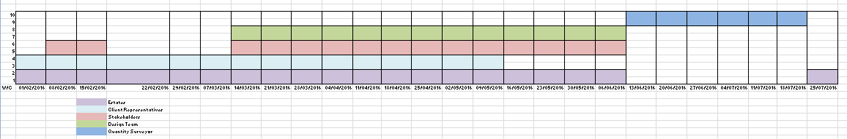

Financial Plan
Each stage of the project needs an amount of the budget set aside for its completion. Without this there is no control over the budget and a project manager could find that after a couple of weeks they have spent the entire budget. An expense schedule is put together using the total cost of labor, equipment and materials. Using this schedule the Project Manager can see the forecast spend vs actual spend at any stage in the project. Below is a copy of a blank cash flow forecast document that I use for projects.

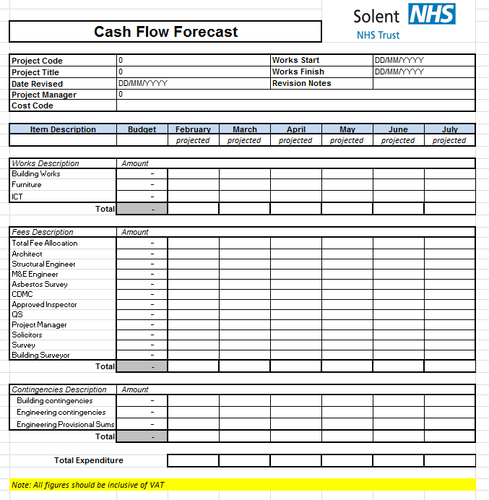

Quality Plan
It is important that the quality expectation is realistic and not just what the client wants. The project team need to establish what the client would like and where needed discuss and agree more realistic options. Once agreed the quality plan can be documented. In the quality plan there will be set targets for each project deliverable. Criteria and standards are set for each quality target to ensure they meet the expectation. This can either be by:
- Quality Control Plans - This controls the deliverable as it is being build
- Quality Assurance Plans – This is a plan of activities which will be carried out to show that the quality target has been achieved.

The quality plan also describes how management processes will be carried out at execution stage of the following:
- Time
- Quality
- Change
- Cost
- Risk
- Procurement
- Acceptance
- Issues
- Communications

Communications Plan
The communications plan shows the type, frequency and method of getting information to your stakeholders. It also outlines the responsibilities of the project team or appointed person/people for distributing this information.

Risk Planning
There will always be an element of risk involved in any day to day task, even the best planned project is not exempt from risk. The risks to the project will change as you progress through the stages, it is therefore important that risks are monitored and reported on. The Project Manager will need to understand the organisation and stakeholders risk tolerance level before they evaluate and rank the risk.
Below is a highlight report form that my organisation uses. This is filled in weekly by the project manager and the red risks are put onto a risk register that is reported on at Trust Board level.
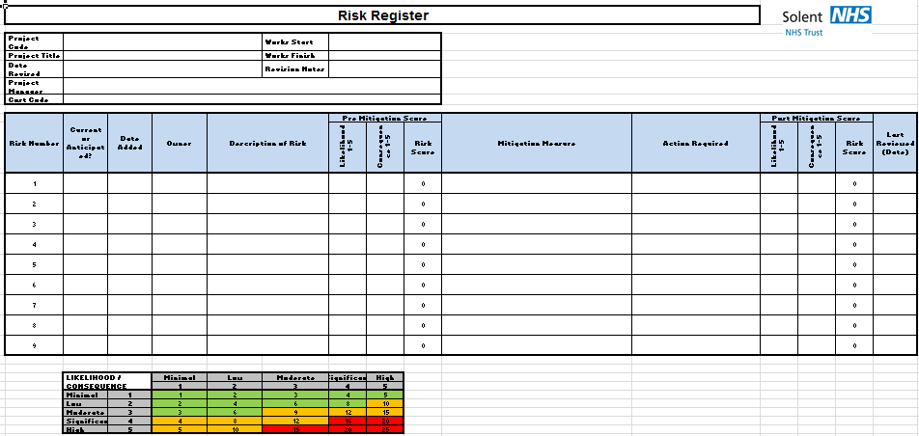
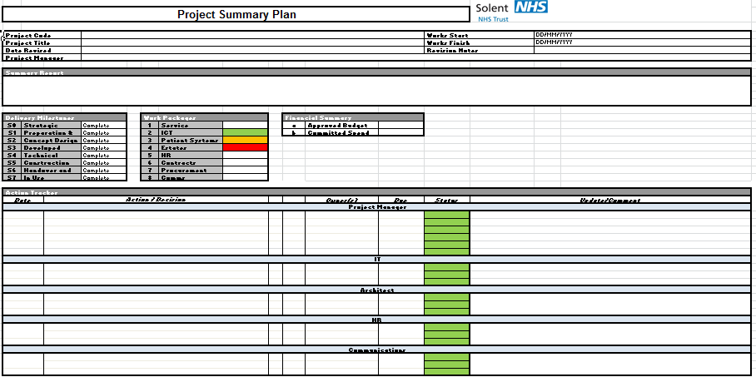
Procurement Plan
The procurement plan identify the goods and services that will be purchased from external suppliers along with quantities and when these will need to be ordered and delivered within the project Programme. At this point justification would be made as to why internal resources may not have been used.

The procurement plan will also explain the Tender process and how the preferred supplier will be appointed.

Student Statement:

By submitting this assignment, I confirm that this is my own work.

Student Signature | Laurel Huxham | Date

For Tutor / Assessor Use Only
Total Marks
Marks Obtained
Percentage / Grade

