
Assignment Cover Sheet

Student Name: | Christian Blackmore
Student Number: | 1394
Course: | Construction Management
Assignment NO: | 07

Marking Criteria:
We expect the learners to write minimum one well expressed point in three lines against each allocated mark. This means one needs to write 15 lines with 5 well expressed points to get high grades for a 5 marks question.
For high grades use examples and illustrations where appropriate.
Assignment 7

- Give short answers for the following questions:

I. Define materials management and its scope.

Material management involves planning, programming, organising, directing, controlling and co-ordinating all activities concerning materials. This process integrates the continuous supply of materials throughout the organization; this will achieve correct levels of service ensuring that the right materials are available at the:-

- right place
- right time
- right quality
- right quantity
- right price

The material management process enables the correct application of procedures for good quality material, equipment and products at the lowest possible cost to the organization. Materials can constitute 70% of overall costs to some organizations, if profit is to be made materials must be obtained at a low price and work must be completed on time complying with correct quality standards. Consideration should be made to control correctly the following items to ensure that costs are kept low:-

- Materials planning
- Purchasing
- Storing facilities
- Inventory control
- Receiving, Inspection and dispatching
- Value analysis, standardisation and variety reduction
- Materials handling and traffic
- Disposal of waste and surplus, material preservation

The specific objectives of materials management are closely tied to the organizations main objectives of achieving an acceptable level of profitability or return on investment, and remaining competitive in an increasingly competitive market. The major objectives of materials management are low costs, high levels of service, quality assurance and low level of tied-up capital.

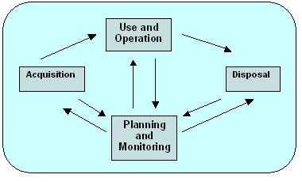

II Describe the various functions and objectives of materials management.

Materials Management has various different functions that include planning, procuring, storing and providing the suitable material for quality products, right quantity at right place at the right time in order to organize and plan the production activity in an integrative way. The quality of material must be assured at all times and should not be compromised with the cost of the material.

The functions and objectives of material management can be classified into two categories:-

Primary functions & objectives:-

- Reduce material costs
- Efficient materials planning
- Buying & purchasing
- Procuring & receiving
- Storing & inventory control
- Supply & distribution of materials
- Quality assurance
- Reduce material waste

Secondary functions & objectives:-

- Standardization of materials
- Product design & development
- Manufacturing & purchase decision
- Material coding & classification
- Estimation & planning
- Co-operation from other departments
- Conception of future outlook

Material management can be very advantageous for some organizations such as reducing the overall costs of materials, materials will be available when needed and in the quantities required, better handling of materials, reduce duplicate orders, quality control, reduce material surplus, cordial relation with suppliers, stock reduction and improve cash flow management.

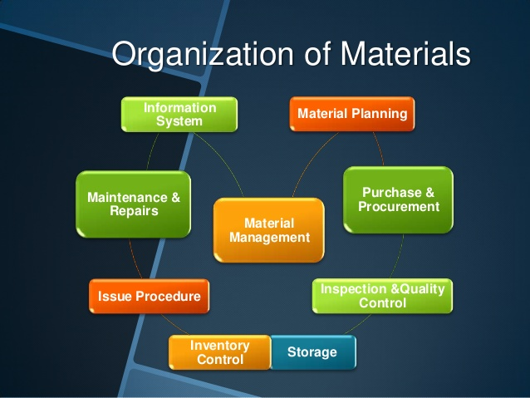

III Discuss the possible disadvantages of "integrated materials management approach".

Although this procedure has many advantages for any type of business there are also some disadvantages, this can be caused by poor material management systems or administrative reasons if this occurs there can be substantially effects on the overall costs of a project.

Materials are a major component of any project therefore care must be taken in controlling all aspects involved correctly to ensure that; over ordering of materials does not occur causing problems with storage space and wastage problems, delays in receiving materials due to bad organisation or suppliers being out of stock causing lack of materials on site which subsequently causes setbacks in project deadlines and extra costs, materials arriving before programmed date causing inventory costs and possible deterioration in quality.

It is essential that the whole process is coordinated correctly by the materials manager to ensure an orderly flow in productivity and functions on site.

IV Discuss the various vendor rating techniques. Why an organisation should try to rate its vendor?

Selecting suppliers can represent one of the most important decisions any company with need to make as this will affect the performance and costs of the project. They are selected on many occasions by their capabilities and not purely on the competitive process. An analysis of proposed suppliers must be executed to establish which complies with the company’s requirements.

There are various techniques which can help with the selection process:-

- Categorical method - This method involves categorizing each supplier’s performance in specific areas defined by a list of performance variables. The evaluator will then assign a mark to each area being in simple terms; excellent, good or unsatisfactory.

- Cost - ratio method – This method evaluates supplier performance by using standard cost analysis. The total cost of each purchase is calculated at its selling price plus the buyer’s internal costs associated with quality and transportation costs.

- Weighted point method– This method involves specific quantitative performance factors which will be assigned to each item. Weights are assigned to quality, service and price this enabling the overall results to be compared for final selection.

There are occasions when there can be a multi-supplier choice, this occurs when for example the chosen supplier is unable to provide all materials required in which case the buyer must select another supplier from their list who is capable of providing the materials they need. Certain companies prefer to have more than one supplier even though it increases there workload.

All companies should evaluate a supplier before buying from them; the reason for this is to ensure they are provided with quality materials, when they are required and at the right price. Good relations between buyer and vendor should always be kept, making sure payments are on time this will also improve the service provided.

V What advantages does a construction agency derive by treating materials management as a separate and important function?

The construction industry over the years have realised the importance of treating materials management as a separate function because of the complications and bad managing of materials that occurred when treating each function separately.

As the inter-related functions are integrated organizationally this increases performance, efficiency and functionality of works. By having centralized authority and responsibility for all aspects of materials function enables various departments to direct their problems to one central department this allowing them to deal with any problems more effectively.

Implementation of computer-based systems has helped to create an effective and efficient controlling process of materials activities. Materials come in various sizes and types that require proper handling and management to achieve the required productivity level. These systems are electronic data processing systems (EDP) which becomes very effective when all material activities are centralized under the integrated material management function. These systems have improved the handling and collection of information passed between departments which leads to better decision making.

Under integrated materials management resources will be exposed to numerous aspects of the materials process, unlike within other companies where they may only allocated one function, this will boost morale and improve quality of work within the department.

Activity:-

Visit an organisation which has already computerised its materials management department. Study the system design for materials management, classification & coding system and find out any correction or modification required.

The use of computerised material management (material handling) facilities is a rapidly expanding facility used more in the manufacturing industry as opposed to the construction industry.
- Improved environment in terms of Health & Safety
- Improved efficiency
- Automated stock control ensuring that materials are readily available when required.
- 24 Hour, 7 day per Week operation
- Each item stored would carry a bar code which will define the product and the application in which it will be used thereby obviating confusion as to the intended use of each product.
- Reduces the requirement of local storage and provides facility for call off to products for just in time delivery to the point of use.

Understanding the huge level of benefit resulting from computerised material management (materials handling) it should be noted that -:

- Computerised material handling is not a mobile facility and can only be utilised to secure positive benefit in a manufacturing, major retail facility or warehouse environment.

- Computerised material handing would not normally be considered for general construction projects with the possible of exception of significantly major projects such as power station construction when high levels of components are held on site during the project execution period.

- Computerised material management can be utilised on general construction as this provides facility to call off products and equipment from manufacturers & supplies for Just in Time delivery.

Please not that it has not been possible for me to attend this activity properly as I am resident in Spain and do not have access to facilities that have computerised material management processes.

Student Statement:

By submitting this assignment, I confirm that this is my own work.

Student Signature | Christian Blackmore | Date | 25-09-2015

For Tutor / Assessor Use Only
Total Marks
Marks Obtained
Percentage / Grade

