
Assignment Cover Sheet

Student Name: | Ray Wilson
Student Number: | 1336
Course: | Project Management
Assignment No: | 10

Assessment 10 Total Marks: 30

1. Give short answers for the following questions: (14)

- Outline knowledge areas of project procurement management.

There are four project management processes in the Procurement Management Knowledge Area. The first is provided by the Planning Process Group, one is performed in the Executing Process Group, one is supervised by the Monitoring & Controlling Group, and one is administered by the Closing Process Group as illustrated below;
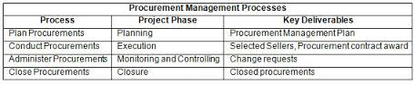
- The first process that of Plan Procurement Management, creates the Procurement Management Plan which is the framework for all of the other processes.
- The second process, the Conduct Procurements, is where the bidding process for a contract is conducted. The responses or bids of the sellers are evaluated according to criteria set up in the Procurements Management Plan, and the seller is selected and the contracted awarded.
- During the course of the project, the Control Procurements process manages the relationship, evaluates the performance of the seller on the contract, and any changes or corrections that are required to be implemented by the seller are monitored.

- Finally the Closing process group finalizes the Project or Phase closure

- Procurement management centers of four key elements. What are these?

The process of identifying which elements of the project should be procured from resources outside of the organization is called Procurement planning. This could range from major specific items such as compressors, generators and the like down to smaller items like sanitary ware. Whereas outsources items such as pipe spools, which can be fabricated in house, and precast elements are items normally made in house by larger companies. These procurement decisions are always made early on in the planning processes. The four associated Procurement planning major elements are;

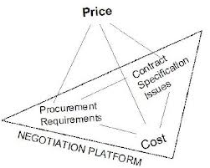

- Whether or not procurement is needed (or can it be in house?)
- How much to procure (taken from WBS with overage normally allowed for)
- When to procure (in line with project schedule and product shelf life)
- What to procure (items that need to be outsourced or manufactured cheaper)



- How is market evaluation important in procurement? And which processes are involved in market evaluation?

One of the primary roles of procurement management is to determine what sources are available to provide the timely provision of services or products for the project to succeed. Failure in this field can lead to schedule overruns and additional costs no Client wants to see so it is vital this activity is managed correctly. The PM and procurement team must determine what products and services are available and from whom and on what terms and conditions they are available, and this requires an evaluation of the marketplace.

There are three specific foundations procurement will come across:

- Sole source: Only one qualified seller exists in the marketplace and he would normally supply specialized equipment as an example.

- Single source: The performing organization prefers to contract with a specific seller as he has previously delivered goods at the right price, right time etc.

- Oligopoly: which is a market or industry that is dominated by a small number of sellers and the actions of one seller will have a direct effect on the other seller’s prices and the overall market condition.

While in most free market enterprise societies there are multiple vendors offering comparable products, there may be times when choices of vendors are limited therefore it is important to consider the following when evaluating procuring services or products;

- Get the relationship right
- Be prepared to take a risk
- Know what you are buying. Is it the people? Or are you paying for what they create?
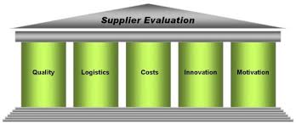
- Be interested in what you are buying
- Make supplier communication open and transparent
- Make the brief clear, insightful and detailed
- Think value over cost
- Be careful what (and how) you measure
- Be demanding but fair
- Get to know the people before you buy the agency

- At which stage in a project does a project manager completes make or buy analysis?

The make-or-buy-analysis, as illustrated below, should be made in the preliminary procurement scope definition. This will clearly define if the entire project, or in the case of large construction projects, parts of the project should be made externally and procured or provided for in-house capabilities. Sometimes, during the project development, additional make-or-buy decisions may be needed.

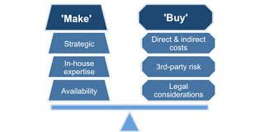 An essential characteristic of procurement management is the judgment on whether to make or buy a product. It sometimes makes sense to outsource as this can be cost effective however it is also necessary and more viable to create an in-house answer to the project procurement needs.
The costs of the either option must be considered, but so too must the ongoing expenses of the solutions. If a company elects to lease a compressor for example, the ongoing expenses of leasing this piece of equipment should be weighed up against the expected expense of purchasing the same item and the monthly costs to insure, maintain, and manage it.

- What are cost reimbursable contracts?
Cost-reimbursement, or cost-plus, is a type of contract where a contractor or vendor is paid for all of its allowed expenses up to a set limit, plus additional payment to allow the company to make a profit.

Under a cost-reimbursement contract, the contractor, vendor or supplier agrees to provide the buyer its best efforts to complete the required contract. These contracts provide for payment of allowable incurred costs, to the extent prescribed in the contract. They include an estimate of total cost to obligate funds and establish a ceiling that the contractor cannot exceed (except at its own risk) without the approval of the purchaser.
There are three general types of cost-reimbursement contracts, all of which pay every allowable, traceable, and reasonable cost incurred by the contractor, plus a fee or profit which differs by contract type.
- Cost plus fixed-fee contracts that pay a pre-determined fee that was agreed upon at the time of contract formation.
- Cost plus incentive fee contracts have a larger fee awarded for contracts which meet or exceed performance targets, including any cost savings.
- Cost plus percentage of cost pay a fee that rises as the contractor's cost rise. Because this contract type provides no incentive for the contractor to control costs so it is rarely utilized.

- What type of information is contained in procurement management plan?

The Procurement management plan describes the obtaining process throughout the project procurement life cycle that includes identifying the procurement needs, types of procurement documents to solicit bids from sellers and seller’s responses, authority, roles and responsibilities of the project procurement team, acceptance criteria, and contract closure.
The first major process involves the creation of the project procurement management plan. Decisions are made during this development on which items shall be made by the project team and which will be bought in. Procurement documents will be prepared and criteria will be developed upon which to base the selection of vendors.
This plan, a sample is shown below, will be based on analysis of the requirements for the project, consulting documents such as the scope baseline, the project schedule, the risk register etc. which will provide the information needed.

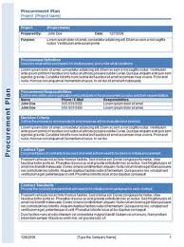

The plan will also detail the following:
- The process of independent estimating
- The relationship between the project team and the procurement office within the performing organization (if one exists).
- The type of contracts to be used
- The coordination between sellers and the project team and among project activities, project reporting, scheduling, business operations, and other project concerns.
- The procurement forms, such as contracts, the project team is required to use
- How multiple vendors will be managed to supply their contracted product.

- Describe the inputs of solicitation planning.

Solicitation planning, forms part of the Facilitating process as illustrated below, and is the process of preparing to solicit sellers to provide products and goods the project needs.
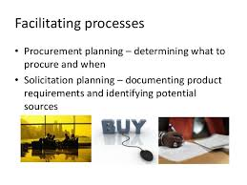

There are three inputs to solicitation planning.

Procurement Management Plan: This plan details the procedures and expectations of procurement group within the performing organization.

Statement of Work: This statement provides detailed material on what the seller will be providing for the performing group. This document will allow the seller to determine if it can provide the product and meet the requirements of the project team and the governing specification and standards.

Other planning outputs. Other planning outputs which may have been modified from when they were considered as part of procurement planning, should be reviewed again as part of solicitation. In particular, solicitation planning should be closely aligned with the project schedule.

2. Discuss contract administration procedures. (8)
In contract administration, the emphasis is on obtaining supplies and services, of requisite quality, on time, and within budget.
The specific nature and extent of contract administration varies from contract to contract. It can range from the minimum acceptance of a delivery and payment to the contractor to extensive involvement by program, audit and buyers throughout the contract term. Factors influencing the degree of contract administration include the nature of the work, the type and size of the contract, and the experience and commitment of the personnel involved.
Contract administration starts with developing clear, concise performance based statements of work to the extent possible, and preparing a contract administration plan that cost effectively measures the contractor's performance and provides documentation to pay accordingly.
Post award coordination, either by conference, letter or some other form of communication, should be the beginning of the actual process of good contract administration. This communication process can be a useful tool that helps the buyer and contractor achieve a clear and mutual understanding of the contract requirements, and also helps the contractor understand the roles and responsibilities of the buyer representatives who will administer the contract, and reduces future problems.
Good contract administration assures that the buyer is satisfied with the product or service being obtained under the contract. One way to accomplish customer satisfaction is to obtain input directly from the customers through the use of customer satisfaction surveys. These surveys help to improve contractor performance because the feedback can be used to notify the contractor when specified aspects of the contract are not being met. In addition, the contracting and program representatives can use the information as a source of past performance information on subsequent contract awards. Customer satisfaction surveys also help to improve communications between the procurement, project, and contractor personnel.
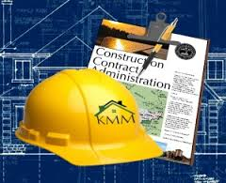

Contract administration activities to be carried out as a minimum;
- Pre-planning meeting: Contractor, PM and client to establish roles and responsibilities and review the Statement of Requirements and ensure that the contract starts with everyone understanding their role in the process;
- Once contract is in place, the PM will manage the execution of the work;
- Monitor and document progress of the contract with all its elements;
- Resolve any difficulties as soon as they are encountered. Document the problem and its resolution and send one copy to the Contracting Manager. If the problem cannot be resolved, seek assistance from the Senior Project Manager or Regional Manager, then support from the Contracting Manager;
- Should problems persist, contact Contracting Manager and/ or Claims Management for advice before talking to the Contractor/Consultant;
- For any Change Orders processed within the contractors authority, complete a change order log and submitted to the Contracting Manager;
- For processed Change Orders, complete a change order log and submitted to the Contracting Manager for approval;
- Document the file for all change orders or issues which might surface later;
- Record action, telephone conversations, meetings,
- Ensure to exercise only your authorities as they were given to you through your supervisor;
- Work is progressing and invoices are received; assess that the work is progressing as it should be, in accordance with the schedule;
- Sign off on invoices, with financial coding, for the work completed as per the contract terms and conditions for payment;
- Work is completed, contractor to provide a list of deficiencies and a list of warranties.
The type of Inputs, Tools and Techniques and Outputs associated with contract administration as listed for reference as follows;

Inputs
- Deliverables
- Change requests
- Contractor/ Consultant invoices
Tools and Techniques
- Contract change control system
- Inspection and Audits
- Performance reporting
- Payment system

Outputs
- Contract documents
- Claims management
- Contract changes
- Payment requests

3. What is the purpose of contract closeout process? How is it performed? (8)

The Contract close-out involves both product verification (ensuring all work was completed correctly and satisfactorily) and administrative close-out (updating the records to reflect final results and archiving the information for future use).

The project manager, main stakeholders, the customer, and, in some cases, even the supplier may complete product verification together to confirm that the contract has been completed. Contract close out is closely associated to administrative closure, because it is the process of confirming the work was completed.

The contract terms and conditions prescribe specific procedures for contract close-out and developed specific documentation requirements are available for use by its project managers.

Contract close out activities are;
- Evaluate contractor/supplier, and review performance and the capability of the contractor/supplier with Contracting Manager
- Ensure financial system is aligned with the project file, for documentation and audit trail.
- Prepare Lessons Learned data.

- 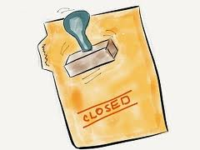

Close out Inputs are as follows;
Contract documentation; includes, but is not limited to, the contract itself along with all supporting schedules, requested and approved contract changes, any technical documentation developed by supplier/contractor, performance reports, financial documents such as invoices and payment records, and the results of any contract-related inspections.

Close out Tools and Techniques;
Procurement audits; are structured reviews of the procurement process from procurement planning through contract administration. The objective of a procurement audit is to identify successes, failures, lessons learned etc., that warrant consideration for other future projects.

Close out Outputs;
- Records Management and Contract file; a complete set of indexed records must be documented for inclusion with the final project records.
- Formal acceptance and closure; the organization responsible for contract administration should provide the selling contractor with formal written notice that the contract has been completed. Requirements for formal acceptance and closure are defined in the contract.

The size of the project causes the formal closure process to vary accordingly, therefore contract closeout requirements should be documented within the contract.

Student Statement:

By submitting this assignment, I confirm that this is my own work.

Student Signature | Raymond Wilson | Date | 16th Jan 2015

For Tutor / Assessor Use Only
Total Marks
Marks Obtained
Percentage / Grade

