
Assignment Cover Sheet

Student Name: | Salma Mohamed Safaa
Student Number: | 1170
Course: | Interior Designing
Assignment NO: | 3

Student Statement:

By submitting this assignment, I confirm that this is my own work.

Student Signature | Salma Safaa | Date | 21/07/2014

For Tutor / Assessor Use Only
Total Marks
Marks Obtained
Percentage / Grade

Student Name: | Salma Mohamed Safaa
Student Number: | 1170
Course: | Interior Designing
Assignment NO: | 3
Page NO: | 1

Interior Designing Course
Unit 3: A Sense of Style.
Q.1.
I. The difference between fashion & style:
Style and fashion express nearly the same ideas of personal, social and cultural identity, reflecting the concerns of the user and the ambition of the age.
But Architectural Style means much more the fashion. Fashion can be liked to any specific object but style is cohesive and is a pleasing whole. And while fashion is ephemeral (of the moment), style has more solid, monumental and permanent presence.

II. Creating a Sense of Style:
- You have to posses a sense of suitability in order to posses a sense of style.
- Understanding the situation and the factors that will be merged together like colours, proportions and juxtapositions.
- The sense of style is achievable by:
1- Developing interest in this field and acquiring appropriate qualifications.
2- Analysing what both pleases and suits you.
3- Proper training to achieve being a professional interior designer.

Student Name: | Salma Mohamed Safaa
Student Number: | 1170
Course: | Interior Designing
Assignment NO: | 3
Page NO: | 2

III. What is of great importance when mixing styles together:
- Must be considered that bringing items from a style should mix well and coordinate and most importantly be balanced with the other style.

IV. Key characteristics of American Country Style.

- This Style has two strands:
1- The Shaker Style.
2- New England Style.

- Key characteristics:
1- Natural wood flooring with plain or checked weave rug. 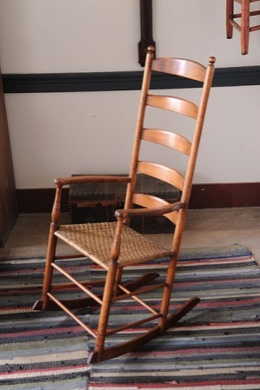 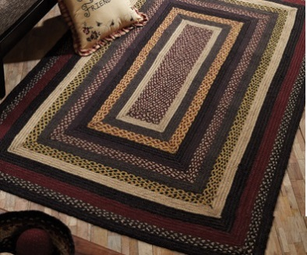 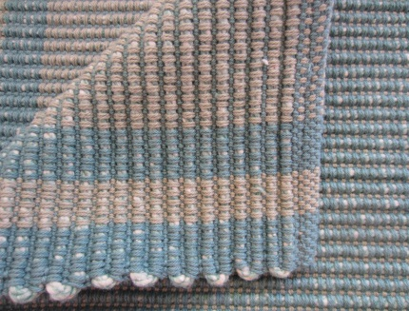
2- White plain rugs.
3- Cross-stitched hand embroidery.
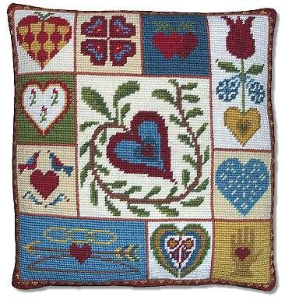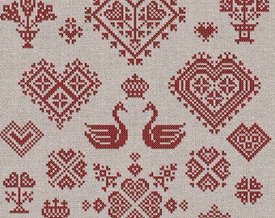
Student Name: | Salma Mohamed Safaa
Student Number: | 1170
Course: | Interior Designing
Assignment NO: | 3
Page NO: | 3

4- Gingham and checked materials used in subdued amounts of interest.
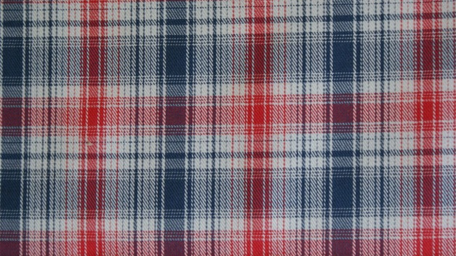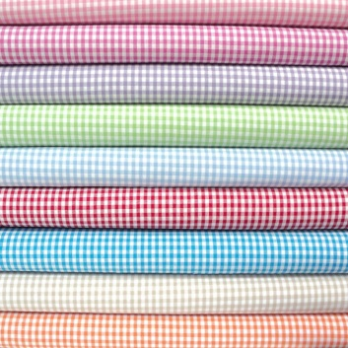
5- Clutter free floor space.

Examples:

Blue shaded Living room .
Wooden flooring with weaved rug. White simple walls,
cosy squashy sofas with blue checked cushions
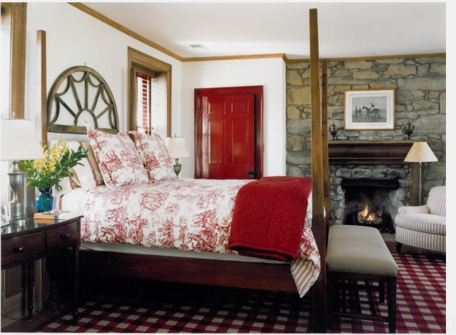 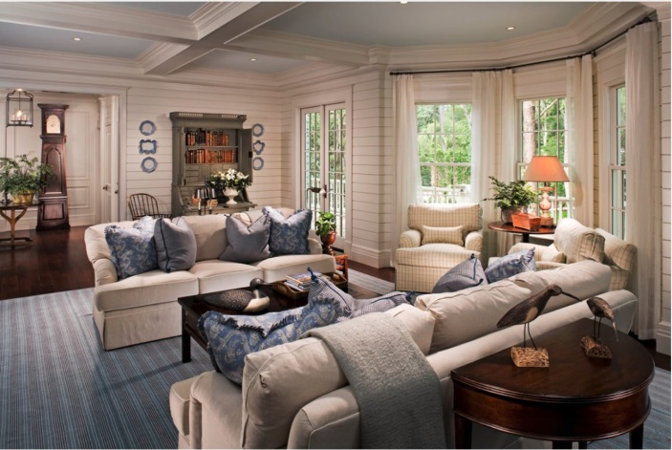 A vibrant red tones Bedroom. Wooden flooring with checked rug, White washed walls, Cherry Furniture.

Student Name: | Salma Mohamed Safaa
Student Number: | 1170
Course: | Interior Designing
Assignment NO: | 3
Page NO: | 4

V. Best option for window treatment in Contemporary Style:

- Natural roll up Blinds or Simple Roman Shades mounted inside the window frame.
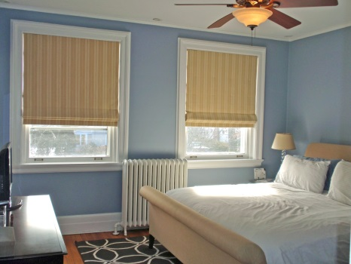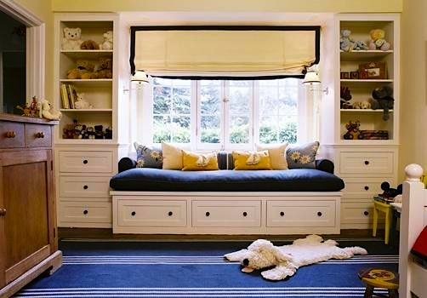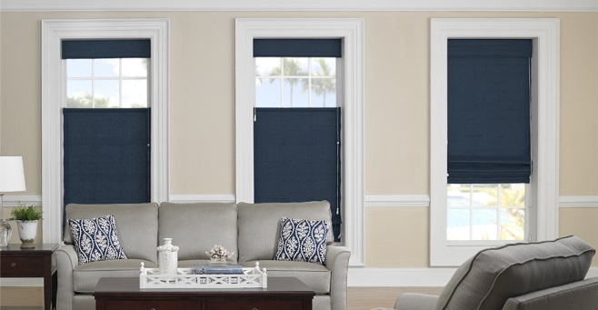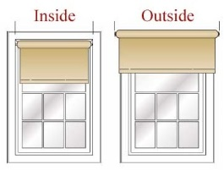

Q.2
There are three important characteristics of French Chic Style:
1- Scrolled metal furniture in delicate designs in silver, soft gold or bronze.
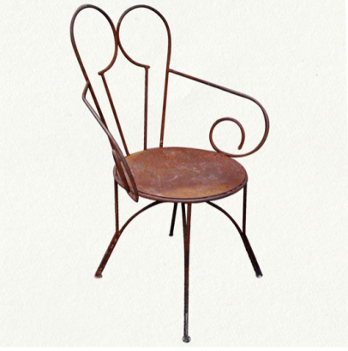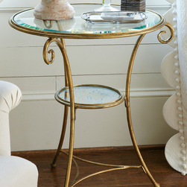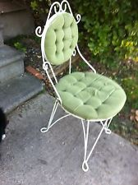

Student Name: | Salma Mohamed Safaa
Student Number: | 1170
Course: | Interior Designing
Assignment NO: | 3
Page NO: | 5

2- Pelmented or swaged window treatments with shimmering voiles or organza sheers.
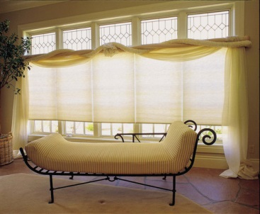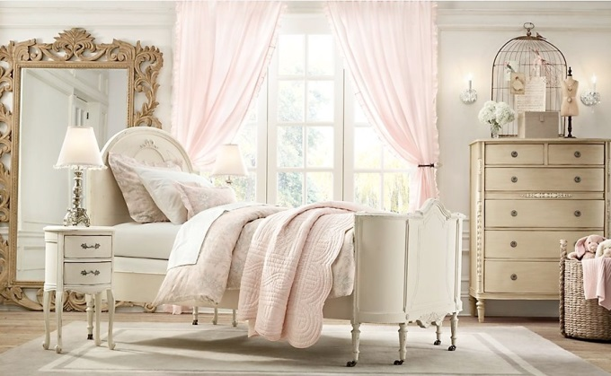

3- Fabrics: Velvet, chenille, silk and linen, whether plain or with self-patterns.

Case Study A period property with some of the architectural features that are interesting. Laura the owner wants to retain those feature to give the house a modern feel.
- Laura can mix Victorian Style with Contemporay Style

1-Walls & Ceilings:
-The popularity of wall paper increased in that style.
-For walls, use wallpapers with the floral prints, preferably within the shades of red, blue and green. Use small floral motifs, because they will add hints of Victorian décor having a modern twist. 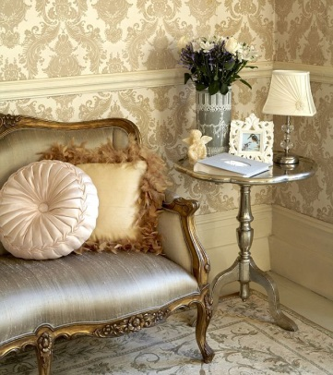 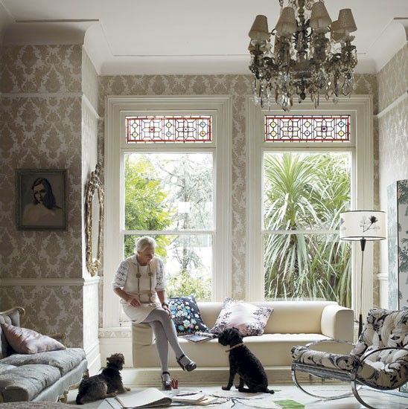
Student Name: | Salma Mohamed Safaa
Student Number: | 1170
Course: | Interior Designing
Assignment NO: | 3
Page NO: | 6

2-Windows: -For the windows, use draperies in Victorian colors and braided tiebacks. The material can be brocades or velvet.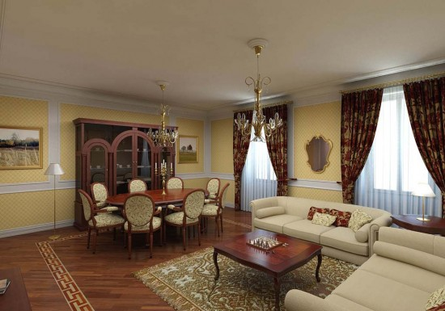

3-Floors: - Parquet or any wooden floors, covered with bordered rectangular carpets.
-Victorians loved carpet and also the more highly patterned, the better. Choose floral or oriental designs with a faded look.
-Encaustic tile–small, patterned mosaic tiles–were often laid in hallways, through the front door all the way to the garden gate.
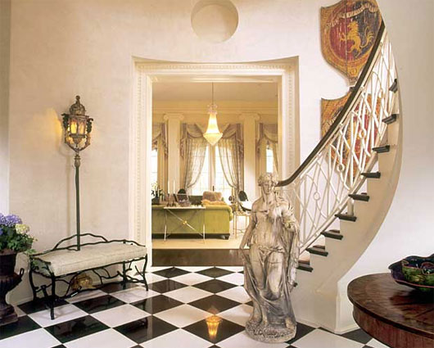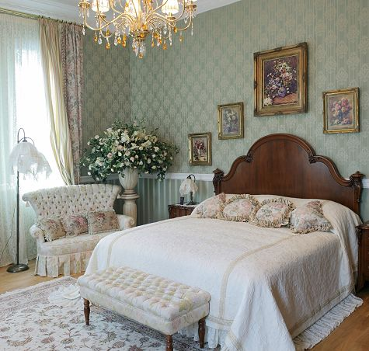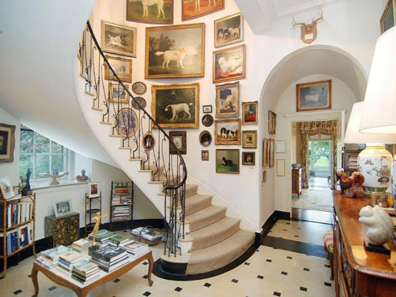
5-Furniture: - Mahogany was a favourite wood for furniture in the Victorian Style.
-Furniture in deep wooden finishes and carved.
-For sofas and chairs upholstery, apply for velvet, embroidered fabrics and brocade. The use pillows in the same fabric and festooned with lace, ribbons or frills.

6-Accessories: - Consider things like gilt mirrors, crystal sconces and chandeliers, and pretty pillows.

