
Assignment Cover Sheet

Student Name: | Sara Spiers
Student Number: | 1486
Course: | Diploma in Wedding Planning
Assignment NO: | 1

Marking Criteria:
We expect the learners to write minimum one well expressed point in three lines against each allocated mark. This means one needs to write 15 lines with 5 well expressed points to get high grades for a 5 marks question.
For high grades use examples and illustrations where appropriate.
Please insert your completed assignment ( in word format) here:

Q.1. i. What is meant by wedding etiquettes?

Wedding etiquettes are the customary behaviours expected of the wedding party and guests which, when performed, are seen to be the “proper” way of behaving, without causing upset or offence to others (Lefevre, 2013: p.11). Events such as announcing the engagement, the engagement party, choosing the wedding party, save the date and invitations, and wedding party attire are just a few pre-wedding etiquettes. Etiquette during the ceremony itself is determined by the type of ceremony and the culture adopted by the couple, however, in most weddings, etiquette includes the processional and the order of entrance by the wedding party, giving away the bride, the vows, and the recessional. Etiquette is seen to be the traditional way in which couples get married and modern, informal weddings do not always strictly adhere to etiquettes. Traditions are more relaxed but do form the basis of weddings as a whole.

ii. What is a sake sharing ceremony and in which culture is it performed?

Sake-Sharing, or ‘san-san-kudo’, translated as three-three-nine times, is a traditional Japanese custom whose purpose is to formally bring together the bride, groom and sometimes their parents during the wedding. The ritual begins with pouring sake into a nested set of three cups. The bride and groom each take three sips from each cup. The symbolism behind the three is thought to represent the flaws each human possesses (ignorance, hatred and passion). Others believe the three represents “heaven, earth, and mankind” and “love, wisdom, and happiness” (Japanese Style, n.d.) The symbolism behind “ku”, meaning 9, is thought to be a lucky number (Beaucoup, n.d.) Some couples choose to bring together their parents in the ceremony and each couple takes a sip from the cups, also bringing together the three couples (Beaucoup, n.d.)

It’s typical that this ritual takes place last in the order of events to mark the end of the ceremony (Jeremy and Robson, 1989: p117).

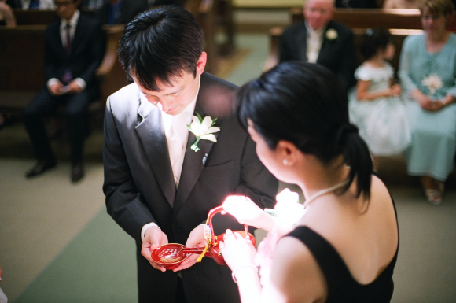 (Ah, 2013)

iii. Why is the civil ceremony for weddings important in Russia?

A civil ceremony is the official marriage ceremony for couples in Russia. The Communist government, after the revolution in 1917, prohibited religious ceremonies and ruled that weddings were to be secular and should take place in registry offices. Many Churches were closed down by the government at this time (Wegren, 2003: p144). These ceremonies take place with close friends and family who gift the couple with bread and salt to symbolise a long and healthy life. Couples often follow up the ceremony with a large reception with friends and other relatives in another location, usually at home. The guests celebrate with food, drinks and entertainment over a 2 day period.

After the fall of communism, religious ceremonies once again became popular, however, to this day, they have no official status (Monger, 2004: p240). Couples often have the civil ceremony and follow by having a church ceremony with many more guests at a later date.

iv. Outline the main skills required for a wedding planner.

A wedding planner needs to be multi-skilled in order to organise successful events. The first and most important skill is to be able to plan. Planning requires attention to detail, priorotisation, self-motivation, discipline and understanding of the couple’s wants and needs. A wedding planner also requires organizational skills as he or she is responsible for booking vendors, negotiating contracts, payments and managing all operations on the day.

Wedding planners need to be knowledgeable of every aspect of a wedding, whether it is what works best in a venue, reputable suppliers, and the costs associated. Financial knowledge is also key in order for the planner to work with the couple to plan and deliver their dream day within their budget. Having this knowledge and good relationships with suppliers also means that they can negotiate packages and pricing, and receive special discounts that couples may not get if they booked directly.

Certain beneficial personality traits that wedding planners should possess also include creativity, a calm nature, people skills and a sense of humour. All of these traits give clients the trust in you to be in charge of their day and to make it an enjoyable experience, rather than a stressful one.

v. What is the role and scope of the wedding consultancy in the modern world?

The Wedding Industry has grown extensively in recent times. On average, the UK Wedding industry contributes over £10bn to the UK economy and each wedding is worth over £36,000 in total (Hitched W.I.F.E, n.d.) With such a large amount of money invested in their big day, it isn’t unusual for couples to want the best price and a professional to guide them through the process and ensure they get value for their money.
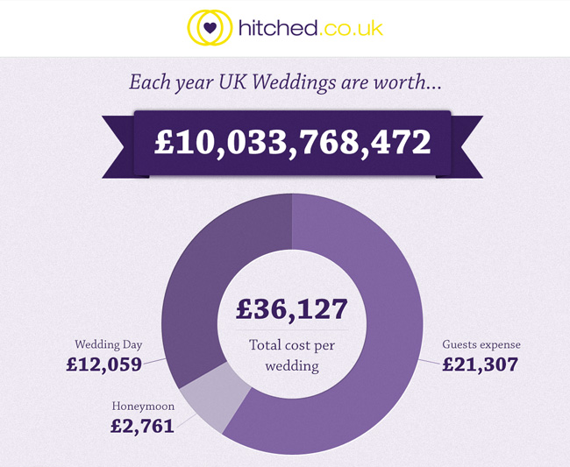 (Hitched W.I.F.E, n.d.)

Hiring a wedding planner was once thought to be something only the wealthy would do, however, now it is thought that 25% of brides hire a wedding planner (Grande, 2014) which costs them around 10-15% of their total budget (Stewart, n.d.) and this is thought to be on the rise. The role of wedding consultants, planners or coordinators, is to carefully plan, book and execute a couple’s wedding, as well as offering expert advice and recommendations to create their dream wedding within their budget. In recent times, the role of the wedding planner has varied. Some couples choose for the wedding planner to help with all aspects of the wedding, some couples choose to organise parts themselves and leave the rest to the wedding planner, and some only hire a wedding planner to oversee everything on the day.
Q.2.
a) Traditional English Wedding Reception

A fruitcake is the traditional wedding cake served and a groom’s cake is also served which now tends to be chocolate-flavoured. Another tradition, the “ribbon pull”, originated in Victorian times where ribbons with a silver charm are fed through each layer of the cake which the bridesmaids pull for luck.

The Tudor tradition of expressing wishes by throwing shoes at the couple when leaving the church still exists today; however, shoes are tied to the wedding car instead.

b) German Wedding Traditions

Parents plant trees on the birth of their daughter which are later sold when she becomes engaged to go towards her dowry. Also, a small booklet of the life of the couple is created and sold at the reception to contribute to the honeymoon.

Guests bring crockery to the reception to break which the bride and groom sweep up, symbolising an unbroken household. Also, the best man “steals the bride” and takes her to a bar, while the groom must find them and in turn, pay for their drinks. At the end of the night, the guests try to stop the couple from leaving, blocking the path with ribbons and they can only leave by promising another party.

Activity:
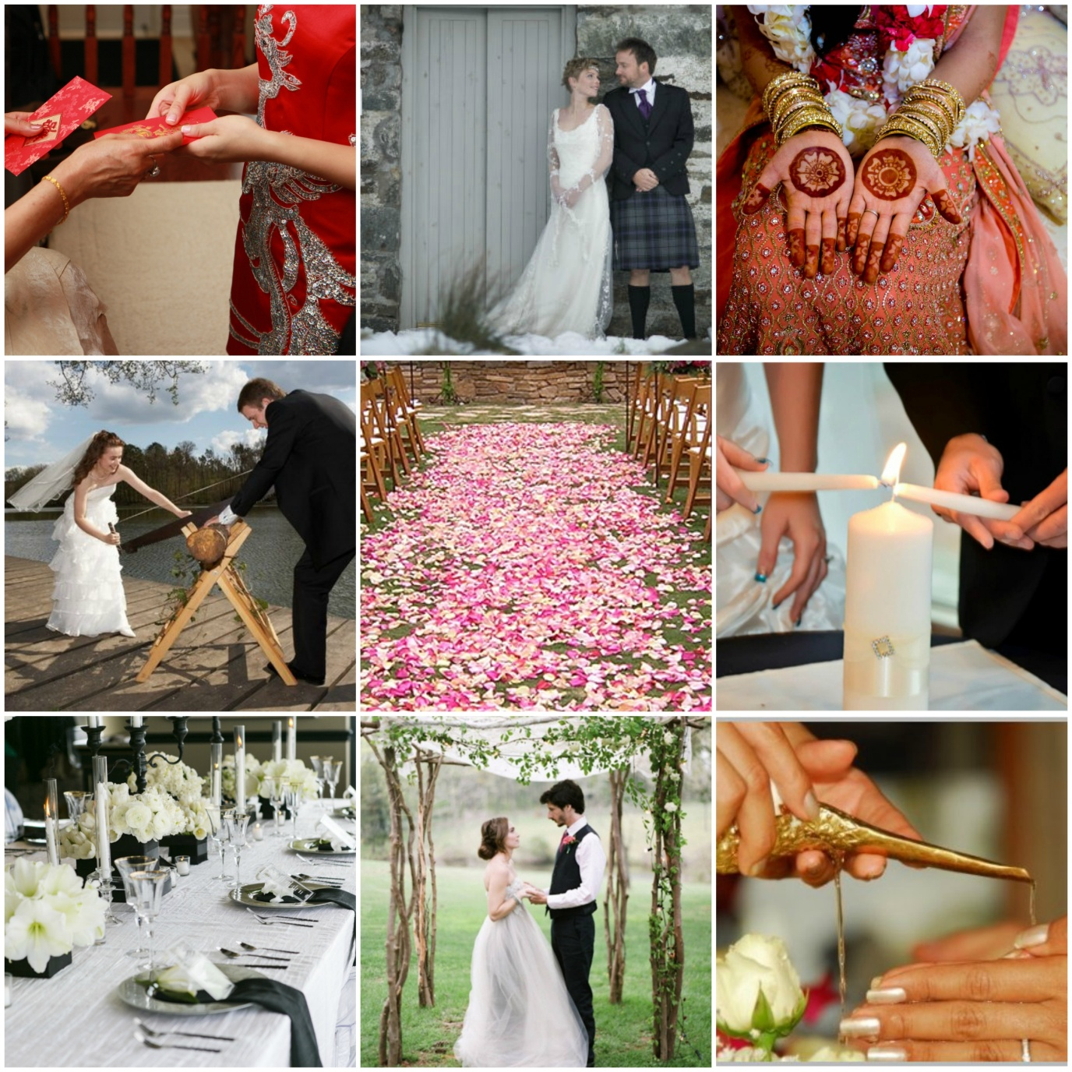
Top Left: Chinese Red Attire & Envelopes
Top Centre: Scottish Tartan Kilt
Top Right: Indian Pink and Red Sari & Henna
Middle Left: German Baumstamm Säge Ceremony
Middle Centre: English Rose Petal Aisle
Middle Right: Colombian Candle Lighting Ceremony
Bottom Left: French Floral Décor
Bottom Centre: Jewish Chuppah
Bottom Right: Thai Water Ceremony
References:

Ah, K. (2013). San San Kudo. Available URL: http://kimberlyah.com/2013/06/16/san-san-kudo/. Last accessed 13 July 2015.

Beaucoup. (n.d.) Japanese Wedding Traditions: San San Kudo. Available URL: http://www.beau-coup.com/japanese-wedding-traditions.htm. Last accessed 13 July 2015.

Grande, D. (2014). Wedding Planning for Brides to Be. 1st Edition. USA: PCM Inc. & Dagart Publishing.

Hitched W.I.F.E. (n.d.) Each Year UK Weddings are Worth £10 billion. Available URL: http://hitched-wife.org/wedding-facts-economics/summary-stats/each-year-uk-weddings-are-worth-10-billion-pounds/. Last accessed 14 July 2015.

Japanese Style. (n.d.) Japanese Wedding Traditions and Customs. Available URL: http://www.japanesestyle.com/archive/partywedding/japanese-wedding-traditions-san-san-kudo. Last accessed 13 July 2015.

Jeremy, M. Robson, M.E. (1989). Ceremony and Symbolism in the Japanese Home. 1st Edition. Manchester: Manchester University Press. p117.
Lefevre, H. (2013). The Everything Wedding Etiquette Book. 4th Edition. Massachusetts: Adams Media. p11-12.

Monger, G. (2004). Marriage Customs of the World: From Henna to Honeymoons. 1st Edition. California: ABC-CLIO Inc. p240.

Stewart, M. (n.d.) Hire a Wedding Planner. Available URL: http://www.marthastewartweddings.com/226785/hiring-wedding-planner. Last accessed 14 July 2015.
Wedgren, S. (2003). Russia’s Policy Changes: Security, Stability and Development. 1st Edition. New York: M.R. Sharpe Inc. p144.

Student Statement:

By submitting this assignment, I confirm that this is my own work.

Student Signature | Sara Spiers | Date | 20.07.15

For Tutor / Assessor Use Only
Total Marks
Marks Obtained
Percentage / Grade

