
Assignment Cover Sheet

Student Name: | Kyle Pentland
Student Number: | 1605
Course: | Diploma in Environmental Management (Level 4)
Assignment NO: | 6

Marking Criteria:
We expect the learners to write minimum one well expressed point in three lines against each allocated mark. This means one needs to write 15 lines with 5 well expressed points to get high grades for a 5 marks question.
For high grades use examples and illustrations where appropriate.

Page 1
Q1.
“Environmental Conservation” is the planned management of man’s surroundings at a local, national and global level to prevent the degradation, neglect and removal of pollution from our world. Whilst promoting and enforcing a sustainable way forward for future generations. Without conservation of natural resources a planet of over 7 billion demanding people is not capable of sustaining the nation's needs for water, electricity, timber, recreational lands, fisheries, and other natural resources.
In 1804 the world’s population reached 1 billion. It now stands at 7.4 billion, increasing around 90 million a year. Conservation in Developed Countries includes technology to find an alternative to burning fossil fuels. Conservation in Developing Countries includes education of women and an increase in birth control. Without awareness and education the world will exhaust food, freshwater and land resources and ultimately sustainability. Nigeria’s population could overtake U.S.A’s by 2050.
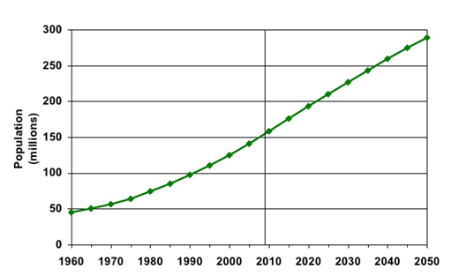
Nigeria population forecast
Population growth drives all of our natural resource problems, like water and energy. The three are affected by and change the other. Humans and all living organisms rely on these basic resources found in the earth's environment for their very survival. If a population becomes out of control in a particular species, natural resources are
Page 2
used up at an unsustainable rate and the ecological cycle is destroyed. Ultimately, without resource conservation, all species (including ourselves) would be destroyed.

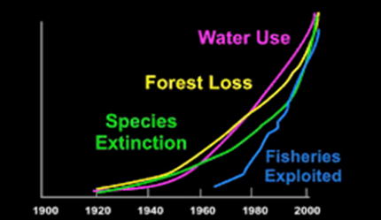
All resources trends are interconnected
Whenever we do not use our resources in an efficient, recyclable and resourceful way, there will be pollutants produced. Pollution disturbs our ecosystem and the balance in the environment. Humans must understand and address the consequence of their energy consumption. With unsustainable modernisation and development in our lives pollution has reached its peak; giving rise to global warming and human illness. Between 350,000 and 500,000 people die prematurely each year as a result of outdoor air pollution in China.

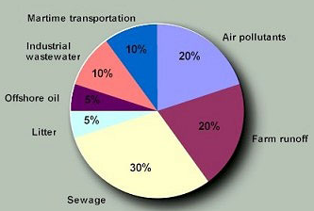
Pollutants entering the South China Sea
Page 3
Humans can cause irreversible damage to many fragile Ecosystems, seeing only short-term gain instead of long-term benefit. Rising sea temperatures, pollution and over fishing have decimated up to 50% of the Great Barrier Reef, which is permanent. However, planned conservation of 30% of the reef was turned into a no-go zone for fishing. Latest statistics show about 80% of the babies of big coral trout from these green zones are being dispersed via ocean currents to settle in the fished areas. Far from reducing fish stocks, they were improved long term.

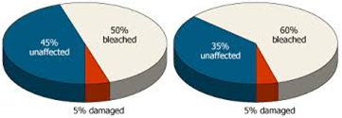
G.B.R damage 1998 and 2002
Q 2.
Natural resources refers to materials and energy in the natural world that could be used by humankind. This usage must be achieved in a planned, sustainable way for the long term health and existence of the resource that’s being exploited. It brings together land use planning, water management, biodiversity conservation, and the future sustainability of industries like agriculture, mining, tourism, fisheries and forestry. It recognises that people and their livelihoods rely on the health and productivity of our landscapes, and their actions as stewards of the land play a critical critical role in maintaining this health and productivity.

Page 4
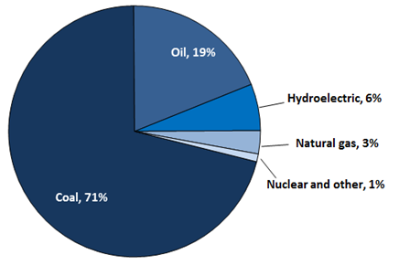
Natural Resource consumption in China, 2008

Sustained yield is the use of these resources in such a way where man can benefit from it without endangering the resources. Bluefin Tuna stocks are believed to have dropped 96% in 50 years due to unsustainable fishing practices.
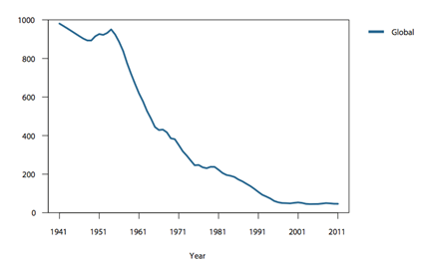
Tuna stock Biomass (thousand tonnes)
Restoration is necessary for animal and habitat that has been decimated. Virginia’s northern flying squirrel populations were nearly eradicated by industrial logging between the 1880s and 1940s. From 10 indiviuals in 1985, there are now 1100.

Page 5
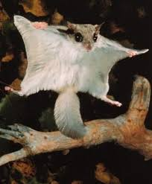
Virginia flying Squirrel
Protecting land rich in Biodiversity is key to our future. There exists many laws on the protection of plants, forests and animals. For example, The Wildlife Protection Act, 1972 is an Act of the Parliament of India enacted for protection of plants and animal species. However, governments must have the political will to enforce these laws as corruption or just pure apathy can lead to abuses.
Reutilisation is the reuse of waste materials. If the waste materials require some type of treatment before use, it becomes recycling. The advantages are less product needs to be processed saving on energy. Reduced disposal needs and costs. Reuse can bring sustainable, well paid jobs.
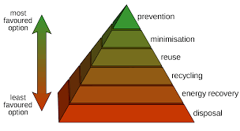
Another principle of Conservation is Substitution. It can It can be defined with 2 major aspects. 1, the use of an abundant resource over a rarer one, when the purpose is the same. 2, the use of renewable resources over non-renewable ones.

Page 6
Allocation seeks to allocate resources in order to optimize long term objectives. This can be dictated by the market price of the particular resource but general welfare can overrule this. Other factors can dictate how resources are allocated, such as goverment controls like rations and quotas. An example of this is fishing quotas:

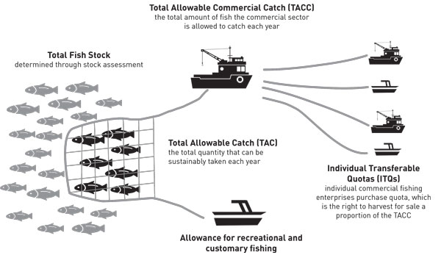
Integration in resource management is understood as the responsible and broad-based management of the land, water, forest, and biological resources base (including genes) needed to sustain agricultural productivity and avert degradation of potential productivity.
Q3.
One of the main drivers of wildlife extinction is habitat loss. The mass destruction of Indonesia's rainforests and carbon-rich peatlands for palm oil and paper threatens this vast Biodiversity. It is home to between 10 and 15% of all known species of plants, mammals and birds. Orangutans, elephants, tigers, rhinoceroses and more than 1,500 species of birds call it home. Indonesia has lost 75% of its forest. With Orangutans population now at about 5% of what it was in 1900.
Page 7
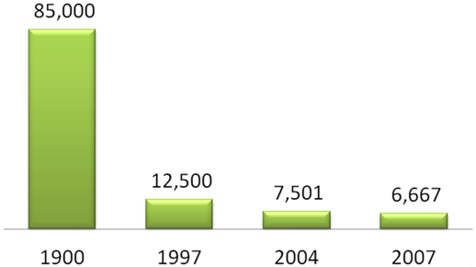
Orang-utan population decline
Unfortunately, many animals are ignorantly classed as cute and cuddly, making them attractive for the international pet trade. One such animal is the Slow Lorise, from South-East Asia. It is taken from its habitat, with only a torch needed to find due to the large reflection of its eyes at night. Once caught from forest to pet store, it will suffer a 90% mortality rate. In the process, its teeth will be removed with pliers, as they are sharp. Lorise body parts are all used in moronic superstitious beliefs and medicine.
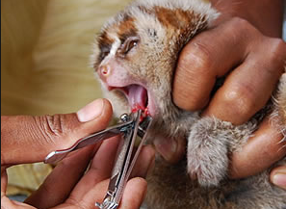
Lorise having teeth removed
Page 8
Hunting for food decimates wildlife populations, especially within Sub-Saharan Africa where bush meat is seen as a normal way for people to attain their protein requirements. Entire areas of forest can be emptied with traps, guns and machetes and entire families of 20 or 30 chimpanzees murdered in one go. They have declined to about 10% of their original numbers. An area the size of the U.S.A. used to be home to these creatures. They now live in small pockets across a few countries.
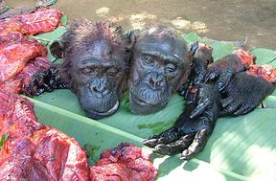
Bush meat, D.R. Congo
The introduction of an alien species to a new Environment can destroy a fragile Ecosystem that has taken millions of years to evolve. In Australia, especially, the natural Environment is highly primitive and fragile to change. Some of the animals brought to Australia are the Red Fox, Cane Toad and European Rabbit. There are believed to be 24 birds, 78 frogs, and 27 mammal species that have become extinct since alien species were introduced.
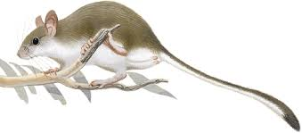
The white-footed Rabbit Rat - extinction late 1800s.
Page 9
The loss of animal species is an environmental tragedy with broad and deep impact. Animal, plant and marine biodiversity keeps ecosystems functional. Healthy ecosystems allow us to survive, get enough food to eat and make a living. When species disappear, ecosystems and people (especially the world’s poorest) suffer. Biodiversity is especially important to the poor, 75% of who live in rural areas and depend on nature for their food and livelihoods. 121 plant and animal species have become extinct in later 10 years.

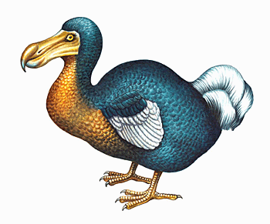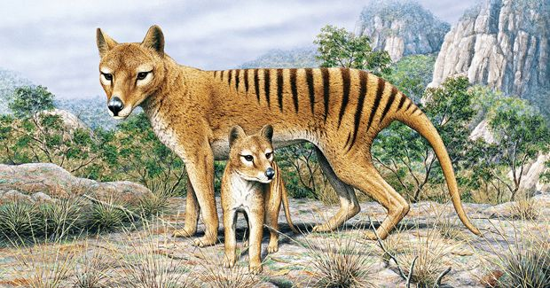
Dodo extinct late 17th century Tasmanian Tiger extinct 1936

Student Statement:

By submitting this assignment, I confirm that this is my own work.

Student Signature | Kyle Pentland | Date | 21/02/2016

For Tutor / Assessor Use Only
Total Marks
Marks Obtained
Percentage / Grade

