
Assignment Cover Sheet

Student Name: | MAJALIWA FREDRICK
Student Number: | 1506
Course: | DIPLOMA IN ACCOUNTING AND FINANCE
Assignment NO: | 6

Marking Criteria:
We expect the learners to write minimum one well expressed point in three lines against each allocated mark. This means one needs to write 15 lines with 5 well expressed points to get high grades for a 5 marks question.
For high grades use examples and illustrations where appropriate.
How to Prepare and Analyze A Balance Sheet
Assessment 6 Total Marks: 30

1. What is Balance Sheet and why it is prepared? Identify and explain any two purposes of Balance Sheet (10)
Answer:
A balance sheet is a Statement of Financial Position which does not necessarily the value of a business, but Only an estimate of market Value. Assets of a business ultimately valued by their ability to generate revenue and shows a true value of assets is determined from actual sale to third party.
Most businesses borrow money to help them to operate. So a balance sheet has a special section – called liabilities. This shows how much money has been borrowed or invested – and where it came from. The term ‘balance’ means that all the money invested or borrowed must be accounted for in another section, called assets.
The balance sheet is an accountant’s snapshot of the firm’s accounting value on a particular date, as though the firm stood momentary still.The balance sheet states what the firm owns and how it is financed

Why is balance sheet prepared, first of all, it is mandatory required by law to prepare balance sheet for the interest of investors and other stake holders like public consumers, tax laws, government institutions and others. Again balance sheet portrays the financial position of the business, it increases confidence to investors if it prepared with transparency by following Generally Agreed Accounting Principles. Balance sheet is prepared and ensured that double entry concept of accounting is followed. From balance sheet business managers are able to determine how much business owns, and how much it owes to creditors or investors. It also show shareholders equities as at the date the balance sheet is prepared.

2. Distinguish between fixed and current assets and describe current ratio. (10)
Answer:

Assets can be defines as Items that a business owns and have an identified value. For example computers, plant and equipment, leased assets, the value of the land and buildings if the freehold is owned by the business.

Fixed Assets are:-
Fixed assets (non-current assets) represent future economic benefits which are expected to be consumed at a slow pace (generaly over more than one financial year). Every fixed asset can be considered an unexpired expense, and at balance sheet date a company must review to what extent the individual asset has been consumed during the accounting period
- Tangible Assets = equipment, buildings, land
- Intangible Assets = brands, logos, patents, goodwill
- Goodwill = quality of workforce, reputation, management, location, relationship with customers. Goodwill only tends to be included when purchased at an agreed price
- Fixed Assets are normally valued at Cost less Depreciation (The amount lost through ‘wear & tear’).
Two central accounting issues:
- How do we determine tha appropriate value of an asset at the point of acquisition?
- How do we systematically recognise the expensing of the asset over time?
International Accouting Standard number 16 Property, Plant and Equipment addresses these questions in general and more specifically for tangible fixed assets.

While Current Assets are Items which can easily be converted into cash (e.g. cash, stock, debtors)
- Generally listed in the order in which they can be converted into cash
- Valued at cost or market price (whichever is the lower)
- Often includes “Provision for loss” (safeguard against unsold goods or bad debts) and Prepayments (items which have been paid for in advance)

Current assets are cyclic; there is movement between the cash, stock, and debtors items.
- The stock is used e.g. to feed the children
- Trade Debtors (parents) pay for the food in their fees
- The Cash is used to buy more stock.

See the figure describing cyclic nature of assets:-

Cash
Trade debtors
Stock

3. What do you understand from the following equation? (10)

Assets = Liabilities + Net Worth
Answer:
Assets = Liabilities + Net Worth, this equation is called Accounting equation where
- Assets stands for what business owns( monetary resources that result in economic benefits
- Liabilities stands for what business owes including debts, loans, etc. and
- Net worth (Net capital, equity, owners’ equity, shareholders equity) stands for value to its stakeholders or business owners. Which are value after liabilities are met, which is the money invested plus profits earned and reinvested in the business( retained earnings)

The diagram below summarizes the accounting equation as follows:
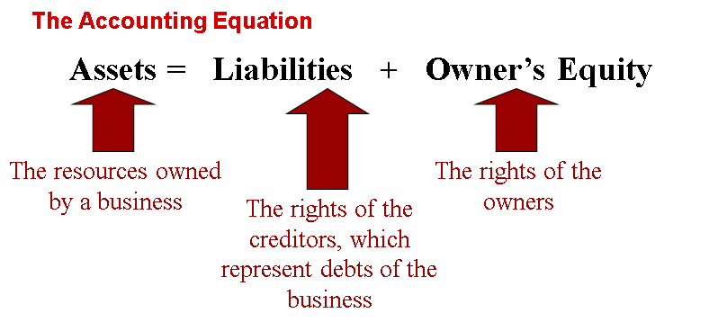

Student Statement:
By submitting this assignment, I confirm that this is my own work.

Student Signature | 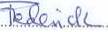 | Date | 16 October, 2015

For Tutor / Assessor Use Only
Total Marks
Marks Obtained
Percentage / Grade

