ELIZABETH ABIDEMI AKINLABI

1380

ASSESSMENT 3

DIPLOMA IN FASHION DESIGN

ELIZABETH ABIDEMI AKINLABI
1380
ASSESSMENT 3
PAGE 1

FASHION FORECASTING

- Give short answers for the following questions;

1; How do income groups influence fashion?

Income groups influence fashion because the financial situation or earning power of an individual can be categorized through surveys etc. The information is then grouped, and fashion appeal affordable to each income group is then made available. That is how income groups influence fashion.

2; why is awareness of fashion forecasting important for the designer and buyer?

Fashion forecasting awareness is a necessity both for the designer and buyer as the quality of information gained from a fashion forecast inspires a style direction, which is needed for the designer to create styles that will be accepted as fashion. For the buyers it is important to know what is trending, so the right choices can be made in terms of what the consumer will find acceptable as fashion at that time, this aids in managing inventory properly, as this prevents overstocking, and the consumers from overexposure.

ELIZABETH ABIDEMI AKINLABI
1380
ASSESSMENT 3
PAGE 2

3; what is meant by fashion trend?

Fashion trends are the styles that run similar in major collections, it shows which key pieces are of major interest and deemed prophetic. These are the styles that capture the zeitgeist.

4; what are the different factors that affect fashion trend?

Factors that influence fashion trends are; experience, it takes experience to predict the fashion trend. What the key trendsetting designers are creating is also a source of influence. Economical influences, fashion cycles, social influences and technological influences.

- Define the following terms;

Classics: are styles that are ‘characterized by simplicity of design’, this prolongs the longevity of the garment, as it can’t easily be dated, it stays relevant, never becoming obsolete.

Fads: this is fashion that lacks the fortitude of design; it does not grasp the attention of the consumer for too long, therefore giving it a short life span.

Interrupted cycles: this is when certain products are no longer produced or stocked because of the unpopularity of these products; these products are
ELIZABETH ABIDEMI AKINLABI
1380
ASSESSMENT 3
PAGE 3

no longer available to the consumer. Economic depression and war can also destabilize the fashion cycle, causing an interrupted cycle.

Recurring cycles: by borrowing some ideas from the past, designers give some styles a fresh twist, with color, fabric and silhouette. This is a resurrection of outdated fashion.

Fashion adaptation: this is adapting a trend to suit potential consumers by using their income level, age range, and lifestyle amongst other factors.

Traditional fashion adoption: this is when high fashion is modified to suit the budget of the consumer, who wants the fashion appeal but cannot afford it. The major disadvantage of traditional fashion adoption is the loss in the quality of design of the garment, making it unattractive towards the end of its cycle.

Reverse adoption: this is the opposite of the traditional fashion adoption, it is when fashion begins with the consumers, this is quite common over here in Lagos, we are a young fashion industry and lack the structure of most fashion industries, and street style is usually refined for the red carpet.

Dissemination: this is when an idea is created and produced for a particular market.

ELIZABETH ABIDEMI AKINLABI
1380
ASSESSMENT 3
PAGE 4

ACTIVITY: Look into some old and new fashion magazines, read fashion columns in the daily newspaper. Compare contents with fashion looks six months ago. From the information you find, try to analyze the fashion directions for the future. Organize your ideas for the few basic trend forecasts. For color, fabric, silhouette and line.

For future fashions, I believe there will be more movement towards unisex clothing, the boyfriend blazer was a trend last year, this year variations of masculine silhouettes have been introduced as seen by Chloe at fashion week.
I also see more flashbacks evolving, subtle in 2014, the 70’s is coming on strong, Louis Vuitton’s patchwork denim platform 70’s inspired boots has become a favorite this year, I see more of the 70’s to come, this is also evident in the comeback of suede and denim everything, from embroidered denim jackets to bejeweled denim pants, a recurring cycle is evident.
Surface embellishment is a hit in 2015; this trend began taking its roots in 2014, from delicately embroidered sheer fabrics, to gold work and beading, etc. I believe this a strong trend for red carpets, it is also somewhat ostentatious, in that owning a quality piece is similar to owning a work
ELIZABETH ABIDEMI AKINLABI
1380
ASSESSMENT 3
PAGE 5

of art, I believe this has also influenced accessories, accessories will be bolder this year; chunkier more flamboyant, unlike 2014.
Owing to the ethnical and tribal influences, as the world becomes smaller via social media, prints will continue to get more colorful, bright colors in interesting designs, over here, in Lagos, bright prints are a staple because of our weather, I see us taking it further with more flamboyant surface embellishment and fabric manipulation. I also see hats making a major comeback in 2015, as harsh weather conditions will prompt the reestablishment of hats a major fashion must have.

ELIZABETH ABIDEMI AKINLABI
1380
ASSESSMENT 3
PAGE 6

From current fashion magazines, collect five examples of each of the following types of fashion; (a) High fashion; (b) mass fashion; (c) Classic; (d) fad.

High Fashion:

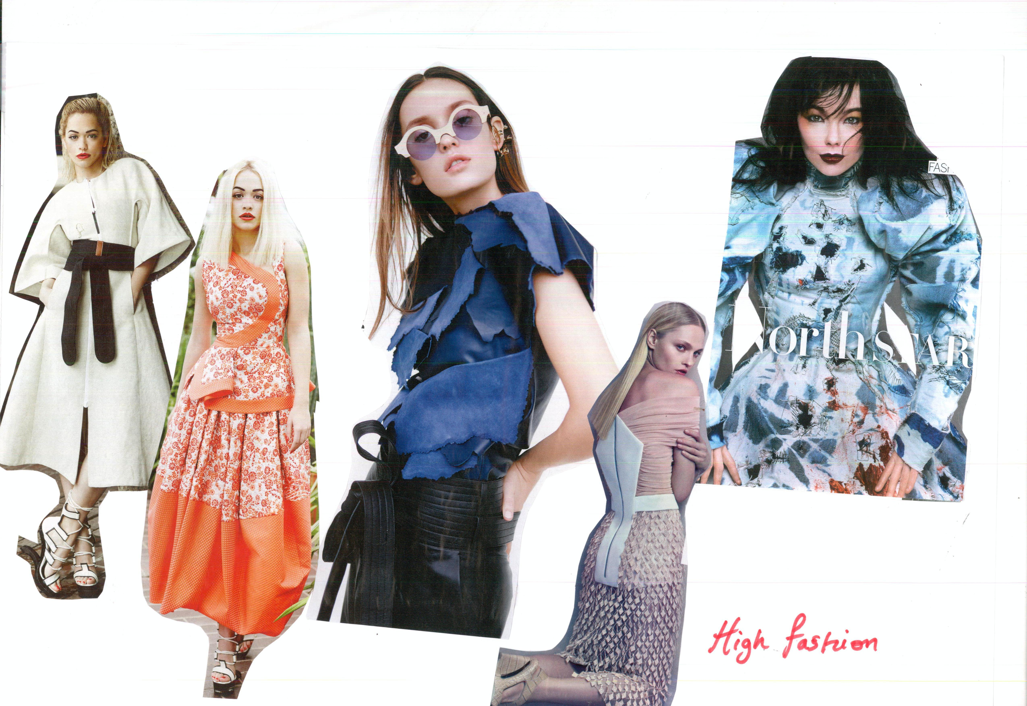

ELIZABETH ABIDEMI AKINLABI
1380
ASSESSMENT 3
PAGE 7

Mass Fashion:

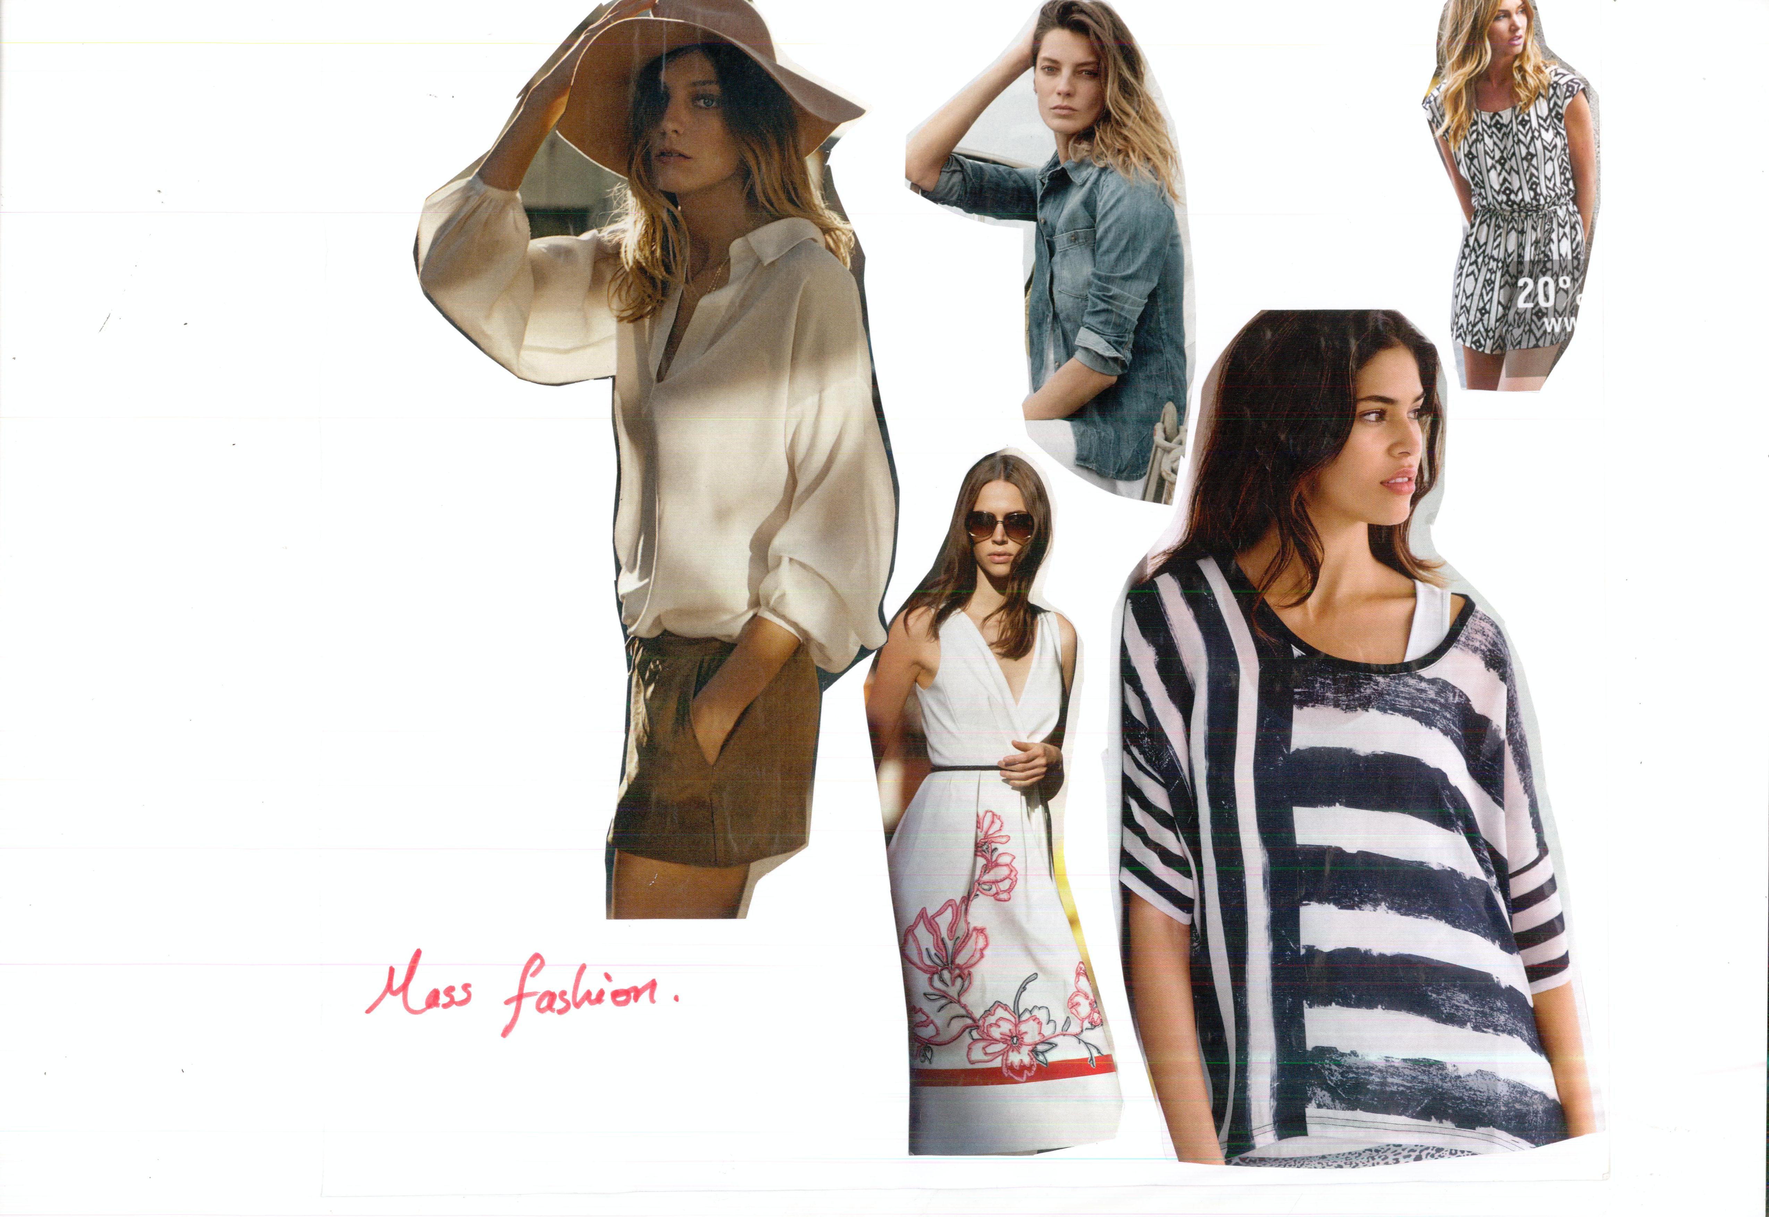

ELIZABETH ABIDEMI AKINLABI
1380
ASSESSMENT 3
PAGE 8

Classic:

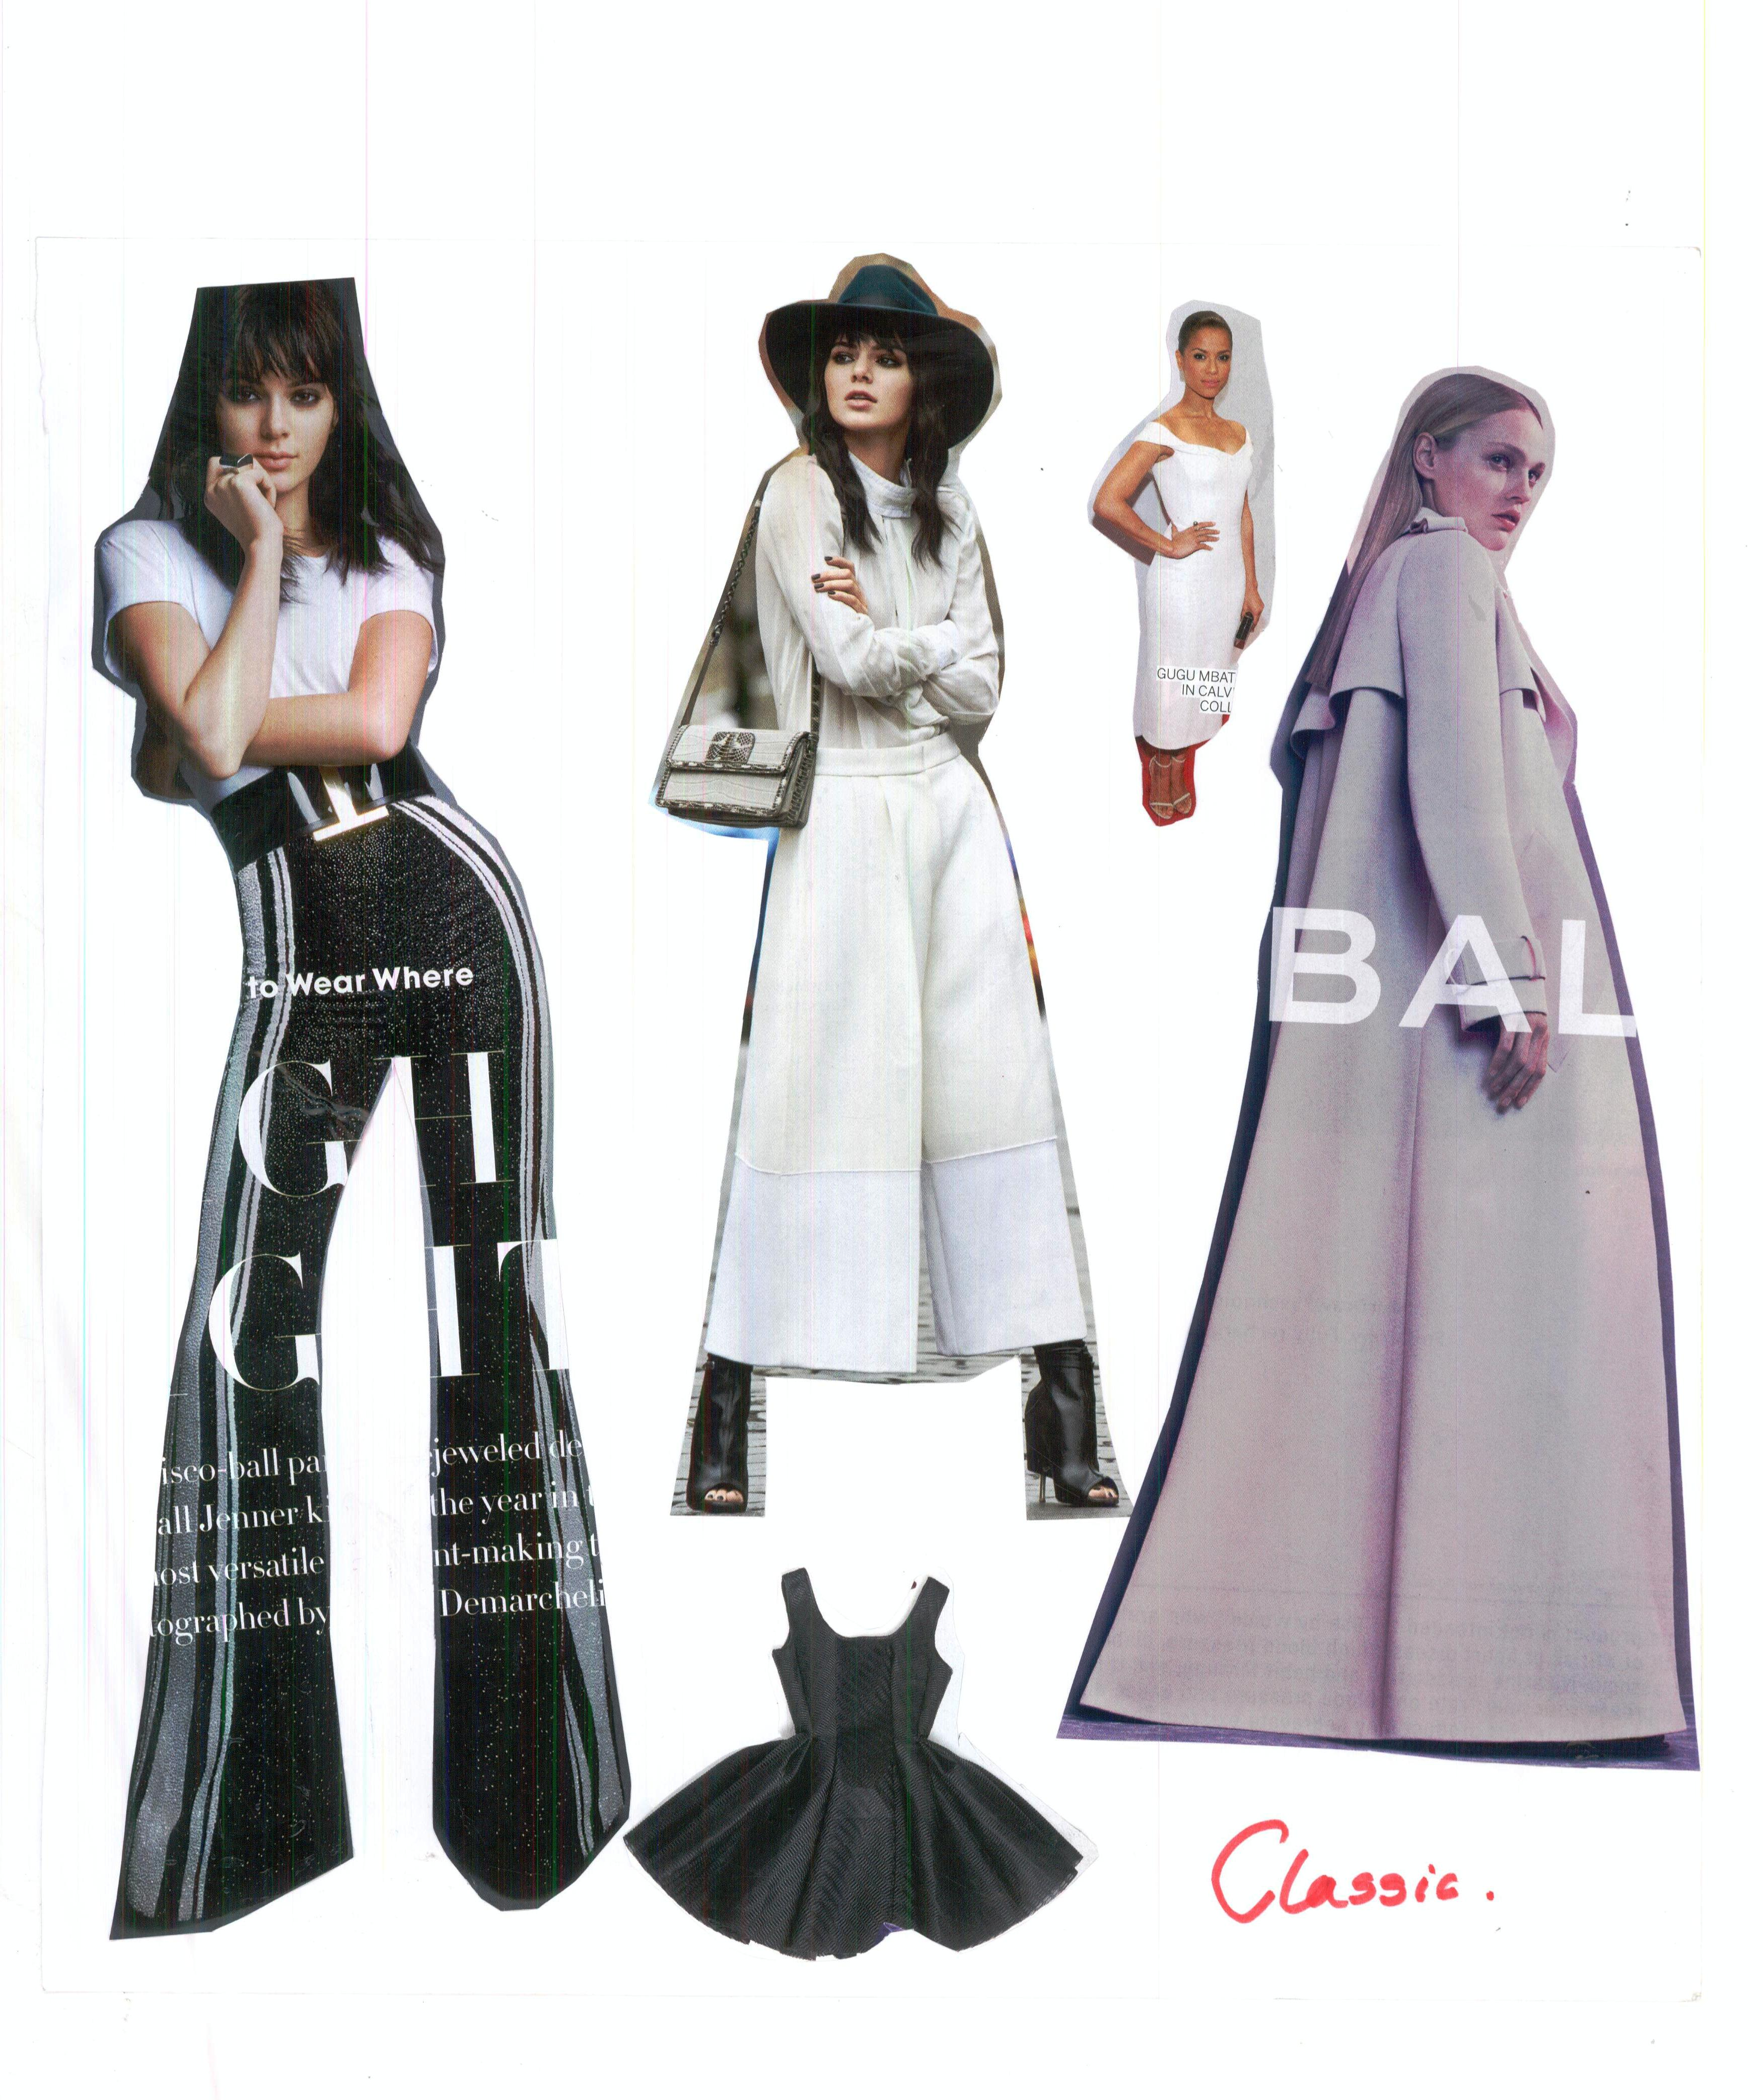
ELIZABETH ABIDEMI AKINLABI
1380
ASSESSMENT 3
PAGE 9

Fad:
