Room By Room Designing

Assessment 14 Total Marks = 30

Q.1 Short Questions: (20)

- How important it is for a designer to know about the function of a room before decorating it and which questions would you ask your client as a designer to establish the purpose of the living room before decorating it?
Answer:
Before decorating a room it is very important to know about its function because function is what makes that room to be what its supposed to be (kitchen, bathroom, bedroom, etc.), when you know function then you can chose mood, lighting, furniture that will be suitable or appropriate for that room. If your client wants for example a kitchen, function is obvious, but when it comes to a family room, you need to ask your client few very important questions like:
Is it for entertaining or just relaxing, watching TV etc;
Will the space be multi-functional;
Will there be any changes in clients life style in the near future (do they expect kids).

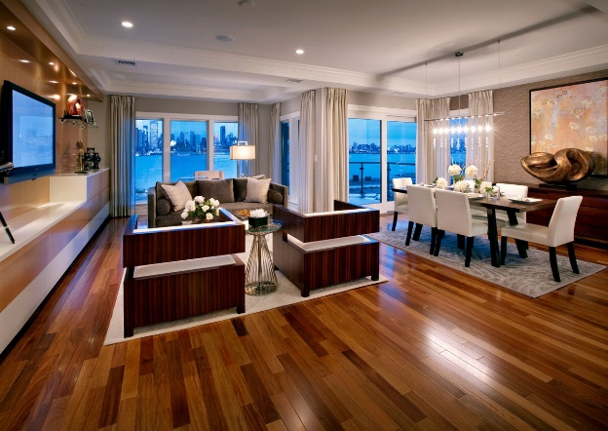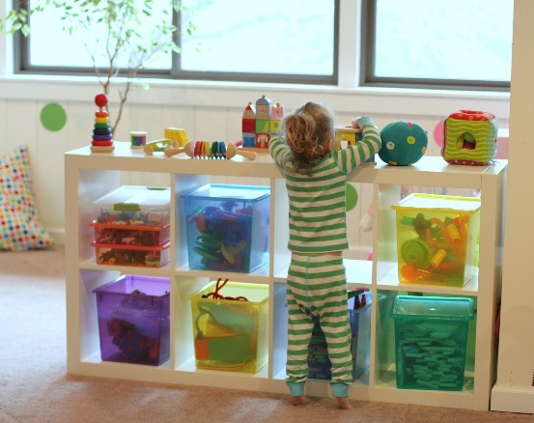
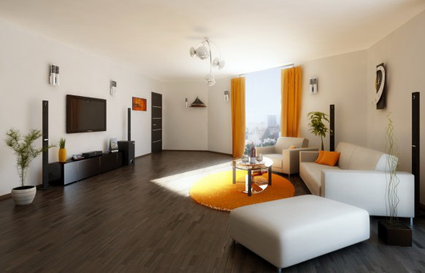

- Apart from carpeting what other options do you think are available for practical flooring for a family living room?
Answer:
There are many options for a family living room apart carpet, there are wood treatments (parquet, wood boards or wood trips), linoleums, floor boards (stripped, sealed, sanded, stained, painted or stencilled), sealed cork tiles etc.

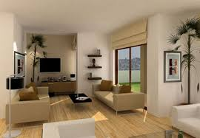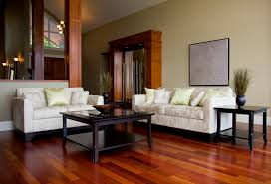
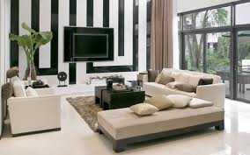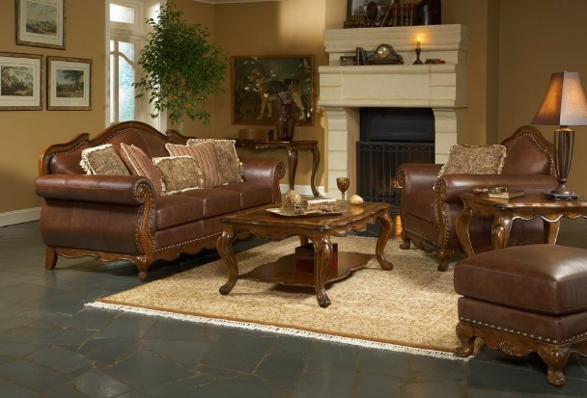
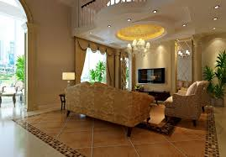

- How far a well planned lighting scheme is important for a fully functional kitchen?
Answer:
It is very important to have a well planned lighting scheme for a fully functional kitchen, kitchen demands the most care when deciding lighting scheme that’s why it should be planned in the very beginning, planning and making provisional lighting scheme ideally it should come at the same time as planning plumbing.

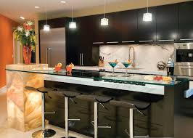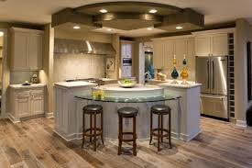
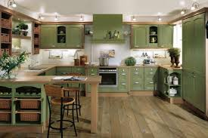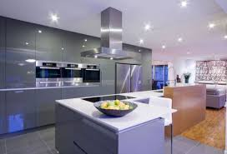

- Which type of flooring is most suitable for the connecting spaces?
Answer:
Because it is a high traffic area hard wearing surfaces should be installed there, but it also connects rooms so its important to establish a strong link between them. Connecting spaces flooring surfaces should be tough and easy to clean. Ceramic tiles could be laid, linoleum, vinyl in tile or sheet form, sealed cork tiles, carpet is very common too.
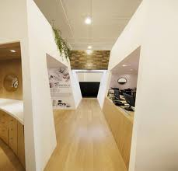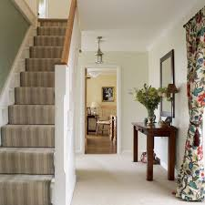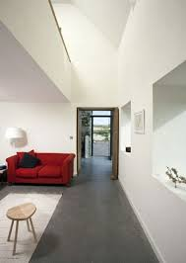

- How important it is to establish the visual link between the overall scheme and the hall ways?
Answer:
To establish the visual link between the overall scheme and hall ways is very important, it has to be connected yet not the same, but it can be tricky especially when the stairways are involved.
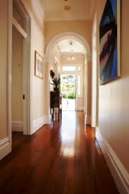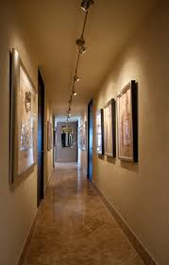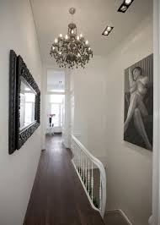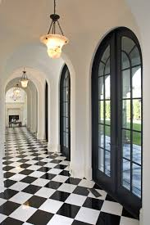

- Why is it important to draw a floor plan for a room before buying furniture for it?
Answer:
Its important to draw a floor plan for a room before buying furniture because the you can know exactly what you can bring in the room, which furniture is too big or small for the room, this way you will make sure that all the doors will open and close properly, nothing will get in the way and you can avoid placing drawers and cupboards too close which will make using them difficult or even over-cramp the room.
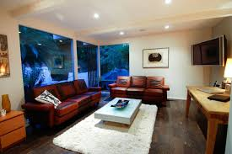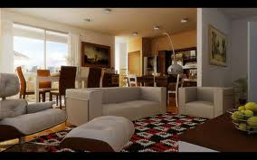
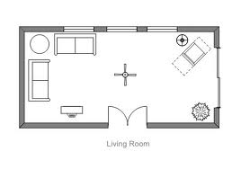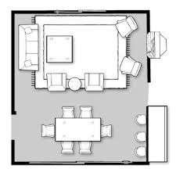

- Which safety measures would you take when designing a room scheme for an elderly person?
Answer:
Safety measures when designing a room scheme for an elderly person are very important, its also for comfort, not just safety that’s why the room you choose for an elderly person should always be at the ground floor for their comfort and safety. There are some obvious safety provisions are:
Highlighting any changes in the floor level;

Keep their room at a warmer temperature as elderly people require warmer temperature than younger people;
Bright lighting is essential;
Elimination of sharp corners;
Storage at an easy access level;
Smoke alarms;
Connected cold and hot water taps;
Corded track curtains operated from the side, etc.
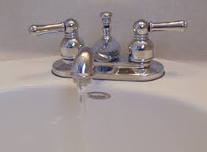
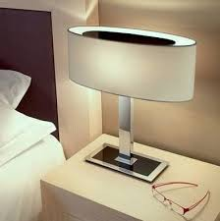
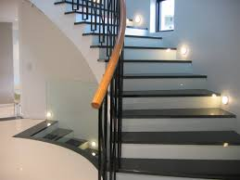


- When two people have to share a room and they both have totally different tastes how will you solve the problems relating to colour, pattern etc.
Answer:
The best way to solve a problem relating to colour and pattern when it comes to two different people is to carefully select it mid-way between two tastes. It can also be solved by compromising between different aspects.

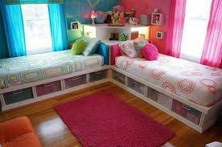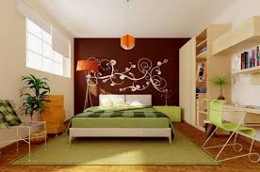
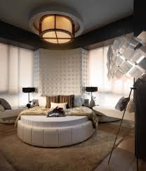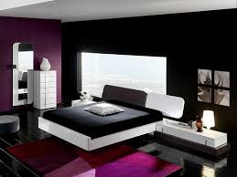
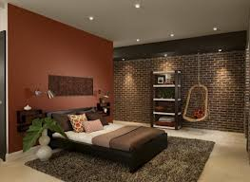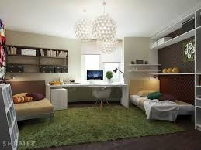

- How far it is important that the ensuit bathroom scheme should relate to the adjoining room’s scheme?
Answer:
As en-suit bathroom is most likely to be used just by the occupants of the adjacent bedroom, that’s why its very important that its scheme should relate to the adjoining bedroom and it should be tailored for their needs without considering others.

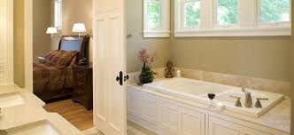
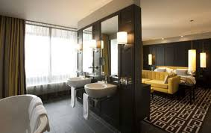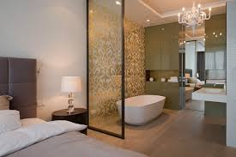
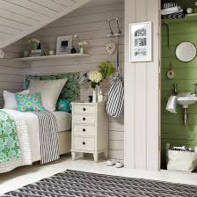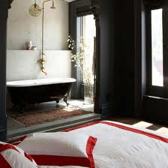

- Which basic equipment is usually required in a home office?
Answer:
Basic equipment like desk, chair, desk lamp, shelves or filling cabinets, computer, telephone, fax machine and any stationary depending on people’s needs are usually required in a home office.
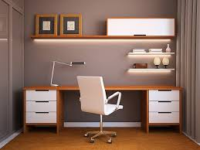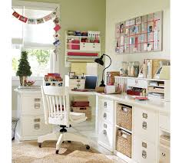
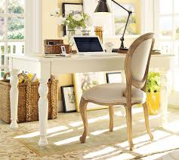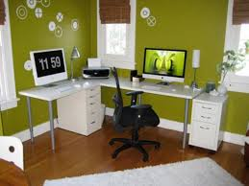
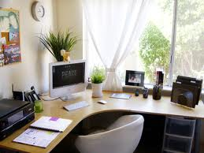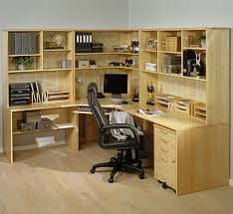

Activity (10)

- List things that you have in your bedroom and also list things that you want to have?
Things I have: Ottoman storage bed, wardrobe, TV stand with TV, full length mirror, exercise bench, baby crib.
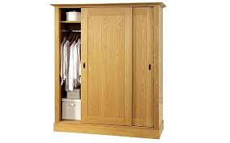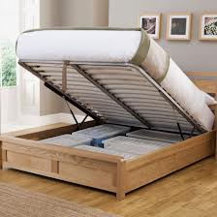
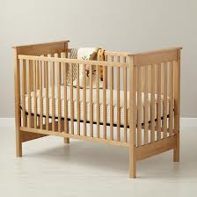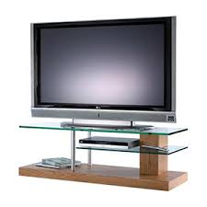


Things I want to have: Dressing table.
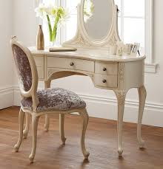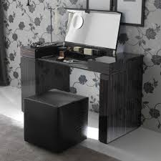

- Measure your bedroom and convert these measurements to scale.
Answer: My bedroom’s measurements are 3.66m x 3.96m
Scale 1:10 is 0.366m x 0.396m
- Do you have enough storage space in your bedroom?
Answer: Yes, I think that I do have enough storage space in my bedroom.
- If you are asked to create some more storage space how would you manage to do this?
Answer: I would put one more wardrobe or a chest drawer or even bedside tables as there’s enough space in my bedroom for it.

Unit 14 Brentwood Open Learning College Page 1

