
Assignment Cover Sheet

Student Name: | Carly Clarke
Student Number: | 1162
Course: | Diploma in Beauty Therapy & Salon Management
Assignment NO: | 6

Student Statement:

By submitting this assignment, I confirm that this is my own work.

Student Signature | c.clarke | Date | 27/02/2015

For Tutor / Assessor Use Only
Total Marks
Marks Obtained
Percentage / Grade

1

Mrs Carly Clarke
Student Number: 1162
Assessment: 6
Beauty Therapy & Salon Management
Address:
18 Morgan Court
Claydon
Ipswich
Suffolk
IP6 0AN

Assessment 6

Q.1. Multiple Choice Questions:

- Make up is used to enhance the facial features and to;
- To make us look attractive

- Which of the following foundations give heavy coverage?
- Cream Foundation

- What is the matching color foundation for olive skin?
- Dark beige or brown

- While applying face powder the strokes of the brush should be;
A) First upwards and then downwards

- Mascara is applied from;
- The base to the tips

- Blushers are used to;
C) To add warmth to the face

- Make up application;
A) Varies from client to client.

- The skilful application of different cosmetic products can;
- Can create balance in the face

- Face powder is used to;
- Reduce shine

- Which type of face powder would you used for an evening make up?
- Iridescent

2

Carly Clarke
Student Number: 1162
Assessment: 6

Q.2. Subjective Questions

- List at least three contra-indications to make up treatment.

There should be no treatment given if you see any contra-indications during your inspection and consultation. An example of these is;

- Any cuts or bruises in the area
- Skin disorders like Eczema
- Any recent scar tissue

- While preparing your trolley for a makeup treatment which equipment will you include?

When preparing the trolley for a treatment the following items should be included;

- Gown for the client
- Headband
- Tissues/ Towels
- Cotton wool
- Water
- Palette and spatula

Then you want to include the makeup and the brushes as follows;

- Selection of makeup brushes to use will all the make up
- Cleanser/ toner and moisuriser
- Foundation
- Face powder
- Blusher
- Mascara
- Lip Liners/ Lip Pencils/ Lipsticks
- Eyeshadows
- Pencil sharpener
- Mirror for the client to see

3

Carly Clarke
Student Number: 1162
Assessment: 6

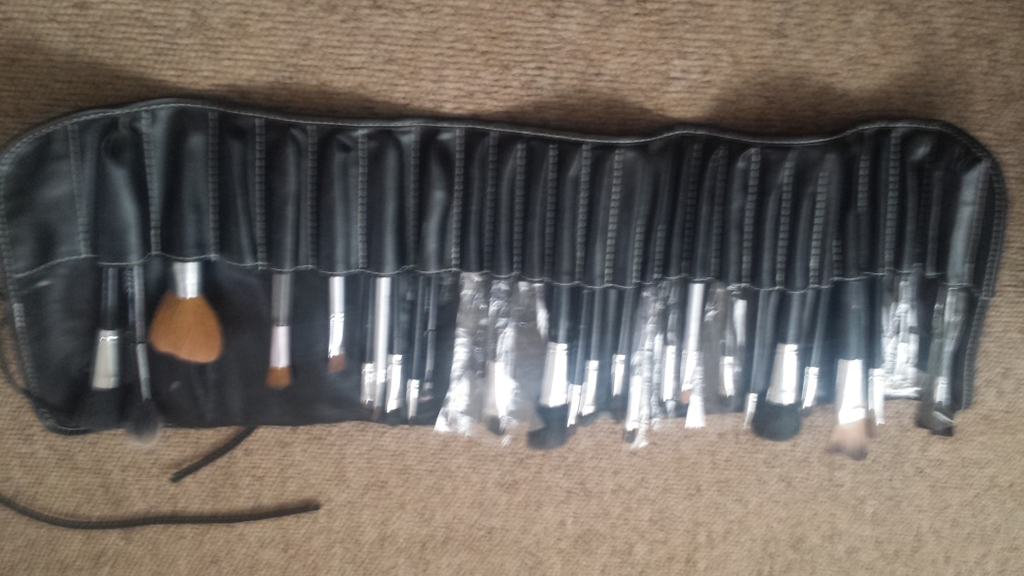

(Example of makeup brushes)

- Which foundation do you think is suitable for dehydrated skin?

A cream foundation would be best for dehydrated skin as it is oil based and will provide a heavier coverage.

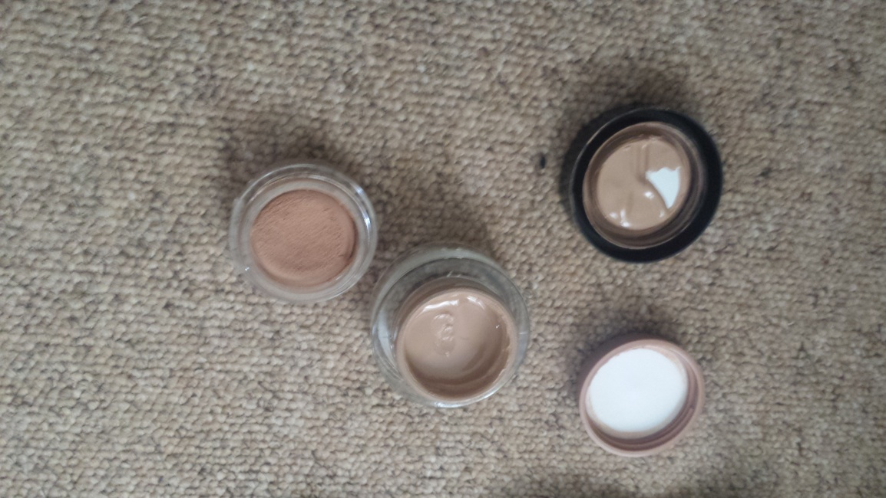

(Examples of Cream Foundations)

4

Carly Clarke
Student Number: 1162
Assessment: 6

- What are the contouring cosmetics? What are the following cosmetics used for?
- Shader
- Highlighter
- Blusher

Contouring cosmetics can be used to change the shape of the face or the facial features. Using the basis of darker and lighter they can draw attention to or from areas of the face.

Shaders can be used to reduce the size of an area. These want to be a darker colour such as beige for pale skins and a darker colour for those with darker skin and foundation.

Highlighter does the opposite of shading and will draw attention to the area. The pale colours of the highlighter will reflect the light. Pale skins should use light cream and ivory tones. Darker tones should use a pale peach for warmer tones and a pale rose for pinker tones.

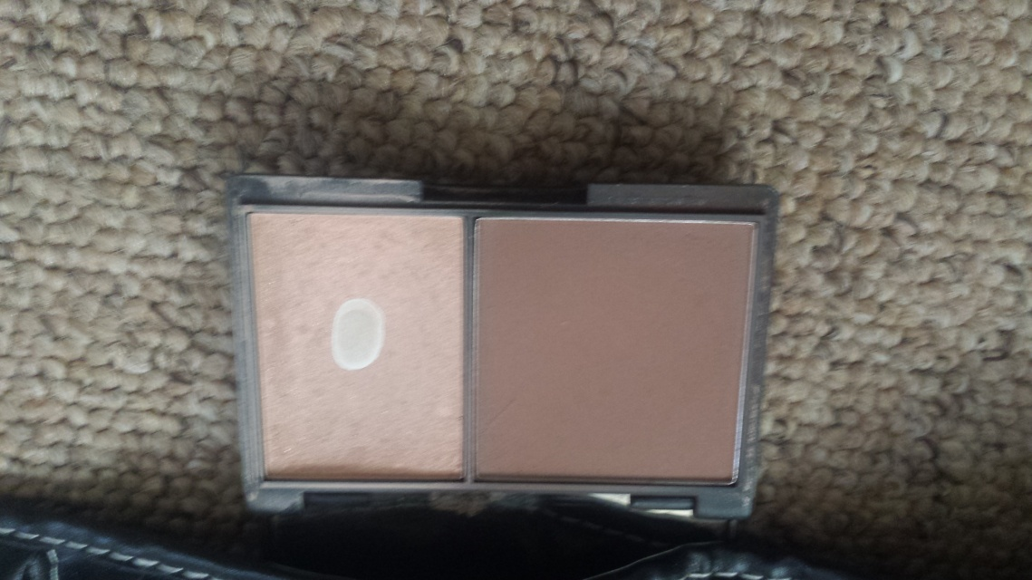
(Example of shader and highlighter)

5
Carly Clarke
Student Number: 1162
Assessment: 6

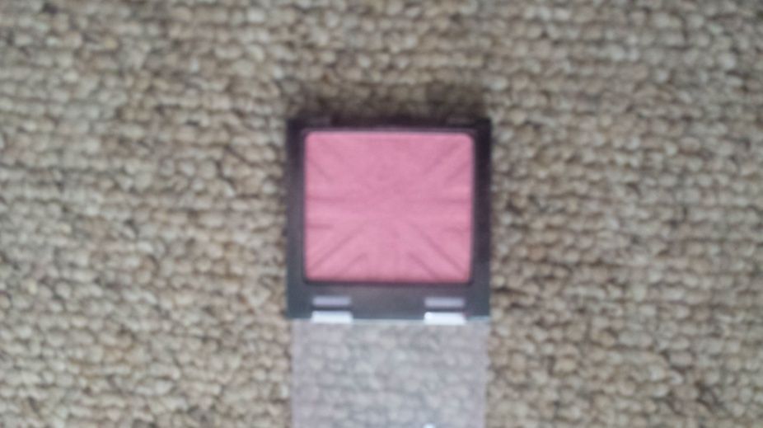

(Example of blusher)

Blusher is added to add warmth to the face and give the skin a healthy glow.

- A client comes to you for her makeup application. She has combination skin with sensitive areas. Which types of products would you used for her makeup treatment?

Because the client has sensitive skin the products used should be Hypo-allergenic. These are best for sensitive skin because they have fewer pigments and no perfume which can cause issues with sensitive skin.

A liquid foundation would be best as it is water based, this should be used in conjunction with a powder to soak up the oily parts of the skin.

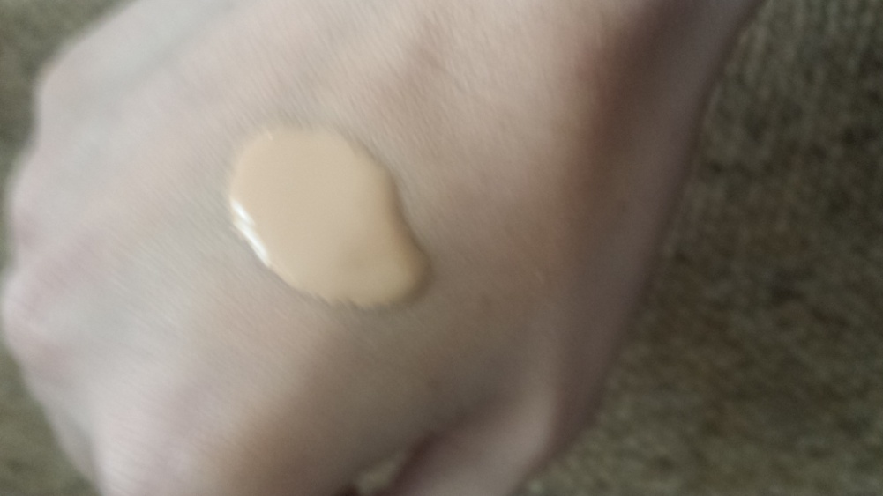

(Liquid foundation)

6

Carly Clarke
Student Number: 1162
Assessment: 6

- How would you apply mascara in order to achieve a thick coverage?

To get a thick coverage you want to ensure you use the point of the mascara to reach the smaller and thinner lashes. Placing a tissue under the base lashes you then want to stroke the mascara down the length of the lashes. This should be done from the base to the tip. You then apply from the base in a zig zag motion and separate the lashes with a clean brush.

- How important is it to know about the client’s skin type before choosing the cosmetics for her?

It is extremely important to carry out an assessment of your client. This is so you can determine what products will be best to use on her. For example someone with sensitive skin will need hypo-allergenic products. If not they can have an allergic reaction or it can cause breakouts. It is best for the therapist as well to cover themselves legally by using the correct products. Using the correct products will also enhance the look of the client, using the wrong ones could make them look patchy and less attractive.

Q.3.

Which type of facial problems can you disguise using foundation?

Foundation can be used to conceal blemishes and even out the skin tone. If you use a founadation such as a cake or compact foundation they will give a heavy coverage and can cover badly blemished (acne) or even scarred skin. Some foundations are so pigmented and thick they can even cover tattoos.

