
Assignment Cover Sheet

Student Name: | Ray Wilson
Student Number: | 1250
Course: | Construction Management
Assignment No: | 08

Student Statement:

By submitting this assignment, I confirm that this is my own work.

Student Signature | Raymond Wilson | Date | 8th Sept 2014

For Tutor / Assessor Use Only
Total Marks
Marks Obtained
Percentage / Grade

Assessment 8 Total Marks: 30

1. Give short answers for the following questions: (20)

I. What do you understand by inventory management?
Inventory managements main purpose is to ensure that there are enough spare parts available to meet the project needs but also to not carry surplus stock that could be unnecessary and costly.
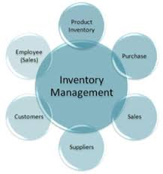
There are a number of Inventory models on the market that can determine the procurement level of stock, when it needs to be replenished to avoid shortages, the amount it needs replenishing by and the frequency therefore controlling and keeping cost to a minimum.
These models, through analysis, assists construction companies in reducing excess inventory levels by improving inventory turnover rates, adjusting individual product safety stock quantities while maintaining on-time delivery schedules and controlling stock-outs. Results from the analysis can be used by management to meet its inventory level objectives in a declining sales environment. The following graph illustrates the results from one of these types of analyses.
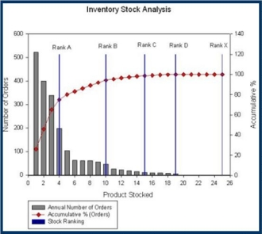
Analysis and Financial Data
The following indicators and tests are applied to solve the inventory issues:
- Sources of demand information for parts and consumables include sales forecast, future orders, order back-logs, etc.
- Limiting factors such as part availability, production constraints and delays, delivery issues etc. are also taken into account.
- Accuracy of past forecasts is measured to isolate possible areas of improvement.
- The right event data out of the vast stream of data is identified and used to build the best fitting forecast model to suit a project’s needs.
- Models continuously monitor demand pattern changes and update forecasts used to plan parts and consumable stock replenishment and to maintain the appropriate inventory levels.
- Forecast errors and knowledge of desired service levels are used to better manage high and low-end inventory risks.
Benefits
The benefits that can be realized from utilizing this solution:
- Isolate the information and model to controlling inventory levels, forecasting demand and the replenishing of stock effectively.
- Reducing the excess inventory of consumables and parts enables the user to free up cash which is vital for the company’s on-going survival.

II. How would you maintain spare parts inventory on a construction project?
Firstly a sensible selection of spare parts, normally used and based on the amount of equipment available , would be identified and procured bearing in mind the outlay and these should be kept to a minimum on site. Clearly the bigger the organisation the more flexibility there is with regards to amounts of stock held. It is also worth noting that if these spare parts can be obtained in country or even be manufactured at the project workshop then the need to carry surplus stock can be further reduced.
If suitable historic records have been kept to record breakdowns and spare part requirements etc. a fair degree of confidence can be achieved that the amount of spare parts held in stock will indeed keep the machinery operating. One aspect of keeping a lower stock of parts is to consider the type of equipment to be used so that spare parts can be inter changed, therefore as an example a range of “bobcats” from the same supplier would have advantages whereas spare parts and the consumables can be interchanged with confidence. In some cases different parts and consumables can be interchanged on different manufacturer’s equipment and this also needs to be investigated and considered and this is outlined in a later question.

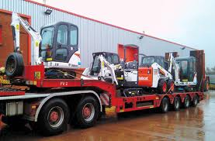

There are three types of spare parts used for machinery and these are items for slow moving parts which can be stocked based on cost against loss of production, fast moving parts which are determined by actual working conditions encountered by the equipment and are therefore vital to be available in stock and consumable parts such as oils and filters (see samples below) which can be procured and stored with a fair degree of accuracy based on the service requirements of the equipment.

III. What are the advantages of interchangeability of spare parts? Also List the problems of establishing interchangeability of spare parts?
As there is a limited number of primary manufacturers who make major components such as axles, transmissions, brake systems, air systems and the like for diesel engines it is quite common for the components to be used and be interchangeable on a wide range of machines regardless of the badge or brand type, making it possible to stock a limited amount that can be used on the project machine range.
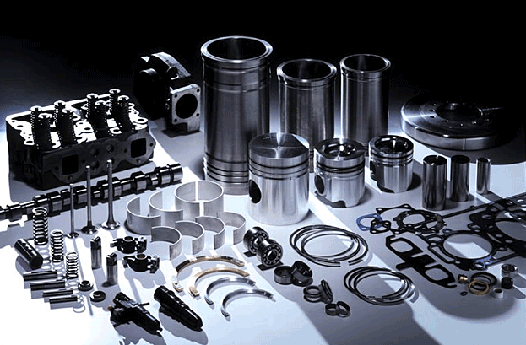
This brings difficulties however as each manufacturer will identify similar components by differing item code numbers within their catalogue range therefore identification cannot be established without potential problems or errors occurring. This risk of this problem can be reduced however by establishing a list of parts from different manufacturer’s that can be interchanges between machines.
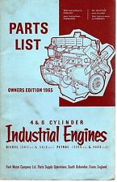 Main manufactures should compile these lists or catalogues identifying which component can be interchanged therefore allowing the user to use this information to establish item that can be stocked at a minimum but used on various machines as and when required.
The same interchangeable issues can be said of smaller types of machine spare part items such as belts, bearings, seals, gaskets etc. which tend to be replaced more often and can be used on various items of equipment, but as these items tend to be less expensive, easier to store and can be sourced readily from local suppliers. Therefore a listing of these types of items will also assist the user significantly having the correct stock available at hand or he will have the comfort that a component can be easily obtained in a short time frame if needed.

IV. Why is lubrication of equipment important?
Lubrication of construction equipment, as with any moving mechanical part, is an integral part of servicing.
Whilst the primary function is to make the components “slippery”, there are more advantages to using the right lubricant. In addition to friction reduction, the correct lubricant also reduces wear and tear that occurs during operation, reduces operating temperatures, minimizes corrosion of metal surfaces, and assists in keeping contaminants out of the system.
Following the manufacturer’s recommendations, which are usually detailed in charts and schedules, is vitally important as the right type, quantity and timing must be adhered too to ensure best performance is achieved and that the machine warranty is not invalidated which could lead to costly repairs or insurance premiums.
It is imperative therefore that suitable lubricants are purchased, correctly stored and the appliances are at hand to dispense the lubricant and also the personnel applying the lubricants have sufficient knowledge and if possible are qualified to administer the lubricants to the machines that need periodic inspection and servicing.
V. What is the utility of a data bank?
The purpose of an equipment data base cannot be underestimated.
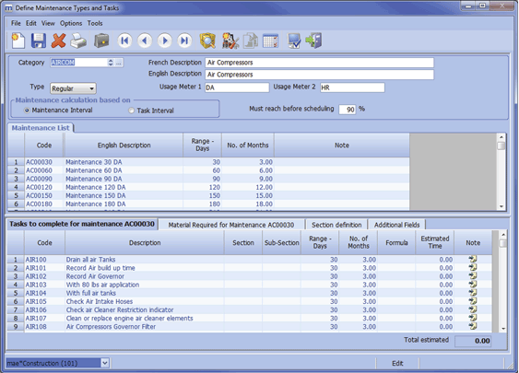

All equipment used on a construction project must have all its maintenance records held in a central location so as to ensure accurate information is readily available for current and future use (and if available it’s historical records also). In the modern construction world computer software packages have been developed, like the one illustrated above, which track accurate records of the preventative maintenance carried out on equipment.
Falsified information is one practice to be avoided with regards to maintaining plant and equipment as this could lead to costly break downs and potential catastrophic failure of components, therefore this type of record keeping will be more accurate than a manual system but of course not all projects are large enough to accommodate the luxury of computer based systems and manual systems are still used.
Regardless of the type of system used the records should be simple, honest and clear. The output from the record keeping should be a pro-forma that allows the data recorder and his supervisor/manger the provision to sign for the records after both have diligently checked the information and this must include at least,
- Preventative maintenance records
- Daily operations inspections
- Equipment repair history
- Information on oils, Lubricants and fuels used
- Spare parts used and their parts information
All of this information should provide a clear and reliable source of the checks and balances needed to keep construction equipment well maintained for current and future usage.

2. What are the requirements of lubricants? How should lubricants be stored? (5)
If construction equipment is properly maintained and lubricated the reliability of the equipment will be significantly improved with less chance of breakdowns.
Modern day equipment operates at high speed and with greater load capacities proper lubrication is vital so that these machines can operate long hours often in extreme climate and on harsh ground conditions.
All the equipment is usually entered onto a lubrication plan and these can be sorted and a listing printed from a software programme as highlighted in the previous answer. Wherever practical the lubricants should be grouped together by type and grade and, providing they meet the manufacturers requirements and specifications, this enable the maintenance team to store a minimum amount of different types of lubricants which will alleviate the potential for choosing the wrong type to be applied and also cut down on required storage space.

There are basically six types of lubricants (see illustration sample above) which are used for construction equipment and they are,
- Engine Oil - which provides rust protection, foam prevention, anti-wear properties and oxidation stability.
- Hydraulic Oils – which acts as a medium for power transmission and cools moving system components
- Adhesive Gear Oil – which cling to surfaces even at high operating speeds and temperatures
- Extreme Pressure Gear Oil – used where there is a sliding contact process between gear faces/surfaces and they have ability to absorb shock loads and prevent scoring
- Heavy duty Grease – used for bearings and gears and guard against water contamination and shear breakdown
- Track roll Grease – used specifically for rollers bearings and have good anti-oxidant properties and create good mechanical stability
Lubricants should be stored in an area easily accessible to all work fronts/sites and should also be stored in a covered location that is dust free and sheltered from extreme climate conditions.
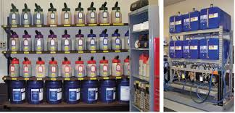
If outdoor storage cannot be avoided then barrels or drums should be kept on their sides or if upright covered so that dust and rainwater do not gather and potentially impregnate the product rendering it unusable.
In cold weather after periods of storage it is permissible to apply exhaust pressure steam to enable the lubricant to become more liquefied but direct flame should never be used on a storage container containing lubricants.
It is also important to note that hoses, nozzles and funnels used in dispensing the lubricant should be kept absolutely clean so as to avoid issues such as attraction of solids, dust and other contaminants and catchment trays should also be used to avoid environmental spills.
Good records kept to ensure lubricants are used as planned and are not used if storage has been over a long period as lubricants lose their quality over time (use old stock first).

3. What are the general rules of equipment replacement? (5)
Machinery replacement is critical to the survival of contractors operating in the equipment intensive fields of construction. A replacement analysis (method) needs used and carried out when the replacement of equipment is being considered which based on sound economic theory and bearing in mind the importance of historical data in this process.
There are numerous factors to be taken into consideration during this analysis such as downtime periods, economic climate, end of tax year or planned major overall windows
This analysis therefore should generally review the following as a minimum,
- If a trade-in offer for the older equipment is more than the “street value” this can be seen as a reduction in the price of new equipment.
- Whilst comparing alternatives, rather than focusing on the actual cost, the decision should be based upon the amount of work that will be accomplished by the alternative equipment.
- Presently used equipment should be analyzed to determine whether it should be kept and used as backup or replaced altogether with new.

- Interest rates should be used in the calculation of the cost of equipment and also making allowance of the same in adjusting the cost to a common time value.
- The current inflation rate should be applicable to the cost adjusted.
- Taxes need to be equalized and the method used should convert costs to a common tax basis before comparing them.

