
Assignment Cover Sheet

Student Name: | Ray Wilson
Student Number: | 1390
Course: | Environmental Management
Assignment No: | 12

Assignment 12 Total Marks 30

1. What is environmental risk management? 15

Environmental Risk is universally defined as the “actual or potential threat of adverse effects on living organisms and the environment by effluents, emissions, wastes, resource depletion, etc., arising out of an organization’s activities.”
Environmental exposures therefore, whether physical, chemical, or biological, can induce detrimental reactions and this may affect soil, water, air, natural resources or entire ecosystems, as well as the plants, animals (including humans) and the surroundings where they live. With growing oversight, this type of risk is not typically covered under conventional liability protection, but gaps in coverage can be filled by innovative specialty programs made available by insurers. Given the increase in environmental exposures, the global risk and insurance community would be wise to evaluate its awareness, vulnerability, preparedness and response in managing developing and unexpected pollution risks.
The first step therefore is to ensure environmental risk management is effective within an organization by identifying the most critical assets of the enterprise. How these assets function within the broader landscape of the environment is important. The organization must determine if any of these assets are a threat to the long-term stability of the environment and how they will ultimately impact the life of the business.
An organization must then identify any changes that may be a threat to its continued existence. As an example, if a company uses large quantities of paper, the fact that the level of natural tree growth continues to dwindle is a long-term threat to the existence of the organization. The company must find a way to ensure that the paper source continues to grow as the business grows. This could be mitigated by purchasing a segment of the forest sector or implementing a recycled paper program or both.

Vulnerability is paramount in determining the risks associated with specific types of events. The organization must make an assessment of which areas are most likely to cause problems and which ones are unlikely. This allows the business to allocate assets in an effort to stave off the likely effects of the threat. A business will be able to find the most critical elements of environmental threat and move the most amount of assets to combat this possibility.
Another viable option for handling environmental risk management includes the transfer of risks to another party. This can be handled by outsourcing certain aspects of the company's operations, or by utilizing risk insurance programs to guarantee a limited amount of liability in the event of a catastrophe.
While an organization can adjust its operations to handle certain criteria in which it operates on a daily or long-term basis. There are a number of threats in which a company has very little control. Particularly if it is headquartered in an area in which these events are commonplace. Using environmental risk management, an enterprise will adjust to these threats by establishing itself in areas in which these events generally do not occur. It is important therefore that companies plan and assess all the potential risks and the outline below gives indication of the inputs and outputs needed.
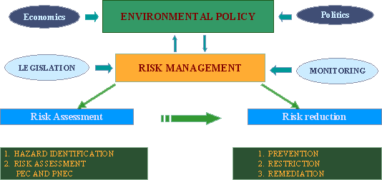
There are numerous software packages available that can facilitate environmental risk and the solution they provide can normally be completely customized to suit the exact risk management needs of any organization, allowing companies to proactively identify risks, evaluate the likelihood and impact of those risks, relate them to mitigating controls and actions, and track their resolution. They should always provide the following as a minimum;
- Completely customizable: A Risk Management solution that can be completely customized to match your organizations risk management requirements.
- Organization wide: Manage risks and controls for all Business Units from one central system.
- Key Risk Indicators: Use Key Risk Indicators to monitor your risk status, for proactive risk management.
- Risk Maps: Track the impact of mitigating activities using interactive Risk Map reports.
Environmental issues nowadays go beyond borders. Whether directly or indirectly caused, environmental liability has become an international matter for companies with the potential to negatively impact the environment while they conduct business in other countries. Many companies are not even aware of their risks or accountability for incidents occurring while they conduct business across a border or thousands of miles away on another continent. Further complicating this issue, legal and regulatory directives can be as varied as the languages spoken, often involving highly complex legal frameworks.
In an effort to clean up and protect the environment while managing collective costs, many countries are now improving the regulatory framework on the prevention and remediation of environmental damage. As part of this trend, both the United States and the European Union for example, have taken the lead in establishing directives to moderate the liability resulting from environmental pollution incidents. This legislation impacts every business operating in the U.S. and Europe. The European Liability Directive (ELD) and the Comprehensive Environmental Response, Compensation and Liability Act (CERCLA) (aka “Superfund”) respond directly to releases or threatened releases of hazardous substances that may endanger public health or the environment. These rulings establish a common basis for the financial liability to businesses for the environmental threats or damage they cause. Moreover, professionals and experts alike, have determined that the ELD has more far-reaching impact than initially expected and many other countries have followed suit, developing their own legislative framework for compliance and consequences for violators.
Just keeping track of the thousands of environmental laws and the effects of emerging regulations can be a full-time job in itself. Few companies, especially the smaller ones, have the in-house expertise to manage this.
Potential business liabilities are numerous and include the following examples:
- Damage to brand reputation
- Penalties for violation
- Damages resulting from faulty or defective construction or materials
- Losses from first- and third party property and material liability
- Expenses for clean-up of emissions
- Business interruption losses during contamination removal
- Costs associated with premiums, litigation, investigation, and compliance
- Expenses for remediation measures
- Historical (pre-existing) coverage for past events or operations
An event can create a range of environmental exposures ranging from liability for on-site cleanup, potential damage resulting from direct pollution of surrounding natural habitat, and even claims for long-term damage to the environment, such as damage to soil, groundwater, and surface water. All such hazards are typically not protected by traditional insurance and can result in substantial financial losses as well as ultimate effect on human health as illustrated below;

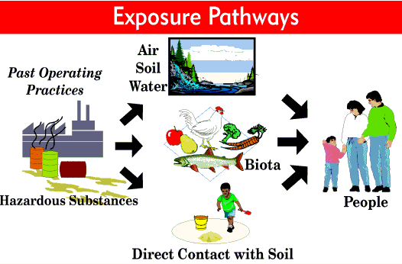
In Summary therefore companies and organizations must assess, mitigate, and monitor definite risks involved with their daily operations. A specific area of risk that must be identified is that on the local and global environment. Accidents, natural events, and deliberate assaults are all possible ways for an enterprise to cause pollution or other risks. In order to limit, and hopefully prevent these situations, environmental risk management places a strong emphasis on targeting the problems that could arise and implements a system of metrics that help with prevention.
This practice is now adopted by both public and private sectors of the economy. An organization must establish procedures that manage the uncertainty of its operations, which involves following certain protocol and implementing tools that will ensure conformance to those procedures. These procedures must be applied to day-to-day activities that may be a threat to environmental well-being, as well as overall infrastructure assessment, to lower or eliminate damage to the environment caused by the organization.

2. Identify and discuss various tasks involved in environmental risk management. 15

Some of the tasks involved in ERM are as follows;

Research and monitoring

Environmental research, assessment and monitoring is the starting point of environmental management and it integrates physicochemical, biological/ecological and toxicological assessment tools for contaminants and contaminated land. Evaluation and interpretation of the results are also key issues of the management process. Conventional and innovative methods such as dynamic testing, in situ and remote assessment, risk-based monitoring and early warning are used for this purpose. They help understand the response of the natural environment to pollution events and remedial actions.
The planning of the research, assessment or monitoring process is crucial for successful risk management. Standard methods are of moderate benefit only, if their results do not meet the site’s needs or fail to provide a proper solution for the actual problem. Instead of standardizing the method itself, the risk-based concept should be standardized to underpin the selection of a problem-orientated methodological tool-kit. Selecting and applying the proper tools is essential for obtaining suitable results when making a decision.

Governments and the private sector are now embracing the need to manage the environment for varying reasons. The theory and methods of environmental risk assessment, the use of environmental effect, fate and hazard information in risk management of chemicals and contaminated land, explains why an integrated assessment is needed both for the risk of chemicals and polluted sites in both sectors. Efficient tools such as early warning and environmental monitoring with special sensors, or in situ measurements and decision making, modeling and mapping are needed. Nanotechnology methods, using the special molecule of cyclodextrin, can be used as a versatile tool in environmental assessment and monitoring.

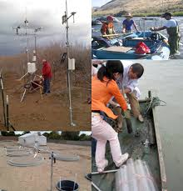

Research, assessment and monitoring, as illustrated above, help provide the following vital information;
- Providing a broad scientific overview of the environment, human uses of the environment and the local, regional and global environmental problems.
- Interpretation of a holistic approach to solving environmental protection problems
- Finding a harmonic way between nature’s need and engineering capabilities
- Understanding interactions between regulation, management and engineering. A good basis for specializing in environmental management.
- Obtaining information about novel technologies, innovative scientific and engineering tools
- Showing the broader horizons for engineers and clear engineering solutions for environmental managers, owners and other decision makers
- Keeping the public involved/informed which ultimately fosters trust.
Environmental legislation
Environmental law is the body of law that seeks to protect or enhance the environment. It is nothing new as there have been laws aimed at protecting or improving the environment since at least Old Testament times (Deuteronomy 23: 12-13, which concerns sewage disposal).
From such historical beginnings a wide variety of laws have been developed to protect the environment. Early laws, often focused on the protection of rights associated with the ownership of property could, indirectly, protect the environment. More recent laws have been made to protect the environment itself. Globally, environmental laws apply in many countries and states and grant wide rights (such as the right to a clean and healthy environment which is, for example, part of the Indian Constitution). Environmental laws cover a huge variety of issues from the local (e.g. noise control) to the global (e.g. climate change control).


Increasingly the fixed emission limit controls that dominated the last century have been replaced or complemented by voluntary and market based approaches to controlling pollution and protecting the environment (e.g. the Packaging Waste Regulations and the Emissions Trading Regulations). As we move into the 21st Century, environmental laws which are enforceable against a relatively small industry sector, for example, waste management, will indirectly affect everyone. Operators in such sectors seeking to comply with environmental laws will place restrictions on their customers and this will affect the marketplace, and so influence many day to day decisions, e.g. the ban on ozone-depleting CFCs led to changes in the design of fridges and aerosols.
Environmental law was one of the faster developing areas of law at the end of the last century. It is difficult to find an area where rules do not apply. Such laws are often very detailed, sometimes deeply technical, at times over-complicated and arguably in places the framework appears incoherent. Despite this, the environment in the UK, for instance, is highly regulated, arguably better protected and appears in many areas to be in a better state than it was 25 years ago. A question that has yet to be satisfactorily answered is whether the same or better environmental outcomes can be achieved in a more efficient manner. The European Commission and the UK Government are increasing looking at whether the burden and design of environmental regulation is appropriate. There have been a number of recent reviews and consultation papers on these issues but with the exception of the environmental permitting program in England and Wales neither body has yet to make significant progress in this area.
Ultimately it would be foolish to suggest that many environmental issues can be satisfactorily addressed by environmental laws alone. The issue of what to do with waste is a good example. There are laws at every level to address the waste problem yet too much waste is produced and not nearly enough is recovered. We are running out of room for landfill. Incineration or using waste as a substitute fuel are deeply unpopular. Everyone – from trans-national corporations to the individual consumer - has a part to play in solving this challenge, which the astonishingly complex web of environmental laws cannot solve alone. Clearly the world as a whole has a major problem to resolve.

Standard setting
Standard-Setting Codes are intended primarily for application to standards that fulfil social, environmental and economic policy objectives.
By adhering to procedures that constitute good practices for setting standards, standard-setting organizations help to ensure that the application of their standard results in measurable progress towards their social and environmental objectives, without creating unnecessary barriers to international trade. In addition, the Standard-Setting Code can serve as a minimum bar against which to measure processes to develop voluntary standards. The intention of the Standard-Setting Code is not to promote the development of an ever increasing number of standards initiatives, but to improve consistency between standards, enhancing their effectiveness.
Standard practices should be based on relevant international normative documents, where appropriate. The normative documents from which this Standard-Setting Code draws are ISO/ IEC Guide 59 Code of good practice for standardization, and the WTO Technical Barriers to Trade (TBT) Agreement Annex 3 Code of good practice for the preparation, adoption and application of standards. The need for a Standard-Setting Code was based on an assessment of these documents and definition of additional standard-setting practices not covered by these documents that are unique to social and environmental standard-setting.
Standards are usually arrived at in the context of criteria which describe the known relationships between risk levels and other factors. Standards may refer to;
- Human exposure to risk (e.g. radiation exposure standards) Effluent standards (e.g. industrial toxic wastes) Ambient environmental quality (e.g. drinking water quality standards)
- Occupational conditions (e.g. length of working hours)
- Product, technology or technical process design (e.g. consumer or industrial machines)
- Product composition (e.g. processed food standards)
- Product or technology performance (e.g. building structures)
- Product labelling and advertising (e.g. pesticides)
- Product packaging (e.g. pressurized gas containers, child-proof drugs
Standard-Setting Codes incorporate guidance that provides supplemental information to the Code criteria as well as interpretation of key terminology and phrases in the criteria. The guidance is an integral non-binding supplement to the Standard-Setting Code and should be taken into account when undertaking standards development.
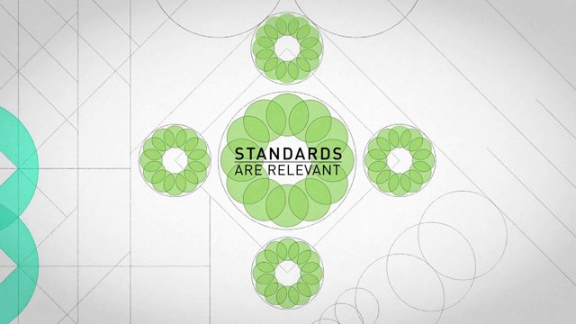
Regulation and enforcement
For environmental legislation to ‘work’ it must not only be well designed but also efficiently and effectively enforced. Strategies must be developed as to how inspectors should go about the task of intervening in the affairs of regulated organizations to ensure compliance and enforcement—a question regarding which there is currently little consensus.
This question can be viewed from a number of angles: descriptive; analytical; and normative. The practices of a representative sample of environmental regulators, identifying a number of distinctive intervention strategies (which are only limitedly shaped by existing theoretical models). Examining the strengths and weaknesses of each strategy and to consider how best to balance the sometimes competing criteria of effectiveness, efficiency and legitimacy. Finally, consideration on how resource allocation and intervention strategies can best be integrated, whether there is a single ‘best practice’ strategy, and if not, what sorts of hybrids might be developed.
In Europe, the elected Commission has a responsibility under Article 17(1) of the Treaty on European Union to ensure that both the Treaty on European Union and the Treaty on the Functioning of the European Union as well as measures adopted pursuant to them are correctly applied. The Commission is therefore often referred to as the "Guardian of the Treaties". With over 200 legal acts to monitor in 27 Member States, this is a major task in the environmental field.
These legislative measures cover all environmental sectors, including water, air, nature, waste, noise, and chemicals, and others which deal with cross-cutting issues such as environmental impact assessment, access to environmental information, public participation in environmental decision-making and liability for environmental damage. Over the last 40 years, the body of law which makes up the European environmental acquis has steadily expanded although in more recent years it has been reaching maturity. Nevertheless, this body of law is continually under assessment with significant developments having taken place in the chemicals sector, but also in the waste, air and water sectors.
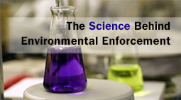
Emergency response
Generation and implementation of effective emergency response and spill control procedures are fundamental aspects of a safe environmental management system. Nearly every emergency affects the environment so although the following touches on items such as chemical spills, fires etc. they all must cater for protecting the environment.
The on-site emergency plan, should address procedures for dealing with emergency situations involving loss of containment in general terms. In brief, the main points for inclusion are;
- Containing and controlling incidents so as to minimize the effects and to limit danger to persons, the environment and property;
- Implementing the measures necessary to protect persons and the environment;
- Description of the actions which should be taken to control the conditions at events and to limit their consequences, including a description of the safety equipment and resources available;
- Arrangements for training staff in the duties they will be expected to perform;
- Arrangements for informing local authorities and emergency services; and
- Arrangements for providing assistance with off-site mitigation action.
The emergency plan/procedure should be simple and straightforward, flexible and achieve necessary compliance with legislative requirements. Furthermore separate on-site and off-site emergency plans should be prepared. The emergency procedures should include instructions for dealing with fires, leaks and spills. The procedure should describe how to;
- Raise the alarm and call the fire brigade;
- Tackle a fire or control spills and leaks (when it is safe to do so);
- Evacuate the site, and if necessary nearby premises.
Evacuation of areas in the event of fire or toxic gas emission should be addressed in an emergency evacuation procedure. This should specify designated safe areas, assembly points and toxic gas shelters. The procedure should also identify responsible personnel whose duties during area evacuation include;
- Responsibility for a specific area;
    - Collecting ID badges from plant racks;
- Ensuring roll calls are undertaken to identify missing persons;
- Communication of missing persons to central emergency services.
A firefighting strategy should consider;
- Appointment of fire wardens, with subsequent training;
- Location plans of fire hoses, extinguishers and water sources;
- Access for emergency services;
- Provision of firewater lagoons.
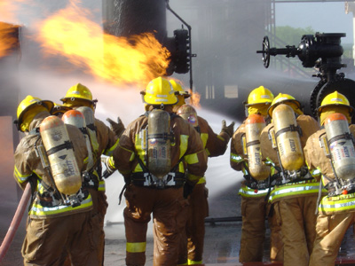

The emergency spill control procedure should include the following key sections that enables the removal of substance to safe place;
- Spills involving hazardous materials should first be contained to prevent spread of the material to other areas. This may involve the use of temporary diking, sand bags, dry sand, earth or proprietary booms / absorbent pads;
- Wherever possible the material should be rendered safe by treating with appropriate chemicals (refer to Stabilization / dilution to safe condition);
- Hazardous materials in a fine dusty form should not be cleared up by dry brushing. Vacuum cleaners should be used in preference, and for toxic materials one conforming to type H (BS 5415) should be used;
- Treated material should be absorbed onto inert carrier material to allow the material to be cleared up and removed to a safe place for disposal or further treatment as appropriate;
- Waste should not be allowed to accumulate. A regular and frequent waste removal procedure should be adopted.

Once the hazardous material has been contained to prevent spread of the material to other areas, the material should be treated wherever possible to render it safe and then Stabilization / dilution to safe condition. Acids and alkalis may be treated with appropriate neutralizing agents. Due to the differing properties of the various groups of chemical, an appropriate treatment strategy with suitable chemicals should be established in each case. For example, highly concentrated hydrochloric acid will fume when spilled so prior to neutralization the spill should be diluted with a water spray.
Once the material has been treated the cleared up the area should be washed with large volumes of water. Most chemical plants and associated areas are serviced by chemical drains that feed to the effluent treatment plant. The washing operation will represent an abnormal loading on the effluent treatment plant, and it is vital that in any situation where this is likely to happen the staff responsible for operation of the effluent treatment plant are notified so that appropriate measures can be adopted. The effluent treatment plant operatives are likely to require the following information;
- Approximate quantity of hazardous material;
- Approximate composition of hazardous material;
- Physical properties of hazardous material;
- State of hazardous material (whether neutralized etc.).
In the case of fire water run-off, much larger volumes of water are employed and the provision of firewater lagoons to contain potentially toxic firewater is required.

Availability of neutralizing substances / foam
Process specific emergency spill kits (acid, alkali, solvent, toxic etc.) and appropriate personal protective equipment should be readily available with supporting procedures. These spill kits should be maintained on a regular basis to ensure that they are always available and fit for purpose. This ensures that the most appropriate measure is at hand to deal with a spill or fire in the most effective way.
Issues that should also be addressed include;
- Containment (as illustrated below);
- Maintenance and condition of fire hoses, extinguishers.
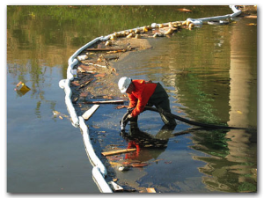
Existing guidance provides comprehensive information with respect to best practice for emergency response and spill control procedures.
Guidance for emergency responses for chlorine, anhydrous ammonia, LPG, nitrocellulose, flammable dusts, and flammable liquids storage plants and chemical warehouses are given in the specific guidance notes listed below.
Additional material providing much insight into analysis of offsite consequences through a risk management program is now available from the United States Environmental Protection Agency. This provides guidance on offsite consequence analysis for toxic gases, toxic liquids, and flammable substances. The risk management analysis will have a significant impact on the format and content of an emergency response or spill control procedure.

Student Statement:

By submitting this assignment, I confirm that this is my own work.

Student Signature | Raymond Wilson | Date | 19th June 2015

For Tutor / Assessor Use Only
Total Marks
Marks Obtained
Percentage / Grade

