
Assignment Cover Sheet

Student Name: | Elizabeth Abidemi Akinlabi
Student Number: | 1380
Course: | Diploma in Fashion Design
Assignment NO: | 8

Marking Criteria:
We expect the learners to write minimum one well expressed point in three lines against each allocated mark. This means one needs to write 15 lines with 5 well expressed points to get high grades for a 5 marks question.
For high grades use examples and illustrations where appropriate.
Please insert your completed assignment ( in word format) here:

ELIZABETH ABIDEMI AKINLABI
1380
ASSESSMENT 8
PAGE 1
Give short answers for the following questions:

- What is meant by ‘binary colors’?
Binary colors are created when two primary colors are mixed together.

- Grey color is formed when black is mixed with white. Is it a warm or a cool color? What do you think? And how best can it be used in creating an attractive color scheme?

I think grey can be a warm and a cool color, in it’s natural state, grey is cool and ‘restful’, but when mixed with bright tones like red and yellow, the mixture of grey and red becomes rose and the mixture of grey and yellow becomes tan, the warm colors bring out the warmth in grey. Grey is best used in an achromatic color scheme, using the grey in between the extremes of black and white to create balance, makes a very attractive color scheme.

- Which of the following colors should a stout person wear? Dark or light and why? A stout person should wear dark colors because
ELIZABETH ABIDEMI AKINLABI
1380
ASSESSMENT 8
PAGE 2

dark colors on a stout figure would create the
illusion of a smaller figure.

- If you want to create an illusion of height and slimness using color, how would you do it? To create an illusion of height and slimness, I would use a cool dull color like a dark and dull shade of blue, I would design the outfit solely with that color, so as to create the illusion of height and slimness.

- Wearing black for a grey haired lady is the most suitable choice. But how should she wear this in the best possible way? The grey haired lady wearing all black should use the neutral color white on collars, yokes or as a scarf tied around the neck to help diffuse the intensity of the black near her face, also some dull warm colors might also be used, that is only if the lady’s features permit it.

- For a person of sallow complexion, which type of color is the best choice? And why? A person with a sallow complexion must choose to wear colors that ‘reflect color in the cheeks’, to achieve this effect, warm tints are the best, different variations of the rose color, red and certain shades of green as not all greens are suitable for this complexion
ELIZABETH ABIDEMI AKINLABI
1380
ASSESSMENT 8
PAGE 3

type. Shades of blue green, navy and blue also
helps to bring out the color in the cheeks.

- Which types of colors will be more suitable for a
Blonde persons dress? The colors suitable for that of a blonde persons dress differ according to the colors of the eyes and features. A green eye, grey blue eyed blonde person will look great in greens, violets and blues, where as a blonde person with similarities to the brunette, who is fair haired and brown eyed will look good in browns.

ACTIVITY

Collect fabric swatches of different color harmonies. Also name the color scheme. Create a contrasting color harmony using at least three colors of your choice. Design a fabric using at least three colors.

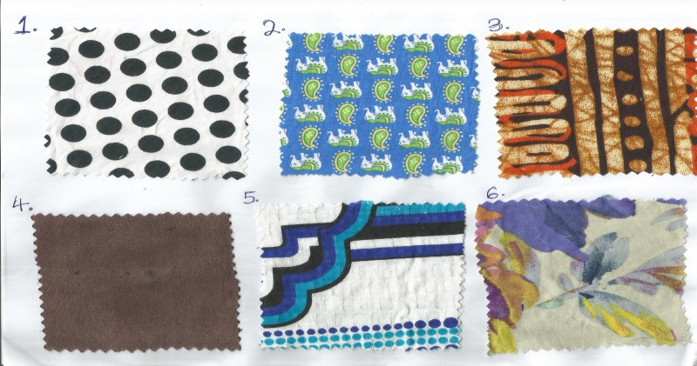

ELIZABETH ABIDEMI AKINLABI
1380
ASSIGNMENT 8
PAGE 4

- This swatch has been designed in an achromatic scheme, black polka dots on a white background.

- This swatch’s dominant color is blue followed by the green and yellow. These colors follow each other on the color wheel, making it analogous.

- This batik style swatch is made up of contrasting colors of a vibrant orange and dark brown. In the background, the fabric has tinted brown streaks on a somewhat beige background.

- This maroon swatch is of a single color scheme.

- Swatch no 5 is of the monochromatic scheme, two different hues of blue are outlined with a neutral color black and placed on a neutral white background.

- The 6th swatch has related harmonies in different hues, violet, purple, lavender, accent notes of blue, also tints of those colors are also present, yellow is played with on this swatch, from a bright yellow to a burnt orange, somewhat analogous, the swatch also possesses complimentary harmony.

ELIZABETH ABIDEMI AKINLABI
1380
ASSIGNMENT 8
PAGE 5

Contrasting color harmony using purple, green and orange.

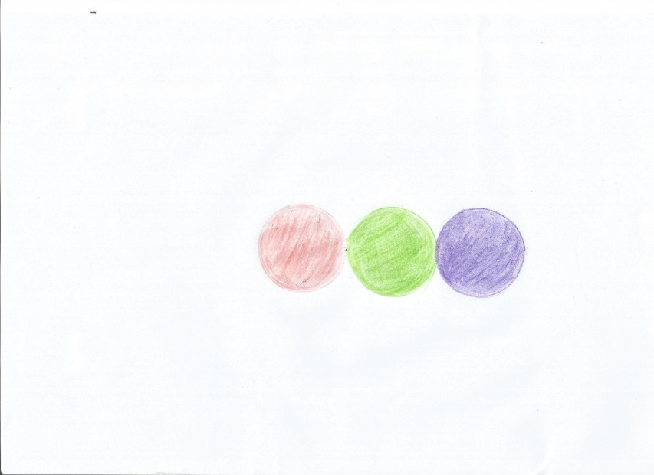

FABRIC DESIGN

I was inspired by geometric patterns, I used primary colors of red, yellow and blue, creating a very bright color hue, I wanted something, vibrant and exciting for summer, I also injected, white as a neutral to ease the monotony of the patterns.

ELIZABETH ABIDEMI AKINLABI
1380
ASSIGNMENT 8
PAGE 6

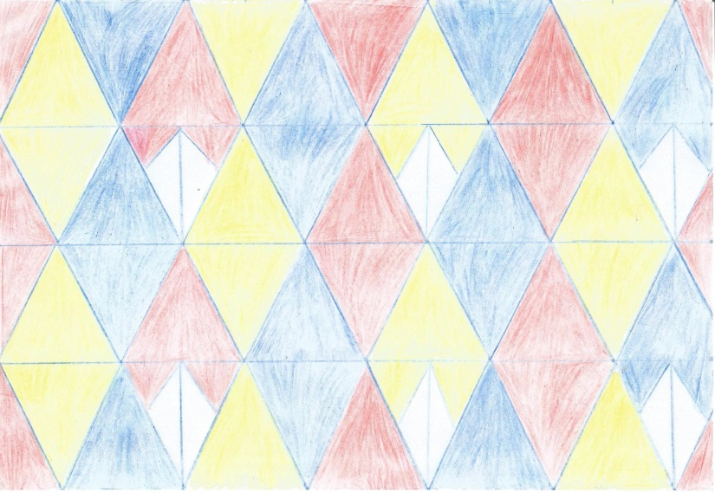

Student Statement:

By submitting this assignment, I confirm that this is my own work.

Student Signature | Elizabeth Abidemi Akinlabi | Date | 30/06/2015

For Tutor / Assessor Use Only
Total Marks
Marks Obtained
Percentage / Grade

