The Client- Designer Relationship

Assessment 15 Total Marks = 30

Q.1. Short Questions: (24)
(All questions carry equal marks)

- When visiting the client for the first time how the survey is started?
Answer:
When first time visiting client survey starts by interior designer taking detailed measurements of the space so that the scale drawings can be produced as a basis for spatial planning and subsequent layout, then they are recorded on the rough floor plan. Marking and measuring windows, doors, any existing fitted furniture and any existing services (such as gas and soil pipes, radiators, electrical sockets etc). It is also important to allow enough space for the inclusion of dimension. Designer would also have to indicate the way room faces.
Secondly designer has to find facts, carry out analysis of the space which would include non-measurable information.
Designer would also have to make sure that the building is in a good state of repair, for which might be that the specialist inspection would have to be carried out.

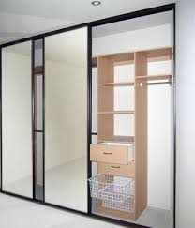
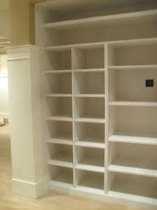


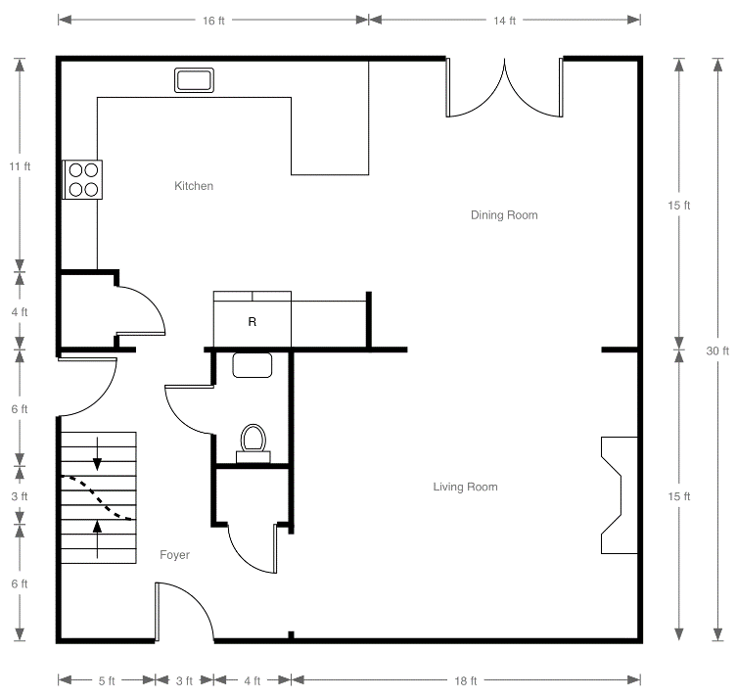


- If the client is not clear about what he wants. What would you do as a designer?

Answer:
If client is not clear about what they want designer should ask questions.

- How is a commercial brief different from the residential one?
Answer:
A commercial brief is different from the residential because it needs to take into account market facts. And to understand exactly how the operation works and any particular requirements, it would be required to know the commercial area.

- What is the fact finding process? Which sort of information is included in it?
Answer:
Fact finding process is gathering information about the space that designer has to design. Information includes taking measurements of the whole space and space that are non-measurable (this includes existing fitted furniture, radiators, sockets etc), its also important to find information about fabrics (and other materials) in interior.






























- What is pre-liminary research? Is this required for a residential project or not?
Answer:
Preliminary research can be described as initial research. In interior design it can be visiting other similar establishments (to look at the layout, space, style etc), researching materials and finishes etc.
Residential projects requires preliminary research too, it might be about specific theme, style and period of architecture, materials and finishes too.


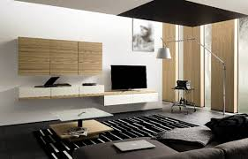


- What does a design analysis consist of?
Answer:
Design analysis consist of doing a check on the:
Ceiling (are there any beams or bulks that could be lost or mouldings which needs to be restored);
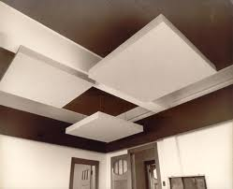

Walls (what are they built of stone, bricks, building block etc, are there any plaster work, what is the condition and style of skirting board);



Flooring (does it suit client’s lifestyle and practical choice, what its made of, are there any squeaky boards etc);
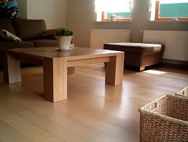

Fireplace (its fuel and where to store it, maintenance);

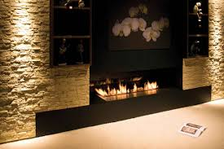

Electrics (position, quality, types of fittings etc, television and phone aerials points, computer terminal);
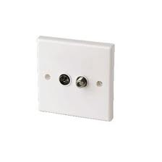

Heating (what is property being heated by);


Joinery (what is the quality, adequacy, height etc of joinery, are there any new joinery required);
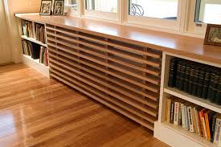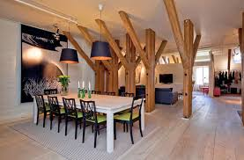

Doors (what type are they, is there any need for doorways to be enlarged);
Windows (what is condition of fitting, how do they open, type of windows, do they need attention etc);
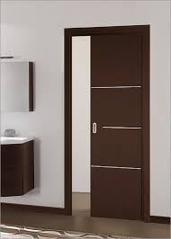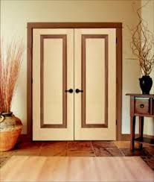

Activity (06)

Prepare a briefing questionnaire.
Questionnaire:
How many people lives in the household?
How much time do they spend in the house?
What do they like to do in the house?
Are there any elderly people, infant/toddlers/kids or pets in the house if so are there any specia safety considerations?
What materials are preferred?
What budget is available?

Unit 15 Brentwood Open Learning College Page 1

