
Assignment Cover Sheet

Student Name: | Saleema Choudrey
Student Number: | 1240
Course: | Fashion Designing
Assignment NO: | Unit 9

Choosing the Right Material.
Assessment 9

- Write Short notes on the following topics.
A) Engraved roller printing
A Heavy copper cylinder which is called the roller is engraved with the print design by carving design into the copper. This printing technique is developed in late 19th century and early 20th century. Designs with up to 16 colors can be done with the roller.

B) Flat-Bed screen printing
An industrial flat-bed screen printing process is done automated. By moving the fabric through the machine on a conveyor belt so the print will repeat frequently on the fabric.
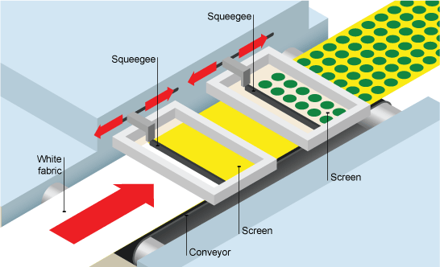

C) Rotary screen printing
Rotary screen printing uses cad and squeegees. One roller is used for each colour. This is a very fast process used in the continuous printing of furnishing and clothing fabrics.
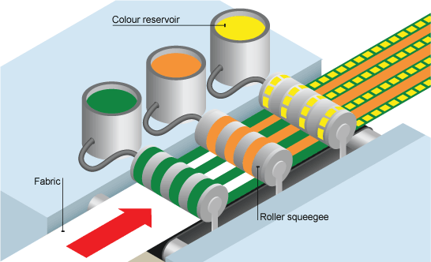

2. What is the difference between weft knitting and warp knitting?
Weft knitting
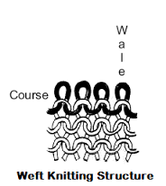
Weft-knitted fabric is made by looping together long lengths of yarn. It can be made by hand or machine. The yarn runs in rows across the fabric. If a stitch is dropped it will ladder down the length of the fabric. The fabric is stretchy and comfortable and is used for socks, T-shirts and jumpers.
Warp knitting

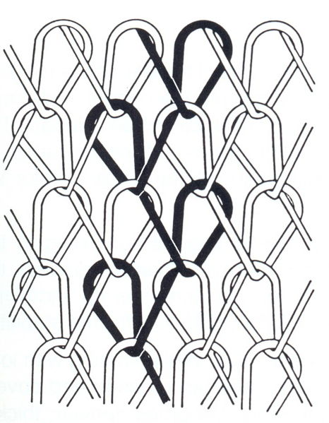
In warp-knitted fabric the loops interlock vertically along the length of the fabric. Warp knits are slightly stretchy and do not ladder. Warp-knitted fabric is made by machine. It is used for swimwear, underwear and geotextiles

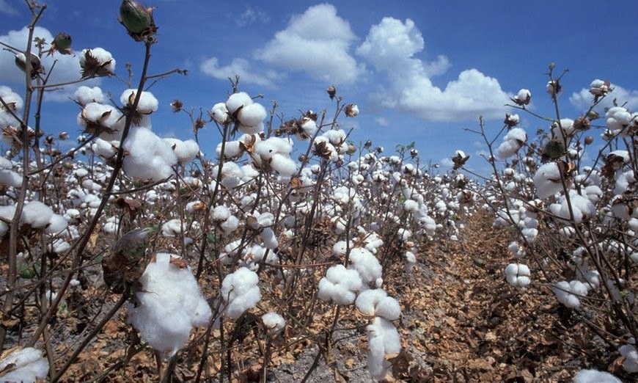
Activity
- Examine the fiber content label in your wardrobe. How many garment are made from natural fiber? How does the fire content affect the care of the garments?

I have examined a few fiber content 3 out of them are made of naturel fiber. Which are silk, wool, cotton. These type of fiber should be looked after with care.

Cotton catches fire very quick, smells like paper, and looks like ash after burn.
Silk and Wool burns slowly, shrinks away, smells like burnt hair, might still burn after flame.

- Visit a local fabric store and find example of a plain weave, a twill weave, a satin weave and a non-woven fabric. Collect swatches of each type.

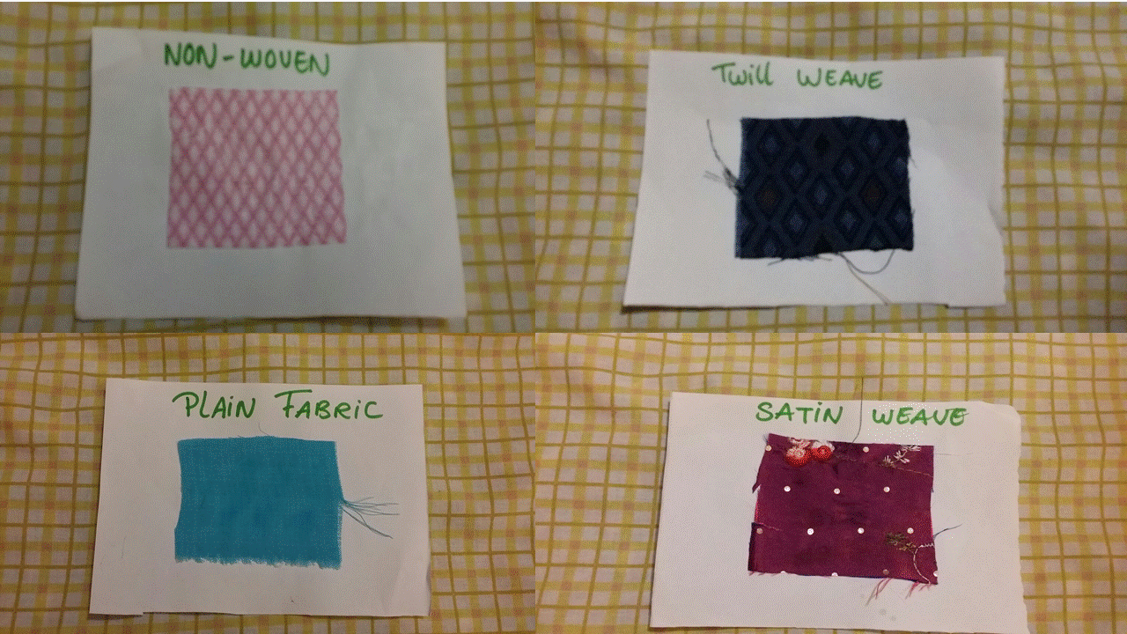

Reference:

https://www.google.co.uk/imgres?imgurl=https://upload.wikimedia.org/wikipedia/commons/d/dc/Trikot.jpg&imgrefurl=https://en.wikipedia.org/wiki/Warp_knitting&h=599&w=466&tbnid=qR9343K210J6CM:&tbnh=160&tbnw=124&docid=JjdpZ4Nhv4FysM&usg=__t2LfGmZGSSfwnBKFGculPqgXxMY=&sa=X&ved=0ahUKEwjHz52PmMHLAhUBAxoKHZpsDxoQ9QEIIDAA

https://www.google.co.uk/search?q=weft+knitting&espv=2&biw=1366&bih=599&tbm=isch&imgil=EpIaeZqB8pFh-M%253A%253B2iMGvXgxjdcoeM%253Bhttp%25253A%25252F%25252Fwww.knittingmagic.biz%25252Fguide-3%25252Fbasic-technology-general-remarks.html&source=iu&pf=m&fir=EpIaeZqB8pFh-M%253A%252C2iMGvXgxjdcoeM%252C_&usg=__PBTPpycK49CmgZiiI47gaKEK3qo%3D&ved=0ahUKEwjDl8a5msHLAhVGfhoKHZRWCl0QyjcIJQ&ei=ljjnVsP0Csb8aZStqegF#imgrc=EpIaeZqB8pFh-M%3A

www.H&M.co.uk

www.primark.com

www.pinkvilla.com

Student Statement:

By submitting this assignment, I confirm that this is my own work.

Student Signature | s.choudrey | Date | 29/03/2016

For Tutor / Assessor Use Only
Total Marks
Marks Obtained
Percentage / Grade

