
Assignment Cover Sheet

Student Name: | Salma Mohamed Safaa
Student Number: | 1170
Course: | Interior Designing
Assignment NO: | 11

Student Statement:

By submitting this assignment, I confirm that this is my own work.

Student Signature | Salma Mohamed Safaa | Date | 30/11/2015

For Tutor / Assessor Use Only
Total Marks
Marks Obtained
Percentage / Grade

Student Name: | Salma Mohamed Safaa
Student Number: | 1170
Course: | Interior Designing
Assignment NO: | 11
Page NO: | 1

Interior Designing Course
Unit 11: Furniture
Q.1. Short Questions:
i. When selecting furniture for a room it is very important it is to consider the principles of scale and balance for the furniture.

When we walk into a room and it just feels right or doesn’t, it is usually either because the Elements and Principles of Design were used properly, or were totally ignored. Of the five Principles of Design, the two most important are Scale and Balance.

Scale is the relationship of sizes of object in a room to each other. Balance is a sense of visual equilibrium insured by close attention to the visual “weight” of the elements in a room. This involves the ratio of vertical lines to horizontal lines and the proportion of light items to solid ones.
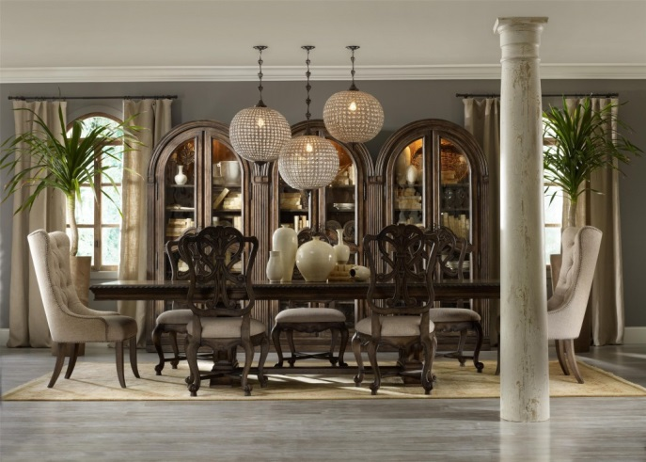
This dining room for example has a perfect sense of balance and scale. The heavy wooden table and the two solid upholstered chairs at its heads are balanced by the openness of the wooden chairs and the lightness of the base of the table. Also the two tall plants on both sides balanced by the high storage and the long pendants from the ceiling.

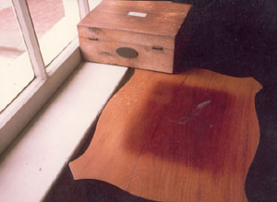

ii. Environment factors can hugely influence the arrangement of furniture in a room.
All climatic conditions like hot and cold, dryness and humidity all should to be considered when positioning the furniture. Strong sunlight will make both wood and fabrics fade. If furniture is covered in a fabric likely to fade do not place it near the window.
Student Name: | Salma Mohamed Safaa
Student Number: | 1170
Course: | Interior Designing
Assignment NO: | 11
Page NO: | 2
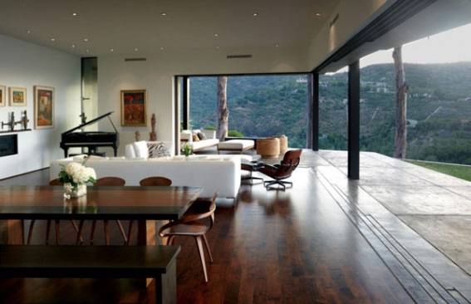
Musical instruments are preferred to be placed near an inside wall, rather than near windows and radiators, to be as far as possible from the outside noise.

iii. To create a focal point in a room:
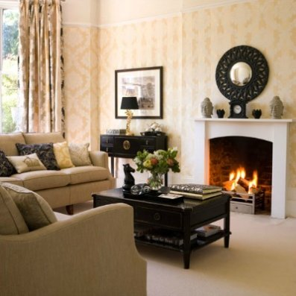
Creating a focal point in a room is probably the most important part of interior design. A focal point is a feature or aspect that commands our attention, the first thing we focus on when we enter a room and around which the furniture and decorative items can be arranged.

Ideally a room will have an obvious focal point such as a fireplace, a beautiful staircase or an exposed brick wall. Use it as your focal point.

But if a room doesn't have a natural focal point a designer should create one. Creating a focal point is possible in any room. A designer should consider what is there, the horizontal planes of the floor and ceiling, the vertical planes of the walls, windows and doors.
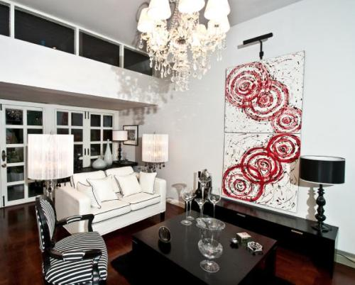
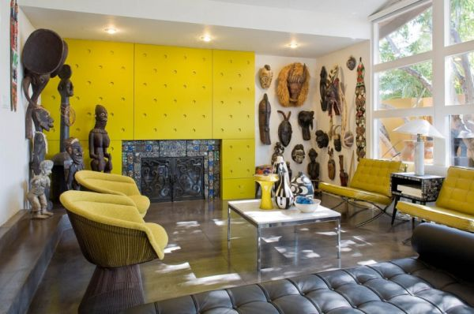
A TV is often the key focus in a living room, but with a bit of thought and creativity something much more interesting can be created; a vibrant painting can be the focus for a living room, with the seating arranged around the outside. A high or interesting ceiling can be enhanced with appropriate lighting. A wall painted in a strong colour or with a distinctive wallpaper works well as our eye is naturally drawn to it.
Artwork and mirrors are designed to draw attention and are an easy way to create a focal point. Considering oversized piece or an arrangement of several smaller pieces grouped together.

A master piece of furniture can make a real centerpiece and is even more stunning when combined with other decorative items such as a sofa with elegant cushions, a dining table with a chandelier above or a console table with a mirror above.
Student Name: | Salma Mohamed Safaa
Student Number: | 1170
Course: | Interior Designing
Assignment NO: | 11
Page NO: | 3
iv. Upholstered furniture:
This is from the word upholster. To upholster is to provide some interior furnishings products with padding, springs and covering material.

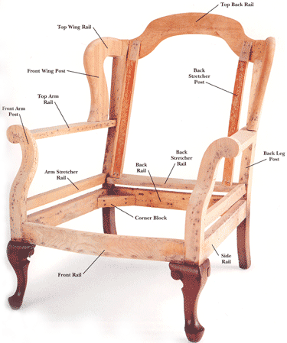
v. To check the quality of Upholstered furniture, it is needed to understand the how it is constructed internally and to know how that the workmanship and materials could impact both price and durability.

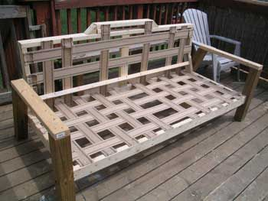
- The frame is constructed out of wood. For good quality the wooden frame should be made from oak, walnut, teak or pine. The joints should be glued and double or triple dowelled, corner-blocked and screwed.

- The webbing comes next; it is used to hold the other layers that will come above. Good quality webbing should be made from jute, flax or a synthetic material and woven into a basket weave design, which is tacked to the bottom of the frame.

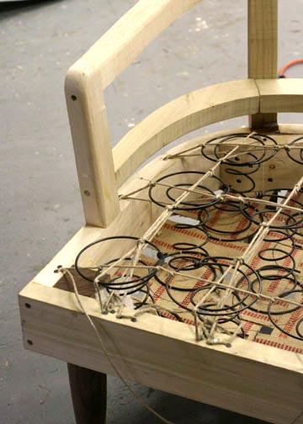
- After webbing comes the springs. The coil springs are set close enough together to provide good support without actually touching each other and these are hand tied in place.

- On top of the springs goes a tough layer of canvas or hessian, which is sewn firmly to keep the padding intact. For good padding it must consist of polyurethane foam, polyester, rubberized hair, foam rubber or feathers.

- There is a final layer of fibre fill or cotton felt, which comes over the upholstery fabric. Sometimes this layer has a protective covering of muslin to reduce the tension on the covering and also maintains the shape.

Student Name: | Salma Mohamed Safaa
Student Number: | 1170
Course: | Interior Designing
Assignment NO: | 11
Page NO: | 4

vi. When inspecting wardrobes, dressers, desks and bureau- book cases and these sort of furniture, check that:

- The doors swing well and fit well.
- Drawers should slide easily and smoothly and their bottoms should be strong but their insides should be smoothly finished.
- For good quality furniture, check it has thin layers of wood.

vii. To check for the quality metal furniture:
Metals Types used for making furniture:
Angle iron, wrought iron, brass, copper, stainless steel, chrome plated tubing.

To check for the quality make sure that:
- There are no bubbles
- Metal surface is smooth.
- Free of weak spots.

viii. If a room is too small which type of furniture should be chosen to suit the proportions of the internal architecture.
- Choosing suitable heighted furniture. Overly heighted furniture should not be placed there in a low ceiling space.
- Using light dense looking furniture; such as furniture made of glass, laminates, shiny metals, cane and light-coloured wood will lessen the effect of solidity than solid looking furniture, such as dark wooden pieces.
- Choosing furniture that isn't fully upholstered will appear much less dense.

Student Name: | Salma Mohamed Safaa
Student Number: | 1170
Course: | Interior Designing
Assignment NO: | 11
Page NO: | 5

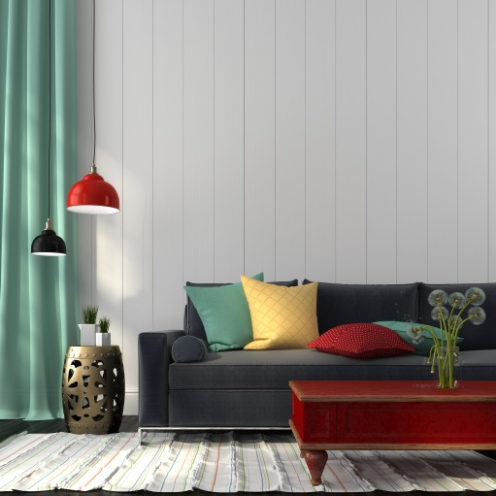
xi. If a designer want the furniture to stand out in a room, furnishing should be chosen in contrasting colours with the background (the walls and the surrounding).
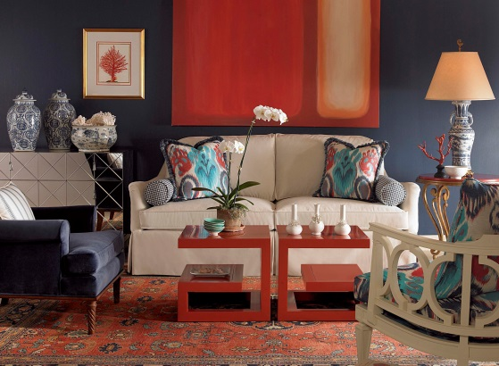

Q.2.To blend the furniture into the background, leaving much less cluttered appearance. A designer should choose furnishings with colours that closely match their background.
for example: a beige sofa against a beige carpet and beige walls.

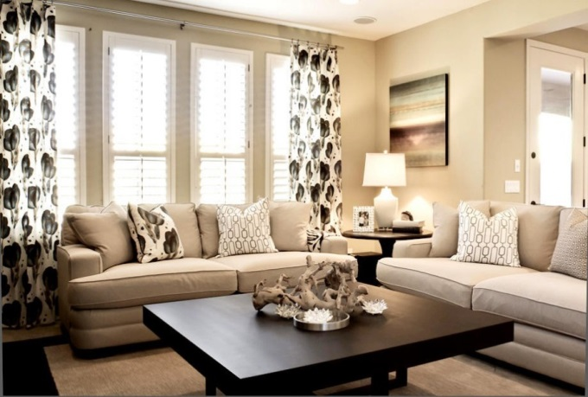
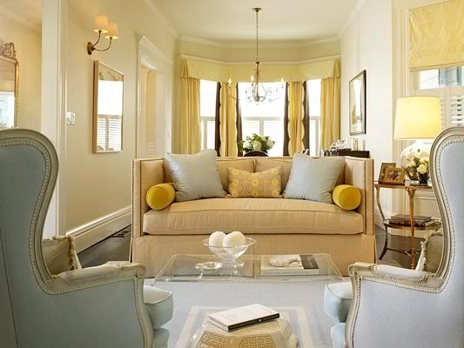

Student Name: | Salma Mohamed Safaa
Student Number: | 1170
Course: | Interior Designing
Assignment NO: | 11
Page NO: | 6

Q.3. There are two types of upholstery:
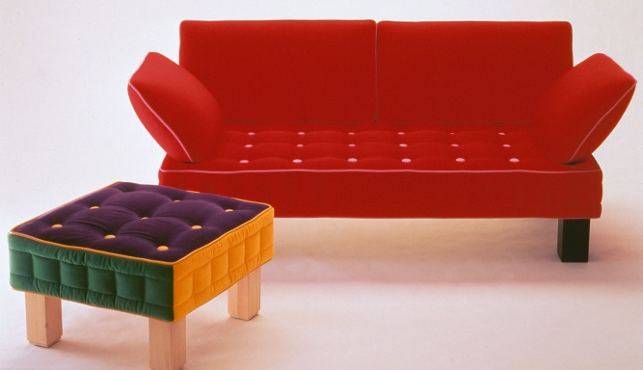
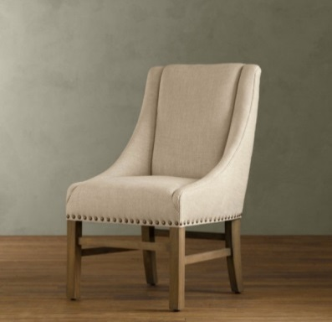
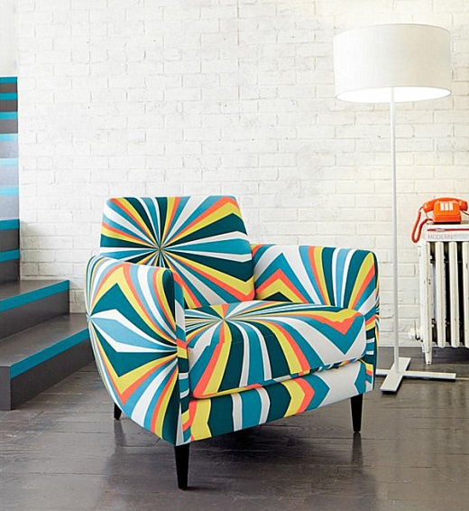
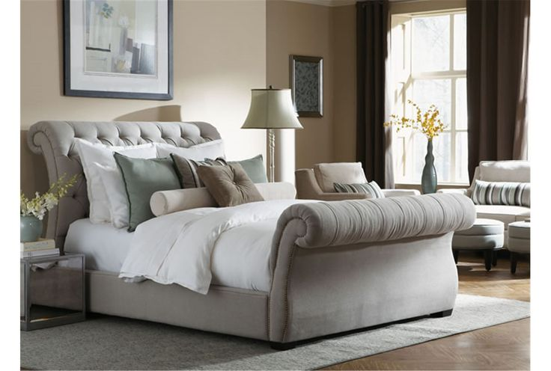
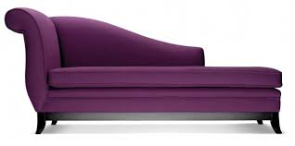
1. Fully upholstered furniture, that are completely covered with upholstery with no frame showing, except the lower part of the legs. Such products include seats, arm chairs, sofas, stools, boxes, mattresses, pouffes.

2. Exposed frame furniture, that have parts of the frame showing. Such as occasional chairs, dining chairs, chaises and stools.
