
Assignment Cover Sheet

Student Name: | Christina Kechagia
Student Number: | 1574
Course: | Diploma in Fashion Design
Assignment NO: | 4

Marking Criteria:
We expect the learners to write minimum one well expressed point in three lines against each allocated mark. This means one needs to write 15 lines with 5 well expressed points to get high grades for a 5 marks question.
For high grades use examples and illustrations where appropriate.
Please insert your completed assignment ( in word format) here:

Assessment 4
The Process and Structure of Fashion Industry
Q: 1. Give short answers for the following questions:
- What is meant by market segmentation?
Market segmentation is a marketing strategy which involves dividing a broad target market into subsets of consumers, businesses, or countries that have, or are perceived to have, common needs, interests, and priorities, and then designing and implementing strategies to target them.

“Design is a visual thinking, perhaps of a higher order than verbal thinking”. Explain
Designers surround themselves with photographs of ideas, fabric swatches, and anything else that will stimulate creativity. They leave their studios to shop, visit museums, study nature, attend the theatre, or people-watch. Designers usually carry sketchbooks, jotting down ideas whenever and wherever they find them. They hunger for information, letting ideas mingle and shape themselves into new forms. Awareness is the key to developing good design. Designers must learn most of all to keep their eyes open, to absorb visual ideas, and to translate them into clothes their customers will like. Some people are more sensitive to good composition than others, but practice and observation make a person more aware, sensitive, and confident. Design direction comes from many sources. A designer needs to study almost constantly to capture the subtle nuances of the environment.

Explain briefly the developing of a sample garment.
Sketching
Ideas originate on the drawing board. Starting with an idea for a silhouette or a neckline, the designer may experiment, sketching alternate ways to complete the design.
The First Pattern
The next step in the design procedure is the development of the first pattern, the pattern used to cut and sew the sample garment
The Sample Garment
After the pattern is made in Manila paper or tag board, it is laid out on the fabric, traced, and cut out by the assistant designer or the sample cutter to be sewn into the first sample or prototype.

What is a CAD system and how it has revolutionised the fashion industry?

Computer-aided design (CAD), also known as computer-aided design and drafting (CADD), is the use of computer technology for the process of design and design-documentation. Computer Aided Drafting describes the process of drafting with a computer. CADD software, or environments, provides the user with input-tools for the purpose of streamlining design processes; drafting, documentation, and manufacturing processes. CAD may be used to design curves and figures in two-dimensional (2D) space; or curves, surfaces, and solids in three-dimensional (3D) objects.

Project: Market research

a) Compare two dresses of similar price by two different designers, try them on. Which one has the best fit? Compare fabric choices in terms of quality and suitability to the design. Compare styling which is more innovative? Which dress is the best buy? Sketch both the garments

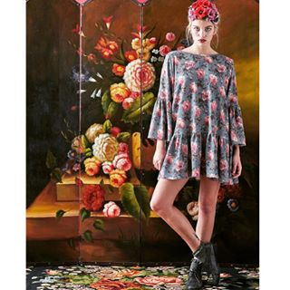

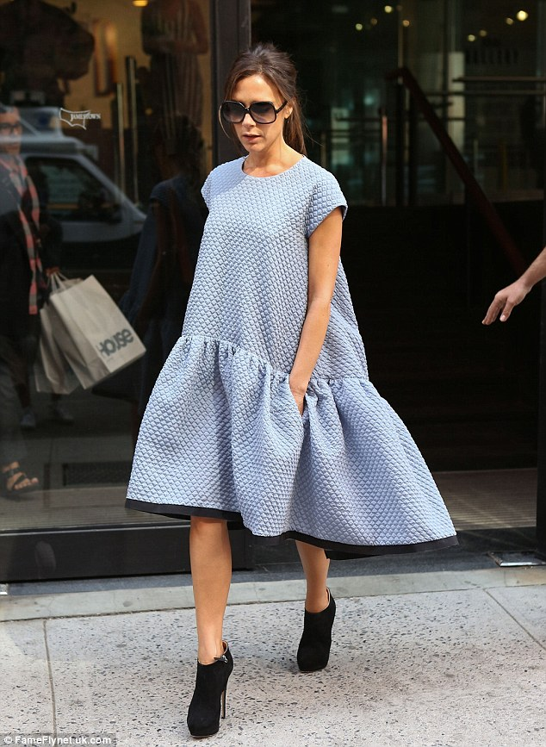
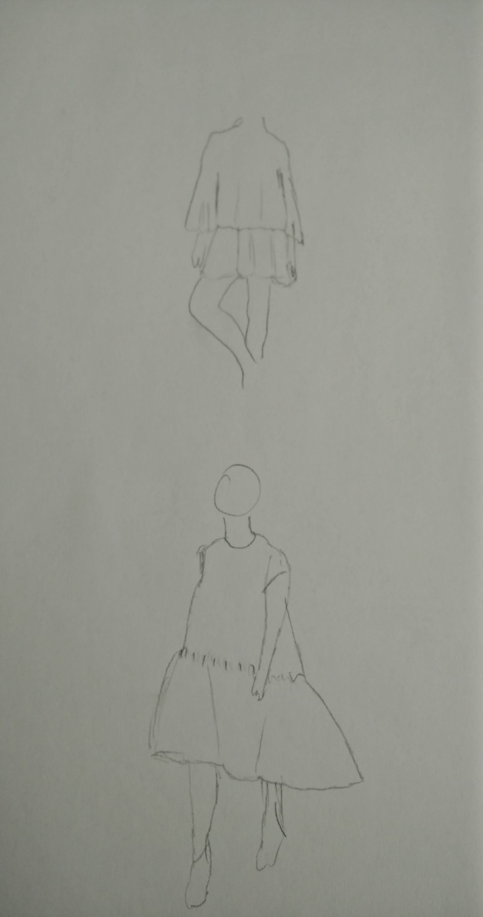

Two casual loose fit dresses. The first fabric is more light not to heavy. Its synthesis is70% polyester , 20% silk and 10%elastic. Its very soft and very comfortable. You can wear it all day long as a dress or either with a jean.
The second one is a more difficult dress you need to be very thin if you don’t want to look big. The cotton fabric makes it comfortable and cool. It has good movement and its perfect for an evening or a more casual look.
The second one is definitely more innovative design the colour is new for this season and it has definitely better quality.
The best buy I think is the first one because is more easy to fit to all bodies and it looks more comfortable but I would choose the second one because is more impressive.

b) In a local department store, compare contemporary and junior departments. List the major manufacturers in each department, and explain the general styling differences.

In a department store you can find so many different types of manufactures. Some of them are cheap and some very expensive.
After a research I made in a local department store I found thr following

Louis vuiton zara
Channel H & M
Prada River Island
Dolce cabbana Next

The more expensive clothing will have the better quality material, even when it is the same, for example cotton, there are varying levels. The thread count will be a lot higher in an expensive piece and it will feel weightier and last longer. Also when you have printed material there is also the additional cost in making sure that the print aligns in expensive. In cheap garments they don't care about this as it would produce to much wastage. Expensive clothes are more complicated than cheaper clothes. They will have extra folds and creases that are intended to fit over your body better. A good indicator of this is how it looks on the hanger. Cheap clothes often look much better on the hanger because they hang straight. Expensive clothes can often look strange on the hanger because all the little tailoring bits of the garment don't fall flat. This is because your body isn't flat and the garment is designed for the body.

Student Statement:

By submitting this assignment, I confirm that this is my own work.

Student Signature |  | Date

For Tutor / Assessor Use Only
Total Marks
Marks Obtained
Percentage / Grade

