
Assignment Cover Sheet

Student Name: | Sumbal Jamil
Student Number: | 1149
Course: | Fashion Design
Assignment NO: | 5

Student Statement:

By submitting this assignment, I confirm that this is my own work.

Student Signature | Sumbal jamil | Date | 26-11-2013

For Tutor / Assessor Use Only
Total Marks
Marks Obtained
Percentage / Grade

Q1.Short answers.
(b). Name the warm colours. How best these can be used in dress designing?
Answer. Colours that give the feeling of warmth are warm colours. Warm colours are energetic and tend to advance in space. The colour of fire and sun are warm colours.
- Red: Often associated with evil, danger, energy, vitality, speed and courage. It’s dynamic when used in a design.
- Orange: blends with the physical energy of red with the intellectual influence of yellow. It can be also a difficult color to wear.
- Yellow: a cheery color that embodies light and warmth. It is the color of the mind. A creative energy which is joyful and uplifting.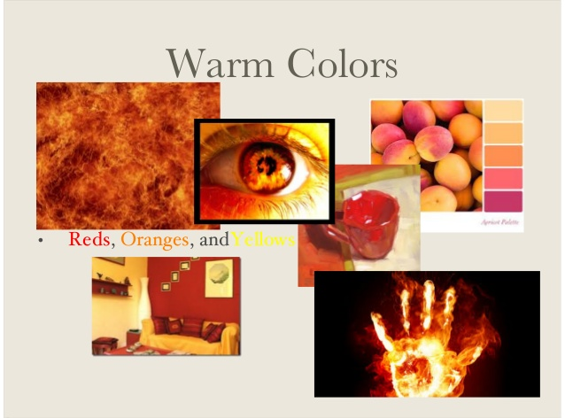

(d). what is the difference between conventional and geometric design?
- Conventional design: When an object from nature is adopted to suit the purpose of the object and becomes decorative, the motif ceases to be naturalistic.

- Geometric design: It is not derived from nature. It is derived from circles, rectangle, triangle, parallel lines and so on.

(c).Why it is important for a designer to consider the scale of a pattern, when using patterned fabric in dress designing?
Answer. It is very important to consider the scale of a pattern for a designer because the scale of a pattern must complement the design. Pattern can be a large part of how a design looks and the scale of a pattern should match the scale. a small sized body wearing large scale textures can get lost in textures because of the extreme contrast between fabric surface and figure dimension. On the other hand pettiness is emphasized by the large scale textures. Very heavy people who wear large scale texture will appear heavier because there is repetition of size. That’s why it is important for a designer to consider the scale of pattern.
- .What is meant by “hand and weight” in textile industry?
Answer. Hand: Refers to the actual feel of the wool; a good 'hand' has great resilience and softness, fineness, length, strength, and is pleasing to the touch.
Weight: A process by which the weight of a fabric is increased by impregnating it with mineral salts, starch, or other materials. This process was often used on yardage that was sold by the pound (e.g. silk)

Q2. Define the colour dimension. Explain the terms Hue, value, intensity.
Answer. Colour has three dimensions:
- Hue
- Value
- Intensity
Hue: This dimension, which is the color we see, moves around the outer edge of the color sphere. It moves from yellow, to red, to blue, to green. Hue enables us to tell one color from another.
Value: This dimension refers to the degree of lightness or darkness of the colour. It is the variation of light strength in a colour. The value scale runs from white to black. White is pure light, black the total absence of light; adding white lightens a colour and adding black darkens it. The lighter values are called tints and the darken ones are called shades.
Intensity: It is the relative brightness or paleness of a colour. Bright colours are considered high-intensity, pale one low-intensity. Generally, vivid colours should be combined with others of the same intensity for balance. However balance is also achieved when large amount of pale or dark colours are used in combination with a touch of bright colour in a trim, top stitching, or embroidery.

Q3.Write short notes on the basic shapes in dress designing.
Answer: In dress designing, there are seven basic shapes. They are as follows:
- Triangle: Spanish styles. Fitted bodies, bell shaped gently widening skirt.
- Inverted triangle: wide shoulders, narrow skirt, dolman or raglan sleeves. Good fashion design for large bust.
- Oval: draped and softly molded, very feminine and decorative. Good for well proportioned, ideal figure. Especially suitable for afternoon and evening wear.
- Square: straight or boat shaped neckline, boxy jackets, capes. Generally this style is very good for the very thin figure, however, with proportions well planned and good design, can camouflage various figure irregularities.
- Round: wide, crinoline lined skirts, petal shapes, puffed sleeves. Suitable for formal wear or afternoon frocks. This fashion design is the most attractive on the very young and very thin figure.
- Hourglass: Wide shoulders, natural or wasp waist. Smooth fit over hips and full skirt at bottom. Good fashion design for the tall, thin figure.
- Combinations: Outline of any current fashion silhouette can be altered and combined with another, and adapted for the specific figure type. This irregularities or lack of ideal figure proportions can be minimized while the general effect of current fashion design style is preserved. 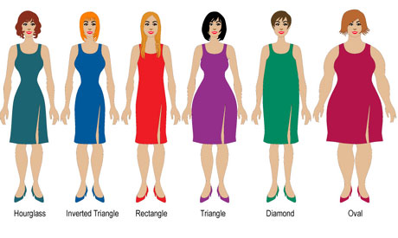

Project

From past fashion:
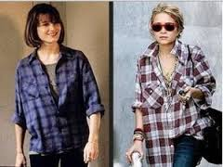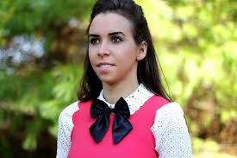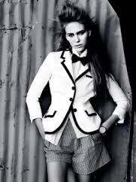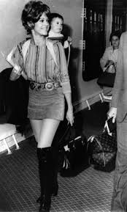

From current fashion:
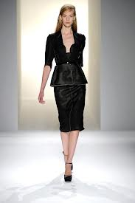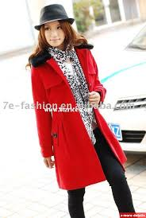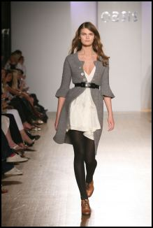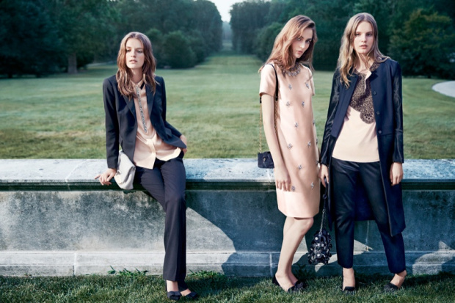

My Design

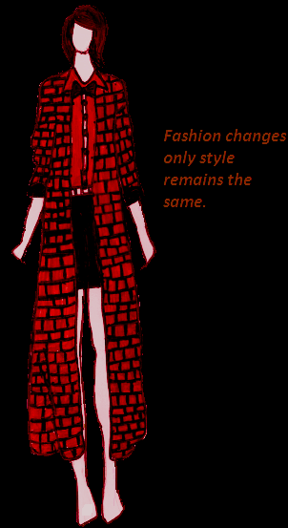

Print Bow-tie Long coat
