
Assignment Cover Sheet

Student Name: | Ray Wilson
Student Number: | 1336
Course: | Project Management
Assignment No: | 3

Assessment 3 Total Marks: 30

1. Give brief answers for the following questions: (14)

I. Where is project plan used? Which type of information does it contain?

A project plan communicates the overall objective of a given project, following the input from the other planning processes described later in the assignment, and details the specific tasks to be completed in pursuit of a clearly stated project goal.

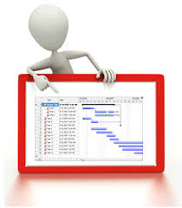Communicate the Goal;
Stating a goal for a project is like identifying the prize you seek before a long and complicated journey to find it. Once declared, it is important that all efforts should be measured on whether or not they bring the team closer to achieving the goal. Therefore, it’s extremely vital to be specific about the desired outcome. For example, a goal to increase profits leaves too much for interpretation. A team could quickly become divided as to how to accomplish this type of goal as there are many different ways. However, a goal to increase profits by reducing project materials costs by a certain percentage, say 5%, in one year or less gives everyone a clear target that is specific, can be measured and set within a reasonable time frame.

Breaking down the Plan into Manageable Tasks;
Once a project goal is set, it needs breaking down into smaller, discrete tasks. This makes a large project more manageable as work packages are bundled together to specific team members or groups who are well-suited for the scope identified. Each assignment should clearly state who will be doing what and why, climaxing in a deliverable outcome by a specific date. In this way, tasks act as mini-goals or milestones that are executed in a specific order to carry the project from inception to completion.

Schedule the required Resources;
Organizing the order of every task in a project plan gives everyone a clear road map. Labor, materials, machinery and any other resources required on a project should be scheduled with measurable milestones. Programs, such as Gantt or PERT charts are readily available to illustrate all tasks and the dependencies between them.

Budgeting and Monitoring Costs/Expenses;
Not too many projects can be executed with unlimited funds. Therefore, one important use of a project plan is to lay out tasks, schedules and resources with the budgeted cost allocated for each element. Continual monitoring is required to ensure that the plan stays within the funds provided and if not stakeholders/owners need to be aware of the situation at the earliest possible opportunity. Bringing a project to conclusion within budget represents one more goal to measure any project’s success.

Forecast Trends;
Most project managers use a Work Breakdown Structure (WBS), to summarize tasks, schedules and budgets for reporting purposes. This popular format provides project managers and team members with an arrangement to track and give the status of the tasks in a project plan. The WBS tasks are then periodically rolled up to forecast the overall well-being of the project. Standards methods like “earned value” use historical expenditures to project total costs if work continues in the same manner to the end of the program. By monitoring this closely mistakes and cost overruns can be picked up and this allows for suitable corrective action before a project slips into negative territory and helps bring the entire effort to a positive completion.

II. Briefly describe the type of information that is contained in a stakeholder analysis document?

Stakeholder analysis is a method for clearly identifying the key stakeholders for a project, understanding where participants stand, and developing cooperation between the stakeholders and the project team. The main objective is to ensure successful outcomes for the project or the changes to come.

Stakeholders are the people or organizations who can be positively or negatively affected by change or action within the organization. They can also be the ones having a positive or negative impact.
Types of stakeholders include:
- Primary: those who are directly affected, either positively or negatively, by an organization's actions.
- Secondary: those who are indirectly affected by an organization's actions.
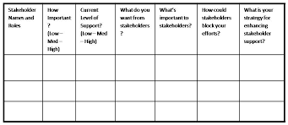
Normally this document (simplistic table shown above) is used for assessing the approaches of stakeholders towards changes or critical actions, stakeholder analysis is frequently used during the preparation phase of a project. It can be revisited on a regular basis to track changes in stakeholder attitudes over time if required. The stakeholder analysis is considered a “highly confidential” document containing very sensitive information and is normally only accessible to those involved and named.

III. Outline the main objectives of integrated change control process.

1. Objectives
The objectives of this Change Control Procedure are outlined as follows:
- To manage each request for change, in order to keep the scope of the project under control with full traceability,
- To allow the impact of all changes to be understood, documented and managed,
- To make sure each request for change is assessed by key project stakeholders,
- To make sure each assessed change request is accepted, rejected, or deferred by the appropriate authority,
- To enable the orderly implementation of each accepted change.

2. Summary of the Change Control Procedure
A change request is a request to change some side of the project that might impact one or more areas of project management that have been placed under change control.
These change requests can effect a variety of phases in the project such as;
The work that needs to be done or that is already in progress which therefore may effect scope, solution definition, deliverable definition, etc. as well as the project schedule, cost, risk or complexity level and even the quality of the project deliverables,
The Change Control Procedure is launched when a need for a change arises. The end result of the procedure is either “the change is implemented”, “the change is deferred”, or “the change is rejected”.

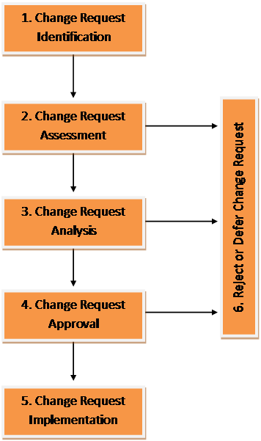

IV. What are the major tools and techniques that help managing integrated change control process?

  - Change control system: This is a collection of formal, documented procedures defining how performance will be monitored and evaluated and which identifies the steps by which official project documents may be changed.

  - Configuration management: Usually, a subset of the change control system, which also formalizes a documented or automated procedure to apply technical and administrative directions to:

  - Identify and document functional and physical characteristics of an item or system.
  - Control any changes to these characteristics.
  - Record and report change and its implementation status.
  - Track versions of different items and system.
  - Audit items and systems to verify conformance to requirements.

Performance measurement: Enable to assess whether variances from baseline require corrective actions.


Additional planning: Projects seldom run as smooth or as planned therefore changes may require revising some or all of the following;

- Cost estimates, modified activity sequences, schedules, resource requirements, contingency plans for risks, ...

  - Project management information system (PMIS): Consist of tools and techniques used to;

- Gather, integrate and disseminate outputs of the project management process.

V. Briefly describe the outputs of integrated change control process.

Project plan updates: If any modification to the contents of project plan or the supporting details be required then the related stakeholders should be notified.

Corrective actions: Any action done that brings project performance in line with the baseline plan

Lessons learned: Causes of variances from baseline, reasoning behind corrective actions, and other types of lessons learned should be documented. These will then become part of historical information for future recomendations.

VI. What is ‘work break down’ structure (WBS)?

A work breakdown structure (WBS) is a chart in which the critical work features, called tasks, of a project are illustrated to represent their relationships to each other and to the project as a whole as per illustration below;

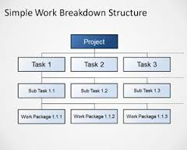
The graphical nature of the WBS can help a project manager forecast outcomes based on various scenarios, which will enable him to optimize decisions that are made with regards to suggested procedures or changes.
When creating a WBS, the project manager defines the key objectives first and then identifies the tasks required to reach those goals. The principal requirement or objective is shown at the top, with increasingly specific details shown as the observer reads down.
When completed, a well-structured WBS resembles a flowchart in which all elements are logically connected, redundancy is avoided and no critical features are left out. Elements can be rendered as plain text or as text within boxes. The fundamentals at the bottom of the diagram represent tasks small enough to be easily understood and carried out. Interactions are shown as lines connecting the elements. A change in one of the critical elements may affect one or more of the others. If necessary, these lines can include arrowheads to indicate time progression or cause-and-effect.
A well-organized, detailed WBS can assist key project personnel in the effective allocation of resources, project budgeting, procurement management, scheduling, QA/QC, risk management, milestone delivery dates and service oriented management.
VII. What are the outputs of project plan development?

The project management plan process identifies all the activities that direct the actions of many other procedures in the planning process group. Developing the project management plan includes the creating of the subsidiary plans and incorporating them into the complete project plan. The main purpose of the project plan is to define how the project is to progress from its commencement to completion.
In brief, the project management plan provides the complex strategy for how the project moves through its life cycle. There are many potential secondary plans that make up the overall project management plan. These supplementary plans provide the specific details for managing each aspect of the project from initiation through closure. The subsidiary project management plans will include some or all of the following;
- Cost management plan
- Process improvement plan
- Communication management plan
- Project scope management plan
- Procurement management plan
- Quality management plan
- Risk management plan
- Schedule management plan
- Staffing management plan
One of the common mistakes that some new project managers make is to confuse a project plan with a project schedule. The problem lies with the output from many common project management software packages as these occasionally do not qualify as a project plan. They form are a good foundation, but a true project plan is made up of much more information than just scheduling information. The overall process requires a concentrated effort to create a plan that incorporates all known information about a project. The table below illustrates the inputs, tools, techniques, and outputs for the develop project management plan process.

Inputs | Tools and Techniques | Outputs
Preliminary project scope statement | Project management methodology | Project management plan
Project management processes | Project management information system
Enterprise environmental factors | Expert judgment
Organizational process assets

2. “Project integration management means tying together all of the other aspects involved in a project to make it a success.” Discuss (5)

Project integration management is primarily concerned with integrating processes to accomplish project objectives. The six process are:
- Develop the Project Charter – By developing the Project charter this initiates the project. The resulting project charter approves the project and gives the project manager the authority to act and apply organizational resources to the project.
- Develop the Project Management Plan – Once developed, the Project Management Plan includes all undertakings needed to create and integrate all subsidiary plans into the Project Management Plan. This plan will be how the project is achieved, managed, and monitored.
- Direct and Manage Project Execution - Directing and Managing Project execution is coordinating how the project team accomplishes the actions to implement the Project Management Plan and complete the work detailed in the Project Scope Statement.
- Monitor and Control Project Work – Monitoring and Controlling Project work measures and balances the projects progress and will identify any corrective or preventative actions needed to assure all project objectives are met.
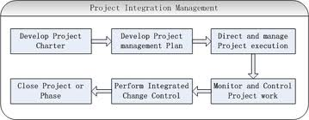
- Integrated Change Control – Integrated Change Control is the change control process for the project which includes evaluating all change requests, authorizing changes, and managing changes to project plans and deliverables. The key benefit to this process is that only validated approved changes are reviewed and implemented.
- Close Project – Closing the project equates to completing all project activities, delivering the final project, and turning over deliverables, providing continual support to operations, and obtaining the client approval to formally close the project.

3. Describe the processes involved in project integration management. (5)

All project management processes are divided into the following five project process groups:
- Initiating - The Initiating Process Group includes those processes necessary for formally authorizing the beginning of a new project. The processes for developing the Project Charter and developing the preliminary Project Scope Statement occur in the Initiating Process Group.
- Planning Process Group - The Planning Process Group includes those processes that establish the project scope, create the Project Management Plan, and identify and schedule the project activities. The process for developing the Project Management Plan is carried out by the Planning Process Group.
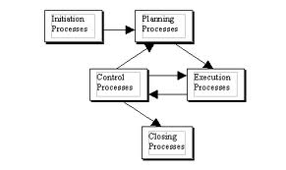
- Executing Process Group – The Executing Process Group consists of those processes necessary for completing the work outlined in the Project Management Plan to achieve the project's objectives. The process for directing and managing project execution, which ensures that the Project Management Plan is implemented properly, occurs in the Executing Process Group.
- Monitoring and Controlling Process Group - The Monitoring and Controlling Process Group is necessary for collecting, measuring, and distributing performance information and analyzing measurements and trends to make continual process improvements. The processes for monitoring and controlling project work and implementing integrated change control occur in the Monitoring and Controlling Process Group.
- Closing Process Group – The Closing Process group consists of those processes necessary for officially ending project activities and handing off the completed product to others. This also includes closing a project that has been canceled.
The project process groups often overlap, interact, and directly affect each other as they all play out the bigger picture project plan. These interactions create project management harmonisation.

Activity (6)

Identify a project that you would like to carry out in your particular field. It could be either a consultation project or a change project.

I would like to continue working on projects similar to the LNG site illustrated below.

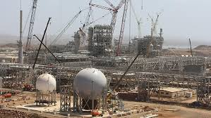

Factors to consider in selecting an appropriate project:

- What problems and opportunities are you facing at work?

Building any multi-billion dollar project requires a well-synchronized plan, aligned project sponsors, and correct financial backing.

A number of key elements will potentially cause problems when considering a new LNG project such as;

• Having the right location
• Having the right partners
• Having the right financial plan
• Determining the right equipment
• Delivering the right equipment to the site at the right time
• Having the right people to put it all together

In addition, variations in capital cost are strongly affected by Plant location, Cost of labor, Feed gas composition and Product specification.

A new LNG construction site provides the opportunity and potential to reshape the locations economy as well as transforming its labor force, leaving a legacy for skills development, and providing high paying employment opportunities for generations to come. It also has the potential to provide the owner with a long term positive return on their investment.

- What processes in your work area are creating barriers or impeding the quality of the services or products you and your department provide to others?

Historically some aspects of project planning is a troublesome area whilst constructing an LNG facility.

Like all projects building and LNG facility needs to have an accurate budget and deadline and poor estimation of the work scope and resources required can lead to obstacles that are difficult to navigate. If the project team starts off with inadequate resources and time it is almost impossible to recover when the project is already in progress and this leads to cost overruns and unhappy clients which is a regular occurrence with LNG new builds.
Another barrier is the ability to attract a skilled labor pool that is essential to a successful LNG construction phase. The labor market, both domestically and internationally, is highly competitive. LNG, as an industry, has various major projects worldwide ongoing that are seeking to attract skilled and trained labor and added to the often remote locations this task is not as easy to achieve despite the rewards on offer to employees. This gives HR an unenviable task, but certainly one that needs utmost effort to succeed.

The importance of gaining necessary support for the project from the local communities and other stakeholders should also not be underestimated. Often these large projects have an adverse effect on the location infrastructure and also cause suspicion and resentment among the local community when facing the prospect of thousands of fly in, fly out construction workers. Therefore a major public relations effort is needed and if not carried out correctly this can lead to serious delays to the project.

- What characteristics of your work are you particularly interested in?

My particular interests are around the following phases:

Quality - Once the scope and contents are defined it is important that the quality of the deliverables is established. It is always important to remember the associated cost of delivering quality and contractors will always commit to this but will inevitably make every effort to cut corners and therefore cost.
It is also important to decide who has the final say over the quality of the outputs and also ensure there are no arguments over the quality (i.e. no qualitative judgment’s, only quantitative) as well as making sure time and people to do the evaluation work are catered for in the overall schedule.

Resources – As highlighted in the previous answer securing the required labor pool is a vital ingredient to ensuring a successful project however the correct equipment is also needed to compliment the workforce. Therefore resources include staff time, workforce with particular knowledge or skill sets, money (e.g. buying equipment), and time (some tasks can't be increased by throwing more people at the problem, e.g. delivery times, setting time for concrete, etc.) are of particular interest and need a lot of focus and time.

Milestones – Past experience has taught me that it is folly to have the entire project as one lump of work, with the only check on progress at the very end. Instead, it makes sense to break the project up into discrete chunks, where related tasks can be lumped together, with a sensible milestone at the end of them.
It makes sense to have a defined milestone, so you know when each section is completed. This way so can also incentivize the contractors at various stages to ensure the milestones are met. Available fuel gas, first power from GTG’s, PR compressor operation, cool down of the plant are prime examples

Scheduling – Clearly you need to put down what you expect to happen when. It will include your dependencies, milestones, and probably resources. I clearly believe that you cannot make a perfect schedule and this is a reality in LNG construction.
As mentioned in the milestone interest section, the advantages of breaking the project into manageable portions will mean the ability to start planning the first section in quite some detail, extending out for a few weeks. As you come to the end of each chunk of the project, you will be able to plan the next one. You can use the information and experience you have just gained from the previous section, and thus you will be able to be more confident.
Although the owner will want certainty, and absolute dates for the project, from the very beginning it is important not to give an answer (no doubt of a date plucked, essentially, from the air) that will come back to haunt you and you need to be realistic about what is and isn't possible in terms of scheduling. Anything else can only lead to trouble for you, the project, and ultimately your executive further down the line. Explaining up front this stance will be in everyone’s interest.

Student Statement:

By submitting this assignment, I confirm that this is my own work.

Student Signature | Raymond Wilson | Date | 17th Nov 2014

For Tutor / Assessor Use Only
Total Marks
Marks Obtained
Percentage / Grade

