
Assignment Cover Sheet

Student Name: | Kyle Pentland
Student Number: | 1605
Course: | Diploma in Environmental Management – Level 4
Assignment NO: | Assignment 8

Marking Criteria:
We expect the learners to write minimum one well expressed point in three lines against each allocated mark. This means one needs to write 15 lines with 5 well expressed points to get high grades for a 5 marks question.
For high grades use examples and illustrations where appropriate.

Page 1
Q1:
The benefits of an E.M.S. to organisations are:
- Serves as a systematic way to manage and improve a company’s environmental performance.
- Helps to achieve real cost savings by more direct efficiencies in energy, water, waste, purchasing and transport thereby improving environmental performance.
- Is part of a company’s overall Management structure that addresses short-term and long-term impacts of all its services and processes environmentally.
- It demonstrates to clients and public at large your commitment and genuine attempts at a smarter, more sustainable future.
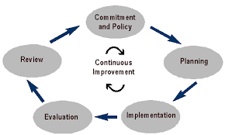

Some key elements of an E.M.S. are:
Policy Statement: Develop a statement of the company’s commitment and understanding of its environmental duties. Use this policy as a framework for planning and action.
Environmental Aspects: Identify environmental attributes of your products, activities and services. Determine those that could have a significant impact on the Environment. Address them and alter them accordingly.

Page 2
Objectives and Targets: Establish environmental goals for your company. When everyone in your company understands both the company objectives and specific team goals, it makes it very easy for them to make decisions, initiate tasks, and work with little supervision.
Implementation: In order to have objectives, you must first implement how these are to be achieved. Implementation shows the employees the company commitments and how they should be followed through.
Training, Awareness and Competence: Ensure that your employees are trained and capable of carrying out their environmental responsibilities.
Management Review: Periodically review your E.M.S. for efficiency and improvement.
Q2:
P.D.C.A. stands for Plan, Do, Check, Act.
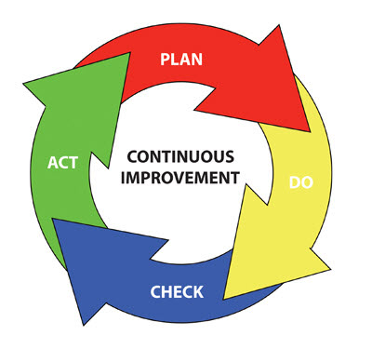
Planning: An organisation first identifies environmental aspects of its operations. Environmental aspects are those items, such as air pollutants or hazardous waste, that can negatively affect people and/or the environment. An organisation then determines which aspects are significant by choosing certain criteria.
Page 3
Once significant environmental aspects are realised, an organisation sets objectives and targets. Ultimately, a devised action plan is needed for meeting the targets. This includes establishing a schedule and outlining clearly defined steps to meet the targets.
Do: An organisation follows through with the plan using the necessary resources (human, financial, environmental etc.). A critical component is employee training and awareness for all staff. Other steps in the implementation stage include documentation, following operating procedures, and setting up internal and external communication lines.
Check: There are many parts needed to scrutinise the stages of the E.M.S. to ensure that it is working to plan. The company needs to carefully watch not only the product to ensure it meets its goals, but also the processes used to ensure they are efficient and environmentally complicit. Analysis of the data and an Internal Audit of the processes are the critical ways to assess the system’s effectiveness. Then, Management Reviewers will appraise all of the monitored data to see what changes (if any) need to be implemented for future enhanced productivity.
Act: Action involves the protocols needed to address any issues found in the check step. Corrective actions remove the causes of previous issues to improve the system. The outcome of the review is also an action to provide the resourcing needed for the updated planning part of the cycle and continued improvement.
An Environmental P.D.C.A. in action would be Santa Clara Water District.
Plan: In 2007, the company undertook analysis of activities, products and services to assess its environmental impact.
Independent assessments were performed including treatment plants, dams and reservoirs.
Results were combined into a comprehensive Environmental Aspect Registry.
Aspects were then ranked based on: Environmental Liability, Frequency, Severity.

Page 4
Do: Based upon Plan, three significant environmental aspects were indentified, including Climate Change and reduction of Greenhouse Gas Emissions.
A Management Program for each aspect was developed including Environmental objectives and Action Plans.
Check: Progress of action plan implementation continually assessed through audits.
Corrective and preventive actions are implemented as necessary through Corrective and Preventive Action Request System.
Act: Status of action plan implementation and progress towards achieving targets and objectives are reported to executive management, which can be re-evaluated.
Q3:
Environmental auditing is a management tool for gauging the effects of certain activities on the environment against set criteria or standards. Organisations of all kinds now recognise the importance of environmental matters and accept that their environmental performance will be scrutinised by a wide range of interested parties.
Environmental audits help improve existing human activities, with the aim of reducing the adverse effects of these activities on the environment. An auditor will study an organisation’s environmental effects in a systematic way and will produce an environmental audit report.
The purpose of an audit is to analyse, test and confirm practices and to verify whether an organisation complies with legal requirements, internal policies and accepted practices. The key objectives of an audit are:
- Waste prevention and reduction
- To evaluate compliance to regulations or other set criteria
- Placing environmental information on the public domain
Audits are carried out in a planned and methodical manner and are conducted to an established schedule. They are objective and information gained from the audit is reported free of opinions. Notes are taken during the audit and the findings recorded.
Page 5
Audits can be integrated into the management system (such as a quality management or environmental management system).
The International Organisation for Standardisation (ISO) has produced a series of standards for environmental auditing. These standards are intended to guide organisations and auditors on the general principle common to the execution of environmental audits.
Within environmental valuation there are a number of methods used to quantify and qualify the environment. They are:
Market-Based: Economically, the environment is valuable and should not be cost free. When customers buy products, the price they pay includes money for the environmental consideration, such as environmental harm and any recycling process. There are three market-based techniques towards environmental valuation:
- Factor of production approach
- Change in producer and/or consumer surplus
- Examination of defensive expenditures
Surrogate Markets: Without clearly defined markets, surrogate markets can be used for environmental resource valuation. Two common markets are:
Hedonic Price method: The price of a property is in direct relation to the benefits to be derived from it. The price which individuals pay, reflects both from environmental and non-environmental characteristics. These would be hedonic prices. This approach identifies how much of a property value is worth due to, for example, water air and noise pollution in that area compared to another.

Page 6
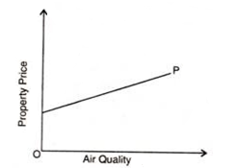
Graph indicating property price rise with improvement in air quality
Travel cost method: What demand is there for a recreational site (i.e. number of visits per year to a park). The variable factors would be price and socio-economic characteristics. The price is usually the sum of entry fees to the site and cost of travel. The consumers’ surplus associated with the demand curve provides an estimate of the value of the park/beach in question.
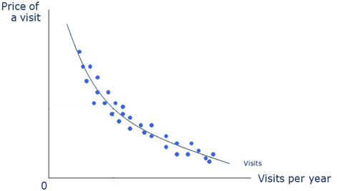
Diagram showing the trend between travel costs and visit rates at a Florida Park.
Non-Market-Based: An example of this would be a contingent valuation. Relying on hypothetical situations to form survey analysis which puts a monetary vale on goods and services. This method asks direct questions to individuals to ascertain how much they might be willing to pay for environmental resources or how much compensation they would be willing to accept if they were deprived of that resource.

Student Statement:

By submitting this assignment, I confirm that this is my own work.

Student Signature | Kyle Pentland | Date | 08/03/16

For Tutor / Assessor Use Only
Total Marks
Marks Obtained
Percentage / Grade

