
Assignment Cover Sheet

Student Name: | Kyle Pentland
Student Number: | 1605
Course: | Diploma in Environmental Management
Assignment NO: | 4

Marking Criteria:
We expect the learners to write minimum one well expressed point in three lines against each allocated mark. This means one needs to write 15 lines with 5 well expressed points to get high grades for a 5 marks question.
For high grades use examples and illustrations where appropriate.

Page 1
Q1:
Amongst earliest man is The Hunter gatherer. They would have possessed a detailed knowledge of their environment. They would have had a large territory in which to forage because of limited food supply and in harsher environmental conditions that provided fewer food resources. They would use fire to drive animals out and promoting growth for new shoots. Foragers usually lived in small groups of 15 to 30 and split up further when food became scarce or when conflicts arose. Family sizes were limited as mothers would only be able to carry one child on migration. An example of hunter gatherers who even exist today would be The Bush Men of Southern Africa. They move every day during the rainy season in search of budding edible greens. They have repeated seasonal movements based on animal migrations or the ripening of different plant food sources.

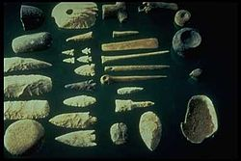

Hunter Gatherer Tools

Taking root 10-12000 years ago, primitive agricultural societies triggered a change in society. Traditional Hunter Gatherer lifestyles were swept aside in favour of semi-permanent settlements and a reliable food supply. Man now did not need to follow the food. He could manipulate and produce it to his own agenda. They used primitive and basic forms of agriculture through artificial flooding and the burning of wood to increase mineral fertilisation. This gave them a degree of permanence provided the land they were farming could be used in a sustainable manner. They tended to have larger numbers due to increased food and were not constantly on the move.

Page 2

For example, in what is now known as Iran, it is thought that climatic changes around 11,500 years ago brought seasonal conditions that favoured annual plants such as wild cereals and barley to be cultivated.

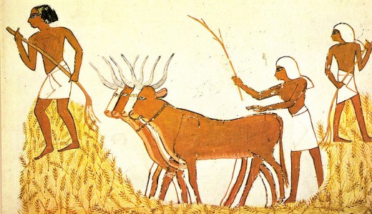

Egypt, 12000BC

By 8000 BC, some groups of foragers had settled down and occupied favourable sites year-round instead of semi-permanent habitations. Their populations increased, as restraints on fertility imposed by the seasonally mobile way of life were relaxed, and they ranged less far for their food. This profound change in human behaviour led to the beginnings of agro-horticultural societies, enabling more people to be supported on a given area of land, although at the cost of the greater effort needed to cultivate crops and raise domestic animals. The effects of settling down, population increase, and growing dependence on agriculture led to increases in the number and size of settlements, to the development of more complex, less egalitarian (equal) societies, and, eventually, to urban life and civilization.

Page 3

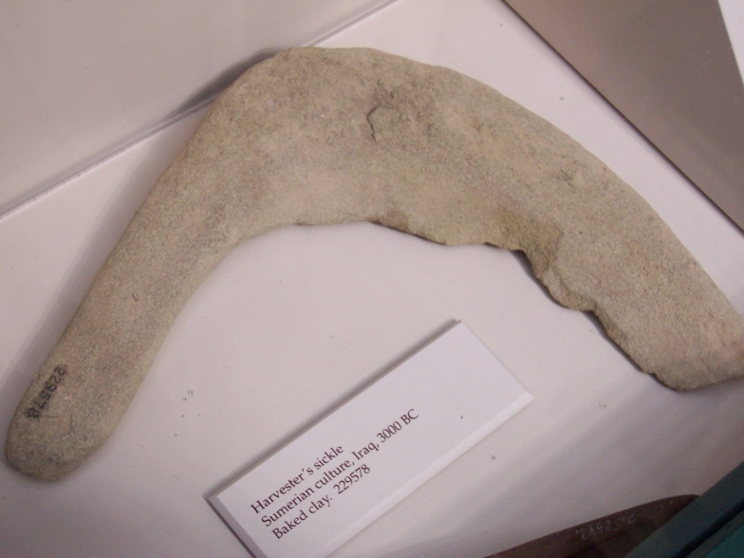
Harvester’s sickle, Samaria, 3000BC

From hunter gatherer, to horticultural societies, to land use on an industrial scale: This was the beginning of agrarian societies. Crops for bargaining and influence as much as sustenance begin the order of things. Agriculture allows a much greater density of population than can be supported by hunting and gathering and allows for the accumulation of excess product to keep for winter use or to sell for profit. The ability of farmers to feed large numbers of people whose activities have nothing to do with the sowing or harvesting was the crucial factor in the rise of surplus, advanced technology, hierarchical social structures, inequality, and even standing armies. Until recent decades, the transition to farming was seen as an inherently progressive one, people learnt that planting seeds caused crops to grow, and this new improved food source led to larger populations, sedentary farm and town life, more leisure time and so to specialization, writing, technological advances and civilization. It is now clear that agriculture was adopted despite certain disadvantages of that lifestyle. Archeological studies show that health deteriorated in populations that adopted cereal agriculture, returning to pre-agricultural levels only in modern times. An example of agrarian society is not needed as it is everywhere we look today.

Page 4

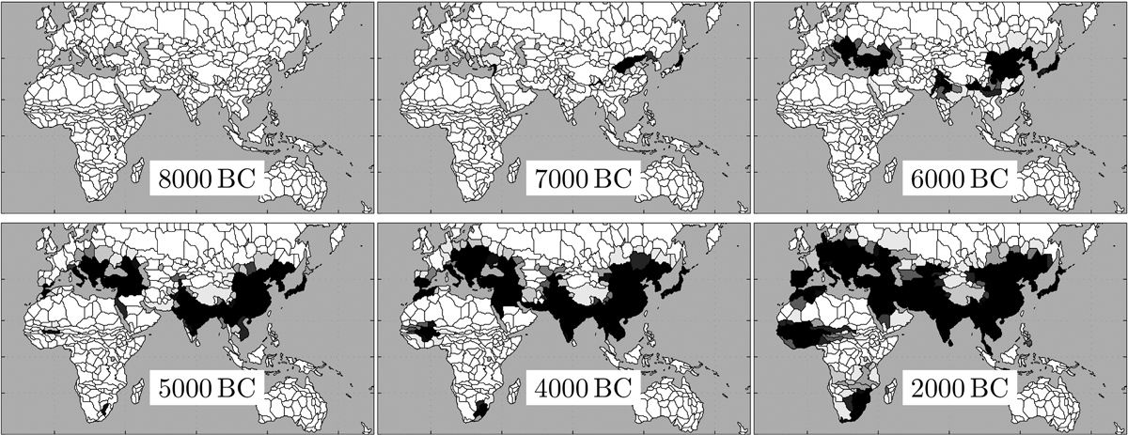
Agricultural land use progression

Page 5

Q2:

Fertilizers: Nutrients are lost from agricultural fields through drainage, runoff, or soil erosion. The amounts lost depend on the soil type and organic matter content, the climate, land gradient, and groundwater depth, as well as on the volume and type of fertilizer and irrigation used. One major nutrient of fertilizer is nitrogen, which is highly soluble in its nitrate form. Leaching of nitrate from agricultural fields can elevate concentrations in underlying groundwater to levels unacceptable for drinking water quality. Excess nitrate in groundwater from surface nitrogen use has been linked to thyroid illnesses, some cancers and reproductive problems in California since the 1970’s. It’s estimated that only about half of all fertilizers are actually absorbed by plants; the remaining chemicals pollute the atmosphere, soils and waterways.

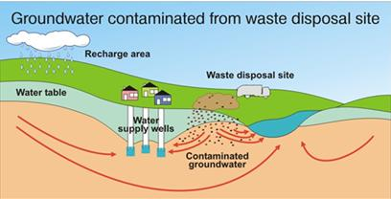

Contaminated groundwater from waste disposal

Pesticides: The trend toward intensive crop production in modern farming has led to increased potential for damage by pests and diseases. Predators that would be present in a biodiverse community are not supported by large fields of a single crop. Farmers instead, rely on chemical measures for crop protection. Use of pesticides on U.S. farms has risen 10 times over the past 40 years as agriculture has become more intensive. Pesticides generally kill not only the pest of concern, but also a wide range of other organisms, including bees/insects and other pest predators. Once the effect of the pesticide wears off, the pest species is likely to recover more rapidly than its predators because of differences in the available food supply.
Page 6

Similarly weed species have gained resistance to herbicides. Rendering large tracts of land useless. Farmers in the USA lost 7% of their crops to pests in the 1940s; over the 1980s and 1990s, the loss was 13%

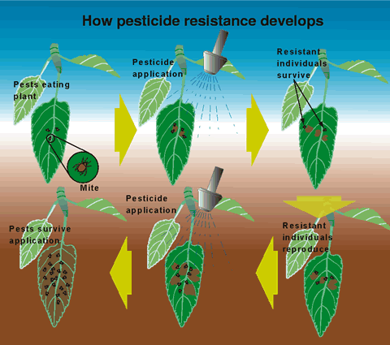

With the use of fertilizers and pesticides in crops, they obviously continue up the food chain because they’re not biodegradable, with up to 98% of some fruits carrying traces of the chemicals. In terms of processed food, residues were found in almost 97 per cent of flour and 73.6 per cent of bread that end up on our supermarket shelf. Advocates say the chemicals protect crops and boost yields. Farmers also use them to prevent blemishes and to ensure fruit and vegetables meet the ‘beauty’ standards demanded by supermarkets. There is evidence linking pesticides to developmental damage to mammals in the womb, as well as cancers and birth defects.

Page 7

Irrigation where water cannot penetrate deeply enough can cause water-logging. For example, there may be an impermeable, non porous layer beneath the soil, like clay. This also occurs on soils, Topographically:- Irrigated water/canal seepage raises the water table in the ground, from beneath. To the naked eye the damage cannot be seen till it’s too late. When soils are water logged, air spaces in the soil are filled with water, and plant roots essentially suffocate. Salinisation of the soil profile is not prevented because upward movement of water and salts from the watertable reaches the root zone. This inhibits water uptake by plants, affects nutrient uptake and may result in toxicity. Irrigated water in warmer climates further adds to higher salt deposits, due evaporation Worldwide, as much as 10% of all irrigated land may suffer from water logging and salinisation.

Page 8
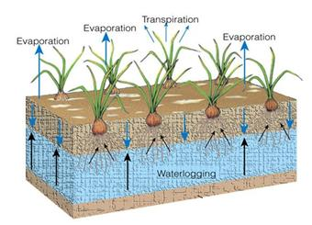

As the world’s population grows, the need for more crops increases. High-yield agricultural crops are those that have been bred, genetically modified, or fertilized to increase these production yields. Agricultural scientists developed new, higher-yielding varieties of numerous crops, particularly the seed grains. Tremendous increases in the global food supply resulted from the use of these higher-yielding crops, along with improved farming technology and methods. Wheat is the staple of 43 countries and 35% of the people of the world. It also provides 20% of the total food calories for the world’s population.

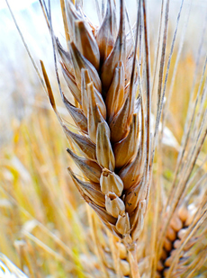

Wheat

Student Statement:

By submitting this assignment, I confirm that this is my own work.

Student Signature | Kyle Pentland | Date | 30/01/2016

For Tutor / Assessor Use Only
Total Marks
Marks Obtained
Percentage / Grade

