
Assignment Cover Sheet

Student Name: | Ray Wilson
Student Number: | 1250
Course: | Construction Management
Assignment No: | 11

Student Statement:

By submitting this assignment, I confirm that this is my own work.

Student Signature | Raymond Wilson | Date | 22nd Sept 2014

For Tutor / Assessor Use Only
Total Marks
Marks Obtained
Percentage / Grade

Assessment 11 Total Marks: 30

1. Give short answers for the following questions: (20)

I. What are the economic objectives of quality control how are they achieved?
Construction projects generally are built with a long life expectancy so it is vitally important that the building or infrastructure being designed, engineered and constructed is built to a quality standard and at a realistically low price.
A good quality control programme must ensure that a right blend of low cost and quality are found which is difficult as by default quality is deemed to indicate cost. This blend can be achieved however if the following kinds of quality control steps are considered and the risks reviewed and controls implemented wherever necessary;
Failures – These are the results of defective materials or products which do not meet the project quality standards. The failures or losses which include such features as re-work of components, field complaints due to non-conformance as per specification or ultimately the scraping of the product clearly come with a potential of huge cost implications.
Appraisal – this can be an expensive element as it consists of maintaining quality levels by means of formal evaluation of product quality which includes essentials such as inspection, testing, outside certification with supported by quality audits.
Prevention – by preventing the defects in the first place there will be a significant cost reduction overall but there are costs still to be borne as employee quality control training, engineering and maintenance of products and plants needs investment.
A contractor’s main objective is to save money by eliminating rejects or substantially reducing his exposure to them, saving cost through embracing design standards rather than surpassing them, and savings to the owner/user through the creation of a better product at no added cost.
These savings can be realized when a contractors meet these challenges with better trained quality minded supervisors, adherence to tried and tested specifications and when there is a realization that effective quality control will improve profit.

II. What are the features of field quality control?
Field quality control is a process by which organizations review the quality of all the factors involved in construction and analyze the expected outcomes. This approach places an emphasis on three aspects:
- Elements such as controls, job management, defined and well managed processes, performance and integrity criteria, and identification of records
- Competence, such as knowledge, skills, experience, and qualifications
- Soft elements, such as personnel, integrity, confidence, motivation, team spirit, the organizational culture, and quality relationships.
Controls include activity inspection, where every product is examined visually either 100% or at a pre specified %, and sometimes perhaps NDT were Inspectors will be provided with lists and descriptions of unacceptable defects such as cracks or surface indications for example and will themselves or with the use of specialists carried tests to determine if products from the construction meet the acceptance criteria required.
All the inspection controls need to be defined, managed and emphasis on well-kept records is a must but the quality manger must manage and balance the cost of expensive equipment and manpower which is subject to many fluctuations due to access, priorities and other construction interfaces.
The competence of Inspectors and technicians cannot be under estimated and it important to ensure those involved with quality are suitable experienced and qualified.
Of equal importance with field quality activities is moral, team spirit, self-motivation, relationships with other stakeholders and most of all integrity as these characteristics will enable all those involved to take pride in their work and produce quality products, enhance experience and give the owner satisfaction in knowing he is getting his desired result.
III. How can contractor quality control be implemented effectively?
During construction activities onsite it should be assured that the work carried out is in accordance with the specified requirements of the contract. To enable this to happen a good quality control program is an essential and must be implemented.
The quality control programs aim is to check whether the contractor complies with the specifications and standards, which the engineer establishes as his criteria for the construction. This field quality control program will also include inspection, testing requirements and detail which documents and check lists will be used for the control of the quality of the materials used, workmanship of the craftsman, and the other miscellaneous methods engaged by the contractor.
The quality control program on any construction project may be administered by the engineer, owner, consultants, prime contractor, construction manager or any permutation of these. In fact on larger projects it is common for sub-contractors, contractor and owner/engineers to have their own Inspection team who carry out inspections, surveillance and audits at varying level dependent on levels of importance and liabilities defined in the Inspection and test plan (ITP) OR quality control plan (QCP).
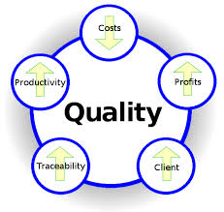
It is important to ensure that the sub-contractor or contractor quality control inspector does not give directions, render interpretations, or change the contract requirements as his role is not to manage the job, direct the work, or to relieve the contractor from any of his obligations. By promoting and leading by example the quality the inspector will effectively ensure quality is achieved in the field.
The quality inspector or engineer cannot tell the contractor what to do or how to do a job, he must act impartial, and nor can he interfere in field operations except to prevent something from being done improperly and he must do this through the correct channels, unless of course it is safety related when “everyone” is empowered to act.
IV. Why are specifications important?
Specifications benefit the owner, the designer, and the construction contractor. They are necessary to explain to and direct the contractor in the pursuit of the quality of workmanship which will be required of the contractor as he builds a construction project.
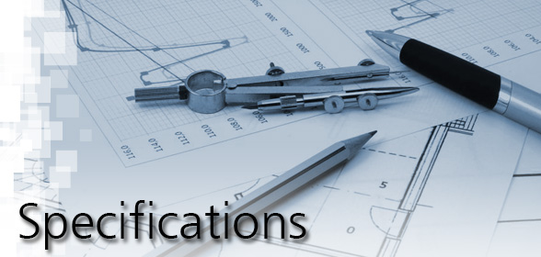The specifications for a construction project are sometimes called the project manual and they consist of everything a contractor would need to know to complete the job. Most specifications are similar on every job, but contain certain changes tailored to the owner's, architects and engineers liking. They specify certain criteria for the materials and sometimes methods used in the construction of the project, such as certain brands and models for items to be used. If an architect wanted a certain color or size of brick for instance, it will be called out in the specs.
Technical specifications therefore perform the following functions within a project;
- Before hiring a contractor, the specification allows the project team to sign-off on the design, with all members having a clear understanding of what the system can and cannot do, its anticipated cost, and its expected impact on other aspects of the facility design
- During bidding it ensures that received bids: will be based on all the requirements of the system (including administrative issues, scheduling, equipment quality, workmanship, site conditions, standards, training, and documentation), will be accurate and competitive, will be within the budget range, will be within a reasonable range of each other, and can be easily and fairly compared.
- Once the contractor has been selected, the technical specifications form part of the legal contract between the contractor and the owner, and must not be subject to interpretation without clarification and written authorization.
- During installation, the specification clearly defines the contractor’s scope of work (including administrative procedures, workmanship, standards, training, and documentation); this benefits the owner by eliminating arguments about what was supposed to happen, and it protects the contractor from unreasonable design changes and scope increase.
- The conventional specification generally controls quality by setting a series of absolute max- min limits on the physical properties for the materials, processes and performance of the item. Unless 100% is specified, this allows the inspector to select the sample from a lot or batch which itself is representative of the component being evaluated.
- Once the contractor has reached substantial completion, the specification makes project close-out much more straightforward (this is where most of the disputes can take place); using the specification, both the owner and contractor have a finite set of tasks that define when the project ends.

V. What are incentives and penalties in specifications?
Quality control measures potentially impose some restrictions on the contractor in completing the work quickly. Left to his own devices, the contractor would attempt to complete the work as early as possible so that he is not penalized for any delay in completion of the project. If the contractor does not follow the specification laid down for different items of work however, some sort of a penalty can be introduced for repealed lapses and defective works. The penalty may be a small amount for the first few lapses.
This small initial penalty should be sufficient for the contractor’s workmen to correct themselves and avoid such mistakes in later operations. However, if the specifications are repeatedly violated, stronger punishments may have to be imposed on the contractor and/or his workforce. Such penalty clauses are often included in contracts.
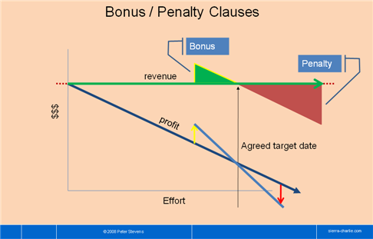 Penalties are a form of punishment for having failed to achieve the desired end, or for doing something undesirable. In a penalty based specification, the contractor knows that he can have below quality levels accepted by paying a penalty, and he can add this into his price anticipated such a penalty, thus costing the owner more than the incentive bid price and ending up with a lower quality product than specified.
On the other hand, when specifications, procedures and good methods of construction are followed, the quality will improve as the project progresses. To acknowledge such meticulous working some incentives are given to the contractor. Incentives and penalties do not serve the same purpose in specifications. From a psychological point of view, they have definitely different effects on people. If we desire to bring about equitable specifications and eliminate the adversary owner-contractor relationship, incentives should be used and penalties avoided.
Incentives can be used for motivating the contractor and his work force to bring about a desired action. In (incentive) specifications, there is no allowance for the acceptance of low quality or out of tolerance work, and the incentive is to motivate the contractor to control his processes in such a manner so as to reduce his inconsistency in attaining the desired quality. Incentives to the workforce usually bring about positive and desirable reactions in a person.

Rather than adopt penalty or incentive based specifications, it is better and prudent to include in the specifications a statement to the effect that all workmanship is to be of the best quality. Workmen engaged in any particular activity will generally know what this means with regards to quality. Third parties, too, can easily determine whether or not a product meets the specified acceptable standard. It is important that the quality of drawings, standards and other miscellaneous engineering deliverable complement the specifications.
2. How can you achieve quality control in the field? (5)
To achieve quality you must plan for quality and this itself is the most important factor in delivering a defined quality product at minimum cost.
A quality plan outlines the requirements of an activity by identifying the sequence of activities, timing, techniques and testing that need to take place to ensure the work is completed correctly.
The quality plan development must cover numerous factors and consider at least the following questions,
- The elements of work that need to be done and when they need to be done?
- How is it to be done; by what method, procedure or equipment?
- Who does it and what is their position in the organization?
- Where is to be activity to be carried out
- What machinery, tools, equipment or instruments are required?
- What is needed by way of information and material to get the scope completed?
- What equipment is to be obtained to do the testing?
- Does any material have to be identified?
- Are any record of the action to be made and kept and if so, what form of data is to be used, what kind of analysis is required and to whom should it be sent etc.?
- What inspection and testing is required and what is the acceptance criteria?
As the planning phase progresses more challenges and questions are developed and a framework and picture emerges that allows Quality Control to be achieved by,
- Developing technical and practical expertise to define the quality requirement for each facility, in a format that can be understood by the design and field management teams.
- Producing design models, drawings, details, and specifications with proper considerations for construction in the field,
- Involving contractor's field management and personnel in construction reviews to determine the best methods of construction and the right tools/equipment for the job, and as the design progresses ensure that potential subcontractors, via the main contractor, thoroughly understands all of the quality requirements and objectives on his part of the work and takes responsibility for quality control and provides proper staff to make it happen,
- Emphasizing the need for careful protection of materials and equipment in the field (in storage/handling and after installation) and by providing the contractor with the information necessary to accomplish this.
- Insuring that he contractors recognize responsibility for quality control function and provide proper staff to make it happen and assisting construction establish effective, on-site quality control programs,
- Frequent visits to the field by technically competent experienced personnel, to review the contractor's quality control records and procedures and be to willingly assist in a team effort to solve problems when unusual conditions are encountered,
- Providing competent resident engineers to exercise sound judgment when quality problems arise, establishing a feedback to the design organization that will make it possible to benefit on future projects from difficulties encountered in the field and involving the appropriate design representative in the solution of problems encountered by the field personnel.

3. What are the advantages and disadvantages of contractor quality control'? (5)
Quality cannot be added at the end of construction as it is an integral part of construction itself and is the responsibility of the workers output and his supervision during the fabrication, building and erection stages.
Quality control involves other entities, which in addition to the construction workmanship include materials testing, document approval and their control, surveying, Inspection and other similar tasks. It is important to understand what quality control brings construction as well as all other supporting industries such as permanent materials, vendors, consumables etc.
Quality control is advantageous in ways such as,
- It requires the contracting companies to ensure their workforce are suitably qualified and trained and also making sure he deals with accredited, reputable and capable suppliers.
- Allows the supervision to better understand and improve construction processes relating to QC
- Reduce unnecessary rework through a methodical checklist approach which benefits from saving time and money.
- Gives access to technical information that will assist in mitigating time delays by dovetailing inspection requirements and checks into production and construction needs.
- Provides a mechanism to continuously improve by planning ahead, doing, acting and checking as illustrated below,
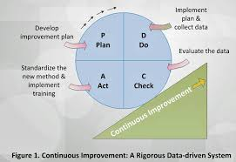

There are however downsides that are perceived by some, such as resistance to change by engineering, designers and constructors, potential duplication of effort from both manpower and equipment perspectives.
It must be said that the positives far outweigh the negatives and if the aspiration of the owner, designer, engineer and the contractor is to work together to build a quality structure, then it is likely that a quality product will result.
After the level of quality has been established by the planner and designer, it is defined in the contract documents by ways of specifications, standards and the procedures and these requirements are then converted into reality during the construction phase. This will always involve testing of materials/equipment plus inspection of workmanship by various entities and at various stages and levels.



