
Assignment Cover Sheet

Student Name: | Ray Wilson
Student Number: | 1390
Course: | Environmental Management
Assignment No: | 2

Assessment 2 Total Marks: 30

Q: 1: Give short answers to the following questions: (10)

I. What is Ozone Layer?

The ozone layer is a deep layer in the stratosphere encompassing the Earth that has large amounts of ozone in it. This layer safeguards the entire Earth from much of the harmful ultraviolet radiation that comes from the sun as illustrated below.

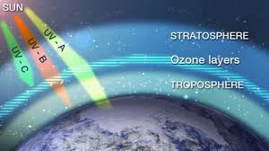
Remarkably, it is also this ultraviolet radiation that forms the ozone in the first place. Ozone is a special form of oxygen, made up of three oxygen atoms rather than the usual two oxygen atoms found on earth itself. It usually forms when some type of radiation or electrical discharge separates the two atoms in an oxygen molecule (O₂), which can then individually recombine with other oxygen molecules to form ozone (O₃).
The ozone layer became a topical discussion point more widely appreciated by the public when it was realized that certain chemicals mankind manufactures, called chlorofluorocarbons, find their way up into the stratosphere where, through a complex series of chemical reactions, they destroy some of the ozone.
II. Outline the effects of Ozone layer depletion on the health of humans and animals?

Stratospheric ozone filters out most of the sun's potentially harmful shortwave ultraviolet (UV) radiation. As this ozone layer becomes depleted, more UV rays are reaching the earth. Exposure to higher amounts of UV radiation could have serious impacts on human beings, and animals as following;
- Harm to human health,
  - More skin cancers, sunburns and premature aging of the skin.
  - More cataracts, blindness and other eye diseases: UV radiation can damage several parts of the eye, including the lens, cornea, retina and conjunctiva.
- Cataracts (a clouding of the lens) are the major cause of blindness in the world.


  - Weakening of the human immune system. Early scientific findings suggest that too much UV radiation can suppress the human immune system, which may play a role in the development of skin cancer.
- Animals:
  - In domestic animals, like humans, UV overexposure may cause eye and skin cancers.
  - Scientists have recently discovered that species of marine animals in their developmental stage (e.g. young fish, shrimp and crab larvae) have been threatened in recent years by the increased UV radiation under the Antarctic ozone hole.
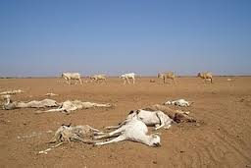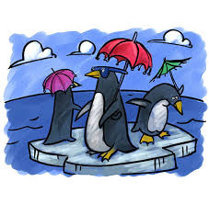
- Already arid regions will deteriorate and this will lead to more famine and loss of food and habitat for various grazing animals

III. What is global warming? How can it affect agriculture output?
Global warming is primarily caused by coal, oil and natural gas which are all carbon-based substances. When we burn these resources they produce water and carbon dioxide. This carbon-dioxide enters the atmosphere and creates a sort of blanket for the globe, trapping heat. The burning of fossil fuels, in power stations and even whilst driving a car for example, increases this ‘blanket effect'. Other well-known greenhouse gasses are for instance methane (produced by certain bacteria and digestive processes) and nitrous oxide (produced for instance when fertilizers are applied to the soil in agricultural lands).
Despite what many people think, global warming does not mean every individual place on the globe gets warmer year round. Instead, it is expected that the weather will get more diverse, and extreme. So dry warm places may get hotter and drier, whereas some places may get even wetter. Depressions get stronger and there is an increased risk of tropical storms reaching temperate areas. The direct result of global warming is an increase in extreme weather events.

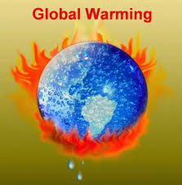
Agriculture is highly dependent on specific climate conditions. Trying to understand the overall effect of climate change on our food supply can be difficult. Increases in temperature and carbon dioxide (CO₂) can be beneficial for some crops in some places. But to realize these benefits, nutrient levels, soil moisture, water availability, and other conditions must also be met. Changes in the frequency and severity of droughts and floods could pose challenges for farmers worldwide. Meanwhile, warmer water temperatures are likely to cause the habitat ranges of many fish and shellfish species to shift, which could disrupt ecosystems. Overall, climate change could make it more difficult to grow crops, raise animals, and catch fish in the same ways and same places as we have done in the past. The effects of climate change also need to be considered along with other evolving factors that affect agricultural production, such as changes in farming practices and technology.
Warmer temperatures may make many crops grow more quickly, but warmer temperatures could also reduce yields. Crops tend to grow faster in warmer conditions. However, for some crops (such as grains), faster growth reduces the amount of time that seeds have to grow and mature. This can reduce yields (i.e., the amount of crop produced from a given amount of land).
For any particular crop, the effect of increased temperature will depend on the crop's optimal temperature for growth and reproduction. In some areas, warming may benefit the types of crops that are typically planted there. However, if warming exceeds a crop's optimum temperature, yields can decline.
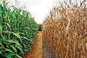

Several of the world's major crop species are particularly vulnerable to increased UV, resulting in reduced growth, photosynthesis and flowering. These species include wheat, rice, barley, oats, corn, soybeans, peas, tomatoes, cucumbers, cauliflower, broccoli and carrots.

IV. What is meant by biodiversity?
Biodiversity is the degree of variation of life and quite simply, as illustrated below, the variety of life. It is a measure of the variety of organisms present in different ecological units. This can refer to genetic distinction, ecosystem variation, or species difference (number of species) within an area, biome, or planet. Terrestrial biodiversity tends to be highest near the equator, which seems to be the result of the warm climate and high primary productivity. Biodiversity is not distributed evenly on Earth and is at its “richest” in the tropics. Marine biodiversity tends to be highest along coasts in the Western Pacific, where sea surface temperature is highest and in the mid-latitudinal band in all oceans. There are latitudinal gradients in species diversity. Biodiversity generally tends to cluster in hotspots, and has been increasing through time but will be likely to slow in the future due to climate change.
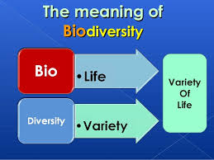 Rapid environmental changes typically cause mass extinctions. Although it is estimated that more than 99 percent of all species that have ever lived on the planet are now extinct, there are currently 10–14 million species of life on the Earth.
Five major mass extinctions (and several minor events) have led to large and sudden drops in biodiversity. These are summarized as follows;
- The Phanerozoic eon (the last 540 million years) marked a rapid growth in biodiversity via the Cambrian explosion—a period during which the majority of multicellular phyla first appeared.
- The next 400 million years included repeated, massive biodiversity losses classified as mass extinction events. In the Carboniferous, rainforest collapse led to a great loss of plant and animal life.
- The Permian–Triassic extinction event, 251 million years ago, was the worst; vertebrate recovery took 30 million years.
- The most recent, the Cretaceous–Paleogene extinction event, occurred 65 million years ago and has often attracted more attention than others because it resulted in the extinction of the dinosaurs.
- The period since the emergence of humans has displayed an ongoing biodiversity reduction and an accompanying loss of genetic diversity. Named the Holocene extinction, the reduction is caused primarily by human impacts, particularly habitat destruction. Conversely, biodiversity impacts human health in a number of ways, both positively and negatively.
V. What is the link between biodiversity and climate change?

The link between biodiversity and climate change has long been established. While throughout Earth’s history the climate has always changed with ecosystems and species coming and going, rapid climate change affects ecosystems and species ability to adapt and so biodiversity loss increases.

From a human perception, the rapid climate change and speed up of biodiversity loss risks human security such as;

- A major change in the food chain upon which we depend
- Water sources may change, recede or disappear
- Medicines and other resources we rely on may be harder to obtain as the flora (plants) and fauna (animals) they are derived from may reduce or disappear, etc.

Some species may benefit from climate change and thrive (including, from a human security perspective, an increases in diseases and pests) but the rapid nature of the change suggests that most species will not find it as beneficial as most will not be able to adapt.

The illustration below indicates the loss of some species (white) and the growth of others in North America due to the current changes to the climate;

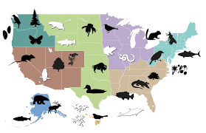
Quote;
The UN’s Global Biodiversity Outlook 3, in May 2010, summarized some concerns that climate change will have on ecosystems:
“Climate change is already having an impact on biodiversity, and is projected to become a progressively more significant threat in the coming decades. Loss of Arctic sea ice threatens biodiversity across an entire biome and beyond. The related pressure of ocean acidification, resulting from higher concentrations of carbon dioxide in the atmosphere, is also already being observed.
Ecosystems are already showing negative impacts under current levels of climate change … which is modest compared to future projected changes…. In addition to warming temperatures, more frequent extreme weather events and changing patterns of rainfall and drought can be expected to have significant impacts on biodiversity”.
— Secretariat of the Convention on Biological Diversity (2010), Global Biodiversity Outlook 3, May, 2010, p.56

Q: 2: ' The fast growth of the human population and its distribution patterns have created environmental problems'. What are these? Discuss (10)

The fast growth of the human population, combined with changes in its distribution pattern, particularly the strong and increasing tendency towards urbanization, constitutes one of two major factors responsible for the creation of environmental problems (the other being technological developments). A variety of environmental problems that are affected by population growth and urbanization include, but are not limited to;

- over-utilization of land
- deterioration of natural areas and habitats
- ecological changes
- depletion of natural resources
- dietary deterioration
- increase of urban pathology
- increased wastes

With this century well under way, natural resources are under increasing pressure, threatening public health and development. Water shortages, soil exhaustion, loss of forests, air and water pollution, and dilapidation of coastlines affect many areas. As the world’s population grows, improving living standards without destroying the environment is a never ending global challenge.
Developed economies currently consume resources much faster than they can renew. Most developing countries with rapid population growth face the urgent need to improve living standards. As we humans abuse nature to meet present needs, are we destroying resources needed for future generations
In the past fifteen years or so in every environmental sector, conditions have either failed to improve, or they are worsening as detailed next;
Public health:
Unclean and contaminated water, along with poor sanitation, kills in excess of 12 million people each year, mostly in developing countries. Air pollution kills nearly another 3 million more. Heavy metals and other contaminants are also causing widespread health problems

Food supply:
Will there be enough food to go around in future? In over two thirds of the 100 or so developing countries studied by the UN Food and Agriculture Organization, the population has been growing faster than food supplies. Population pressures have ruined some 2 billion hectares of arable land — an area approximately the size of Canada and US combined.

Freshwater:
The supply of freshwater is limited, but demand is soaring as population grows and use per capita rises. By 2025, when world population is projected to be 8 billion, 48 countries containing 3 billion people will face shortages (see growth chart below developed in 2000).
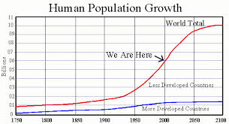
- Coastlines and oceans:
Coastal ecosystems worldwide are under pressure by high population densities and urban development causing receding shorelines, a tide of pollution rising in the world’s seas, ocean fisheries being overexploited and fish catches are down.
Forests:
Nearly half of the world’s original forest cover has been lost, and each year another 16 million hectares are cut, flattened, or burned. Forests provide over US$400 billion to the world economy annually and are vital to maintaining healthy ecosystems. Yet, current demand for forest products may exceed the limit of sustainable consumption by a predicted 25%

Biodiversity:
The earth’s biotic diversity is crucial to the continued vitality of agriculture and medicine — and perhaps even to life on earth itself. Yet human activities are pushing many thousands of plant and animal species into extinction. Two of every three known species is estimated to be in decline.

Global climate change:
The earth’s surface is warming due to greenhouse gas emissions, largely from burning fossil fuels as detailed in Q1.III above. If the global temperature rises as projected, sea levels would rise by several meters, causing widespread flooding and loss of coastlines. Global warming also could cause droughts and disrupt agriculture

There is however hope but this will need a lot of international agreement, government finance and personal commitment to have any chance of reversing this cycle of destruction. Again there are a number of ways to slow down or even reverse this current trend such as;

Toward a livable future:
How people preserve or abuse the environment could largely determine whether living standards improve or deteriorate in the future. Growing human numbers, urban expansion, and resource exploitation do not bode well in this respect and without practicing sustainable development, humanity faces a deteriorating environment and may even invite ecological disaster.
- Taking action:
Many steps toward sustainability can be taken today. These include: using energy more efficiently, burning less fossil fuels, managing cities better, phasing out subsidies that encourage waste etc.
Stabilizing population:
While population growth has slowed, the absolute number of people continues to increase — by about 1 billion every 13 years. Slowing population growth would help improve living standards and would buy time to protect natural resources. In the long run, to sustain higher living standards, world population size must stabilize and stop growing.

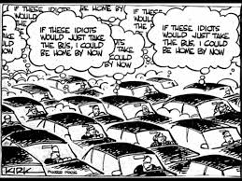

Population and sustainable development
Environmentalists and economists ever more agree that efforts to protect the environment and to achieve better living standards can be closely linked and are mutually reinforcing. Slowing the increase in population, especially in the face of rising per capita demand for natural resources, can take pressure off the environment and buy time to improve living standards on a sustainable basis.
Conclusion
If every country made a commitment to population stabilization and resource conservation, the world would be better able to meet the challenges of sustainable development for the future. Practicing sustainable development requires a combination of wise public investment, effective natural resource management, cleaner agricultural and industrial technologies, less pollution, and slower population growth.
Worries about a “population bomb” may have lessened as fertility rates have fallen, but the world’s population is projected to continue expanding until the middle of the century at least. Just when it stabilizes and thus the level at which it stabilizes will have a powerful effect on living standards and the global environment. As population size continues to reach levels never before experienced, and per capita consumption rises, the environment of our world hangs in the balance.

Q: 3: Outline the efforts that have been made to address the environmental problems at international level. (10)
UNFCCC (“United Nations Framework Convention on Climate Change”) and its Kyoto Protocol was signed in Rio de Janeiro (1992) by over 150 nations and has set a significant standard as a means of solving long-term international environmental problems, but clearly these are only the first steps towards implementation of an international response strategy to combat climate change.
The Kyoto Protocol’s most notable achievements to date are the stimulation of an array of national policies, the creation of an international carbon market and the establishment of new recognized mechanisms. Its monetary impacts on the participating countries are yet to be revealed and realized.
The protocol has also stimulated the development of emissions trading systems, but a fully global system has not been implemented. The Kyoto Protocol is currently constrained by the modest emission limits and will have a limited effect on atmospheric concentrations. It would be more energetic if the first commitment period were to be followed up by measures to achieve deeper reductions and the implementation of policy instruments covering a higher share of global emissions.
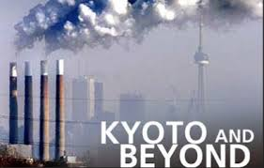
Many options are identified in the literature for achieving emission reductions both under and outside the Convention and its Kyoto Protocol, for example; revising the form and stringency of emission targets; expanding the scope of sectorial and sub-national agreements; developing and adopting common policies; enhancing international technology programs; implementing development-oriented actions, and expanding financing instruments. Integrating diverse elements such as international cooperation and cap-and-trade programs within an agreement is possible, but comparing the efforts made by different countries would be complex and resource-intensive.
Most proposals for future agreements in the literature include a discussion of goals, specific actions, timetables, participation, institutional arrangements, reporting and compliance provisions. Other elements address incentives, non-participation and non-compliance penalties

Under the Protocol countries, such as the USA would be obligated to reduce Greenhouse gas emissions by 7% below 1990 levels for three greenhouse gases (including carbon dioxide), and below 1995 levels for the three man-made gases, averaged over the protocol agreement period. The amounts for each of the developed world countries are listed as percentages of the base year, 1990 and range from 92% (a reduction of 8%) for most European countries to, in the case of Iceland for instance, 110% (an increase of 10%).

Developing countries, including China and India, of course provide the treaty with a real challenge as it is ambiguous regarding the extent to which these nations will participate in the effort to limit global emissions. The original treaty made it clear that, while the developed nations most responsible for the current buildup of greenhouse gases in the atmosphere should take the lead in combating climate change, developing nations also have a role to play in protecting the global climate.

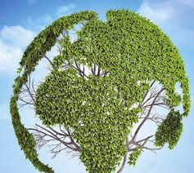

The aim of the treaty/protocol is clear, we need to ensure that ways are found to enable all people of the world to lead healthy, enjoyable, and economically secure lives without destroying the environment, other species and without jeopardizing the future welfare of people and the planet.

Sustainable development, as applied to energy and environment, should consider that energy sources, fossil fuels, land and other raw materials cannot be replaced and they should be used up only as far as they can be substituted by alternatives in future. Where they are renewable they should only be used up at a rate within which they can be reintroduced and in producing and consuming these resources we should not overtax ecologies or the capacity of the planet.

Student Statement:

By submitting this assignment, I confirm that this is my own work.

Student Signature | Raymond Wilson | Date | 30th Mar 2015

For Tutor / Assessor Use Only
Total Marks
Marks Obtained
Percentage / Grade

