
Assignment Cover Sheet

Student Name: | Ray Wilson
Student Number: | 1250
Course: | Construction Management
Assignment No: | 06

Student Statement:

By submitting this assignment, I confirm that this is my own work.

Student Signature | Raymond Wilson | Date | 29th July 2014

For Tutor / Assessor Use Only
Total Marks
Marks Obtained
Percentage / Grade

Assessment 6 Total Marks: 30
1. Give short answers to the following Questions: (20)

- What do you understand by equipment planning '?
Equipment planning can be a complex activity and not only does it require an upfront detailed schedule it must evolve as the project develops so that the ever changing requirements/cycles of construction are catered for.
It is important that equipment planning forms part of the overall operation plan which must clearly show what is to be achieved and indicate the procedure and methods needed. There are a number of software packages available that can facilitate the equipment planning effort and a sample is shown below.
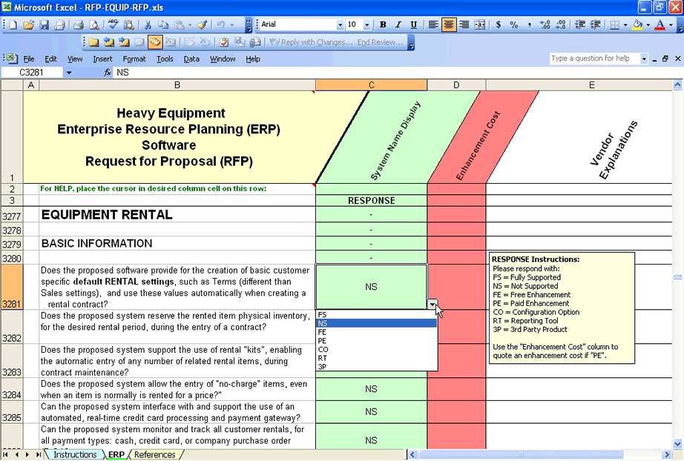
In simplistic terms, tasks are defined and then consideration of the equipment required for each task is developed into a plan. This then allows the planner (supported by construction) to then identify the type, classification and number of equipment items needed to achieve the production rate required to meet the overall project construction schedule. Detailed knowledge, experience and data from previous projects are all ingredients needed to ensure the experienced team can produce a robust equipment plan. Once the equipment plan is initially developed the CPM of analysing the equipment needs is a useful tool and its objectives are described below,
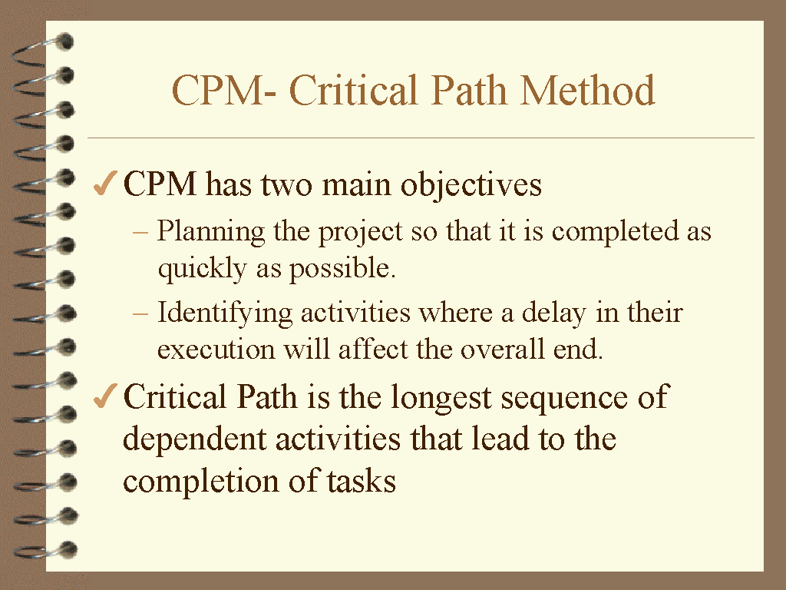
As a basic rule equipment selection should allow for optimising 75% of the time the equipment is available on site taking into consideration the usual slow start as the construction actives commence (when fewer items are required) and then more usage as the project gathers pace and additional equipment can be added. Once the project peaks and equipment is surplus to requirement removal can be carried out in a manner that allows the newest and more efficient equipment items to be retained and other items released or off hired.
- What is the primary requirement of scheduling any project?
The development of an overall operational plan is the primary requirement in the sequence of scheduling any project.
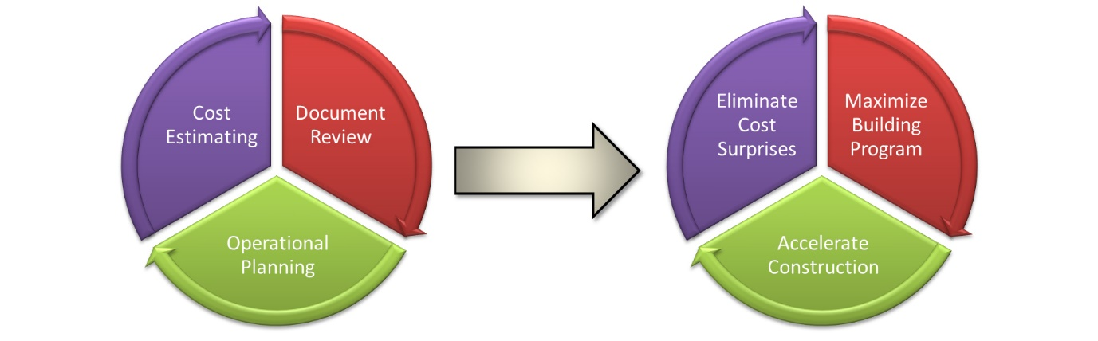
You “plan” for everything that has risks that are not acceptable to the organization. Through the planning process, you identify these risks, then eliminate them or try to reduce their adverse effect to the lowest possible level. A general checklist should be created to assist the participants in addressing all possible areas involving risk.

The planning process, if properly done, is a “continuous improvement process.” It starts with the identification of areas of risk, through the collection of data. The risks are then analyzed. Solutions are found that will address the risks. The solutions are then evaluated for effectiveness and if they meet project needs the “best” solution is selected and then implemented. Audits are conducted to ensure that the implemented solution is effective and “working.” If it is, then the process is taken to the next risk element; and if not, then it is revaluated and the process starts all over again.

- What are the hire-purchase options available to a contractor?
Unless a contractor has a significant pool resource for equipment within his organization he will need to obtain additional equipment to ensure he can achieve the required progress as detailed in the schedule.
He basically has three options available to him once he takes this path, he can either,
- Purchase the equipment or
- Rent it with an option to purchase it at a later date or
- Rent it under a lease agreement.

All the above methods have their merits, advantages and disadvantages but the method chosen needs to be the one that provides the equipment with the lowest outlay with regards to cost taking into consideration the usage made.

For example one contractor may require a compressor that operates full time whilst another may need one only occasionally so clearly the first contractor should buy and the second should hire on a lease basis.

The most important factor to consider if taking a hire purchase option is either rent it or rent it with an option to purchase later but this option is normally more expensive as periodical charges will be included in the agreement and added to the purchase price.

Typical types of items hired below,
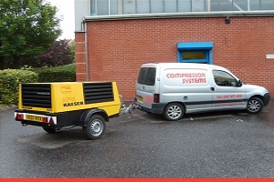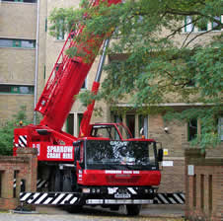
- Why is a proper plant layout important?
Plant layout is one of the pre-planned activities normally arranged along with the overall project layout that allocates areas for offices, car parking, stores and materials used for construction.
These areas are arranged in such a way as to optimise the time needed to move from A to B and as with all the above mentioned the plant layout is important as it can be time consuming, and costly, to move plant and equipment from a workshop to the work site.
Principles of a good plant layout are –
1. A good plant layout is the one which is able to integrate its workmen, materials, machines in the best possible way.
2. A good plant layout is the one which sees very little or minimum possible movement of the materials during the operations.
3. A good layout is the one that is able to make effective and proper use of the space that is available for use.
4. A good layout is the one which involves unidirectional flow of the materials during operations without involving any back tracking.
5. A good plant layout is the one which ensures proper security with maximum flexibility.
6. Maximum visibility, minimum handling and maximum accessibility, all form other important features of a good plant layout.
7. Inherent safety, maximum security and efficient process flow add value to a good plant layout

- What are the disadvantages of purchasing equipment as compared to renting it?
There are numerous reasons not to purchase equipment as opposed to renting it and the following are some of the disadvantages,
- More often than not is will work out more expensive than hiring equipment.
- Purchasing equipment normally requires a considerable outlay of money that could be better used for other purposes.
- Ownership of equipment can lead to a contractor continuing to use outdated equipment way beyond its planned economic life span (that can be costly to maintain and provide increasing production costs) when there are newer versions available on the market.
The case for hiring equipment is a strong one and some advantages are outlined below,
- No Maintenance fees. It is difficult to resist the sheer convenience of removing the need for this maintenance and upkeep affords to companies who rent. This frees up a considerable amount of time, labor, and overall hassle and stress, especially when whole fleets of equipment come into play.
- Transportation is made easier. Renting the equipment removes the burden and cost of moving large items of equipment from site to site since the equipment can often simply be delivered to the worksite by the hire company instead.
- Time and labor. A common thread that unites all of these logistical advantages to renting is the reduction in time and labor costs. These hidden costs often make owning much more expensive than it seems on the surface because, depending on fleet size, additional labor may need to be hired for upkeep and management. Some larger companies even need to set up entire divisions just to handle the logistics and upkeep of their equipment fleets.
- A “level playing field”. One of the biggest factors that sets large companies apart from smaller ones is the amount and quality of resources that they have, including heavy equipment. Larger companies can afford the newest, high-end model with all the latest bells and whistles, whereas a smaller company would normally have to make do with more modest equipment for much longer. Renting levels the playing field by offering a much more affordable way for smaller companies to get access to top-level equipment.
- Servicing. Renting heavy equipment also offers an advantage over ownership in terms of the amount of support and assistance a company is able to receive. The equipment rental staff will be highly knowledgeable about a broad range of equipment, can make recommendations based on your particular needs for the project, and can give you a tutorial on safe and effective handling of the equipment. .
- Tax deductions, no depreciation, no risk of obsolescence and better cash flow are also considerations to take into consideration.

2. What factors affect the cost of the owning and operating construction equipment? (5)
The cost of owning and operating of construction equipment can be summarised in two parts. First consideration is the capital investment needed to acquire the equipment and also the depreciation of that investment over the years ahead.
In addition the following factors also affect the owners’ costs,
- Costs associated with equipment delivery to the owner
- The severity of job conditions in which the equipment is used.
- Number of working hours in a year the equipment is exposed too.
- The number of years the equipment is used
- Care with which the owner maintains and repairs his equipment
- And the demand for used equipment when it is disposed of, which will affect the sell on value that can be recovered.

Secondly are the running costs factors such as,
- Maintenance and repairs
- Petrol, oil, and lubrication charges (i.e. the operating costs).
If available, records of previously used equipment could provide valuable information that may be used for the particular type of equipment and this could be used to forecast these costs and bulk but consumables needed. However, there is no assurance that similar equipment will involve similar costs, particularly if the equipment is used under varying conditions.

3. Discuss the conditions under which the equipment should be taken on rent under a lease agreement? (5)

Both businesses and individuals often choose to forego the expense of buying plant and other heavy equipment making hiring a preferable choice. In doing so equipment terms and conditions are used to detail key factors ranging from rental term and fees to the customer’s use and care of the hired equipment.
These Plant Hire Terms and Conditions contain the following clauses as a minimum:
1. Definitions and Interpretation
2. Rental Term
3. Deposit
4. Fees and Payment
5. Collection, Delivery and Return
6. Hired Personnel
7. Use and Care of the Equipment
8. Maintenance
9. Insurance
10. Theft of Equipment
11. Liability and Indemnity
12. Data Protection
13. Termination
14. No Waiver
15. Severance
16. Law and Jurisdiction
A major condition that cannot be underestimated is the option to purchase the equipment at a later date if it can be determined it is more viable to do so. Although such agreements can be more costly as rental charges are higher.

