
Assignment Cover Sheet

Student Name: | Omnia Rafiq
Student Number: | 1343
Course: | Diploma in interior Design
Assignment NO: | 11

Student Statement:

By submitting this assignment, I confirm that this is my own work.

Student Signature | Omnia Rafiq | Date | 10-4-2015

For Tutor / Assessor Use Only
Total Marks
Marks Obtained
Percentage / Grade

Q.1.i. When selecting furniture for a room how important it is to consider the principles of
Scale and balance for the furniture?
Before selecting any furniture for a room, the first thing to consider is the scale and balance. This involves the ratio of vertical lines (tall pieces) to horizontal lines (low pieces) and the proportion of light items to the solid ones. If a room mostly consists of tall pieces i.e. a wall unit, large pictures, mirrors, tall plants, high backed chairs and sofas, It will look too stiff, formal and uncomfortable.
If there are all low lines i.e. low backed seating, small plants, low storage, low hung mirror, and paintings hung low on the wall, the room overall will look incomplete, Somehow disturbing and again uncomfortable. If most of the objects in the room are solid and heavy, the room will
Look fully stuffed and dark. If all the furnishings are very light say – several occasional chairs, a
Cane or wicker sofa, the room can look insubstantial. There has to be a happy medium in a well arranged room. This however does not mean having half vertical and half horizontal lines or half solid and half-light. Generally most rooms look best with a predominant number of low pieces, set off here and there by taller pieces of varying heights. They could progress, perhaps from a low, upholstered stool or sofa to a wing chair or then to a side table or lamp and finely to a really
Tall lines of an armoire, a bureau - bookcase, or a painting or mirror over a side table, a fire place, and tall plants. Similarly sofa and arm chairs which are solid should be balanced by the openness of occasional chairs, the lightness perhaps of glass table, the height of a storage unit. A dresser or bookcase can be balanced by a tall leafy plant in the room. Planning a room will be much easier, if you start with larger and heavy pieces and balance them carefully with permanent features, such as fire places, doorways or windows and shelves. When all that is clear in your mind, decide where to fill in the smaller pieces. Other features like floor, walls and window treatments- all contribute
Strongly towards the balance of the room. A patterned fitted carpet or Oriental rug will be visually heavier and will have more importance in the room than ordinary wooden or tiled floor. Dark colored walls will look heavier than pale colors. All these factors have to be considered when
Working with the furniture arrangement.

Q.1.ii. How can the environment factors influence the arrangement of furniture in a room?
Extreme climatic conditions like hot and cold, dryness and humidity all need to be considered when positioning the furniture. Strong sunlight will make both wood and fabrics fade, so fabrics used for upholstered pieces placed near window should be as fade resistant as possible. If furniture is
Covered in a fabric likely to fade do not place it near the window. In areas with hot climate, consider the position of the ceiling fan before deciding on the seating armament. Pianos and other musical instruments, if possible be placed near and inside wall, rather than near window and
Radiators.
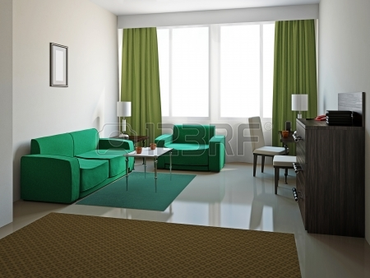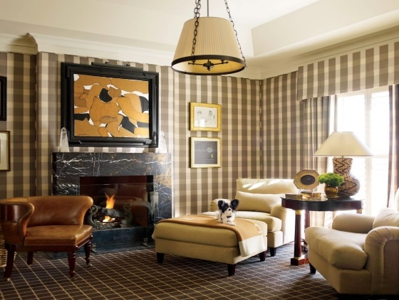

Q.1.iii. How can a focal point created in a room?
If there is no natural focal point in the living room like a fireplace or a window, you will need to create one – a central interest around which you can make various furniture groupings. It can be either a large painting or a group of small ones, a tapestry or a rug mounted on a wall. Other
Possibilities include an interesting book case or a media wall, even a low table holding some interesting items could be a focal point.
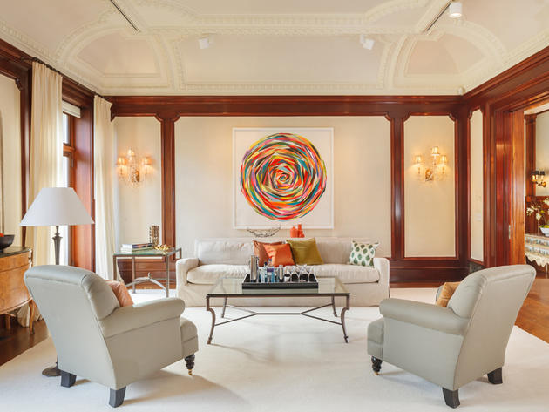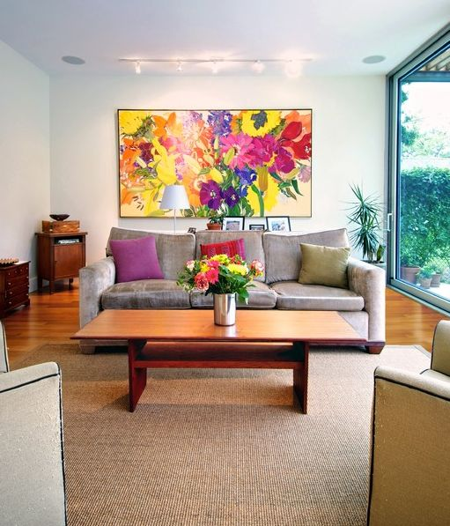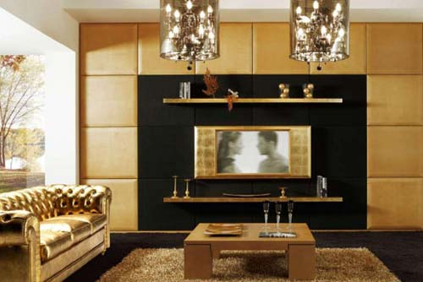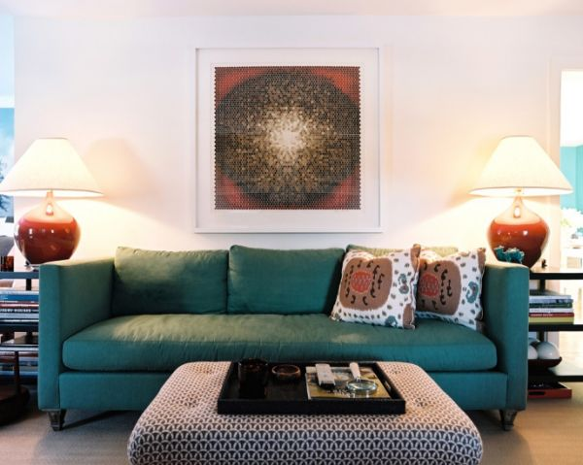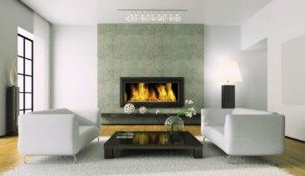

Q.1.iv. What is upholstered furniture?
Upholstery is not just a chair's visible fabric and trim. The upholstery process can be described as creating stable shapes that provide comfort. An upholstered piece's individuality blooms from the furniture type and craftsman's style for seemingly endless combinations and creations. Upholstery covering can be fabric, leather or vinyl. Underneath, you'll find foams and maybe springs. Supplies for the chair-padding process can include upholstery thread, trim, glue and decking fabric under loose cushions. Upholstered furniture offers lot of cushions with foam and it is always enclosed in fabric or leather. It also has a steel or wooden frame on the top of which, springs are attached before cushions being arranged. There are many kinds of upholstered furniture such as: single sofas, double sweater sofas or triple sweater sofas, living room chairs, couches, dining room chairs and much more. Because of the fine finishing the furniture has and also because of perfect colour combination, design and various patterns offered by this model of furniture, many customers opt for upholstered furniture. This is long lasting and good quality furniture that requires very low Maintenance. This means you can give a nice vacuum cleaning every week or every fifteen days and can ensure the perfect look to your living room or your television room. It is always suggested that for high traffic maintenance, stain resistant fabric is much recommended and for family room leather and light cotton fabric is suggested as it is long lasting and quite comfortable. Your investment has to be made wisely that brings you not only good comfort but also adds much interior to your home or office.
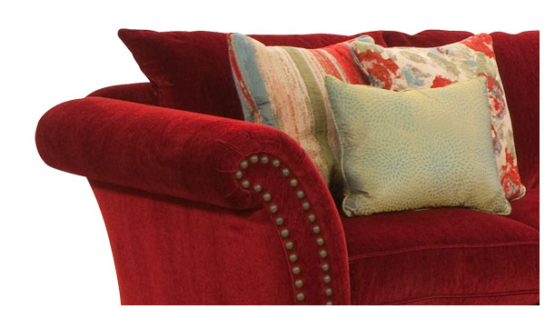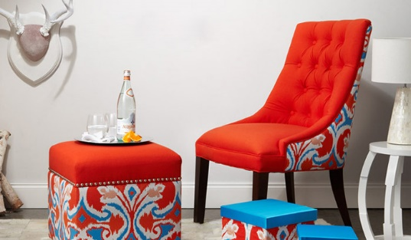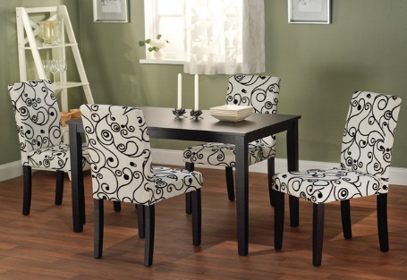

Q.1.v. How will you check the upholstered furniture for quality?
Upholstered furniture should not be judged merely by its upholstery: an expensive fabric may cover shoddy construction. Some deduction is necessary to determine the quality of what lies beneath.
The most important thing about the upholstered furniture is what you see is not necessarily what you get. An upholstered piece should feel as good as it seems, because the inner construction is what counts. Therefore always look at the label detailing the construction of an upholstered piece. In order to know what to look for when buying upholstered furniture.

It is very important to have some idea about the construction of the upholstered furniture.
Good quality furniture should be made from oak, walnut, tweak or pine. The joints should be glued, and double or triple- dowelled, corner-blocked and screwed. Next comes the webbing, which is the bottom most material used on an upholstered piece, to hold the other layers. Good strong webbing should be made from the jute, flax or a synthetic material and woven into basket weave design, which is tracked to the bottom of the frame. In top quality furniture, after webbing come the springs. Such furniture incorporates the coil springs which are set close enough together to provide good support without actually touching each other and these are hand tied in place. About eight springs are used for one chair. Cheaper
Furniture makes use of more rigid springs. On top of the springs, goes tough layer of canvas or hessian, which is sewn firmly to keep the padding intact. This padding consists of polyurethane foam, polyester, rubberized hair, foam rubber, feathers or according to the quality of the furniture. The best quality furniture has a final layer of fiber fill or cotton felt, which is eased just the upholstery fabric. Sometimes that layer has a protective covering of muslin to reduce the tension on the covering and thus maintain the shape. When upholstery fabric is stretched over the furniture it is often trimmed with self or contrast piping to give it more fit and definition.
When checking for the fabric quality, If the furniture is covered with patterned, striped or checked fabric, make sure that the designs are centered; lines and checks are straight. If there are any buttons make sure that they are sewn well through the filling, not just attached to the fabric. Run your hands through the piece to make sure that there are no lumps or bumps.
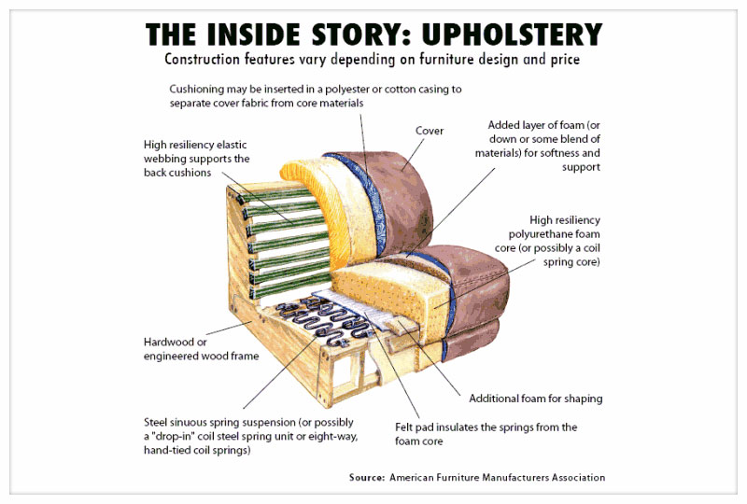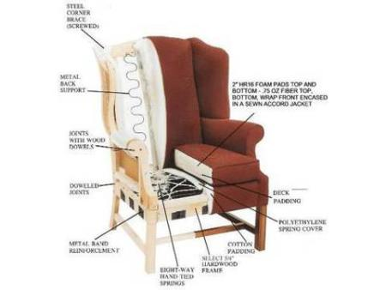

Q.1.vi.When inspecting like wardrobes, dressers, desks and bureau- book cases what
Would you see?
Wood furniture is easier than upholstered to inspect inside and out. Operable parts, such as drawers, table leaves, adjustable shelves and doors, also allow an assessment of quality in how easy they are to operate and how well they fit. Better wood furniture is not nailed together, but joined with double dowels or a variety of joints. The manufacturer's catalogue normally describes the assembly. Inside, the wood should be well-sanded and the joints tight and firm - with screwed corner blocks and neatly applied glue. Drawers should slide smoothly, fit well in their frames and have automatic stops and either side or centre glide supports. Take the drawers out for a better look at both the drawers and the interior of the case. A high-quality method of joinery is the classic dovetail. Drawer bottoms need to be strong, and their interiors well sanded, to prevent fabrics from snagging. Better dressers have dust bottoms beneath each drawer, to catch dust, as well as a wood panel over the back of the case. Hardware on drawers and doors should be firmly attached, preferably bolted through to the inside. Large panels of wood other than pine are usually veneered - and on both sides to prevent warping and bowing. The panels have a laminate or particleboard core, and are used in combination with solid elements such as base rails and posts. Veneers should be mitered together when they meet at corners, rather than butted, and they are usually matched across the surface of a dining table, for example, or down a set of drawers. The most expensive inlays are inset into the wood or veneer, rather than painted or made of decals.
Wood Furniture whether it is new or old, is made of either hard woods Such as mahogany, rosewood, oak, maple, walnut, teak, yew or cherry or of soft wood like pine.
All wood is not equal and so know your wood before you buy it. It is important to check whether the furniture you buy can stand the care and maintenance you offer it and the conditions of your home. For example, in case your home is filled with kids, glass may not be your choice of decorating material.
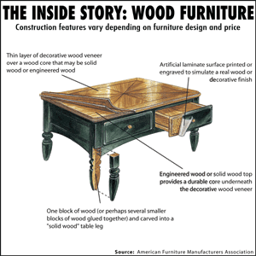
Q.1.vii. How is metal furniture checked for quality?
Metal Furniture like Angle iron, wrought iron brass, copper, stainless steel, chrome plated
Tubing, Should be checked to make sure that there are no bubbles; it is smooth and free of weak spots. It is generally better for the parts of metal furniture to be welded into a unitary construction rather than mechanically joined. The welding itself should be inspected for cracks, and in high quality furniture the weld is ground down so that it is not evident. One way of evaluating a single make of chair is simply to line several up in a row - they should be perfectly uniform in profile. A metal chair should spring back into its normal position after use without deforming. The gauge of the metal determines the resiliency and strength of a piece of furniture; a lighter gauge may deform. If the furniture is made of tubular metal, the bends should not be crimped, nor any smaller in diameter than the other tubing. A solid steel cap, rather than a plug, should fill the end of the tube and be fused and indistinguishable from it. Reflective metal surfaces should be evenly polished, with no scratches or tiny pits. Stainless steel pits less than chrome-plated carbon steel. The better-quality stainless steel has a higher nickel content and is less likely to rust. The quantity of nickel content can be tested with a magnet - the more nickel, the less magnetic attraction. Brass, because it tarnishes, requires regular maintenance.
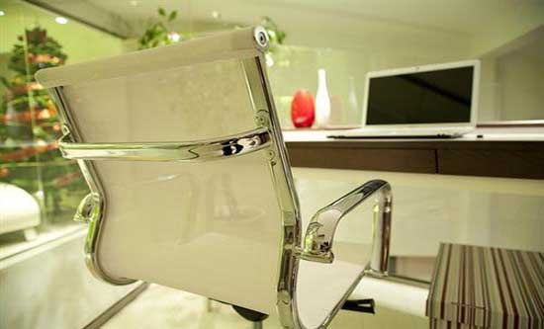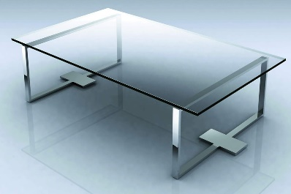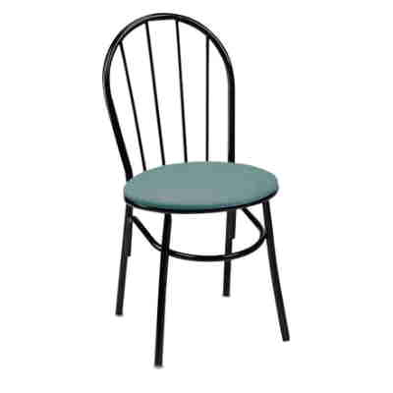

Q.1.viii.If a room is too small which type of furniture would you select for it?
Furniture made of glass, laminates, shiny metals, cane and light- colored wood will lessen the effect of solidity and give an airier feel to a room. Seating need not always mean fully upholstered furniture. A rattan sofa with seat cushions will appear much less dense. Since Using furniture that is very solid looking, such as dark wooden pieces, can make a small room feel very crowded.
So furnishing a small room with few well - chosen and carefully placed items will maximize the light and space in a room, which is essential for the feelings of relaxation and comfort. Furniture that is trim and fit will suit small spaces best. In choosing a sofa, for example, one with fat rolled arms and a multi cushion back will seem too inflated. Pick one with skinny arms and a tight, upholstered back instead. Elsewhere, look for slender legs on dining tables, and stick to beds with simple headboards. Adding Secondary Storage also can be another solution. Typically, small homes are short on places to stash things. That's why it's so valuable to find furniture with storage included. Look for tables with drawers or shelves and ottomans with hidden compartments.
Trunks make excellent coffee tables. And you can tuck a lot of stuff, even luggage, under extra-tall beds.
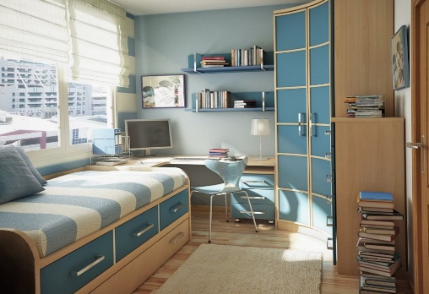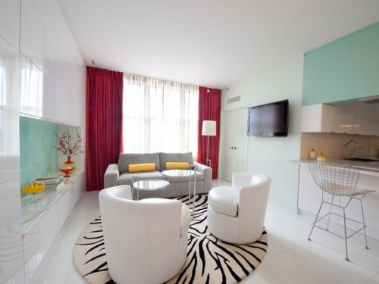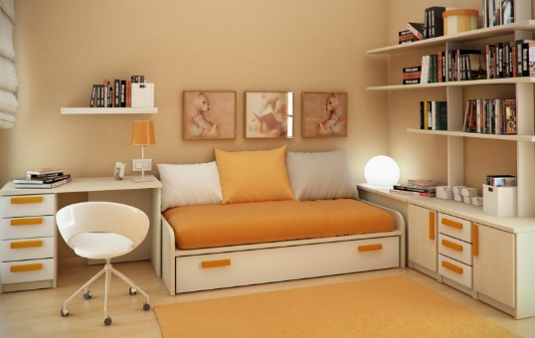

ix. If you want the furniture to stand out in a room. How would you select the
Furniture?
This can be achieved by choosing furnishing in contrasting colours.
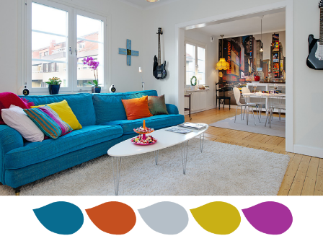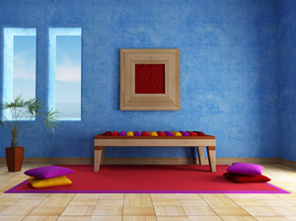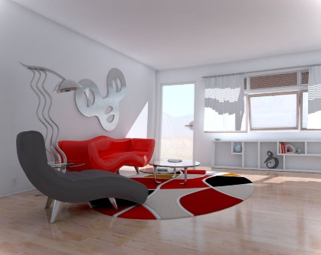

Q.2 If you want the furniture to blend into the background leaving much less cluttered
Appearance. How would you select the furniture?
If you choose furnishing with colors that closely match their intended background, the items will effectively disappear, leaving the room with much less cluttered appearance: for instance, a beige
Sofa against a beige carpet and beige walls.
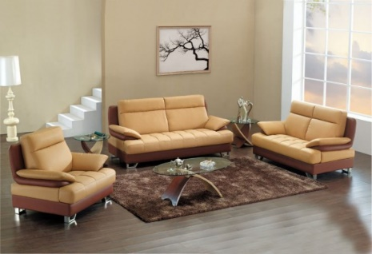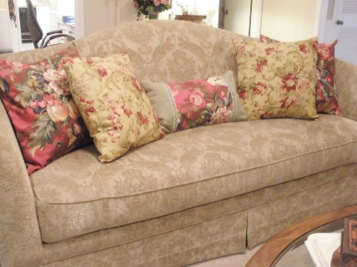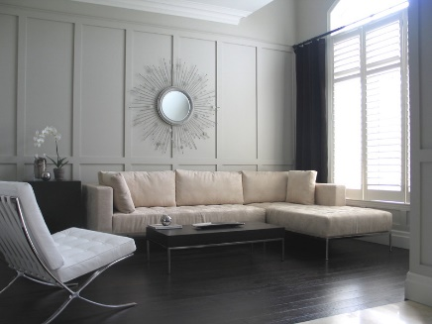
Q.3. How many types of upholstery are there in furniture?
There are two types of upholstery:
1. Fully upholstered pieces, such as sofas, love seats, arm chairs, Slipper chairs and upholstered stools. These are completely covered with upholstery with no frame showing, except possibly the lower part of the legs.
2. Exposed frame pieces, like occasional chairs, chaises and stools that have parts of the frame showing. The frame is constructed first. Arms of a sofa, for example, can be pushed to see if they are stable. Lifting the piece at one end should produce no wobble or creaks; it should move as a solid unit, without give in any sections. A heavy frame usually indicates hardwood construction (wood should be kiln-dried).Some pieces, such as French berg eras, have exposed frames. For stability, the joints should not be nailed but made of interlocking pieces of wood that are double doweled, glued, screwed and reinforced with corner blocks. Visible glue drippings, knotted lumber and legs attached to the bottom of a frame rather than part of its structure indicate inferior quality. If flat wire zigzag seat springs are used, they should be well secured; the best support comes from coiled springs tied together in a number of directions (for example, the eight-way tied spring)
