
Assignment Cover Sheet

Student Name: | Salma Mohamed Safaa
Student Number: | 1170
Course: | Interior Designing
Assignment NO: | 14

Student Statement:

By submitting this assignment, I confirm that this is my own work.

Student Signature | Salma Mohamed Safaa | Date | 28/12/2015

For Tutor / Assessor Use Only
Total Marks
Marks Obtained
Percentage / Grade

Student Name: | Salma Mohamed Safaa
Student Number: | 1170
Course: | Interior Designing
Assignment NO: | 14
Page NO: | 1

Interior Designing Course
Unit 14: Room by Room Designing
Q.1. Short Questions:
I. It is very important for a designer to know the function of a room before designing and decorating. A designer should first be aware of all the activities, the movement and the circulation that will occur in the room. This enables the designer to create a space that is efficient and appealing and helps arranging the furniture right. This will naturally lead to the smaller details that need to be attended this allows the "Form to follow the Function" of the space, and so results in the perfect design.
Before starting work on the project, a designer should ask his client some questions to help establish the purpose of the living room. Will it be:
      - a leisure room for quiet reading, listening to music, letter writing, watching
      - television?
      - a dining room for family meals, smart dinner parties, television supper?
      - an entertainment room for family parties, video viewing, card games?
      - a hobby room for dress making, arranging a sample collection and so on?
      - a work room for study, word-processing, homework, research?
      - a mix of all or any of the above?

II. Apart from carpeting there are other options, available for practical flooring for a family living room. What is important that the floor needs to be extremely hardwearing and relates to all the other surfaces in the room.
- Floor boards: stripped, sanded and sealed or stained, stencilled or painted.
- Wooden Flooring: like parquet, wood strip or wood board.
- Others: sealed cork tiles, Linoleum Sea grass or rush matting.
All these floorings can be softened with a rug in the main seating area in front of the sofas and chairs.

Student Name: | Salma Mohamed Safaa
Student Number: | 1170
Course: | Interior Designing
Assignment NO: | 14
Page NO: | 2

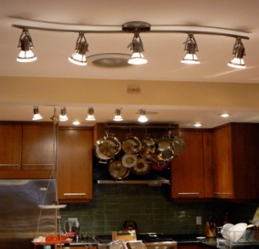
III. A well planned lighting scheme is important for a fully functional kitchen because areas used for preparing and cooking food should be well lit. It is important that the light should be directed exactly where needed and should not be interrupted by shadows. Getting the exact leverage of coverage, function and technique can be challenging. A designer should concentrate on the 3 fundamental types Task, main and decorative lighting.
- For the actual lighting, track lighting that covers the entire space or moves through the center of the whole design.
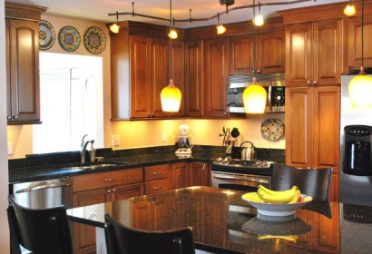
- A big pendant or a chandelier will be able to give the dining room a good light.
- Task lighting type will be great for sink, food preparation region and cooking.
- A decorative type of lighting will be a great idea for the top and bottom of the cupboard.
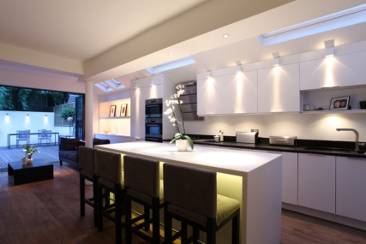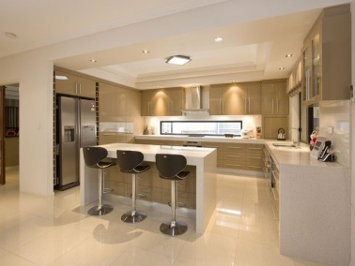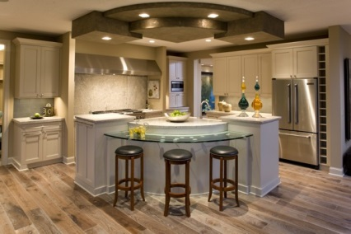
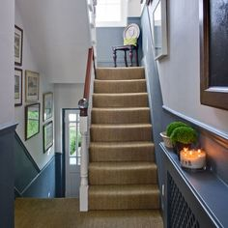
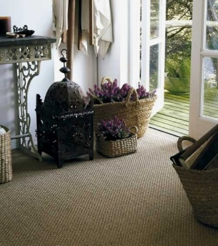
IV. The Suitable types of flooring for the Connecting Spaces: should be of hard wearing materials, as these common areas of the house suffer from the daily tramp of feet, mud, dirt and snow.
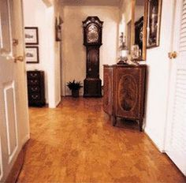
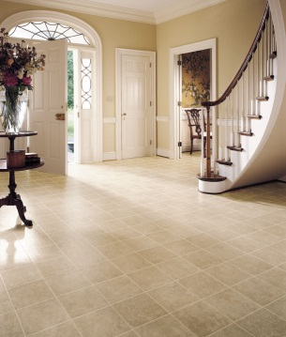
If carpeting is chosen: it should of heavy quality, in a wool and nylon mixture with a hard twist or looped pile. Other than carpeting: ceramic tiles, sealed cork tiles, studded rubber or linoleum.

Student Name: | Salma Mohamed Safaa
Student Number: | 1170
Course: | Interior Designing
Assignment NO: | 14
Page NO: | 3

V. It is important to establish the visual link between the overall scheme and the hallways . Hallways are very important part of your home. They are “face” of your home so they need to be unique and stylish but most important they should send the feeling of welcoming since guests enter from the entrance door and transfers to the other spaces smoothly.
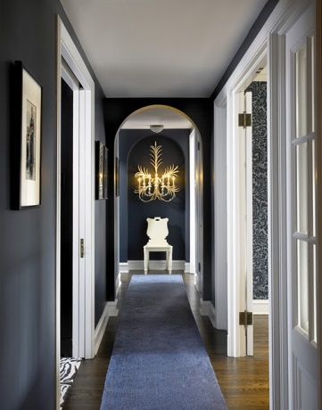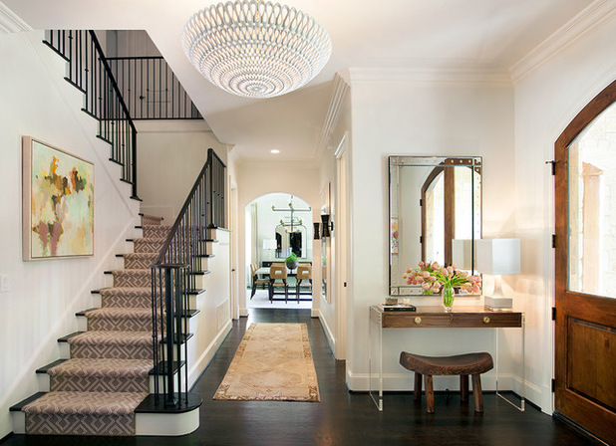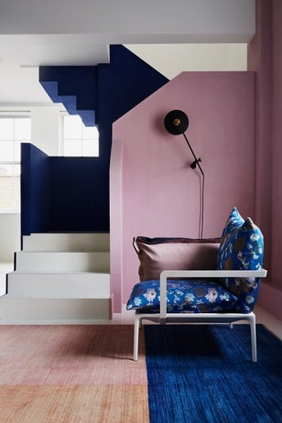
VI. It is important to draw a floor plan for a room before buying furniture for it .The designer need to be aware of the bedrooms needs;
- List the pieces of furniture that would be required in the room and know where the furniture will be placed.
- Study how much space is needed for movement around the room, enough space for the wardrobes, cupboards and chests to be accessed and opened easily.
VII. When designing a room scheme for an elderly person safety measures should be considered.
- First of all Leveling; the room you should be at ground level to be easy to move around also if there is any changes in the floor level it should be highlighted.
- A comfortable easy to get out of chair.
- A warmer temperature space than usual.
- Storage with easy openings.
- The elimination of all sharp corners for safety reasons.
- A smoke alarm system.
- In the bathroom, mixer taps and a controlled temperature shower system
- Curtains on a corded track, operated from the side, to ease opening and closing.
Student Name: | Salma Mohamed Safaa
Student Number: | 1170
Course: | Interior Designing
Assignment NO: | 14
Page NO: | 4

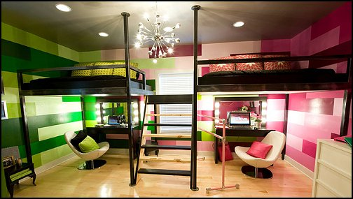
VIII. When two people have to share a room and they both have totally different tastes.
The task of making the space functional for both can become a daunting and challenging task; however this problem can be solved through colour & pattern.
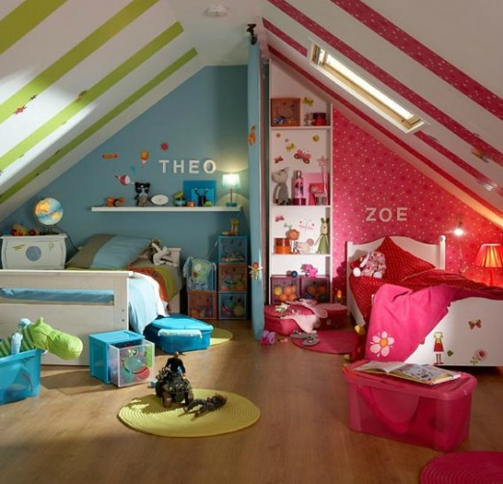
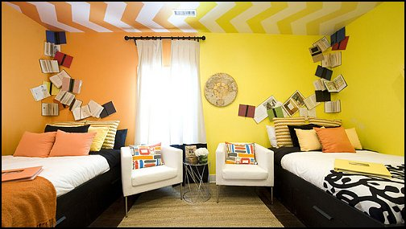

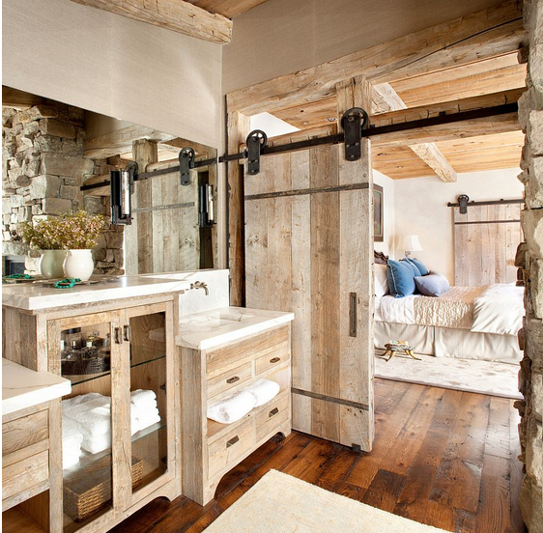
IX. It is very important that the scheme of an ensuit bathroom should relate to the adjoining room’s scheme
because it is only meant to be used by the owners of this room; as so, it should be tailored for their needs without considering others. The schemes of both needs to relate to each other, while at the same time maintain their own individual character. This can be achieved easily by revisiting the bedroom scheme in the bathroom. For example, the flooring of the bedroom continues into the bathroom, share the same walls colour, using the same schemed accessories, etc.
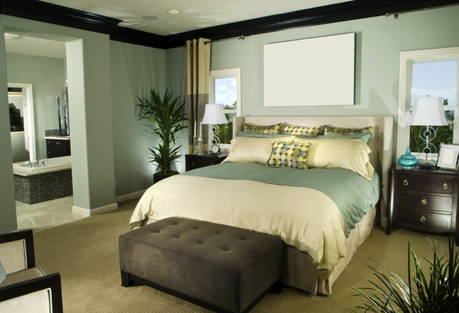
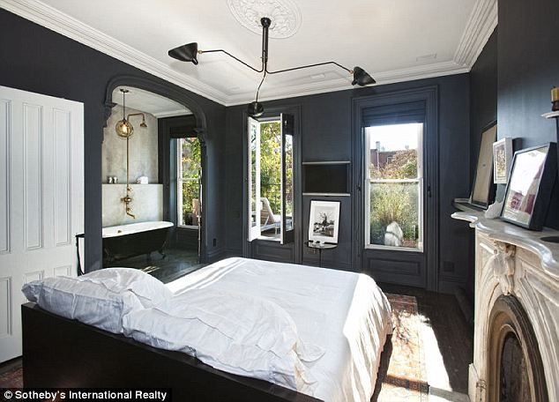

Student Name: | Salma Mohamed Safaa
Student Number: | 1170
Course: | Interior Designing
Assignment NO: | 14
Page NO: | 5

X. The basic equipment that is usually required in a home office is the desk along with its chair. There is no office space without a desk!!

Activity My bedroom is a shared room with my sister.
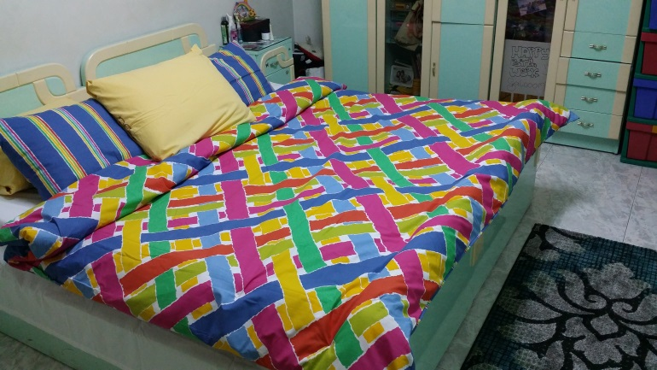
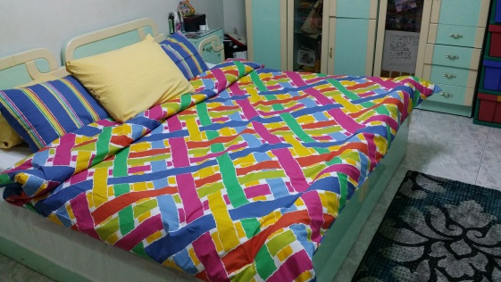
- Things I you have in my bedroom :
- 2 single beds 1.00m * 2.00m, we are used to placing them side by side as to form a king bed.
- 2 sidetables (commodes)
- Dressing table
- Wardrobe
- Bookcase

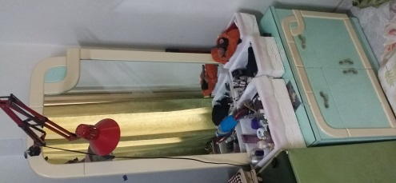
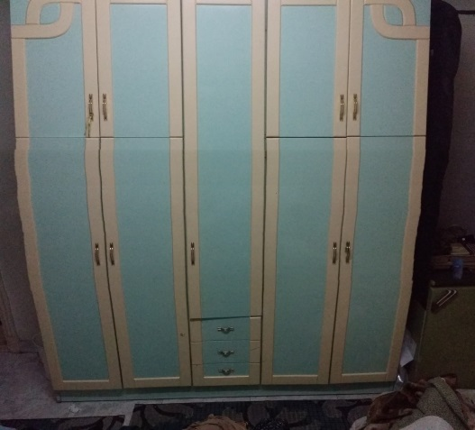
- Things that I want to have:
- 1 double bed instead of 2 single ones
- Storage for shoes

- My bedroom layout in scale :

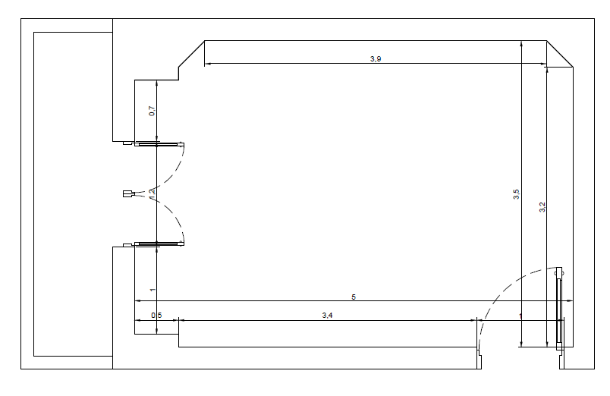

Student Name: | Salma Mohamed Safaa
Student Number: | 1170
Course: | Interior Designing
Assignment NO: | 14
Page NO: | 6
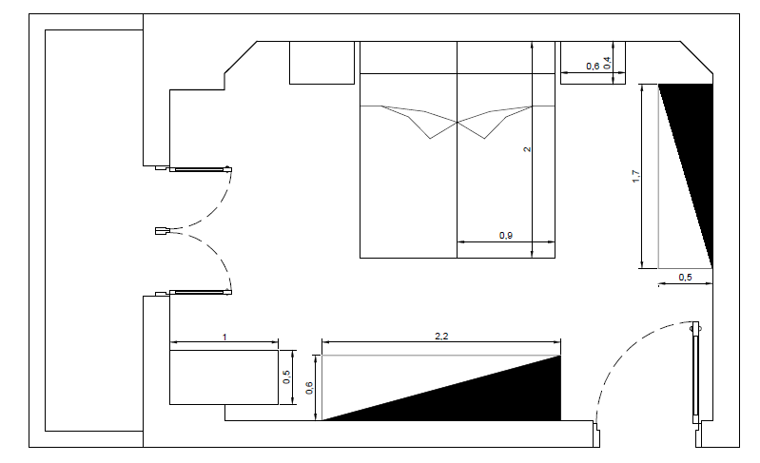
- My bedroom Furniture layout in scale :
- Storage space needed in my bedroom can be added easily:
- Storage for shoes
- Shelves above the bed
After exchanging the 2 single beds to a double one with less width, that leaves more space around the bed and in the room. Where a Storage for the shoes can be added in the corner of the room.

Storage for shoes
