
Assignment Cover Sheet

Student Name: | Ray Wilson
Student Number: | 1390
Course: | Environmental Management
Assignment No: | 10

Assignment 10 Total Marks 30

1. Identify and discuss various types of dams? How each is different from the other structure wise? 10
A dam is a hydraulic structure of fairly impervious material built normally across a river or similar water source to create a reservoir on its upstream side for impounding water for various purposes. These purposes may be Irrigation, Hydro-power, Water-supply, Flood Control, Navigation, Fishing and Recreation. Dams may be built to meet the one of the above purposes or they may be constructed fulfilling more than one. As such, it can be classified as either a single-purpose or multipurpose Dam.

Dams can be categorized in a number of ways. But the most usual ways of classification are mentioned below;
Based on the functions of a particular type of dam, it can be classified as follows;
- Storage dams; Are constructed to store water especially during the rainy season when there is a large flow in the river. Many small dams impound the spring runoff for later use in dry summers. Storage dams may also provide a water supply, or improved habitat for fish and wildlife. They may store water for hydroelectric power generation, irrigation or even for a flood control project. Storage dams are the most common type of dams and in general a dam means a storage dam unless qualified otherwise.
- Diversion dams; A diversion dam is constructed for the purpose of diverting water of the river into an off-taking canal (or a conduit). They provide sufficient pressure relief for pushing water into ditches, canals, or other conveyance systems. Such shorter dams are used for irrigation, and for diversion from a stream to a distant storage reservoir. It is usually of low height, as illustrated in the photo below, and has a small storage reservoir on its upstream. The diversion dam is a sort of storage weir which also diverts water and has a small storage. Sometimes, the terms weirs and diversion dams are used synonymously.
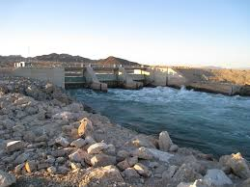
- Detention dams; Detention dams are constructed for flood control. A detention dam checks the flow in the river on its downstream during floods by storing some flood water. Thus the effect of unexpected floods is reduced to some extent. The water retained in the reservoir is later released gradually at a measured rate according to the carrying capacity of the channel downstream of the detention dam. Thus the area downstream of the dam is protected against flood.
- Debris dams; A debris dam is constructed to retain debris such as sand, gravel, and drift wood flowing in the river with water. The water after passing over a debris dam is relatively clear of such debris.
- Coffer dams; Are enclosures constructed around the construction site to exclude water so that the construction can be done in dry. A coffer dam is thus a temporary dam constructed for facilitating construction. These structure are usually constructed on the upstream of the main dam to divert water into a diversion tunnel (or channel) during the construction of the dam. When the flow in the river during construction of hydraulic structures is not much, the site is usually enclosed by the coffer dam and pumped dry. Sometimes a coffer dam on the downstream of the dam is also required.
Based on structure and design, dams can also be categorized as follows;
- Gravity Dams - A gravity dam is a massive sized dam fabricated from concrete or stone masonry. They are designed to hold back large volumes of water. By using concrete, the weight of the dam is actually able to resist the horizontal thrust of water pushing against it. This is why it is called a gravity dam. Gravity essentially holds the dam down to the ground, stopping water from toppling it over. Gravity dams are well suited for blocking rivers in wide valleys or narrow gorge ways. Since gravity dams must rely on their own weight to hold back water, it is necessary that they are built on a solid foundation of bedrock
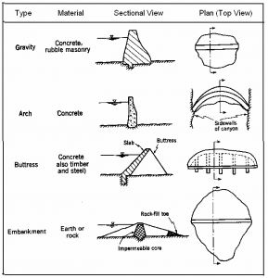
Typical cross section of some types of dams
- Earth Dams - An earth dam is made, quite literally, of earth (or soil) built up by compacting successive layers of earth, using the most impervious materials to form a core and placing more permeable substances on the upstream and downstream sides. A facing of crushed stone prevents erosion by the elements such as wind or rain, and an ample spillway, usually of concrete, protects against catastrophic washout should the water overtop the dam. Earth dam resists the forces exerted upon it mainly due to shear strength of the soil. Although the weight of this structure also helps in resisting the forces, the structural behavior of an earth dam is entirely different from that of a gravity dam. The earth dams are usually built in wide valleys having flat slopes at flanks (abutments).The foundation requirements are less stringent than those of gravity dams, and hence they can be built at the sites where the foundations are less strong.
- Rock fill Dams – Rock fragments and large boulders are the basis for a rock filled dam. An impervious membrane is placed on the rock fill on the upstream side to reduce the seepage through the dam. The membrane is usually made of cement concrete or asphaltic concrete. In early rock fill dams, steel and timber membrane were also used, but now these are obsolete. A dry rubble cushion is placed between the rock fill and the membrane for the distribution of water load and for providing a support to the membrane. Sometimes, the rock fill dams have an impervious earth core in the middle to check the seepage instead of an impervious upstream membrane. The earth core is placed against a dumped rock fill. It is necessary to provide adequate filters between the earth core and the rock fill on the upstream and downstream sides of the core so that the soil particles are not carried by water and piping does not occur. The side slopes of rock fill are usually kept equal to the angle of repose of rock, which is usually taken as 1.4:1 (or 1.3:1).
- Arch Dams - An arch dam is curved in plan, with its convexity towards the upstream side. They transfers the water pressure and other forces mainly to the abutments by arch action.
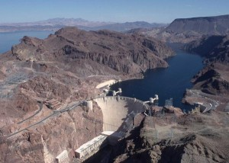
Famous Arch Type - Hoover Dam (USA)
These types of dams are quite suitable for narrow canyons with strong flanks which are capable of resisting the thrust produced by the arch action. The section of an arch dam is approximately triangular like a gravity dam but the section is comparatively thinner. The arch dam may have a single curvature or double curvature in the vertical plane. Generally, the arch dams of double curvature are more economical and are used in practice.
Examples of Arch dam: Hoover Dam (USA), as sown above, and Idukki Dam (India).
- Buttress Dams – There are three types of Buttress dams;
(1) Deck type,
(2) Multiple-arch type, and
(3) Massive-head type.
A deck type buttress dam consists of a sloping deck supported by buttresses. Buttresses are triangular concrete walls which convey the water pressure from the deck slab to the foundation. Buttresses are compression members. Buttresses are typically spaced across the dam site every 6 to 30 meters, depending upon the size and design of the dam. Buttress dams are sometimes referred to as hollow dams because the buttresses do not form a solid wall stretching across a river valley. The deck is usually a reinforced concrete slab supported between the buttresses, which are usually equally spaced.
In a multiple-arch type buttress dam the deck slab is replaced by horizontal arches supported by buttresses. The arches are usually of small span and made of concrete.
In a massive-head type buttress dam, there is no deck slab. Instead of the deck, the upstream edges of the buttresses are flared to form massive heads which span the distance between the buttresses. The buttress dams require less concrete than gravity dams. But they are not necessarily cheaper than the gravity dams because of extra cost of form work, reinforcement and more skilled labor. The foundation requirements of a buttress are usually less stringent than those in a gravity dam.
Steel Dams - A steel dam consists of a steel framework, with a steel skin plate on its upstream face. Steel dams are generally of two types;
    - Direct-strutted, and
    - Cantilever type.
In direct strutted steel dams, the water pressure is transmitted directly to the foundation through inclined struts. In a cantilever type steel dam, there is a bent supporting the upper part of the deck, which is formed into a cantilever truss. This arrangement introduces a tensile force in the deck girder which can be taken care of by anchoring it into the foundation at the upstream toe. Hovey suggested that tension at the upstream toe may be reduced by flattening the slopes of the lower struts in the bent. However, it would require heavier sections for struts. 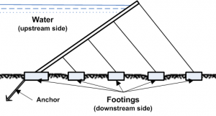Another alternative to reduce tension is to frame together the entire bent rigidly so that the moment due to the weight of the water on the lower part of the deck is utilized to offset the moment induced in the cantilever. This arrangement would, however, require bracing and this will increase the cost. These are quite costly and are subjected to corrosion. These dams are almost obsolete. Steel dams are sometimes used as temporary coffer dams during the construction of the permanent one. Steel coffer dams are supplemented with timber or earth fill on the inner side to make them water tight. The area between the coffer dams is dewatered so that the construction may be done in dry for the permanent dam.
Timber Dams - Main load-carrying structural elements of timber dam are made of wood, primarily coniferous varieties such as pine and fir. Timber dams are made for small heads (2-4 m or, rarely, 4-8 m) and usually have sluices; according to the design of the apron they are divided into pile, crib, pile-crib, and buttressed dams.
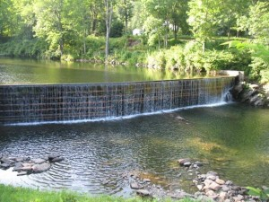
Typical Timber Dam
The openings of timber dams are restricted by abutments; where the sluice is very long it is divided into several openings by intermediate supports: piers, buttresses, and posts. The openings are covered by wooden shields, usually several in a row one above the other. Simple hoists—permanent or mobile winches—are used to raise and lower the shields.
- Rubber Dams: A symbol of sophistication and simple and efficient design, this most recent type of dam uses huge cylindrical shells made of special synthetic rubber and inflated by either compressed air or pressurized water. Rubber dams offer ease of construction, operation and decommissioning in tight schedules. These can be deflated when pressure is released and hence, even the crest level can be controlled to some extent. Surplus waters would simply overflow the inflated shell. They need extreme care in design and erection and are limited to small projects.

2. List main purposes of dams. 10

Dams have two main functions. The first is to store water to compensate for fluctuations in river flow or in demand for water and energy. The second to raise the level of the water upstream to enable water to be diverted into a canal or to increase ’hydraulic head’ –– the difference in height between the surface of a reservoir and the river downstream. The creation of storage and head allow dams to generate electricity (hydropower provides nearly a fifth of the world’s electricity); to supply water for agriculture, industries and households; to control flooding; and to assist river navigation by providing regular flows and drowning rapids. By products in building large dams include reservoir fisheries and leisure activities such as boating.
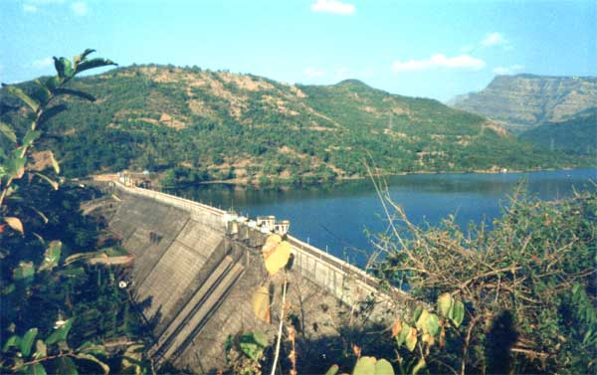
The primary functions summarized above are detailed as follows;
- Hydropower generation is a major source of electricity in the world and its capability is a function of the amount of flow and hydraulic head. Although the head is usually related to the height of the dam, a low dam can have a high head if the powerhouse with its turbines and generators is located some distance downstream of the dam. Pipes known as ’penstocks’ direct water to the turbines. Once the water has spun a turbine it flows into the ’tail water’ below the dam through a ’tail race’ pipe.
- Most of the built-up areas around the world are supplied with water sourced from rivers that are restricted behind low dams or weirs. Other major sources include deep upland reservoirs contained by high dams across deep valleys.
- Dams, regardless of type, are regularly used to control and stabilize water flow, often for agricultural purposes and irrigation.
- Flood prevention Dams impound floodwaters and then either release them under control to the river below the dam or store or divert the water for other uses. For centuries, people have built dams to help control devastating floods.
- Land reclamation Dams, also known as land fill, is the process of creating new land from ocean, riverbeds, or lake beds. The land reclaimed is known as reclamation ground or land fill. (picture below shows land being reclaimed in Abu Dhabi)
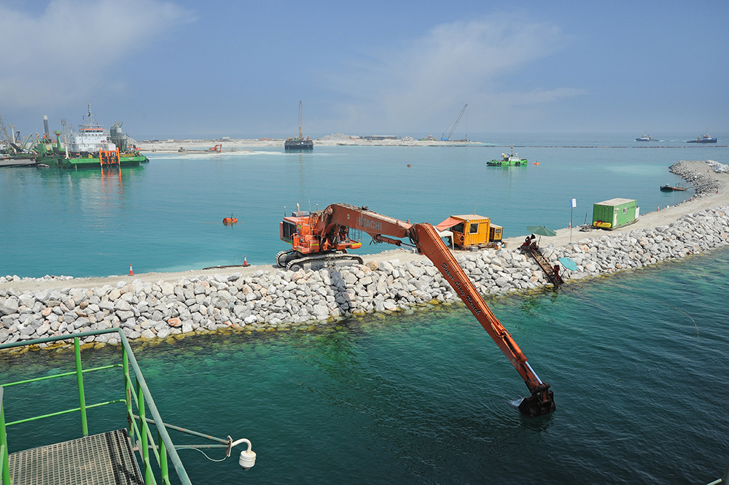
- Small dams are typically used to divert water for irrigation, power generation or other uses, with usually no other function. Occasionally, these are used to divert water to another drainage or reservoir to increase the flow there and improve water use in that particular area.
- Navigation Dams and locks provide for a stable system of inland river transportation throughout the heartland of the Nation.
- Recreation and aquatic beauty Dams provide prime recreational facilities throughout the world. Boating, skiing, camping, picnic areas, and boat launch facilities are all supported by dams.

3. Write short notes on the followings: 10

Biodiversity management

The conservation of the Earth's remaining biodiversity is one of the most important challenges facing humanity. However, there are no easy solutions in managing this challenge because biodiversity conservation has to operate in complex socio-economic, political, cultural and institutional environments.

The number of species of microorganisms, animals and plant life, the enormous assortment of the genes in these species, the different ecosystems on the planet, such as deserts, rainforests and coral reefs are all part of the biologically diversity here on Earth. We are learning more every day about the answers to many of the challenges and question which needs to be moved closer to the forefront of our collective consciousness as new environmental challenges emerge. Biodiversity is the incredible, dizzying variety of life that surrounds us, including all of the earth’s plants, animals, their habitats, and the natural processes that they are a part of.


It has become clear that biodiversity is the cornerstone of our existence on Earth. It is also important to conserve biodiversity for the sake of our own curiosity and aesthetic appreciation. The lake district in the UK, for instance, is a spectacular region, but what would the region be without its wonderful variety of wildlife and wildflowers? This area is full of biodiversity wonders, many of which are unique to the area.
Medicines originating from wild species, including penicillin, aspirin and quinine, have saved millions of lives and alleviated tremendous suffering. Over 40% of all prescriptions are for medicines that originated from plants and animals. No one knows how many more cures await discovery, hidden in Earth’s poorly studied species but without them we may never progress medical research.
There are 80,000 species of edible plants known on Earth, but 90% of the world’s food comes from a mere 20 of these species. Edible plant species, both those we know of and those we don’t, offer a tremendous resource of possibilities that could greatly add to the security of our food. How many of these have high potential for commercial exploitation and for feeding the hungry? Certainly a great many. Breeding cultivars with their wild counterparts can also confer resistance to diseases and increase crop yield.
Biodiversity, and its management, is the life support system of our planet- we depend on it for the air we breathe, the food we eat, and the water we drink. Wetlands filter pollutants from water, trees and plants reduce global warming by absorbing carbon, and bacteria and fungi break down organic material and fertilize the soil. It has been empirically shown that native species richness is linked to the health of ecosystems, as is the quality of life for humans.
The relationships between biodiversity and our sustainable future appear closer and closer the more we look. We literally need to conserve biodiversity like our lives depend on it, as surely they will! Appropriate conservation and sustainable development strategies attempt to recognize this as being integral to any approach. Almost all cultures have in some way or form recognized the importance that nature and its biological diversity has had upon them and the need to maintain it. Yet, power, greed and politics have affected the precarious balance.

Water management

Water management is the management of water resources under set policies and regulations. Water, once an abundant natural resource, is becoming a more valuable commodity due to droughts and overuse due to the ever-increasing global population.
Much effort in water resource management is directed at optimizing the use of water and in minimizing the environmental impact of water use on the natural environment.
Water is an essential resource for all life on the planet. Of all the water resources on the planet only three percent of it is fresh and two-thirds of the freshwater is locked up in ice caps and glaciers. Of the remaining one percent, a fifth is in remote, inaccessible areas and much seasonal rainfall in monsoonal deluges and floods cannot easily be used. At present only about 0.08 percent of all the world’s fresh water is exploited by mankind in ever increasing demand for drinking, leisure, manufacturing, sanitation and agriculture.
This water availability is made up as the pie chart below indicates;

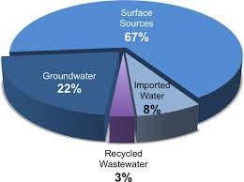Agriculture is by far the largest user of the world's freshwater resources, consuming 70 percent of the fresh water utilized by humans. As the world's population rises and consumes more food, industries and urban development’s expand, and the emerging biofuel crops trade also demanding a share of freshwater resources, water scarcity is becoming an important global issue. An assessment of water resource management in agriculture in 2007 assessed the current availability of water for agriculture on a global scale and mapped out locations suffering from water scarcity. It found that a fifth of the world's people, more than 1.2 billion, live in areas of physical water scarcity, where there is not enough water to meet all demands. A further 1.6 billion people live in areas experiencing economic water scarcity, where the lack of investment in water or insufficient human capacity make it impossible for authorities to satisfy the demand for water.
It is commonly acknowledged that we must come up with a plan to ensure our limited water resources are managed by at least the following items;
- Improve data related to water;
- Treasure the environment;
- Reform water governance;
- Revitalize agricultural water use;
- Manage urban and industrial demand; and
- Empower the poor and women in water resource management.
To avoid a global water crisis, farmers will have to strive to increase productivity to meet growing demands for food, while industry and cities find ways to use water more efficiently.

Forest management
Sustainable forest management means the environmentally appropriate, socially beneficial, and economically viable management of forests for present and future generations. Yet sustainable forest management is an evolving process, and the parameters defining it change over time based on the latest scientific knowledge and society's understanding of the concept.

The forest ecosystem is highly complex, and influenced by numerous external factors. Similarly, different forest types in different regions of the world require different sustainable management strategies. This means that criteria for sustainable forest management must be constantly adapted to new circumstances; they must reflect the national context and the specific ecological and environmental conditions, as well as social, economic, political, cultural and spiritual dimensions.
The challenge for a global forest management plan is therefore to develop an approach that:
- sets robust standards and realistic criteria for sustainable forest management at a global level that enjoy acceptance by stakeholders around the world, and that are continuously updated to incorporate new knowledge, best practices and changing expectations;
- is flexible enough to reflect the specific national circumstances as elaborated with input from all interested parties at local level, yet is also in compliance with international requirements; and
- is accessible, viable and affordable not only to multinational corporations managing large areas of natural forests and plantations, but also to the millions of small family and community-forest owners for which forests represent an important part of their livelihoods. Therefore the plan must cater for the cycle shown below;
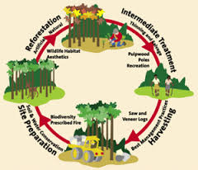 At its most basic, a woodland management plan is a working document, which provides a central point to keep all of the paperwork associated with the management of a woodland, with information about the boundaries, features and woodland character. There are a number of good reasons to produce a woodland management plan:
- Woodland management is a long term commitment. A plan enables an owner to make coherent decisions to manage the woodland to reach their objectives and to pass on information about ongoing management of a woodland to contractors or subsequent owners.
- A management plan allows an owner to provide evidence of compliance with the legal obligations associated with woodland ownership such as obtaining felling licenses or management of protected habitat.
A management plan provides evidence of ongoing activities to support applications for independent certification, it is also a requirement for the payment of a number of Forestry Commission grant schemes.

Student Statement:

By submitting this assignment, I confirm that this is my own work.

Student Signature | Raymond Wilson | Date | 9th June 2015

For Tutor / Assessor Use Only
Total Marks
Marks Obtained
Percentage / Grade

