
Assignment Cover Sheet

Student Name: | Drew Wilkins
Student Number: | 1318
Course: | Diploma in fashion design
Assignment NO: | 4

The Process and Structure of Fashion Industry

What is meant by market segmentation?
Market segmentation is a marketing strategy in which involves dividing a broad target market into subsets of consumers, businesses, or countries who have, or are perceived to have, common needs, interests, and priorities, and then designing and implementing strategies to target them.

“Design is a visual thinking, perhaps of a higher order than verbal thinking”. Explain.
When designing you imagine the design in your head that’s part of the creativity of it, instead of putting it down on paper you imagine it on who’s suited for it and how it’s going to look on that type of person. You imagine the neck line silhouette style and material, you know exactly how you want it to look.

Explain briefly the developing of a sample garment.
When developing a sample garment the first thing you do is sketch an idea starting with the silhouette and neckline drawing on paper which will be on paper (2D) the designer will have to also be able to imagine the design as a 3 dimensional in fabric too. The first rough sketch, a working sketch, is very simple. However, it must be accurate so that the patternmaker can interpret it correctly. The designer must think about the construction of the garment in relation to the sketch which must be drawn in proportion to the body. The working sketch will also contain notes on construction and measurements.
The next step in the design procedure is the development of the first pattern. The pattern used to cut and sew the sample garment. This will be made in sample size for testing and selling purposes. Examples are size 7 for juniors, 10 for missy, 34 for men's trousers, and 38 for men's suits. There are two methods for the pattern maker to use draping or flat pattern for making the patterns.
What is a CAD system and how it has revolutionised the fashion industry?
Computer-aided design (CAD), also known as computer-aided design and drafting (CADD), is the use of computer technology for the process of design and design-documentation. CAD may be used to design curves and figures in two-dimensional (2D) space; or curves, surfaces, and solids in three-dimensional (3D) objects. Although most designers sketch designs by hand. This is an easier way to get your designs done and you get a better idea of what the design is going to look like, it’s easier to learn this way.
Compare two dresses of similar price by two different designers, try them on. Which one has the best fit? Compare fabric choices in terms of quality and suitability to the design. Compare styling which is more innovative? Which dress is the best buy? Sketch both the garments
I tried on two dresses one from new look and another from Jane Norman. The new look dress was better fitted, comfortable not too tight but tight in all the right places, the fabric was not too clingy and very breathable. It’s defiantly well suited for a night out. Would be the more innovative one and defiantly the best buy, whereas the Jane Norman dress although was nice fitted it wasn’t very comfortable and was way too tight, the fabric was too thick and felt like I couldn’t breathe all in all not very pleasant and couldn’t picture lasting all night in it.
Here are my drawings of those two dresses.
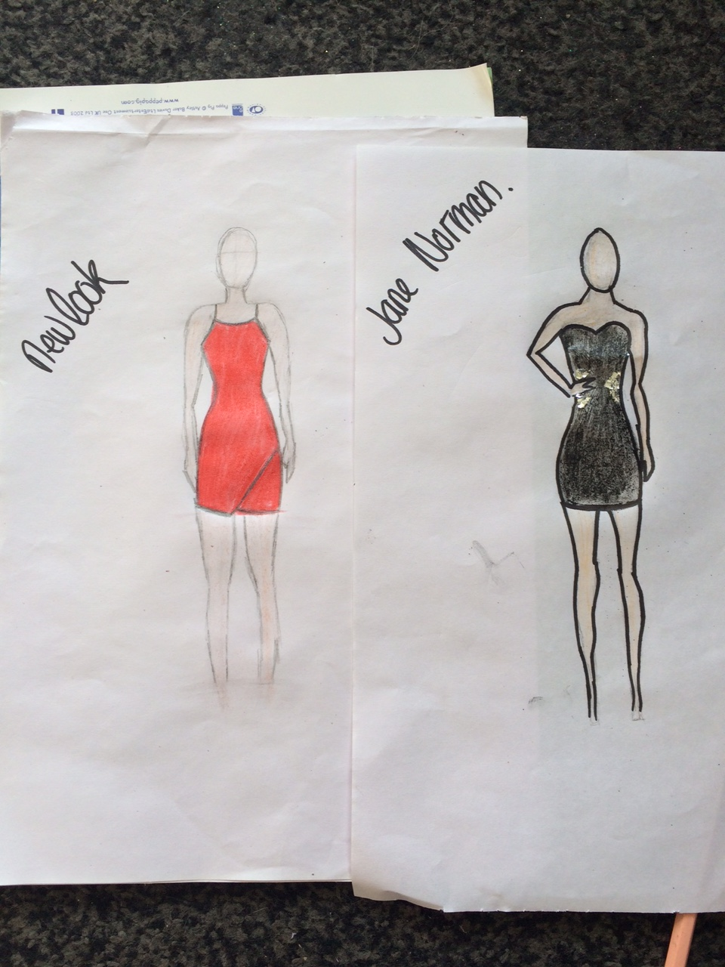

In a local department store, compare contemporary and junior departments. List the major manufacturers in each department, and explain the general styling differences.
In my local department store House of Frasier the major manufacturers are Ralph Lauren, Tommy Hilfiger, Gucci, D&G, DKNY etc.32rt they are in both contemporary and junior departments. The styling differences with the junior departments they are be more playful lose fitting and softer looser materials, whereas the more contemporary departments are more stylish fitting and sophisticated.

Student Statement:

By submitting this assignment, I confirm that this is my own work.

Student Signature | Miss drew wilkins | Date | 29/09/15

For Tutor / Assessor Use Only
Total Marks
Marks Obtained
Percentage / Grade

