
Assignment Cover Sheet

Student Name: | Lauren Kramer
Student Number: | 1432
Course: | Diploma in Diet and Nutrition
Assignment NO: | 6 & 7

Marking Criteria:
We expect the learners to write minimum one well expressed point in three lines against each allocated mark. This means one needs to write 15 lines with 5 well expressed points to get high grades for a 5 marks question.
For high grades use examples and illustrations where appropriate.
QUESTION 1

i. A sedentary man who has calorie requirements of 2400 a day. He takes 500 calories from proteins in his diet. What is the percentage of protein in his diet?
20%

ii. A person has consumed 45 grams of a food. The table shows that 100 grams of this food contains 80 calories. How many calories the person has consumed?
36 calories

iii. Fat content of a daily intake in a balanced diet should be;
25-35%

iv. Based on their nutrient content, food are categoried into;
Five main food groups

v. How many portions of fruit and vegetables a person should eat in a day?
5 portions

vi. One serve of cereal is equal to;
1 cup of cooked rice, pasta, and noodles

vii. Fibre helps in the process of digestion and can;
Lower blood cholesterol

viii. The glycaemic index (GI) is a way of ranking carbohydrate foods based on;
how quickly they increase blood sugar levels

ix. Fat transports;
Vitamins A, D, E and K around the body

x. Anti oxidants are present in;
Green Tea

QUESTION 2

i. What are trace minerals? Why are they called “trace minerals”?
Trace minerals are elements that are needed by the body though diet, in very small (trace) amounts. Anywhere between 1-100mg/day for adults. These minerals include copper, chromium, fluoride, iodine, iron, molybdenum, manganese, selenium and zinc.

ii. Why should we prefer whole grain foods over refined foods?
A whole grain is made up of three main parts; the bran, germ and endosperm. The bran is an excellent source of fibre; the germ is a source of protein, vitamins and minerals; and the endosperm supplies most of the carbohydrates, mainly in the form of starch. Refined grains have been stripped of their outer bran coating and inner germ during the milling process, leaving only the endosperm, to extend shelf life. Unrefined or whole grain forms provide far more nutrients than their refined counterparts.

iii. What are the two main types of sugar?
The two main types of sugar are natural sugars and added sugars.
Natural sugars are those found naturally in fruits, vegetables and dairy while added sugars are any type of sugar added to a food. So a basket of fresh berries has natural sugars, but a packet of frozen berries packed in syrup has added sugars.

iv. Describe methods for healthy preparation of fruit and vegetables.
The best way to enjoy the health benefits fruits and vegetables provide is to eat them while they are fresh. Prepare fruits and vegetables by cleaning them well, and storing them safely.
1. Wash your hands with warm soapy water before handling food.
2. Rinse your fruits and vegetables under clean, cold water to remove any bacteria, dirt, insects or pesticides. You should do this for produce with skin as well.
3. Pat dry the fruit and vegetables with a paper towel to absorb any remaining water.
4. If you plan to cook your produce, keep the pieces as large as you can, and minimise the cooking time in any liquid to retain more nutrients.

v. What is the importance of adequate fluid intake?
Water makes up 50-70% of an adult’s total body weight and without regular water intake our body’s survival time is limited to a matter of days. Water is essential for the body’s growth and maintenance, as it is involved in a number of processes. For example, it helps get rid of waste and regulates temperature, and it provides a medium for biological reactions to occur in the body.
Water is lost from the body through urine and sweat, and must be replaced through the diet. If we don’t consume enough we can become dehydrated, causing symptoms such as headaches, tiredness and loss of concentration. Chronic dehydration can contribute to a number of health problems such as constipation and kidney stones.

vi. What is energy density?
Energy density is the amount of energy, or calories, per unit of measure of food. High energy density means that there are a lot of calories in a little food. Low energy density means there are few calories in a lot of food.

vii. Describe the best sources of dietary fibre. How does it benefit us?
Dietary fibre is found in plant food such as fruits, vegetables and whole grains. It is essential for maintaining a healthy digestive system. The two types of fibre found in food are soluble and insoluble.
Soluble fibre, which can be dissolved in water, is found in beans, fruit, and oat products, and can help lower blood fats and maintain blood sugar. Insoluble fibre cannot dissolve in water, so it passes directly through the digestive system. It is found in whole grain products and vegetables and it increases the rate at which food passes through the gut.

viii. What is Glycaemic Index (GI)?
The Glycaemic Index (GI) ranks food on a scale from 0-100 according to the effect they have on blood glucose levels. A food’s GI indicates the rate at which the carbohydrate in that food is broken down into glucose and absorbed into the blood. Foods with an index number of 70 or more are considered to be high glycaemic, with a number between 55-70 as medium, and under 55 as low.

QUESTION 3

Why is calcium important, especially in children? And what are calcium alternatives for those who exclude milk and dairy products from their diets?

Calcium is a mineral that helps build strong bones and teeth, regulates muscle contractions (including the heartbeat) and makes sure the blood is clotting normally. Calcium can continue strengthening the bones until the age of 20-25 when peak bone mass is reached. After this point, the bones can only maintain or lose their density and grow weaker as a natural part of the aging process. Inadequate dietary calcium intake before this age can increase the risk of brittle bones disease and osteoporosis, as calcium is drawn from the bones as a reserve.

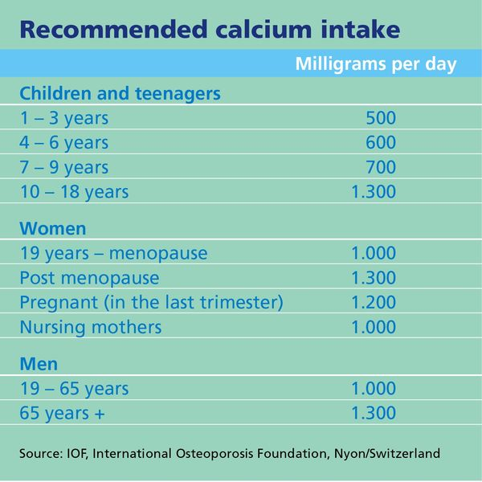

Milk and dairy products are an important source of calcium, but for those who exclude these from their diet or who can’t tolerate lactose (milk sugar), we must look for calcium alternatives.
Other dietary sources of calcium include:
- Calcium-enriched soya milks, yoghurts and cheese
- Dark green leafy vegetables such as spinach, broccoli and watercress
- Almonds or sesame seeds
- Dried fruit – apricots, dates and figs all contain small amounts of calcium
- (for non-vegan) Fish such as sardines and anchovies, especially the bones

Student Statement:

By submitting this assignment, I confirm that this is my own work.

Student Signature | Lauren Kramer | Date | 15/12/15

For Tutor / Assessor Use Only
Total Marks
Marks Obtained
Percentage / Grade

