
+Rhy
Assignment Cover Sheet

Student Name: | Saleema Choudrey
Student Number: | 1240
Course: | Fashion Designing
Assignment NO: | 6

Assessment 6

Question 1

  - How is the formal balance achieved in a dress?
Formal balance in dress designing means the patterns are symmetrical on each side of the dress to achieve the Formal Balance in dress designing.
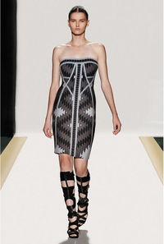

(sample of formal balanced dress)
  - How can harmony be created in a dress?
Harmony in dress designing means all parts of the visual image relate to and complement each other. Patterns and shapes can also help to achieve harmony. By repeating patterns in interesting arrangement it helps to put it all together in one unit.

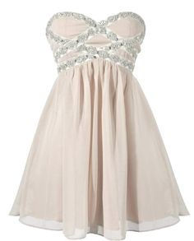
(sample: Dress in Harmony)

  - What is the relationship between the principles and elements in a design?
The elements of designs: Line, Shape, Form, Colour, Texture, space, value are the elements in design on how to MAKE an art. The principle of design: Pattern, Contrast, Emphasis, Balance, Proportion, Harmony and rhythm are tools for how to USE to make an art.
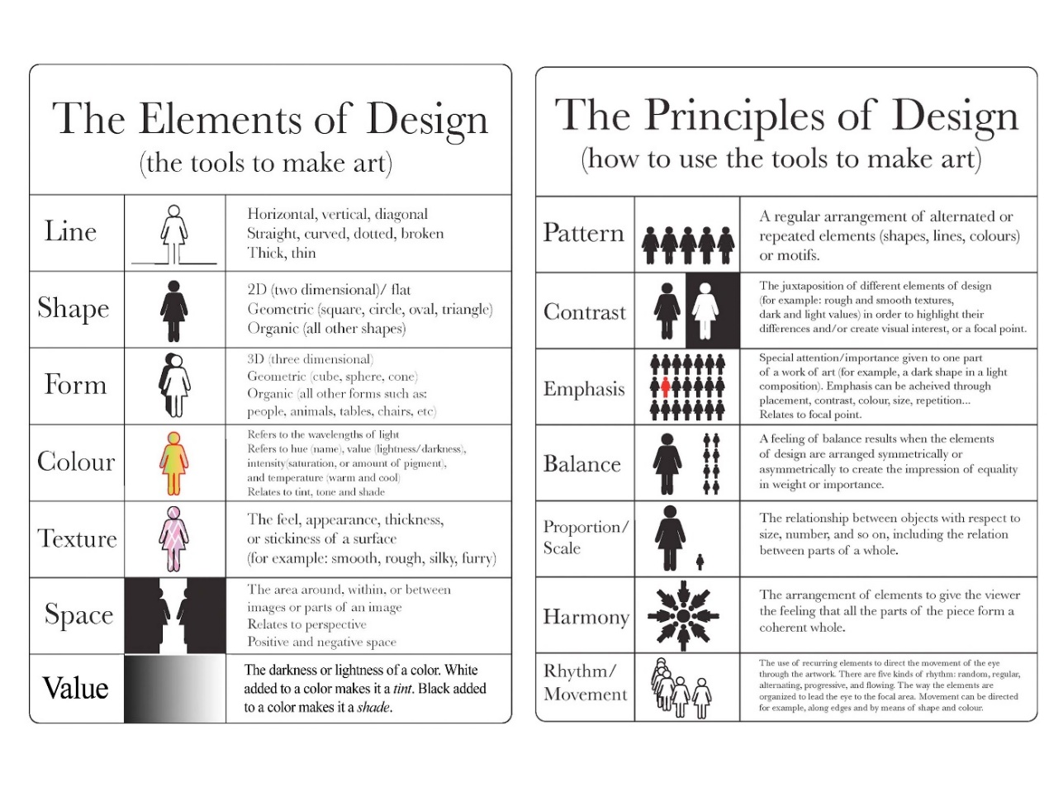

  - Describe at least three way for creating rhythm in dress designing.
Radiation: Repetition from the central point or several points of designs of gathers, fold, pleats or lines.
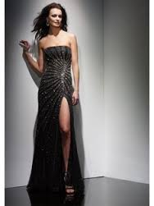
(Sample of Radiation in Dress designing.)

Repetition: Regular repeats of designs, motifs, shapes, buttons, pleats, laces edging, colours, textures, fabric designs. All parts would be the same to see the effect of repetition.
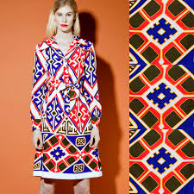
(Sample of Repetition in dress Fabric.)

Progression: The effect of progression is seen by designs of which the colours goes from dark to light. Or lines from thick to thin.
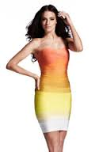
(Sample of Progression in Dress designing with colours changing from Dark to light)

Question 2
What are the principles of design? How do they help a designer analyze the effectiveness of a design?
Balance, Emphasis, Harmony, Proportion, Rhythm are the 5 Principle of design. They help a designer to create, discuss, and evaluate a garment design. These are a guide line to creative designing.
Balance: Symmetrical on each side of a garment.
Emphasis: Is used in dress designing to create a focal point. A feature that’s attractive to others, it can be achieved through size, placement, color or use of lines.
Harmony: Harmony in dress design means all parts of the dress designing part related to each other and complete each other. One unity.
Proportion: Dress designing according body type
Rhythm: repetition in dress designing.

Activity
Find pictures of some dresses from fashion magazines. Describe the beauty of each in terms of line, silhouette, shapes and spaces, colour and texture (fabric, pattern and trims) as well as balance, proportion, rhythm and emphasis. Do all elements and principles work together harmoniously? What elements dominate? Find two garments that you feel are unsuccessful. Analyse them in the same way to discover what elements or principles has not been properly used.

Dress 1.
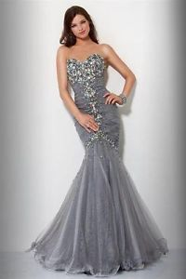
Description: Strapless floor length mermaid fishtail dress.
Line: fishtail
Silhouette: it’s a fishtail silhouette with a Strapless sweetheart neckline that is shaped like the top half of a heart. Floor length dress.
Shapes & Space: triangle shaped dress. Suitable for hourglass body shape. Fuller bust and hips and small waist. Or the inverted triangle fuller upper body, smaller waist and hips
Colour: silver/grey
Texture: The fabric that is used is chiffon with a great fall. The dress is fully lined. Shiny fabric
Balance: formal balance is created in this dress design. Symmetrical on each side of the dress.
Proportion: this dress is disproportionate. This style of dress doesn’t suit any body shape. It will enhance the hourglass body shape. Otherwise it’s not recommended for other shapes.
Rhythm: Rhythm in this dress is created through radiation. The pleats start from knee-length of the dress. The pleats on the waist line is also rhythm through radiation.
Emphasis: Emphasis is created with the glitter in the middle of the dress to create the focal point in the dress. The skirt is falling nicely on the floor.

Dress 2
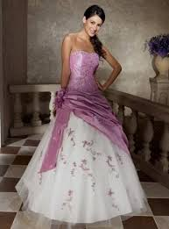
Description: full knee length bridal dress.
Line: A-line
Silhouette: A-line dress, strapless, sleeveless long dress.
Shapes & Space: Perfect dress for hourglass body shape. Lightly sweet hearted neck line.
Colour: white and purple
Texture: silky texture with chiffon layer.
Balance: asymmetrical balanced dress. Both parts are almost the same apart from the middle pleats on the hips.
Proportion: This style dress is appropriate for proportion. Larger or smaller sizes are available or can me adjusted to the required size.
Rhythm: rhythm is created through progression. From dark purple to light purple and white. Asymmetrical pleats on the dress created rhythm through repetition.
Emphasis: The color progression is the emphasis in the dress, and the flowers on the dresses creates a focal point. The pleats also do make a focal point of the dress because of the purple pleats on the white silk skirt.

Dress 3

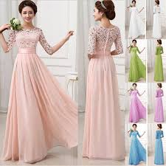

Description: full length bridal dress. Available in various colors
Line: A-line
Silhouette: A-line
Shapes & Space: triangle shaped dress. Suitable for heavier hips and thighs. With a small waist and shoulders. Round neck-line. Full sleeves floor length dress.
Colour: the color of the dress is peach/soft light pink. Also in purple, green, blue and white
Texture: lace fabric for the top of the dress. Finished with silky pleated skirt.
Balance: Formal balance is used in this bridal dress.
Proportion: the dress is disproportionate this dress will give a taller, slimmer look.
Rhythm: Repetition created in the waistline with repeated pleats
Emphasis: The focal point in this dress is the top which is designed with lace fabric and lining.

Dress 4

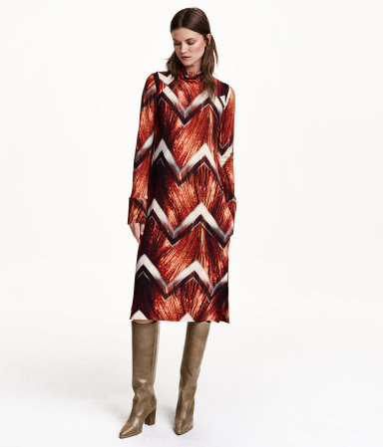
Description: Jersey dress with a print pattern that is doubled at the top with a top that has a polo neck and long sleeves. Mesh insets at the shoulders, an opening with a hook-and-eye fastener at the back of the neck, wide cuffs with a concealed press-stud, concealed side pockets and high slits in the sides of the hem. Unlined.
Line: it’s a straight line dress.
Silhouette: straight fit. Long over the knee dress.long sleeves, polo neck.
Shapes & Space: it’s a perfect dress for any shape. Because of the stretch fabric that is used it will adjust to the body shape.
Color: red, black,white colors used in the patterns of the fabric.
Texture: soft jersey fabric.
Balance: This dress is a formal balanced dress. Except for the fabric pattern overall its symmetrical in balance apart from the shoulders.
Proportion: It’s a good dress for proportion. It fits any body shape.
Rhythm: rhythm is created in the fabric of the dress through patterns
Emphasis: emphasis are the (patterns) zig-zag line on the dress.

Unsuccessful dresses
Dress 1.
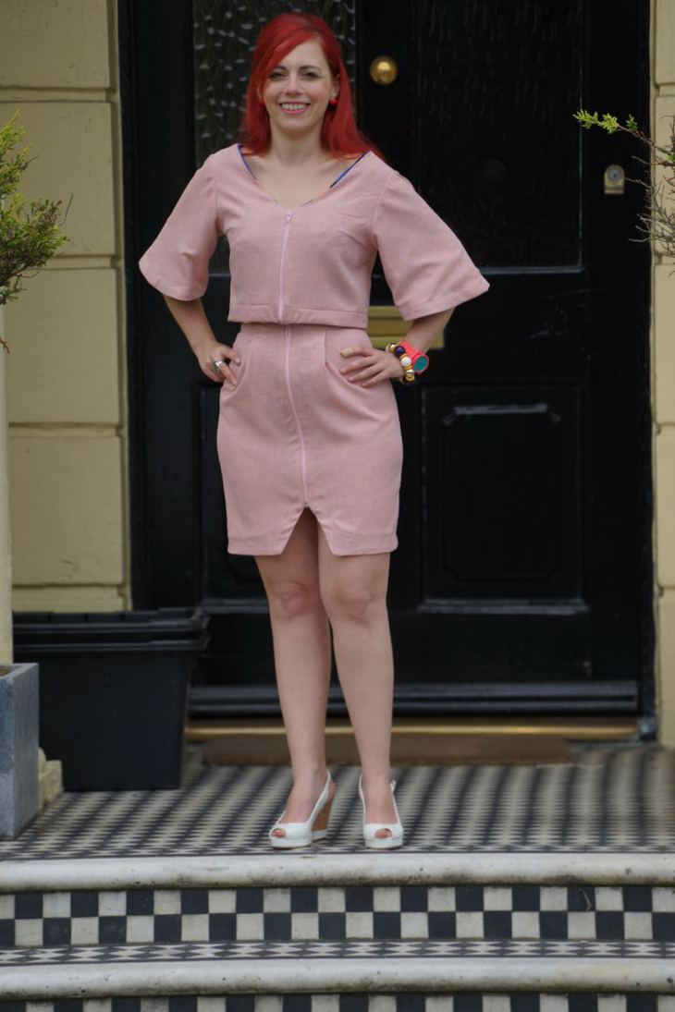

Off light pink coloured dress. Mini dress with 3 quarter long bell sleeves. Straight fit line. Miss shaped round neckline. V-cut in the skirt. Zip inserted in the top as well in the skirt. Dress doesn’t fit in any body shape. It won’t let the wearer stand out while wearing this dress. Cotton fabric used for this dress. It’s a formal balance dress. This dress has no rhythm and it’s disproportionate. Emphasis is created with the v-cut on the skirt. The zips that are used in the dress and the dress is divided in 2 section. The bottom part and the top.

Dress 2
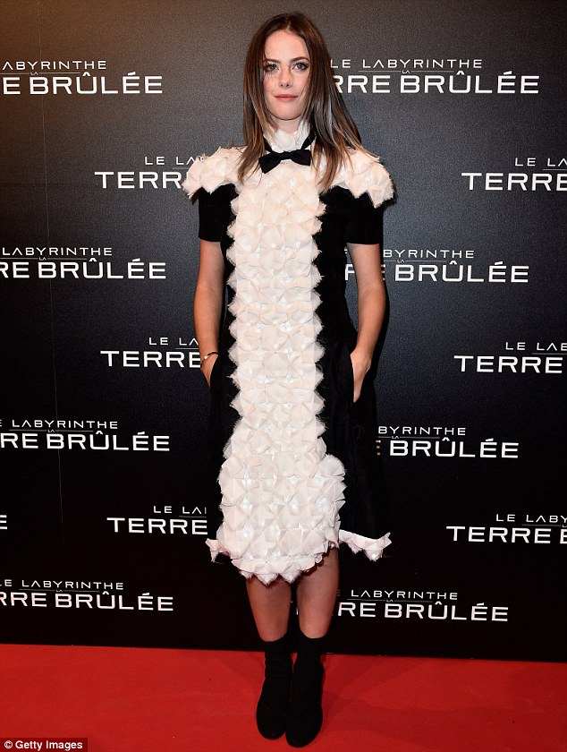
Black and white straight dress. Straight fit dress knee length. Half full sleeves. This dress wouldn’t stand out on any shape. Bow tie on the neckline makes the wearer look squashed. The ruffles in the middle of the dress looks like a cloud. Repetition in rhythm. Focal point are the ruffles. This dress is disapropiate. The black fabric is elastic jersey. The white fabric is cotton used for ruffles. Bowtie is made out of the same fabric as the black dress. The dress is symmetrical in balance,

Reference

www.pinterest.co.uk
www.h&m.com
www.vogue.com
www.veromoda.com
http://www.fashiondesignscope.com/?p=3302

Student Statement:

By submitting this assignment, I confirm that this is my own work.

Student Signature | s.choudrey | Date | 9/October/2015

For Tutor / Assessor Use Only
Total Marks
Marks Obtained
Percentage / Grade

