
Assignment Cover Sheet

Student Name: | Salma Mohamed Safaa
Student Number: | 1170
Course: | Interior Designing
Assignment NO: | 13

Student Statement:

By submitting this assignment, I confirm that this is my own work.

Student Signature | Salma Mohamed Safaa | Date | 15/12/2015

For Tutor / Assessor Use Only
Total Marks
Marks Obtained
Percentage / Grade

Student Name: | Salma Mohamed Safaa
Student Number: | 1170
Course: | Interior Designing
Assignment NO: | 13
Page NO: | 1

Interior Designing Course
Unit 13: The Finishing Touches
Q.1. Short Questions:
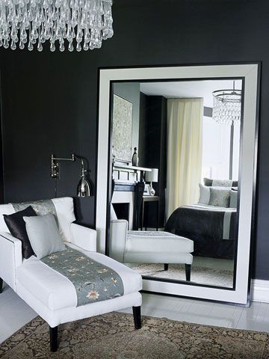
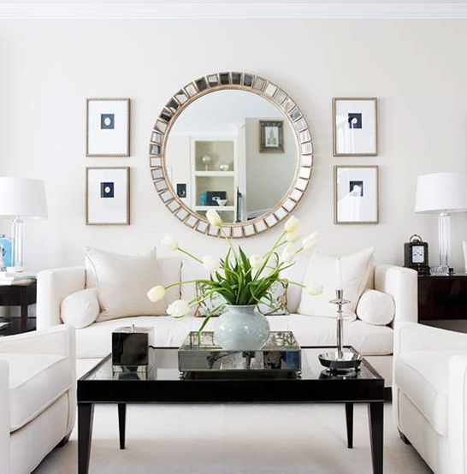
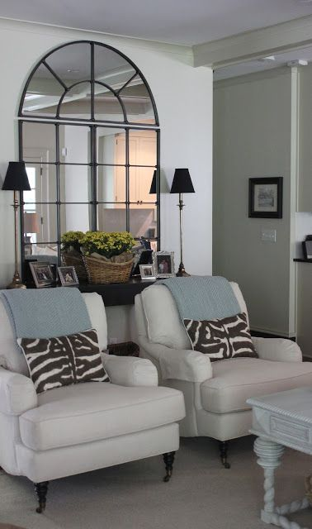
I. Large mirrors are a great way to create a focal point in a room, when they are hung or even standing on a wall along with an attractive piece of furniture in a way that draws attention to it. For example;
This bedroom sitting corner, is the focal poiont of the room perfectly created when the standing white framed mirror stood againt the dark gray walls, beside the white classy love seat.
This Symmetric grouping of Art surrounding a Large Mirror hung over the dominant piece of furniture of the room, the sofa.
This Grand Palais wall mirror looks fantastic in a living room hung above a dark wooden console.

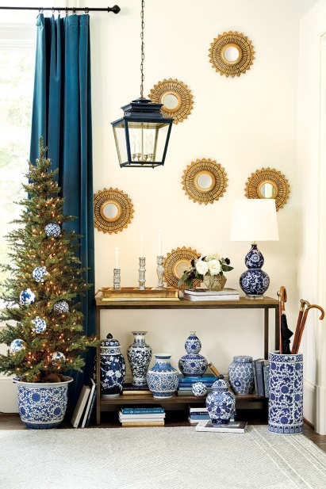
II. When grouping together number of small objects, it is of great importance to consider a common factor that blinds them together, for example; same shape, colour, texture or origin.
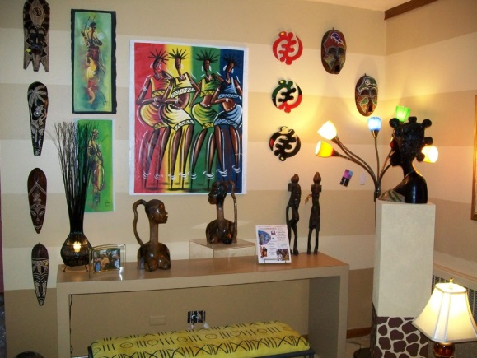
This groug of Artwork and accessories share a common origin of Arfican themed Art.

Decorting this corner with a collection of blues & whites Chinoiseries, with the blue curtain & pendant lamp

Student Name: | Salma Mohamed Safaa
Student Number: | 1170
Course: | Interior Designing
Assignment NO: | 13
Page NO: | 2

III. A set of different photographs and prints be unified by being framed in the same material or in the same color.
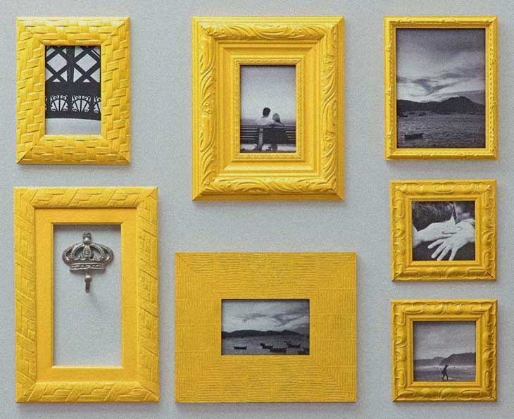
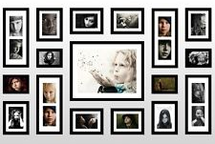
Unified by the choice of the same color of bright yellow frames and greyscale pictures.
Collection of photos being framed in Modern black wooden frames of the same width .
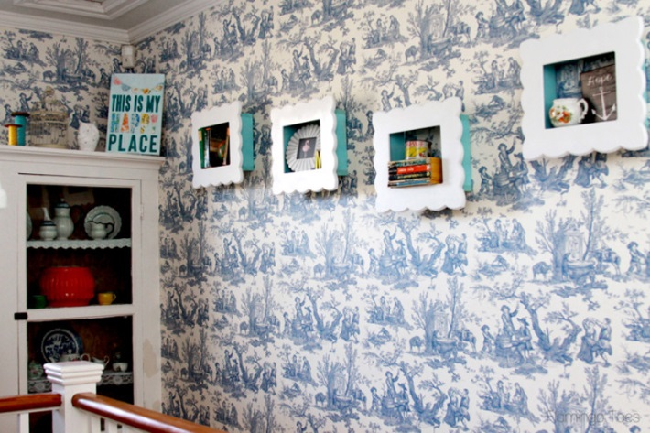
IV. If the walls are strongly patterned, it is best to display the pictures in very deep mounts, so that the subject is not lost in the surrounding background design.

V. To balance large picture with small pictures on the wall, they should be hung in symmetrical arrangements. When things are the same on both sides when divided down the middle (vertically or horizontally), they bring balance.
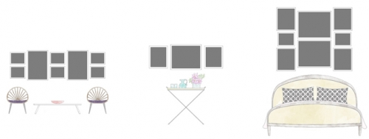

Student Name: | Salma Mohamed Safaa
Student Number: | 1170
Course: | Interior Designing
Assignment NO: | 13
Page NO: | 3

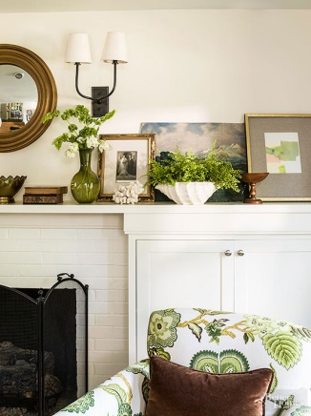
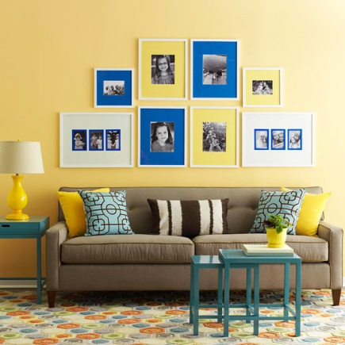
VI. It is very important it is to achieve a balance between accessories and rest of the objects in the room; because accessories are crucial elements as they play an important role in creating accents of colours, form and texture in a room. They provide a focus for the eye and greatly enrich the entire scheme.

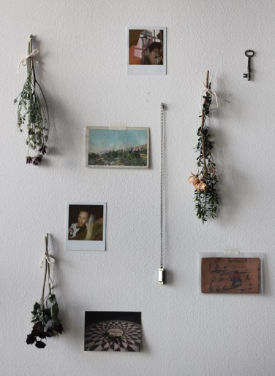
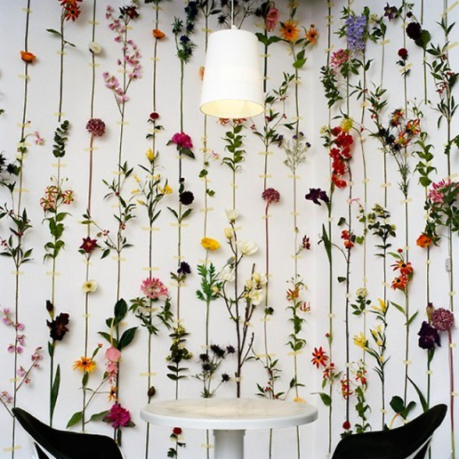
VII. Dried flowers, leaves and berries are perfect in decorating, they can be used to make flower arrangements; large and small, as well as wreaths, garlands and even dried trees. Also most dried plants add scent to the place.
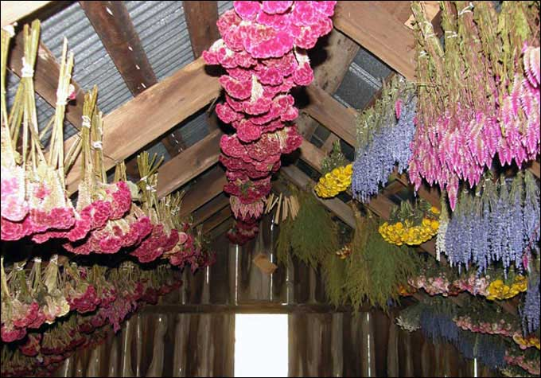
Most can be dried by hanging up-side down in small bunches in any dry and airy place.

VIII. Views on what is good art and bad art vary from individual to individual. But in a designer opinion, what makes some work of art better than others is how it is arranged and displayed.

Student Name: | Salma Mohamed Safaa
Student Number: | 1170
Course: | Interior Designing
Assignment NO: | 13
Page NO: | 4
Activity
A collage of the accessories would like to use in a living room

