
Assignment Cover Sheet

Student Name: | Omnia Rafiq
Student Number: | 1343
Course: | Diploma in interior Design
Assignment NO: | 13

Student Statement:

By submitting this assignment, I confirm that this is my own work.

Student Signature | Omnia Rafiq | Date | 30-4-2015

For Tutor / Assessor Use Only
Total Marks
Marks Obtained
Percentage / Grade

Q.1.i. How can a focal point be created in a room by using mirror?
When you enter into a room, what is the first thing you notice? Maybe it is the rug, a mirror in the wall, the curtains or even that big red sofa. Whatever grabs your attention or generates an instant impact to your perception of the space, is what’s called a focal point. These points of interest (or focal points) can add personality to any area, but sometimes, too much of a good thing can generate confusion in a space and make it feel crowded. When selecting your focal point, ask yourself what the main use would be for this area. Is it meant for reading, gathering friends or watching television? Based on this conclusion, you can select what accent you would like to be seen first.A big mirror is a great way to incorporate a focal point into your living room. It can be put over a mantel piece or bigger pieces of furniture such as sofa .You can even paint the frame in an interesting colour so that it will have more presence in the area.Mirrors are versatile. With an attractive wooden or gilded frame, they are most decorative; they reflect light and help to create the illusion of more space. A large mirror placed at the end of a dark and narrow passage way opens up the area dramatically. In a small room a mirror or mirrors placed opposite a window or windows create a feeling of greater space and airiness; with pairs of windows a smaller mirror placed between them provides added dimension.
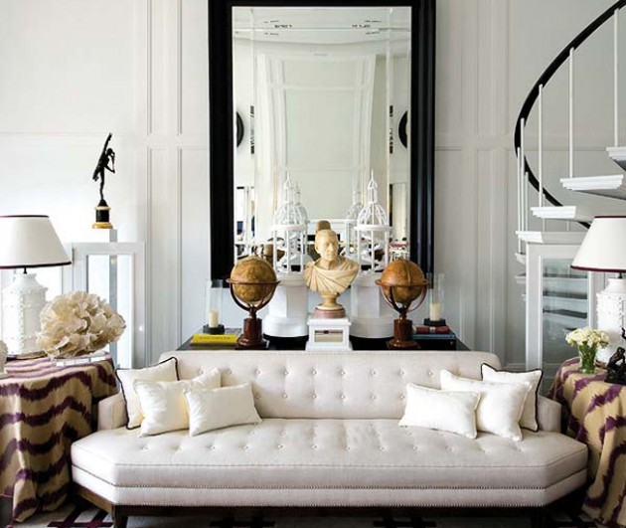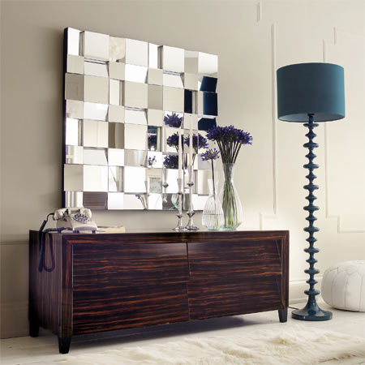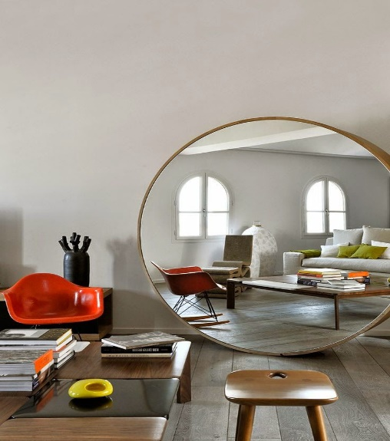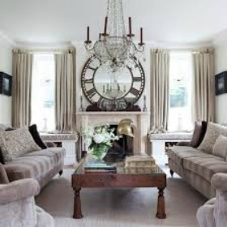

Q.1.ii. When grouping together number of small objects which factor is of great
Importance that should always be considered?
Any arrangement looks better if the grouped items have a common factor, its shape, colour or texture; otherwise the display will risk looking like clutter. You can find a never- ending supply of pottery, art, small trinkets, utensils, antique furniture and more when searching for your favorite old-fashioned finds. Grouping these together can consist of stacking, arranging, and combining for wall art and more. Antique books, suitcases and other stackable pieces can create an elegant and travel-inspired look for any night stand or end table. If you happen to stumble on a weathered piece of furniture like an old oak hutch, you can easily enhance it with many grouped valuables, alike or different, such as clocks, candle holders and other unique finds. For instance, if have a group of old kitchen utensils like spatulas, scoops and whisks, for a fun favourable wall piece, spray paint these items a theme-based colour and group them together; it is unique looking and really stands out in any room.One must take into consideration that the collection of ordinary but unexpected objects often makes more memorable rooms than much rare and more expensive items. Perhaps this is because one is less impressed by the effect of something one knows to be especially good than that of something one has no idea about. Remember that u can always play the role of Picasso; decorating your home with antiques takes being creative, artistic and open-minded. Try grouping old goodies together, mixing the old with the new, and creating crafts out of multiple finds. Always remember, one person’s trash is another’s treasure for fun and unique home-décor ideas.
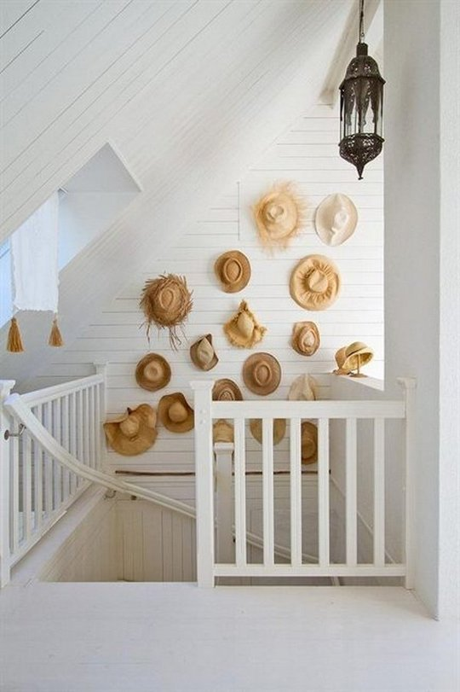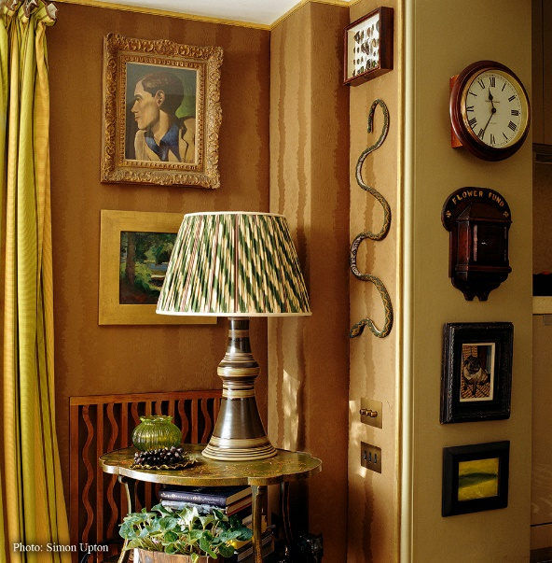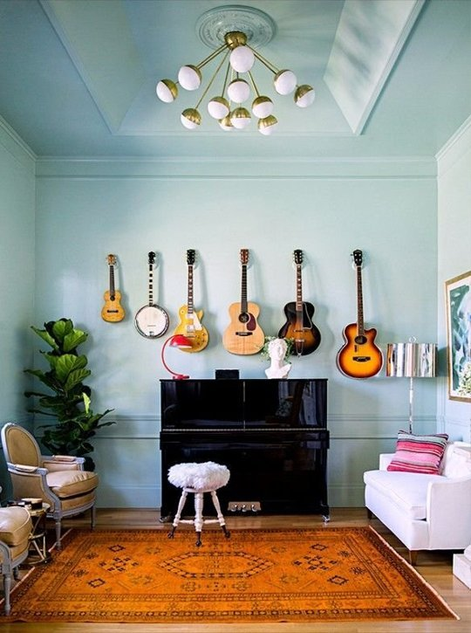

Q.1.iii. How can a set of different photographs and prints be unified?
A set of prints can be given a unity by getting them framed in same material, whether, chrome, brass, gild, silver or natural wood. Again an odd assortment of different subjects will have a unity of their own if they share a color: all sepia tints or all black and white, or all green, ivory or terracotta. Also we can get some sort of unity by hanging prints or photographs having the same size, without framing them.The way the objects and pictures are displayed, play a crucial part in the success of a room. Consider pictures first. By not dotting these around a room - one on each wall- as this will only emphasize the spaces between them. Instead by grouping them together on one wall, even if it means leaving the other three bare. If these are the pictures of smaller subject matter, size and frame, we can accentuate this connection by making the arrangement symmetrical. For example six prints can be hung in two rows of three or in three rows of two. Such symmetrical arrangements are also possible with disparate images and sizes: A large picture could be placed centrally, with smaller size images flanking it on other side. Pictures that are double hung, one on top of the other, also look eye catching, particularly in rooms where they are often viewed from a sitting position such as dining or living rooms.Images for the walls are not limited to drawings, prints and paintings. Also choose from posters, post cards, photographs, framed embroidery. A small piece of special fabric or hand printed wall paper also looks wonderful framed. Large single pictures look best hung over a mantelpiece or over a significant piece of furniture such as sofa or side board, centered within its space. Make sure that the picture

Is no wider than the item it is being hung over, and be aware of hanging it too low over a sofa.
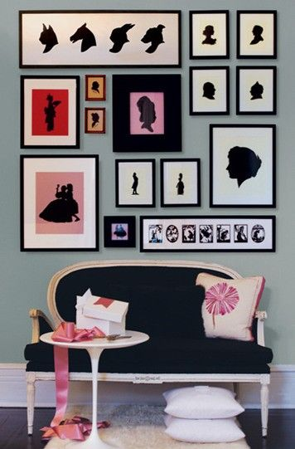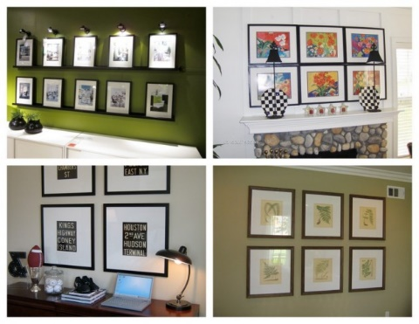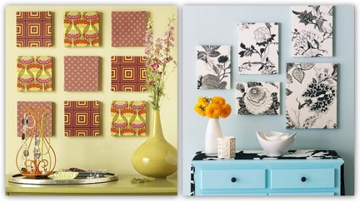
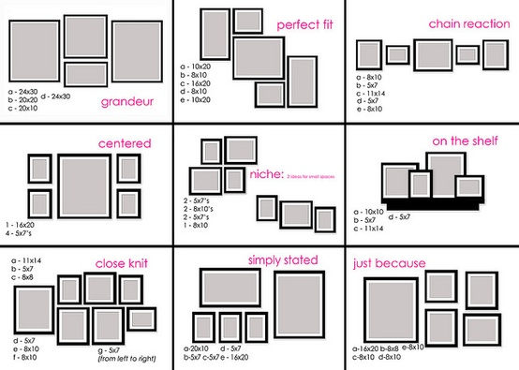
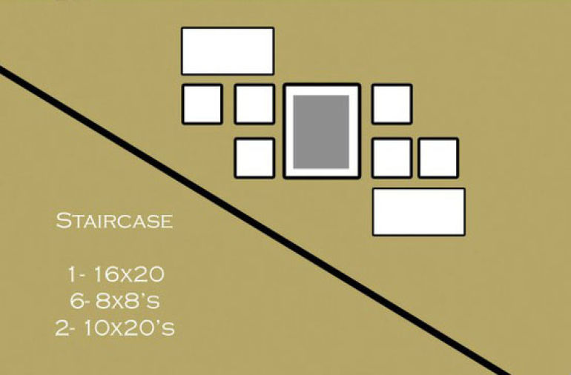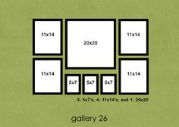

Q.1.iv. If the walls are strongly patterned how you would display the pictures that they are
Not lost in the surrounding background?
If the walls are strongly patterned, it is best to give prints and drawings very deep mounts, so that the subject is not lost in the surrounding background design. This can also be done when framing the pictures using a colour that makes contrast with the colours of the background, so that it can be eye catching!
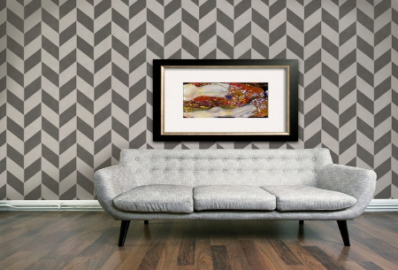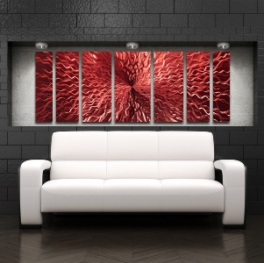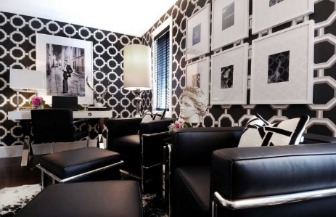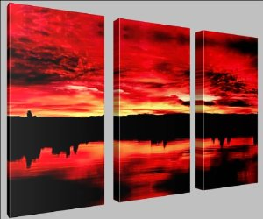

Q.1.v. If there is a large picture on the wall how would you balance it with small pictures?
A large picture could be placed centrally, with smaller size images flanking it on other side.Large single pictures look best hung over a mantelpiece or over a significant piece of furniture such as sofa or side board, centered within its space. Make sure that the picture is no wider than the item it is being hung over, and be aware of hanging it too low over a sofa.
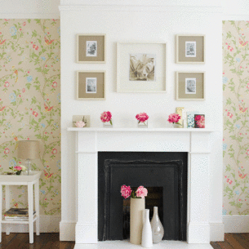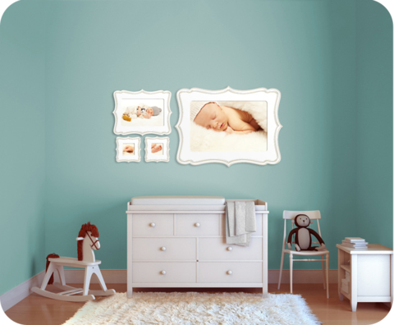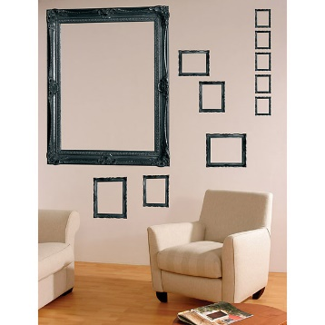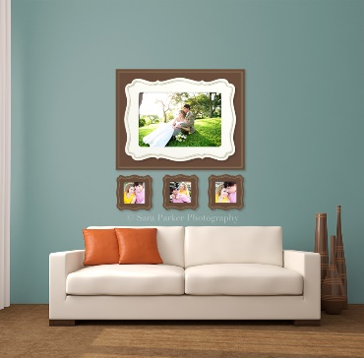

Q.1.vi.How important it is to achieve a balance between accessories and rest of the objects
In the room?
Perfect rooms are as irritating as perfect people. The ideal room is one that manages to look both interesting and relaxing; used but not abused. Upholstery should look neat and cushions should be plumped and well arranged. But at the same time the upholstery should look deeply comfortable and welcoming. If curtains are held back in tie-backs, these should be positioned at just the right height for the folds to look graceful. Blinds should be pulled up so that they are straight. Carpets, rugs, matting and hard flooring- all should look as clean as possible. Polished wood should be kept polished. Marble, glass and any metals should be free of spots. Table tops, window sills, mantel pieces, display units and shelves should look best with some sense of arrangement. Plants, collections and art should be carefully chosen and should be arranged properly but should not look so well arranged in artificial way, that one is nervous about putting down a glass for fear of spoiling an artistic effect. The decorative objects or the accessories are the crucial elements that can finish a scheme off perfectly. From handcrafted items and antiques to flowers and found objects, these are the decorative details that are often small in size but big in impact. In design term, they play a vital role in creating accents of colors, form and texture in a room. Whether displayed singly or in groups, they provide a focus for the eye and greatly enrich the entire scheme. If lighting, color scheme, window and floor treatments and the choice of furniture and upholstery are what make a room comforting, then the paintings and objects, plants, flowers and other embellishments are the
Elements that give it a special charm and make it memorable. They layer an interior scheme, thereby accentuating the colors, patterns, shapes and textures within the room. Some accessories are purely decorative, but others such as candlesticks and vases, have a functional role too. It is important when completing a room to be aware of this difference. Function must determine where something is placed, in terms of both height and location. Decide which of the items you want to be prominent, place them at key focal point in the room. Use other objects in a supporting role. Purely decorative accessories are only worth including if you display them well. Location is important, especially the color against which they are set, how they are lit and whether it is a single object that becomes a focal point or a group that needs to be carefully arranged for the maximum effect.
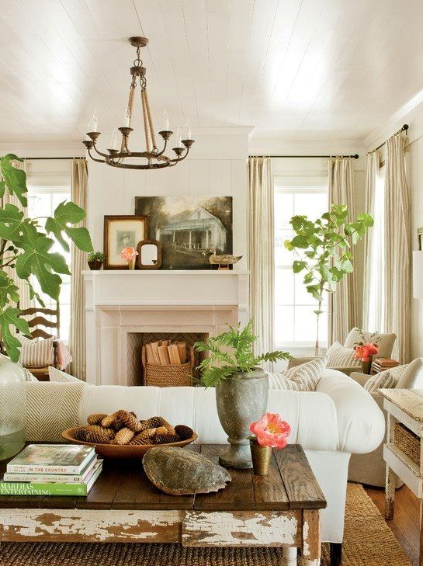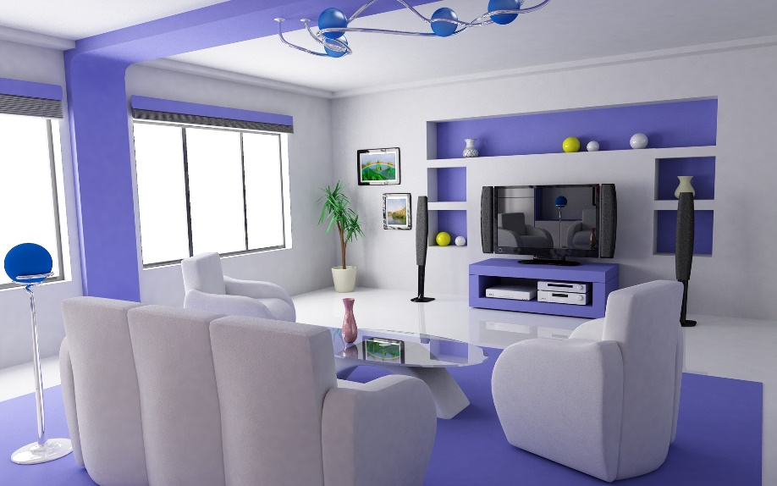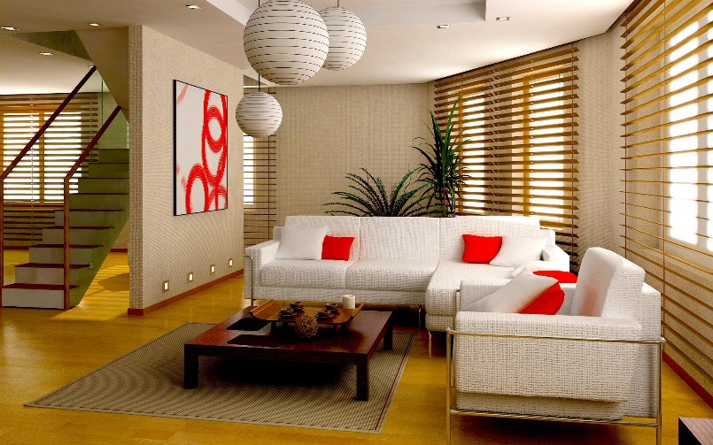

Q.1.vii.How can dry flowers be used creatively for decorating rooms? Mention one simple
Method for drying flowers.
Dried flowers, leaves and berries can be used to made flower arrangements large and small, as well as wreaths, garlands even dried trees. Dried florist’s foam is used for holding flowers in place or crumpled chicken wire can be used to hold everything in place. Almost any plant part—flowers, leaves, or stems—can be dried naturally or artificially. Many interesting and decorative cones, nuts, gourds, seed pods, flowers, foliage, fruits, and even small, graceful tree branches can be obtained by taking a walk in the meadows, woods, or along roadsides. Nature, with its seasonal variability, offers a tremendous diversity of colours, textures, shapes, and sizes of plant materials from which to select, the only limitation being the collector's imagination. There is no one time of the year to collect materials for drying, since some can be gathered every month and stored for future use. Don't wait until late fall and then try to gather everything all at once. Generally, fresh materials to be dried or preserved should be picked at midday, when water and food stored in the plant parts are at low levels. Collect foliage at the peak of its growing season, and pick flowers in perfect or near-perfect condition at early maturity, but not quite at full bloom. Avoid flowers that are damaged or defective. Use a sharp knife or shears to cut the material and place them in water to keep them from wilting.
Since stems dry very slowly and add unwanted bulk, remove them from flowers, leaving only an inch or two to which a wire may be fastened Remove leaves from branches that are to be preserved. Groom foliage so that only the desired portion is dried.

Air Drying
This is by far the simplest and least expensive method used to dry leaves and flowers. It takes little time and skill and nearly always produces satisfactory results. All flowers or stems that are semi-dry and that do not wilt readily can be used. Use a drying rack (an old window screen works fine) for individual specimens or tie flowers in loose bunches with rubber bands or twist-ties and hang upside down in a cool, dry, well-ventilated room. Large flower heads should be hung individually. Do not place the material in a warm oven or in front of electric heaters to speed up the process, because this can be dangerous, but some air circulation is necessary to prevent growth of mold and to allow proper drying. Flowers usually take one to three weeks to dry, depending on the thickness of stems and foliage. The fleshier the flowers or foliage, the more time it will take to dry.

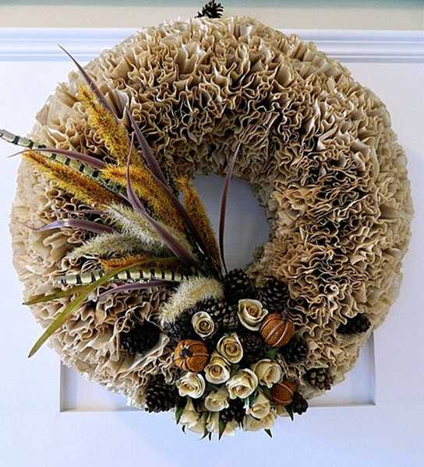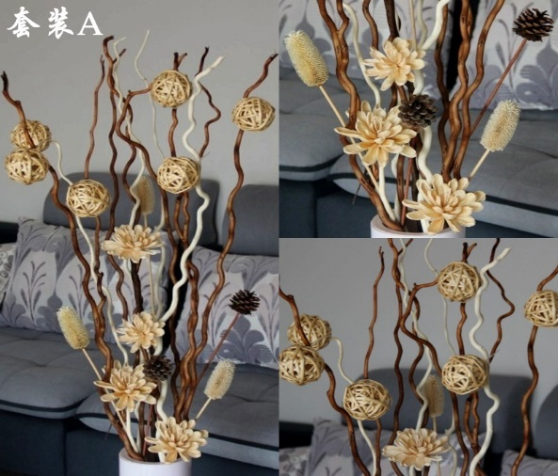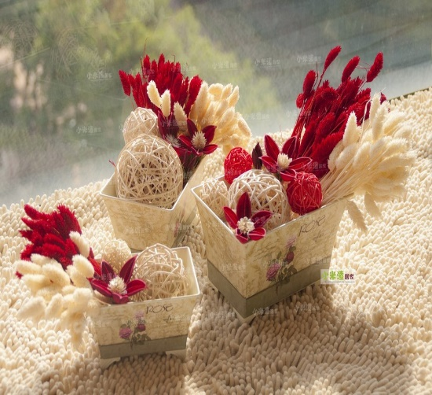

Q.1.viii.What makes some work of art better than others? How can you differentiate good
Art from bad art?
There are two schools of thought on the display of objects: the school for simplicity and the school for clutter. The problem with simple school is that the few objects used for display should be really beautiful or unusual, or at least made to appear so. The difficulty about ‘cluttered’ school is that the collections must be organized to display the possessions to their
Best advantage. Good art involves a careful assemblage of texture, shape and color. Collections of small objects are far more effective when grouped together, rather than scattered thinly around the room. For example, very small objects like, pebbles, shells or polished fragments of stones from the beach can be put into a bowl or goblets and displayed on window sills or shelves. Slightly larger objects can be grouped in a way, so that they have something in common, like color, texture, shape or origin. Alternatively they can be juxtaposed with larger or smaller objects to create more interest and balance. You can add a plant or some dried flowers in a jar for contrast. If arrangements are grouped on some small table which is also used for books, magazines, glasses and so on, leave space so that the composition will not be ruined by putting down a tray, drink or book. If arrangements are placed on a glass table or shelf, you can light them from underneath with some up lighter to add charm, if they are not on transparent surface, try lighting them from above with down lighters from above to add extra brilliance.
For wall art,Here are certain guidelines to follow:
- Most art work stands out on dark walls although some drawings and graphic art can look good even on grey and neutral colors. If the walls are strongly patterned, it is best to give prints and drawings very deep mounts, so that the subject is not lost in the surrounding background design.
- Before hanging different sizes of pictures or other wall mounted objects that vary in size, shape and style, lay them out on the floor first and move them around until you find a composition that works best with other arrangements in the room and the wall space available.
- Decide on the overall shape of the arrangement and mark out the area on the wall in pencil before you attempt to hang several things together. This will save a lot of unwanted nail holes. Vertical arrangement of art makesroom look taller.
- Horizontal arrangements of art make room look longer.
- A lot of small works of art can be hung as a block to balance a large painting.
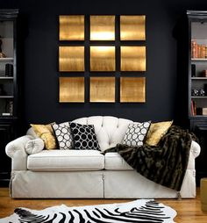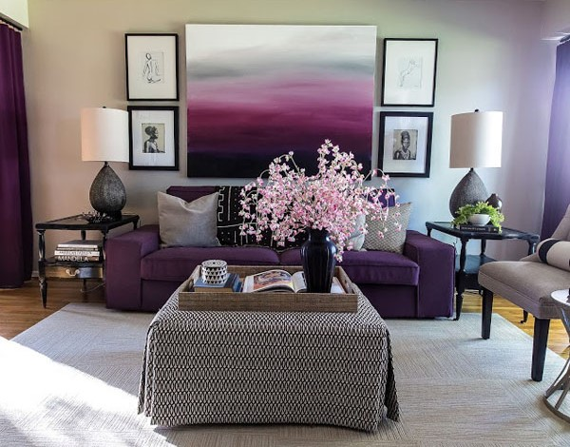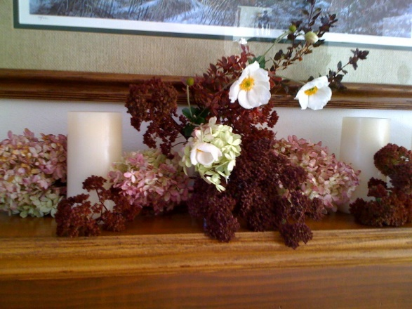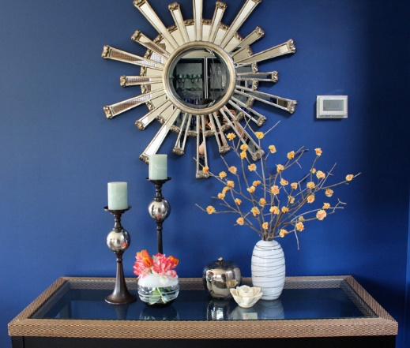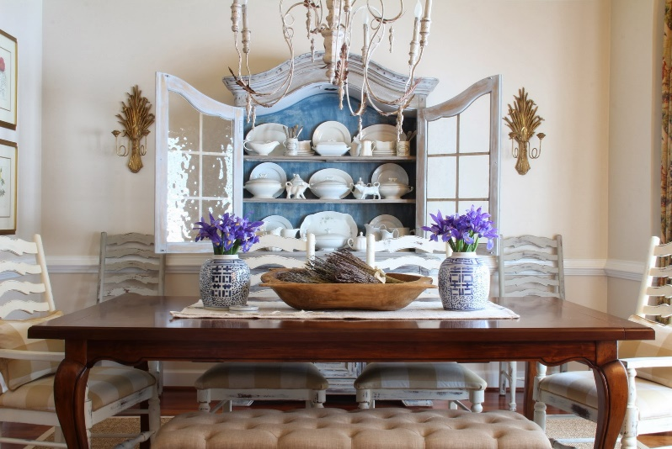

Activity
Make a collage of the accessories that you would like in your living room (use cuttings from the
magazines)
Smaller accessories look better in groups, but I have to avoid bringing in too much. Since there is a fine line between accessorizing and “cluttering” the room.

- I would hang small objects Symmetrically in group .. above the side table
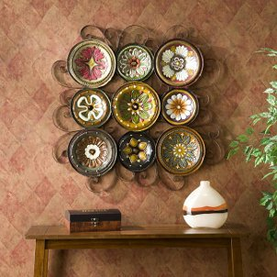

- A large Single Picture Placed Centrally above the Sofa - Or grouped Pictures having the same size and colour
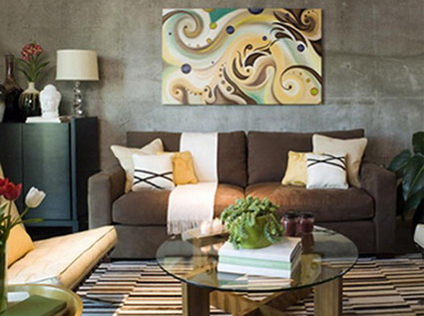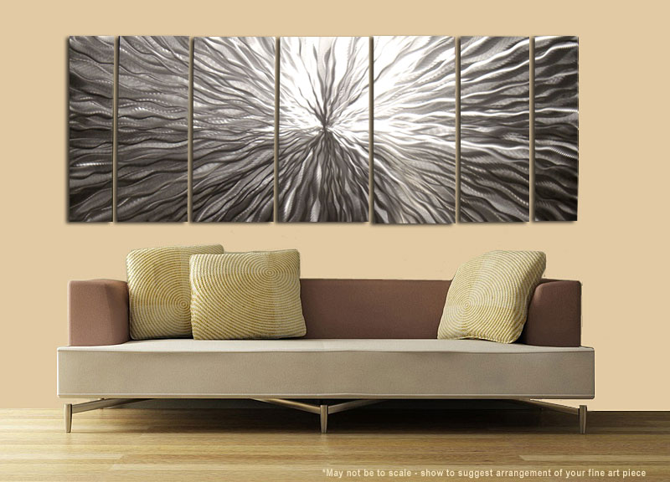

- A large Framed Fabric above the mantelpiece would be eye catching!
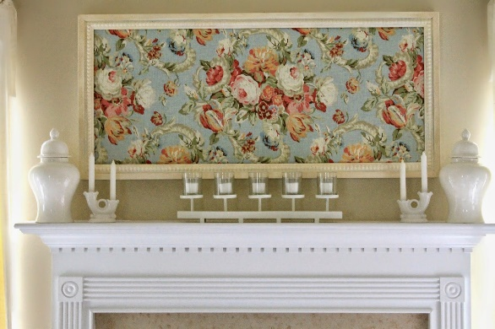

- I would use both dried flowers and small green plant pots that goes well with the neutral design scheme On the end table tops
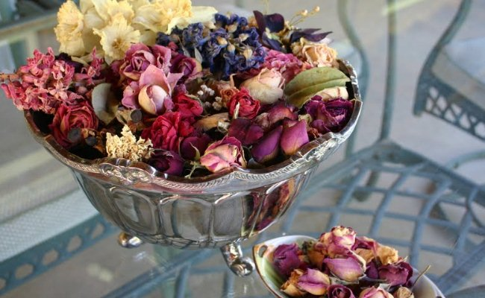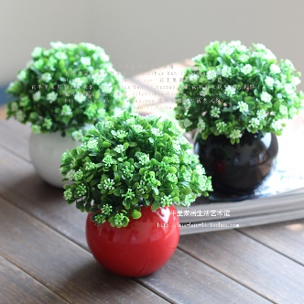
- And one standing large potted green plant closed to the seating area
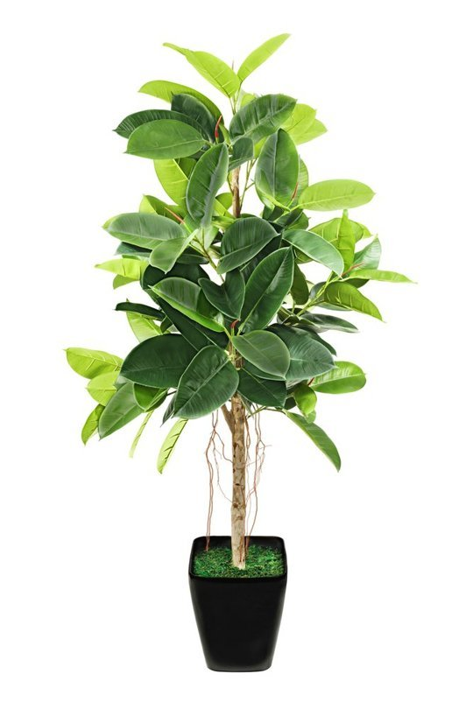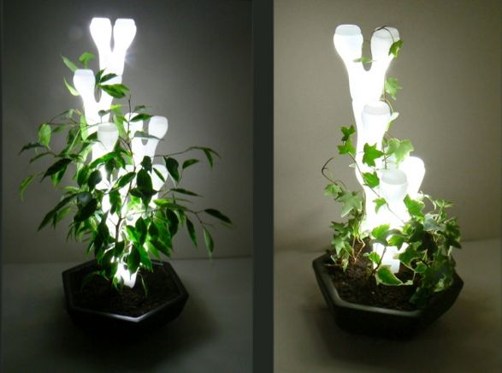
- I would Use up lights behind plants to throw dramatic shadows onto walls and ceilings, as well as illuminating the foliage on a dull day and at night orplants can be put under the down light.

