
Assignment Cover Sheet

Student Name: | Kyle Pentland
Student Number: | 1605
Course: | Diploma in Environmental Management – Level 4
Assignment NO: | Assignment 10

Marking Criteria:
We expect the learners to write minimum one well expressed point in three lines against each allocated mark. This means one needs to write 15 lines with 5 well expressed points to get high grades for a 5 marks question.
For high grades use examples and illustrations where appropriate.

Page 1
Q1:
The main load-carrying structural elements of timber dam are made of wood, primarily coniferous varieties such as pine and fir. Timber dams are made for small heads (2-4 m or, rarely, 4-8 m) and usually have sluices, according to their design. They are divided into pile, crib, pile-crib, and buttressed dams. The openings of timber dams are restricted by abutments. Where the sluice is very long it is sub-divided into more openings by alternate supports: piers, buttresses, and posts. The openings are covered and protected by wooden shields, usually several in a row one on top of the other. Simple hoists, permanent or mobile winches, are used to raise and lower the shields.
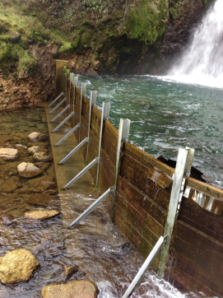
Timber Dam
When it comes to difficulty of design and examination of stresses, arch and dome dams are probably the most astounding and complex. These dams are thin, curved structures commonly containing reinforcement, either steel rods or pre-stressed steel cables the volume of concrete needed is much less than for gravity and gravity arch dams, but the competency of bedrock in foundations and abutments to sustain or resist loads must be (like gravity dams) of a high standard. Arch dams are usually built in narrow, deep gorges in mountainous regions where access and availability of construction materials and transport roads pose especially acute problems.

Page 2
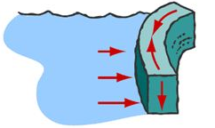
Arch Dam
A gravity dam is an extensive sized dam produced from concrete and engineered to store and contain large volumes of water. By using dense, heavy concrete, the downward weight of the dam is actually able to resist the horizontal thrust of water pushing against it, hence, why it is called a gravity dam. Gravity is essentially pulling the dam downward to the ground, stopping water from toppling over it. Gravity dams are particularly well suited for blocking rivers in both wide valleys or narrow gorge ways. The key to a Gravity Dam is its foundation. Where the Dam comes into contact with the bedrock is the key to its integrity as this ultimately is where the weight lies and forms its stability.
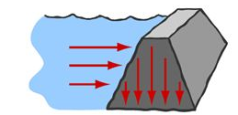
Gravity Dam
Embankment dams are made from compacted earth from natural resources unlike processes concrete and are of two main types, rock-fill and earth-fill dams. Embankment dams depend on their weight to contain the exertion of the weight of the water, similar to gravity dams made from concrete. Rock-fill dams are embankments of compacted free-draining grainy earth with a watertight zone. The earth employed for this often contains a significant percentage of large particles, hence we use the term rock-fill. Earth-fill dams, also called earthen or simply earth dams, are constructed as a simple embankment of well-compacted earth.

Page 3

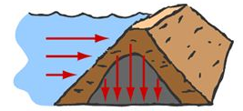
Embankment Dam

Q2:
Hydroelectric power plants generally range in size from several hundred kilowatts to several hundred megawatts, but a there are a few gigantic power plants that have capacities near 10,000 megawatts which is required to supply electricity to millions of people. World hydroelectric power plants have a combined capacity of over a third of a million megawatts that produces over 2.3 trillion kilowatt-hours of electricity each year; supplying nearly a quarter of the world’s electricity.
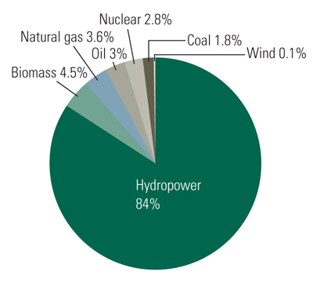
Brazil’s energy requirements
It has been stressed how vital water is for humans. It is important to remember that of the total rainfall falling on the earth, most falls on the sea and most of that which falls on earth ends up as runoff.
Page 4
Only 2% of the total is infiltrated to replenish the groundwater. Well designed constructed and maintained dams contribute significantly toward fulfilling our water supply requirements. To accommodate the variations in weather patterns, dams are needed to store water and then provide more consistent supplies during shortages.
Presently, irrigated land covers about 277 million hectares i.e. about 18% of world’s arable. However it is responsible for around 40% of crop output and employs over a quarter of the population within rural areas. With population increase, irrigation must be expanded to increase food capacity production. It is estimated that 80% of additional food production by the year 2025 will need to come from irrigated land. Even with the conserving of water by improvements in technology, the construction of more dams will be needed.
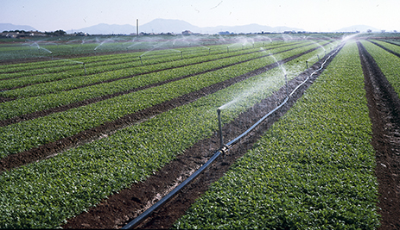
Irrigated Land
Flood control is an important issue for the Netherlands, as 62% of its area is susceptible to flooding, while the country is among the most densely populated on Earth. Sand dunes, human-made dams and floodgates provide defence from unpredictable sea changes. River dams prevent flooding from water flowing into the country by the major Rhine and Meuse rivers, while a complex system of drainage ditches, canals and pumping stations keep the low-lying parts dry for habitation and agriculture.

Page 5
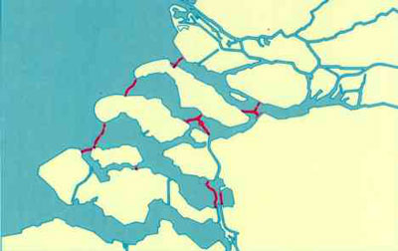
Dams for flood prevention in The Netherlands
Whenever a river is dammed such as the Hoover Dam, in the U.S.A. it allows the water further down-stream to be manipulated and re-directed to where it is needed. This can have benefits in a number of ways:
1. The water can be relocated to areas where it can be used for agricultural purposes; and
2. It avoids cities like Havasu and Bullhead (with a combined population of 70,000) that otherwise would become flooded and cause human and economic disaster.
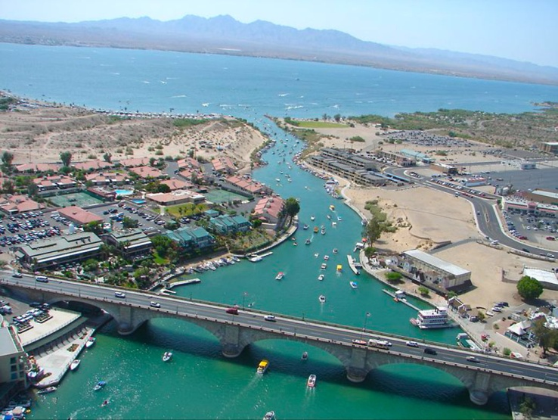
Havasu City

Page 6
Q3:
The words biodiversity management are used in many ways, from economists to miners. They all view biodiversity management from different perspectives. When people discuss biodiversity, they often use it as a surrogate for "wild places" or "abundance of species". Yet from the viewpoint of those engaged in biodiversity-related sciences such as population biology, ecology, evolution, and genetics biodiversity has a specific meaning, which is "the variety and variability of biological organisms". This definition is so broad that it can be clearly understood only by considering particular levels of biological organisation e.g. genes, species, communities, ecosystems, and even our planet. Each part requires different methods of analysis, understanding and different approaches to management. For managers, it is not just a matter of counting species or individuals. They must consider the role of biodiversity in the functioning of ecosystems and how they can be sustained.
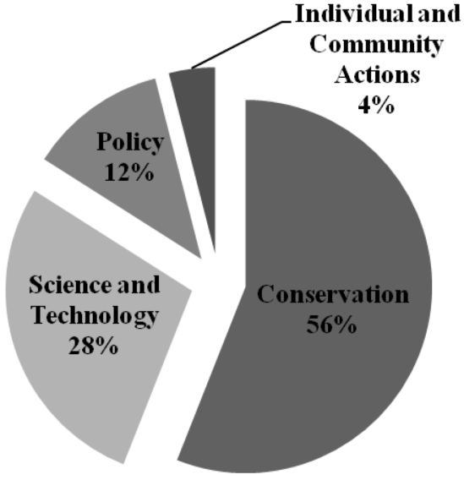
Distribution of given recommendations regarding biodiversity management
Sustainable forest management means the environmentally appropriate, socially beneficial, and economically viable management of forests for present and future generations. Different forests in different regions of the world require different management strategies. Sustainable forest management must be constantly adapted. It must reflect social, economic and political dimensions. The challenge is therefore to develop an approach that best deals with changing management at a global level and that:
Page 7
- sets standards and criteria for sustainable forest management at a global level that enjoy acceptance by stakeholders around the world, incorporating new knowledge, best practices and changing expectations;
- is flexible enough to reflect the specific national circumstances at local level, yet is also in compliance with international requirements;
- is accessible and affordable not only to huge companies, managing large areas of natural forests, but also to the millions of small family and community-forest owners for which forests represent an important part of their everyday lives.
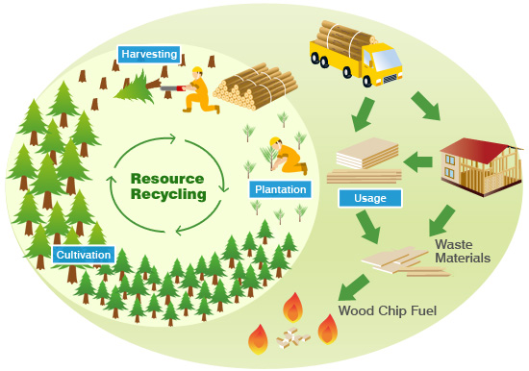
Sustainable forest Management
Underlying all of the Planet’s Water Management work is the belief that a new approach to the way we plan, manage and use water is urgently needed. The good news is that we are making progress. The focus has to be water policymakers at all levels to look at the risks of climate change on water supply, ultimately leading to a re-evaluation of the importance of water-use conservation and efficiency and fundamental changes in water policy both nationally and around the world. The work changes and evolves and more needs to be done. The most important change we can make is to stop taking water for granted and really value its importance.

Page 8
.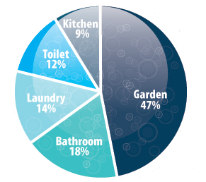
Water usage average Australian Household

Student Statement:

By submitting this assignment, I confirm that this is my own work.

Student Signature | Kyle Pentland | Date | 18/03/2016

For Tutor / Assessor Use Only
Total Marks
Marks Obtained
Percentage / Grade

