
Assignment Cover Sheet

Student Name: | Sukhwinder kaur
Student Number: | 1282
Course: | Fashion design
Assignment NO: | 9

Answer I.
There are some very important dos and don`ts to before using a soldering iron.
Do prepare a safe place in which to work. Do not have any extendsion lead or sockets on the workbench they should be on the floor. Do not let leads from other equipment, such as sewing machines, lamps and extractor fans, go anywhere near the soldring iron. Always work on the piece of glass with masking tape around the edges. Always work in a well-ventilated room or use an exractor fan. Always remember to switch off the soldering iron when you have finished working. Sew step by step by Alison smith .My sewing machine a berginner`s guide by kate haxell.
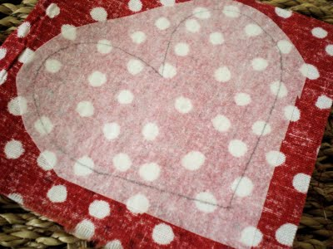
Answer II.
The create a fabric storage area as a sewer you probably have quite a vast collection of beautiful fabrics. Help these fabrics maintain their beauty and structure by storing them safely
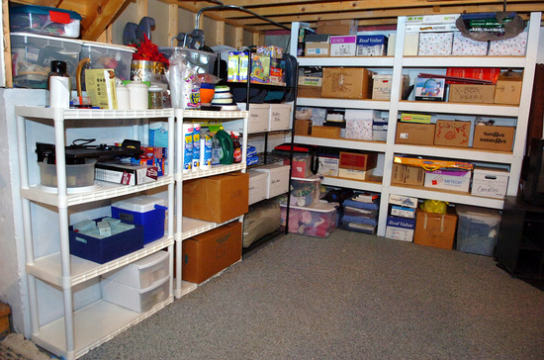
There are different ways to categories your fabric;
By colour: whites, blues, tans, reds, greens, etc.By style: plaid, stripe, toile, polka dots, floral, contemporary graphics, holiday, etc.By texture: cotton, rayon, denim, velvet, silk, canvas, leather, etc. fashion clothing, crafts, etc.Safely store your fabrics by: folding neatil and place in plastic containers. Label the outside by cutting small swatches of each fabric.
Answer III.
The rather than keeping patterns scattered all over the place, keeping them neat and tidy in a designated area. Lining up your patterns in drawers work especially well, you could also keep your patterns tucked inside a sturdy photo box, plastic container, pretty rectangular baskets, etc. lebel the drawers or boxes based on one of the categories below.

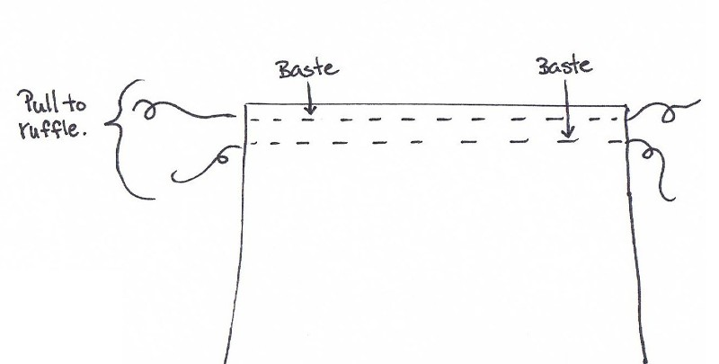
Answer Iv.
The diagonal basting used to prevent slipping of material when inserting zippers or putting in coat linings. Slant stitches on right side from bottom to top, come through to wrong side, dressmaker basting take one long and two or three shortstitches.

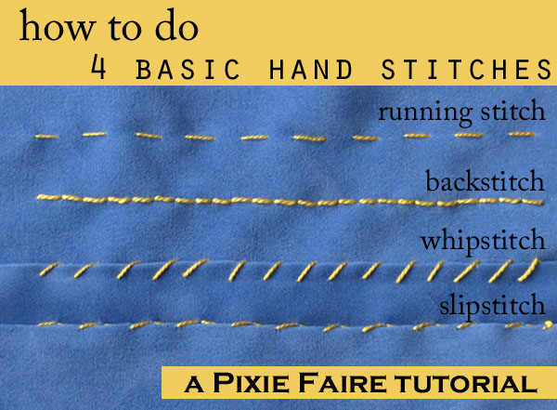
Answer 2.

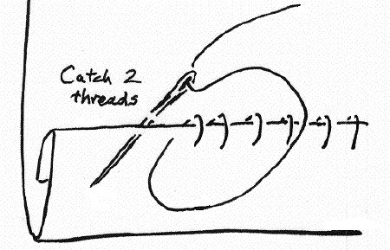
The hemming in hemming, turn in the edge of the fabric ¼ ich, then turn second time, and baste to under fabric. Make small slanting stitches from right to left, catching only a thread or two of the under material. A bias hemming tape may be stitched on to avoid turning hem under. Slip stitching is done for very fine work and is invisible on both sides. Take up one thread on underside of fold and one on underside of fabric.

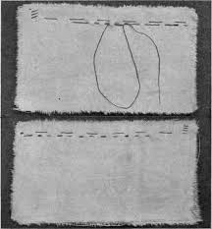
The combination stich top left on picture is two running stitches followed by one backstitch. It is stronger than a straight running stitch, but not as strong as backstitching.
The backstitching is the strongest handmade stitch. Take a tiny running stitch, go back to the end of the stitch, through to the wrong side, and out again to the right side at a distance from the end of the last stitch equal to one running stitch. Continue going back and under, being sure to work in a straight line.

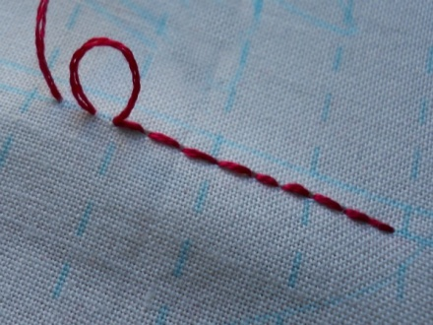
The shirring is the effect gotten by two or more rows of gathering. Make two or three lines of running stitches not more than ¼ inch apart and, holding all the ends together, gather and fasten threads around a pin.
The gathering is not a stitch but is rather an effect. Make a row of running stitches, but at the end, do not fasten. Leave a piece of thread about four inches long, and, holding this tightly, push the material back gently so as not to break the thread. Wind the thread around a pin to hold.
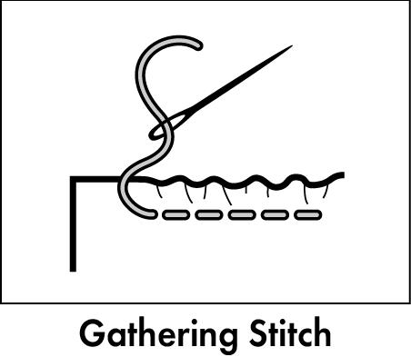
The gauging is used to bring a large amount of material into a small space. Do two or three lines of uneven basting, making sure that corresponding stitches lie directly in line, one above the other. Pull up threads as in gathering and shirring.

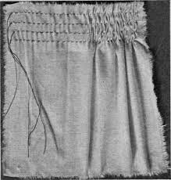
The whipping is done to get a fine finished edge. Roll edge to be whipped a little at time, wrong side facing you, hold roll tightly, and make tiny slanted stitches that pass under, not through the roll.
Answer 3.
The whipped seam is used for piecing when fabric is not wide enough to cut full pattern. Be sure grain of piecing is the same as the grain of garments / sewing project, turn in edges, and overcast with tiny stitches.
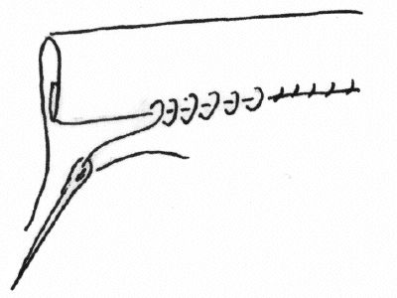
The curved seam must be clipped or slashed in several places to make it lie flat. This is important for smooth finish.

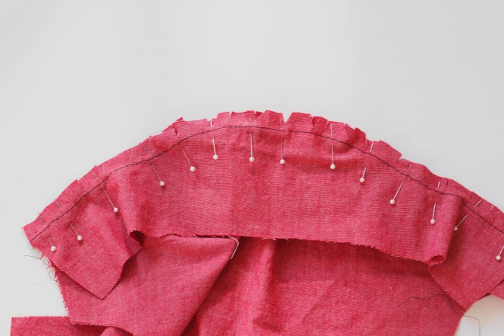
The strap seam is used for decoration. Plain seam is made and pressed open. On the right side, baste a strip of material with edges turned in, and edge stitch both sides. Braid and other trimmings may also be used.
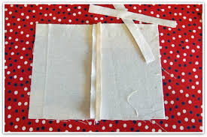
The lapped hemstitched seam is done by lapping seams, as explained under lapped seam. Hemstitch over the basting, trim away seam on wrong side.

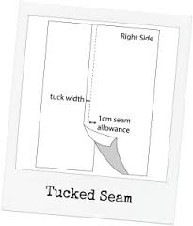
The tucked seam is similar to lapped seam except that the final stitching is done not at the edge, but at a distance from the fold. The effect is like that of a tuck.

Student Statement:

By submitting this assignment, I confirm that this is my own work.

Student Signature | Sukhwinder kaur | Date

For Tutor / Assessor Use Only
Total Marks
Marks Obtained
Percentage / Grade

