
Assignment Cover Sheet

Student Name: | Salma Mohamed Safaa
Student Number: | 1170
Course: | Interior Designing
Assignment NO: | 4

Student Statement:

By submitting this assignment, I confirm that this is my own work.

Student Signature | Salma Mohamed Safaa | Date | 28/09/2014

For Tutor / Assessor Use Only
Total Marks
Marks Obtained
Percentage / Grade

Student Name: | Salma Mohamed Safaa
Student Number: | 1170
Course: | Interior Designing
Assignment NO: | 4
Page NO: | 1

Interior Designing Course
Unit 4: The Principles of Design.
Q.1.
I. The term Human Dimensions is used to describe the set of measurements and dimensional requirements related to certain human activities such as reach, clearance and moving in a space. Also considering the Human Scale in an interior space.
The importance for the interior designer to consider Human dimensions and Scale:
- If the dimensions of an interior space or the sizes of the elements within it makes us feel small, we can say they lack Human Scale.
- If the space doesn’t dwarf us and the elements within the space offers a comfortable fit while moving in and using the space then we can say they are Human in Scale.
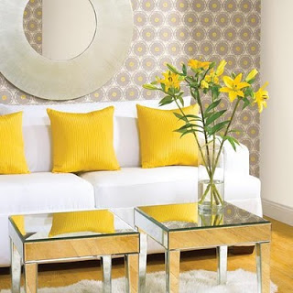
II. Contrasts can be introduced into an interior scheme through different elements:
- Form & Shape:
- Simple/Complex
- Beauty/Ugly
- Whole/Broken.

- Size:
- Large/Small
- Deep/Shallow
Angular shapes placed with rounded shapes create Form Contrast
- Fat/Thin.
Student Name: | Salma Mohamed Safaa
Student Number: | 1170
Course: | Interior Designing
Assignment NO: | 4
Page NO: | 2

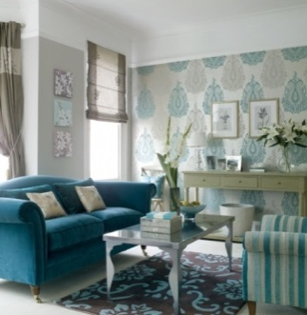
- Colors:
- Grey Scale/Color
Color Contrast:This space shows how that lovely blue hue can easily go light and airy when combined with silver or take on a solid grounded look with a deep chocolate brown.
- Black & white/Color
- Dark/Light.

- Texture:
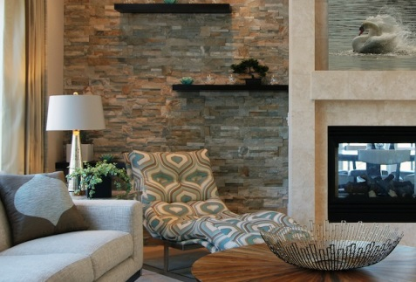
- Fine/Coarse
- Smooth/Rough
- Sharp/Dull.

- Position:
- Left/Right
Texture Contrast: between the Rough stone and elegant fabric.
- Isolated/Grouped
- Centered/Off-center
-Top/Bottom.

- Orientation.

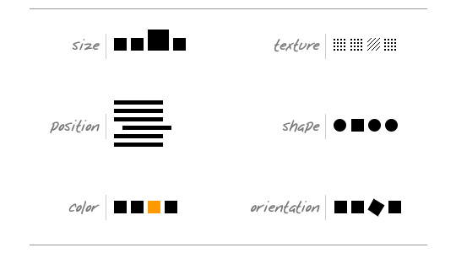
The importance of Contrasts:
Planning a consistent and similar design is an important aspect of a designers work to make their focal point visible. But too much Similarity is boring, here comes the importance of Contrasts in different elements to achieve the Visual Balance in the space.

Student Name: | Salma Mohamed Safaa
Student Number: | 1170
Course: | Interior Designing
Assignment NO: | 4
Page NO: | 3

III. Repetition establishes Rhythm through the repetitive use of an element. It establishes a continuity and a flow of rhythm. For example, a color repeated throughout an interior, grouping artwork to create a whole, or even a place setting can create rhythm if the eye can smoothly connect rather than jump or leap from one object to another.

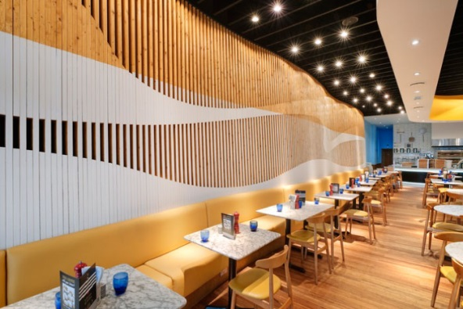
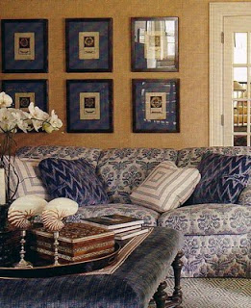
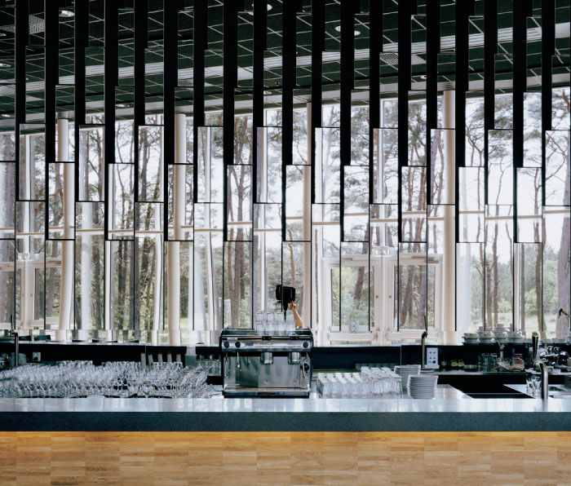
The repeating of wood slats on the wall creates a playful rhythm and draws the eyes through the space.
Repeating a pattern of mirrors
IV. Progression is taking an element and increasing and decreasing one or more of its qualities.

1- Color Progression: a monochromatic color scheme.
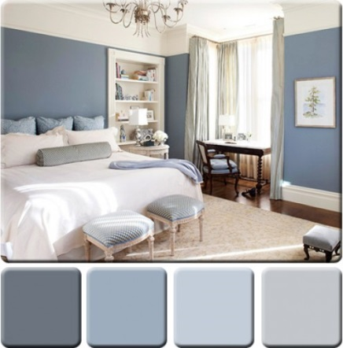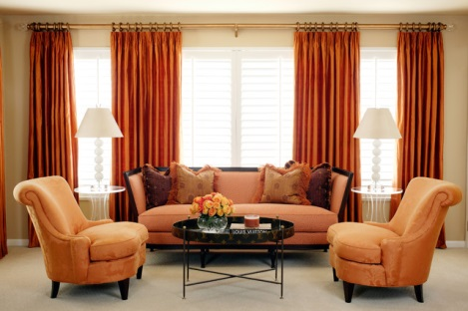

Student Name: | Salma Mohamed Safaa
Student Number: | 1170
Course: | Interior Designing
Assignment NO: | 4
Page NO: | 4

2 - Size Progression: Varying the size of an item or a pattern.

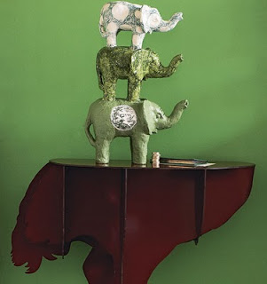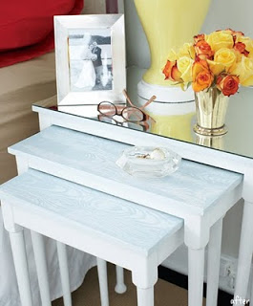
V. "Too many disjoined elements can be dis-quietening to the mind's eye".
An interior designer avoids this is an interior design scheme by making use of rhythm: repetition and progression of recurring elements and patterns; as repetition of design elements help to create movement within a space.
When rhythm is successfully applied it helps you to move your eyes about the space without you even realizing the rhythm is there.
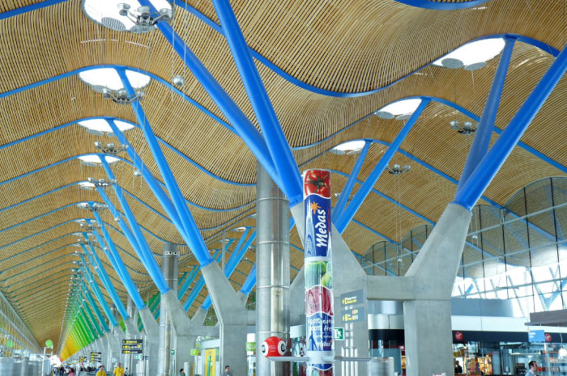
The Barajas Airport is an excellent example of rhythm achieved through repetition and progression of color.

Student Name: | Salma Mohamed Safaa
Student Number: | 1170
Course: | Interior Designing
Assignment NO: | 4
Page NO: | 5

Also another rhythm concept an interior design can follow;
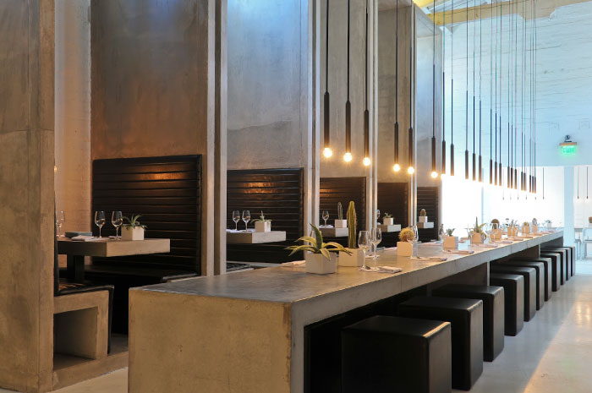
Alternation: is used to create rhythm b alternating two or more elements in a regular pattern may be ABC ABC or AB AAAA BA but always repeating in the same order.

This restaurant as an example displays both repetition in the booths and chairs, as well as alternation seen in the seen in the pendant lights that hang in groupings with a patterned rhythm.

Vi. It is of importance to consider the purpose of the interior space when planning a design.
The whole design scheme must meet the needs of the function or purpose of the space, as well as the activities of the space's different users. When planning a room, we need be aware of the function of that room so we plan accordingly and think ahead as to how many different functions a room will take.
For example: Designing a Living room:
Determine what your living room will be used for. Some uses for living rooms include entertaining, family games, reading and television watching. If you plan to entertain frequently, determine how many guests you will have to ensure you have enough seating and space. If you don't plan to have guests often, the room can be more of a cozy retreat for family. Make sure there is room and furniture for the various activities that will take place in your living room.
Student Name: | Salma Mohamed Safaa
Student Number: | 1170
Course: | Interior Designing
Assignment NO: | 4
Page NO: | 6

Q.2.
"Circulation through a space is a crucial aspect of a design.
Furniture arrangement needs to accommodate free movement or circulation from one space to another. Furniture should be placed to enhance the movement by allowing traffic to flow. The main goal here is to achieve optimal utilization of the space by eliminating unnecessary traffic patterns.
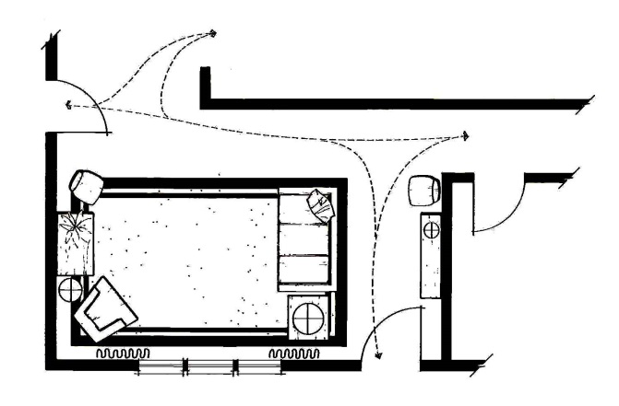
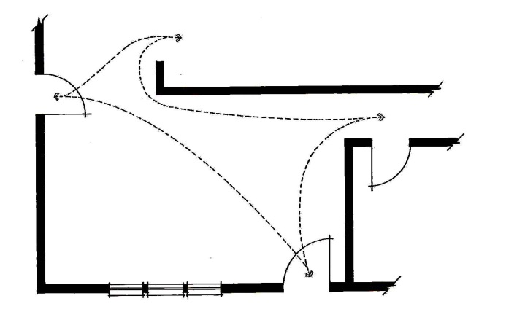
Traffic patterns are natural in every space. These patterns can easily be seen by drawing lines on a floor plan to represent the most logical walking paths that lead from one space to another.
.
Laying the corrected plan over the natural traffic plan will show where furniture should be placed to control the flow.
The traffic pattern of this room consumes nearly half of the available space.

Student Name: | Salma Mohamed Safaa
Student Number: | 1170
Course: | Interior Designing
Assignment NO: | 4
Page NO: | 7

Q.3.
Services like heating, lighting, plumbing and electrical are preferable to be considered in the early stages; as these services have constraints that have to be taken into account and in making necessary decision, as they may impact the design as a whole.
For the best results, starting by understanding the limitations of the space and let your dream design concept evolve from there. It may be wise to consult contractors and/or a specialist companies before planning the design scheme.

