Planning Essentials

Assessment 16 Total Marks = 20

Q.1. Multiple Choice Questions: (05)

- How would you accurately visually convey a room scheme to a client?
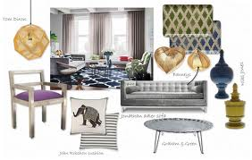
  - produce a sample board
  - produce a concept board
  - produce a sketch

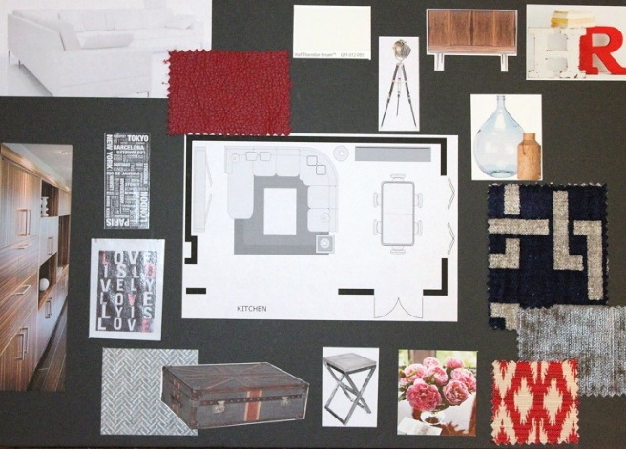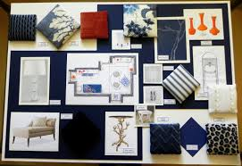

- for the very pre-liminary ideas there is no substitute for;

  - sketching
  - design board
  - sample board
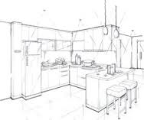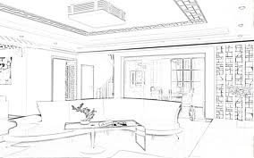
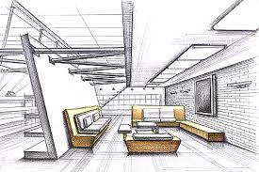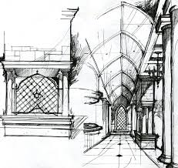

- What document is formulated by the designer after all the relevant information is gathered?

  - a questionnaire
  - a design analysis
  - a client brief

- Once the designer is clear about the availability of budget he can ask the client some questions to know exactly;

  - the client’s needs
  - project design
  - the design scheme

- if there is a pet in the house a designer should know about it because;

  - this may affect the colour and lighting
  - this affects the finishes and surfaces used
  - it may affect the room planning

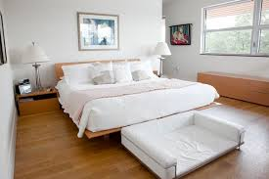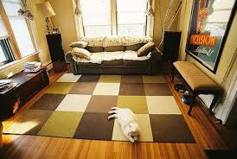
When having pets its better to use easy to clean surfaces and finishes especially flooring.

Q. 2 Short Questions: (15)
(All questions carry equal marks)

- The information collected at the “information gathering stage” usually relates to the four areas. What are they?
Answer:
Function (how long clients plan to live in that home, are there any children or will there be in the future any, are there any pets, elderly people, how do they feel about the space in the house, what kind of bed mattress, chairs they need etc);

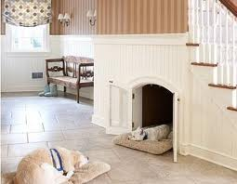
Practicalities (what is the state of floors, ceilings etc, is wiring up to date, what about air conditioning, burglary and smoke alarms, do they want any improvement etc);


Aesthetics (what is the taste of decorating, does client and his/her partner has a similar tastes, what styles for particular room, anything they dislike etc);



Budget (what is maximum budget, can they make compromises on items etc).

- How important it is for the designer to know about the client’s budget and at which stage should he try to know about it?
Answer:
To know a clients budget is very important, then designer can know what he/she can plan, quality of materials etc, and designer should try to find out about it in the very beginning of information gathering.

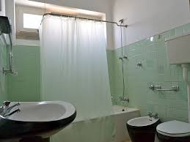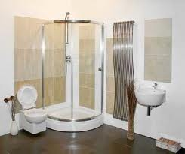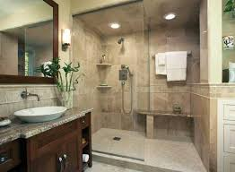

- How is decorating schedule different from the sample board?
Answer:
You have to make a decorating schedule when doing an interior design, it is like a reminder of what exactly is to be done and sample board makes it easier. The difference between decorating schedule and sample board is that decorating schedule shows you when and what exactly has to be done and sample board just helps to visualise everything.

Unit 16 Brentwood Open Learning College Page 1

Planning Essentials

- What do we call the process of gathering information from the client which then becomes the back bone of the designing scheme?
Answer:
The process of gathering information from the client which then becomes the back
bone of the design scheme is a questionnaire. This process may vary according to
whether the work involves redoing the whole house or just a room. Main aspects
are function, practicalities, aesthetics and of course budget.

- A------ board is a designer’s visual response to a brief. This may consist of magazine cuttings, photographs and sketches.
Answer:
A sample board
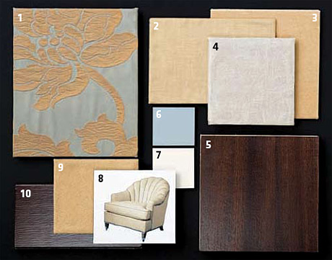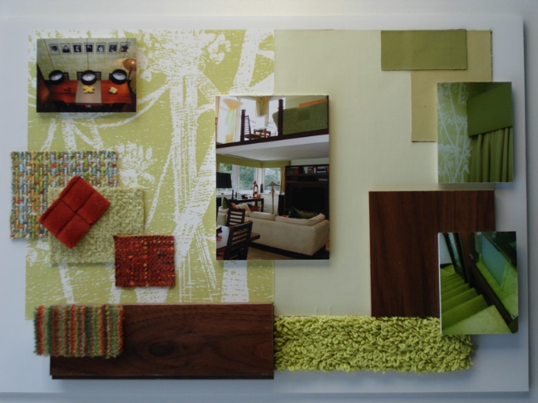

Unit 16 Brentwood Open Learning College Page 2

‘##

