
Brent
Assignment Cover Sheet

Student Name: | Mery Ann P. Alaba
Student Number: | 1406
Course: | Fashion Design
Assignment NO: | Assessment 1

Marking Criteria:
We expect the learners to write minimum one well expressed point in three lines against each allocated mark. This means one needs to write 15 lines with 5 well expressed points to get high grades for a 5 marks question.
For high grades use examples and illustrations where appropriate.
Please insert your completed assignment ( in word format) here:

Assessment 1

- Question

- First World War influence fashion because of the dictated more by necessity than fashion. Women had to enter the workforce while men served on the warfront, so they adopted men’s clothing for its comfort.

The types of changes that they brought they produce straight dresses that completely hid their feminine features to achieve, in a way the position of men in society.

Social events had to be postponed in favour of more pressing engagements and the need to mourn the creasing numbers of dead.

Visits to the wounded, and the general gravity of the time meant that darker colours became the norm.

By 1915 fashionable skirts had risen above the ankle and then later to mid-calf.

- The characteristic features of the twentieth century’s fashion are more dual version like boy and girl can wear the fashion clothes.

The cloche hat was widely-worn and sportswear became popular with both men and women.

Mostly design by Lavin with skilful use of complex trimming, dazzling embroideries, and bended decoration in light, clear oral colors

By 1925 Lavin produced many different products; such a sportswear, furs, lingerie, men’s fashion, Short suit jackets replaced the old long jackets, and more variety of sports clothes.

2. In 1970’s they retained a considerable degree of influence over fashion, British
style was the resolutely un modern, feminine, countrified style of clothing
Popularized by Laura Ashley, which consisted of long flounced skirts and high
necked blouses in traditional floral prints, worn with crocheted shawls.

It is continue to expand till the accident happen to the owner in 1985. Mr. Bill
Blass introduced his own range in 1962, by his disciplined style and
workmanship he became a favored by businesswomen and the wives of senior
executives.

Also 1970’s fashion develop the Italian fashion as a result of ready to wear
industry, the most influential Italian design of that time are Giorgio Armani & Nino
Cerruti.

3. In 19th Century Fashion industry influence by more cheaply than producing an
actual sample garment in the work room by organized a shown fashion house.

The major changes are to present the image of the design to the Client before producing an actual sample garment. Why? Because if the Client liked the design sketch they can change on the pattern before ordered it and resulting garment made money, save time and more presenting complete garments on models to customers began as an economy.

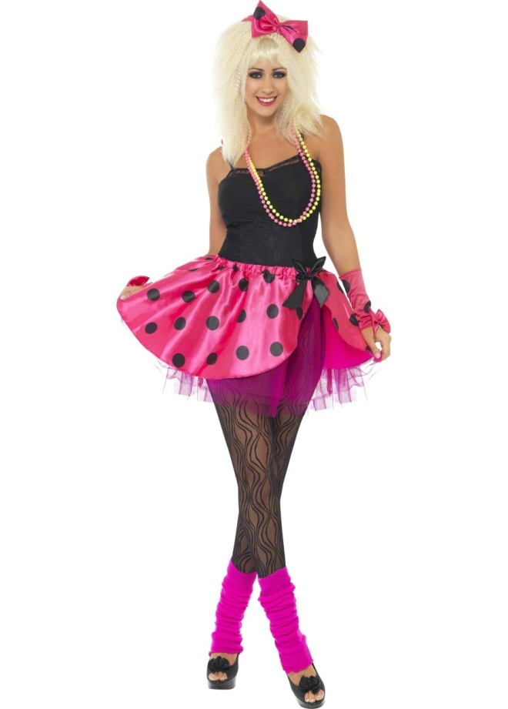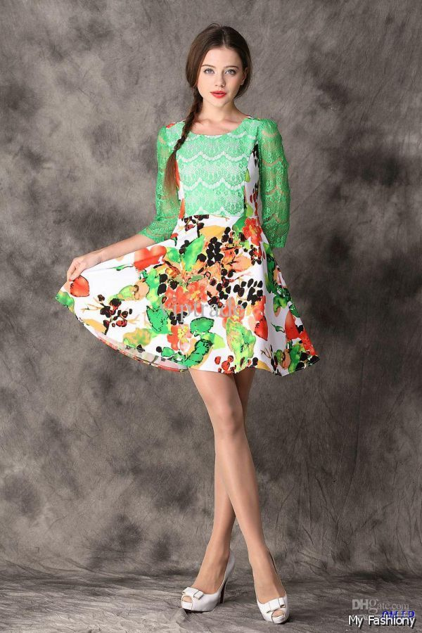

1980’s Present Fashion

In 1980’s fashion clothes is more likely punk fashion as well as retro, sporty type, have high waste, very bright colored, more accessories such a necklace, bangles and colorful earrings. Also it is more open to wear both boys & girls especially the sneaker type. Unlike this year the fashion trend is more likely the same in 1970’s flounced skirts, floral print blouses but not much far from the design this year because it is same small skirt above the knee and colorful, actually for me it is like a “life cycle” repeated with the original fashion into a new fashion but in a different color combination only.

Student Statement:

By submitting this assignment, I confirm that this is my own work.

Student Signature | MERY ANN ALABA | Date | 16-March -215

For Tutor / Assessor Use Only
Total Marks
Marks Obtained
Percentage / Grade

