
Assignment Cover Sheet

Student Name: | SHAKEEL AHMED
Student Number: | 1507
Course: | DIPLOMA IN ACCOUNTING AND FINANCE LEVEL 4
Assignment NO: | 5 - Understanding Profit & Loss Statement

Marking Criteria:
We expect the learners to write minimum one well expressed point in three lines against each allocated mark. This means one needs to write 15 lines with 5 well expressed points to get high grades for a 5 marks question.
For high grades use examples and illustrations where appropriate.
Student Name: Shakeel Ahmed
Student ID# 1507, Assessment # 5,
Page No: 1
Q:1) Below mentioned are some Contents of statement of profit or loss and are described accordingly:
- Gross Sales (2) Returns & Allowances (3) Income Tax (4) Revenues (5) Depreciation (6) Interest (7) Insurance (8) Expenses (9) Operating Income (10) Cost of Goods sold (11) Net Sales (12) Selling & Distributing Expense (13) Repairs & Renewals (14) Gross Profit

- Gross Sales: A measure of overall sales that isn't adjusted for customer discounts or returns, calculated simply by adding all sales invoices, and not including operating expenses, cost of goods sold, payment of taxes, or any other charge. Gross sales are the sum of all sales during a time period. Net sales are gross sales minus sales returns, sales allowances, and sales discounts. Gross sales do not normally appear on an income statement. The sales figures reported on an income statement are net sales.[4]
- sales returns are refunds to customers for returned merchandise / credit notes
- debit notes
- sales journal entries non-current, current batch processed transactions predictive analytics in strategic management/administration/governance research meta frameworks
- sales allowances are reductions in sales price for merchandise with minor defects, the allowance agreed upon after the customer has purchased the merchandise (see also credit note)
- sales discounts allowed are reduced payments from the customer based on invoice payment terms such as 2/10, n/30 (2% discount if paid within 10 days, net invoice total due in 30 days)
- interest received for amounts in arrears
- inc/exc amounts capital goods & services, non-capital goods & services input valued added tax, with cost of non-capital goods sold.
Student Name: Shakeel Ahmed
Student ID# 1507, Assessment # 5,
Page No: 2

input vat - output vat
sales of portfolio items and capital gains taxes
Sales Returns and Allowances and Sales Discounts are contra-revenue accounts. In a survey of nearly 200 senior marketing managers, 70 percent responded that they found the "sales total" metric very useful.
- Returns & Allowances: The financial accounting term sales returns and allowances is used
to describe the value of unsatisfactory merchandise returned by customers or refunds issued by the company to customers. Sales returns and allowances is found on company's income statement.
Most companies allow consumers to return a product if it is found to be defective. Oftentimes a customer may agree to keep a defective product if a partial refund is applied to the price paid. This is referred to as an allowance. Alternatively a customer may decide to return an unsatisfactory product.
Such allowances and returns are reported on the company's income statement thereby reducing revenues. These returns also lower accounts receivable (credit sales) and / or cash on the company's balance sheet. The company's management team is interested in knowing the value of sales returns and allowances since it not only measures customer satisfaction but also serves as a quality control metric.
- Income Tax: Annual charge levied on both earned income (wages, salaries, commission)
and unearned income (dividends, interest, rents). In addition to financing a government's operations progressive income taxation is designed to distribute wealth more evenly in a population, and to serve as automatic fiscal stabilizer to cushion the effects of economic cycles. Its two basic types are (1) Personal income tax, levied on incomes of individuals, households, partnerships and sole-proprietorships and (2) Corporation income tax levied on
Student Name: Shakeel Ahmed
Student ID# 1507, Assessment # 5,
Page No: 3
profits (net earnings) of incorporated firms. However presence of tax loopholes (whose number increases in direct proportion to the complexity of tax code) may allow some wealthy persons to escape higher taxes without violating the letter of the tax laws.

4.) Revenues: Revenue is an increase in assets or decrease in liabilities caused by the provision of services or products to customers. It is a quantification of the gross activity generated by a business.
Under the accrual basis of accounting revenue is usually recognized when goods are shipped or services delivered to the customer. Under the cash basis of accounting revenue is usually recognized when cash is received from the customer following its receipt of goods or services. Hence revenue recognition is delayed under the cash basis of accounting when compared to the accrual basis of accounting.
The Securities and Exchange Commission imposes more restrictive rules on publicly held companies regarding when revenue can be recognized so that revenue may be delayed when collection from customers is not sure.
There are various deductions that may be taken from revenues such as sales returns and allowances which can be used to arrive at the net sales figure. Sales taxes are not included in revenue since they are collected on behalf of the government by the seller. Instead sales taxes are recorded as a liability.
Revenue is listed at the top of the income statement. A variety of expenses related to the cost of goods sold and selling, general, and administrative expenses are then minus from revenue to arrive at the net profit of a business.
There are many standards governing revenue recognition. The revenue recognition standards have been largely consolidated in the GAAP standard relating to contracts with customers.
Similar Terms - Revenue is also known as sales.
Student Name: Shakeel Ahmed
Student ID# 1507, Assessment # 5,
Page No: 4
5.) Depreciation: Buildings, machinery, equipment, furniture, fixtures, computers, outdoor lighting, parking lots, cars, and trucks are examples of assets that will last for more than one year, but will not last indefinitely. During each accounting period (year, quarter, month, etc.) a portion of the cost of these assets is being used up. The portion being used up is reported as Depreciation Expense on the income statement. In effect depreciation is the transfer of a portion of the asset's cost from the balance sheet to the income statement during each year of the asset's life.

The calculation and reporting of depreciation is based upon two accounting principles:
- Cost principle - This principle requires that the Depreciation Expense reported on the income statement and the asset amount that is reported on the balance sheet should be based on the historical (original) cost of the asset. (The amounts should not be based on the cost to replace the asset or on the current market value of the asset etc.)
- Matching principle - This principle requires that the asset's cost be distributed to Depreciation Expense over the life of the asset. In effect the cost of the asset is divided up with some of the cost being reported on each of the income statements issued during the life of the asset. By assigning a portion of the asset's cost to various income statements the accountant is matching a portion of the asset's cost with each period in which the asset is used. Hopefully this also means that the asset's cost is being matched with the revenues earned by using the asset.
There are many depreciation methods allowed for achieving the matching principle. The depreciation methods can be grouped into two categories - straight-line depreciation and accelerated depreciation.
The assets mentioned above are often referred to as fixed assets, plant assets, depreciable assets, constructed assets, and property, plant and equipment. It is important to note that the asset land is not depreciated, because land is assumed to last indefinitely.
Student Name: Shakeel Ahmed
Student ID# 1507, Assessment # 5,
Page No: 5
6.) Interest: A fee paid for the use of another party's money. To the borrower it is the cost of renting money to the lender the income from lending it.
Interest on all debt is normally deductible before taxes are assessed on a company's income. Corporate legislation requires evidence of interest payable on loans, and companies often show a single interest figure in the income statement while providing details in a note that may also include netting out of interest received or some other adjustments. In cost accounting interest is normally kept out from cost computations on the grounds that (being a payment for capital) it is equal to dividend and hence is a finance item and not a cost item. The rate of interest is usually expressed as an annual percentage of the principal and is effected by the money supply, fiscal policy, amount being borrowed, creditworthiness of the borrower and rate of inflation. The two types of interest are simple interest and compound interest.

Law: An advantage, claim, duty, liability, right and/or title associated with a tangible or intangible item. Legal claim or right in or over an asset or property is called a security interest.
Depending on the situation holding an interest may also be a qualification (such as the requirement of insurable interest for an insurance policy) or disqualification (such as a direct interest in the subject matter of a court case by anyone acting in a judicial capacity).
7.) Insurance: A promise of compensation for specific potential future losses in exchange for a periodic payment. Insurance is designed to protect the financial wellbeing of an individual, company or other entity in the case of unexpected loss. Some forms of insurance are required by law while others are optional. Agreeing to the terms of an insurance policy creates a contract between the insured and the insurer. In exchange for payments from the insured (called premiums) the insurer agrees to pay the policy holder a sum of money upon the occurrence of a specific event. In most cases the policy holder pays part of the loss (called the deductible) and the insurer pays the rest. Examples include car insurance, health insurance, disability insurance, life insurance, and business insurance.
Student Name: Shakeel Ahmed
Student ID# 1507, Assessment # 5,
Page No: 6
8.) Expenses: are the decreases in economic benefits during the accounting period in the form of outflows or depletions of assets or incurrences of liabilities that result in decreases in equity other than those relating to distributions to equity participants.
Expense is simply a decrease in the net assets of the entity over an accounting period except for such decreases caused by the distributions to the owners. The first aspect of the definition is quite easy to grasp as the incurring of an expense must reduce the net assets of the company. For instance payment of a company's utility bills reduces cash. Well net assets of an entity may also decrease as a result of payment of dividends to shareholders or drawings by owners of a business both of which are distributions of profits rather than expense. This is the significance of the latter part of the definition of expense.
Types
Following is a list of common types of expenses recognized in the financial statements:
- Salaries and wages
- Utility expenses

- Cost of goods sold
- Administration expenses
- Finance costs
- Depreciation
- Impairment losses
Accruals Principle
Expense is accounted for under the accruals principal whereby it is recognized for the whole accounting period in full irrespective of whether payments have been made or not.
Student Name: Shakeel Ahmed
Student ID# 1507, Assessment # 5,
Page No: 7
As expense is an element of the income statement it is calculated over the entire accounting period (usually one year) unlike balance sheet items which are calculated specifically for the year end date.
9.) Operating Income: Operating income is the net income of an entity not including the impact of any financial activity or taxes. The measure reveals an entity's ability to generate earnings from its operational activities. Operating income is positioned as a subtotal on the income statement after all general and administrative expenses and before interest income and expense.
The operating income formula is:
Net sales - Cost of goods sold - Operating expenses = Operating income
Operating income is closely followed by investors who want to understand the ability of core operations to earn a profit without extraneous financing and other issues interfering with reported results. The measure can be particularly revealing when viewed on a trend line and especially as a percentage of net sales to see spikes and dips in the number over time.
The managers of a business can fraudulently alter the operating income figure with a variety of accounting tricks such as a different revenue recognition policy accelerated or delayed expense recognition, and/or changes to reserves. Operating income is also known as earnings before interest and taxes (EBIT) or as operating profit.

10.) Cost of Goods Sold: COGS an income statement figure which reflects the cost of obtaining raw materials and producing finished goods that are sold to consumers.
Cost of Goods Sold = Beginning Merchandise Inventory + Net Purchases of Merchandise - Ending Merchandise Inventory.
For example:
Beginning Merchandise Inventory = $150,000
Student Name: Shakeel Ahmed
Student ID# 1507, Assessment # 5,
Page No: 8
Net Purchases of Merchandise = $400,000
Ending Merchandise Inventory = $125,000
COGS = 150,000 + 400,000 - 125,000 = $425,000.
In standard accounting practices, gross margin can be calculated by subtracting the cost of goods sold from total sales.
11.) Net Sales: Net sales is total revenue, less the cost of sales returns, allowances, and discounts. This is the primary sales figure reviewed by analysts when they examine the income statement of a business.
For example if a company has gross sales of $1,000,000, sales returns of $10,000, sales allowances of $5,000, and discounts of $15,000, then its net sales are calculated as follows:
$1,000,000 Gross sales - $10,000 Sales returns - $5,000 Sales Allowances - $15,000 Discounts
= $970,000 Net sales
The amount of total revenues reported by a company on its income statement is usually the net sales figure which means that all forms of sales and related deductions are aggregated into a single line item. It is better to report gross sales in a separate line item than just net sales there can be substantial deductions from gross sales that if hidden would prevent readers of the financial statements from seeing key information about the quality of sales transactions.
The best reporting method of all is to report gross sales followed by all types of discounts from sales followed by a net sales figure. This level of presentation is useful for seeing if there have been any recent changes in sales deductions which may indicate problems with product quality, overly large marketing discounts and so forth. If there are large discounts from sales the reason for them should be disclosed in the accompanying notes to the financial statements.

Student Name: Shakeel Ahmed
Student ID# 1507, Assessment # 5,
Page No: 9
If a company's income statement only has a single line item for revenues that is labeled "sales" it is usually assumed that the figure refers to net sales.
12.) Selling expense (or sales expense) includes any costs incurred by the sales department. These costs typically include the following:
i) Salesperson salaries and wages
ii) Sales administrative staff salaries and wages
iii) Commissions
iv) Payroll taxes
v) Benefits
vi) Travel and entertainment
vii) Facility rent / showroom rent
viii) Depreciation
ix) Advertising
x) Promotional materials
xi) Utilities
xii) Other departmental administration costs
If the marketing function is merged into the sales department then a number of additional marketing costs may be included in the preceding list such as the costs of developing advertising campaigns and the artwork costs incurred to develop promotional materials.

The proportions of costs incurred can vary dramatically by business depending upon the sales model used. For example a customized product will require considerable in-person staff time to obtain sales leads and develop quotes and so will require a large compensation and travel
Student Name: Shakeel Ahmed
Student ID# 1507, Assessment # 5,
Page No:10
cost. Alternatively if most sales are handed off to outside salespeople commissions may be the largest component of selling expense. An Internet store may have few direct selling costs but will incur large marketing costs to advertise the site and promote it through social media.
There are varying treatments of selling expenses. Under the accrual method of accounting you should charge them to expense in the period incurred. Under the cash basis of accounting you should charge them to expense when paid.
You would normally report selling expenses in the income statement within the operating expenses section which is located below the cost of goods sold. However under a contribution margin income statement format you would be justified in reporting commissions within the variable production expenses section of the income statement since commissions usually vary directly with sales.
Selling expense is also known as sales expense.

Distribution costs (also known as “Distribution Expenses”) are usually defined as the costs incurred to deliver the product from the production unit to the end user.
It is a broad terminology and it includes several costs. Some of the costs are discussed below.
If the shipper is a distributor and it further sells to the retailer and the retailer sells to the end user then all the separate distribution costs at each stage would be included in the total distribution cost. Moreover in some cases the manufacturer has a production unit at one place and the “product pick up place” by the forwarder at another place. The cost of moving the product from the place of production to the pickup point is also included in distribution cost.
There are other types of costs as well that that are included in the distributions costs. Handling cost of inventory at all points for example production place, storehouse, sales point is part of distribution cost. Packing costs are also part of distribution costs. Distribution managerial cost

Student Name: Shakeel Ahmed
Student ID# 1507, Assessment # 5,
Page No:11
such as the salary expense of distribution manager and his/her office expenses are also part of distribution costs.
Freight cost is usually the most important component of distribution costs. If the product is manufactured and sold in same country then freight cost refers to the “Trucking” or such transport fare to deliver the product.
If the product is sold internationally then it may include “Air Freight, Less than container load (LCL), Day-Definite LCL or Full container load (FCL).” In case the product is transported by air the cost would be higher and if it is transported through LCL the cost would be lower but there is one further point to contemplate that is “Transit Time”. The transit time for LCL is longer and the transit time for moving by air is smaller. Covering all ends there is a need for comparative analysis between the product demand urgency and transport cost. If the product is urgently needed and the shipper is losing sales revenue then it is optimum to reduce transit time and increase the freight expense. For example the sale loss is $10,000 and moving by air increase the freight to $20,000 then it is not recommended to move by Air. But it is recommended to move by Air if the sale loss is $30,000.
13.) Repairs & Renewals: The costs incurred to bring an asset back to an earlier condition or to keep the asset operating at its present condition (as opposed to improving the asset). For example if a company truck is damaged the cost to repair the damage is immediately debited to repairs and maintenance expense. Routine maintenance such as engine tune-ups, oil changes, radiator flushing, etc. is also debited to repairs and maintenance expense. (If an expenditure is made to improve the truck, such as adding a hydraulic lift to the truck or if an expenditure is a major repair that extends an asset's useful life, the amount is not expensed immediately rather the amount is recorded as an asset and is then depreciated over the truck's remaining useful life.
14.) Gross Profit: Gross profit is net sales minus the cost of goods sold. It reveals the amount that a business earns from the sale of its goods and services before the application of

Student Name: Shakeel Ahmed
Student ID# 1507, Assessment # 5,
Page No:12
additional selling and administrative expenses. Gross profit is typically stated partway down the income statement, prior to a listing of selling, general, and administrative expenses.
The gross profit formula is:
Revenue - (Direct materials + Direct labor + Factory overhead)
How to Calculate Gross Profit
The calculation of gross profit is a multi-step process, as outlined below:
- Aggregate gross sales information and all deductions from sales to arrive at net sales. The deductions from sales should include sales discounts and allowances.
- Aggregate direct cost of goods sold information. Be consistent in drawing this information from the same expense accounts from period to period in order to report a consistent gross profit figure.
- Shift factory overhead costs into one or more cost pools.
- Collect allocation information for the period. Again, be careful to use the same basis of information from period to period to create consistent results.
- Allocate the factory overhead cost pool(s) to cost objects (produced goods).
- Charge sold units to the cost of goods sold.
- Subtract the direct cost of goods sold and the factory overhead charged to the cost of goods sold from net sales. The result is the gross profit for the period.
Gross Profit Example
ABC International has revenues of $1,000,000, direct materials expense of $320,000, direct labor expense of $100,000, and factory overhead of $250,000. Therefore its gross profit is $330,000.
Gross Profit Analysis
From an analysis perspective gross profit can be a flawed calculation depending on the level at which it is used. For example Product level: Overhead should not be applied at the individual
Student Name: Shakeel Ahmed
Student ID# 1507, Assessment # 5,
Page No:13
product level so contribution margin (which excludes overhead) is a better analysis tool. Another option is to use just throughput which is essentially revenue minus direct materials expense.
Product line level: Some overhead related to a product line can be applied at this level, so a portion of factory overhead can be included in the calculation.

Business unit level: Probably all of the factory overhead costs listed in the gross profit on a company's financial statements can be included in this calculation.
Thus, the gross profit calculation is less relevant at the unit level and more relevant at the business unit level.
Gross profit is more useful when tracked as a percentage of sales on a trend line. You can then drill down on those periods where the percentage is lower than average to see what caused the reduction. Examples of reasons for a gross profit change are:
- The presence or absence of sales allowances
- A change in the mix of products sold
- Changes in product prices
- Differences in the material content of different products
- Differences in the amount of labor needed to manufacture different products
- Changes in the purchased cost of materials
- Changes in the cost of labor per hour
- Changes in the amount of overtime paid
- Changes in the cost of overhead
- Changes in the method used to allocate overhead
- Changes in the amount of outsourced manufacturing used
Gross profit is also known as gross margin and gross income.
Student Name: Shakeel Ahmed
Student ID# 1507, Assessment # 5,
Page No:14
Q:2)
From the large multi-national corporation down to the corner beauty salon every business transaction will have an effect on a company's financial position. The financial position of a company is measured by the following items:
- Assets (what it owns)
- Liabilities (what it owes to others)
- Owner's Equity (the difference between assets and liabilities)
The accounting equation (or basic accounting equation) offers us a simple way to understand how these three amounts relate to each other. The accounting equation for a sole proprietorship is:
Assets = Liabilities + Owners Equity
The accounting equation for a corporation is:
Assets = Liabilities + Stockholders Equity
Assets are a company's resources—things the company owns. Examples of assets include cash, accounts receivable, inventory, prepaid insurance, investments, land, buildings, equipment, and goodwill. From the accounting equation we see that the amount of assets must equal the combined amount of liabilities plus owner's (or stockholders') equity.
Liabilities are a company's obligations—amounts the company owes. Examples of liabilities include notes or loans payable, accounts payable, salaries and wages payable, interest payable, and income taxes payable (if the company is a regular corporation). Liabilities can be viewed in two ways:
(1) as claims by creditors against the company's assets, and
(2) a source—along with owner or stockholder equity—of the company's assets.

Student Name: Shakeel Ahmed
Student ID# 1507, Assessment # 5,
Page No:15
Owners’ equity or stockholders equity is the amount left over after liabilities are deducted from assets:
Assets - Liabilities = Owner's (or Stockholders') Equity.
Owners or stockholders equity also reports the amounts invested into the company by the owners plus the cumulative net income of the company that has not been withdrawn or distributed to the owners.
If a company keeps accurate records the accounting equation will always be in balance meaning the left side should always equal the right side. The balance is maintained because every business transaction affects at least two of a company's accounts. For example when a company borrows money from a bank the company's assets will increase and its liabilities will increase by the same amount. When a company purchases inventory for cash one asset will increase and one asset will decrease. Because there are two or more accounts affected by every transaction the accounting system is referred to as double-entry accounting.
A company keeps track of all of its transactions by recording them in accounts in the company's general ledger. Each account in the general ledger is designated as to its type: asset, liability, owner's equity, revenue, expense, gain, or loss account.
Balance Sheet and Income Statement
The balance sheet is also known as the statement of financial position and it reflects the accounting equation. The balance sheet reports a company's assets, liabilities, and owner's (or stockholders) equity at a specific point in time. Like the accounting equation it shows that a company's total amount of assets equals the total amount of liabilities plus owner's (or stockholders) equity.
The income statement is the financial statement that reports a company's revenues and expenses and the resulting net income. While the balance sheet is concerned with one point in time the income statement covers a time interval or period of time. The income statement will

Student Name: Shakeel Ahmed
Student ID# 1507, Assessment # 5,
Page No:16
explain part of the change in the owner's or stockholders equity during the time interval between two balance sheets.
Examples
In my examples in the following pages of this topic, I will show how a given transaction affects the accounting equation. I will also show how the same transaction affects specific accounts by providing the journal entry that is used to record the transaction in the company's general ledger.
My examples will show the effect of each transaction on the balance sheet and income statement. My examples will also assume that the accrual basis of accounting is being followed.
When a company records a business transaction it is not entered into an accounting equation per se. Rather transactions are recorded into specific accounts contained in the company's general ledger. Each account is designated as an asset, liability, owner's equity, revenue, expense, gain, or loss account. The general ledger accounts are then used to prepare the balance sheets and income statements throughout the accounting periods.
In the examples that follow we will use the following accounts:
- Cash
- Accounts Receivable
- Equipment
- Notes Payable
- Accounts Payable
- J. Ott, Capital
- J. Ott, Drawing
- Service Revenues
Student Name: Shakeel Ahmed
Student ID# 1507, Assessment # 5,
Page No:17
- Advertising Expense
- Temp Service Expense

Sole Proprietorship Transaction #1.
Let's assume that J. Ott forms a sole proprietorship called Accounting Software Co. (ASC). On December 1, 2014, J. Ott invests personal funds of $10,000 to start ASC. The effect of this transaction on ASC's accounting equation is:
Assets = Liabilities + Owners Equity
+$10,000 = No Effect + +$ 10,000
As you can see ASC's assets increase by $10,000 and so does ASC's owner's equity. As a result the accounting equation will be in balance.
You can interpret the amounts in the accounting equation to mean that ASC has assets of $10,000 and the source of those assets was the owner J. Ott. Alternatively you can view the accounting equation to mean that ASC has assets of $10,000 and there are no claims by creditors (liabilities) against the assets. As a result the owner has a claim for the remainder or residual of $10,000.
This transaction is recorded in the asset account Cash and the owner's equity account J. Ott, Capital. The general journal entry to record the transactions in these accounts is:

After the journal entry is recorded in the accounts a balance sheet can be prepared to show ASC's financial position at the end of December 1, 2014:
Student Name: Shakeel Ahmed
Student ID# 1507, Assessment # 5,
Page No:18
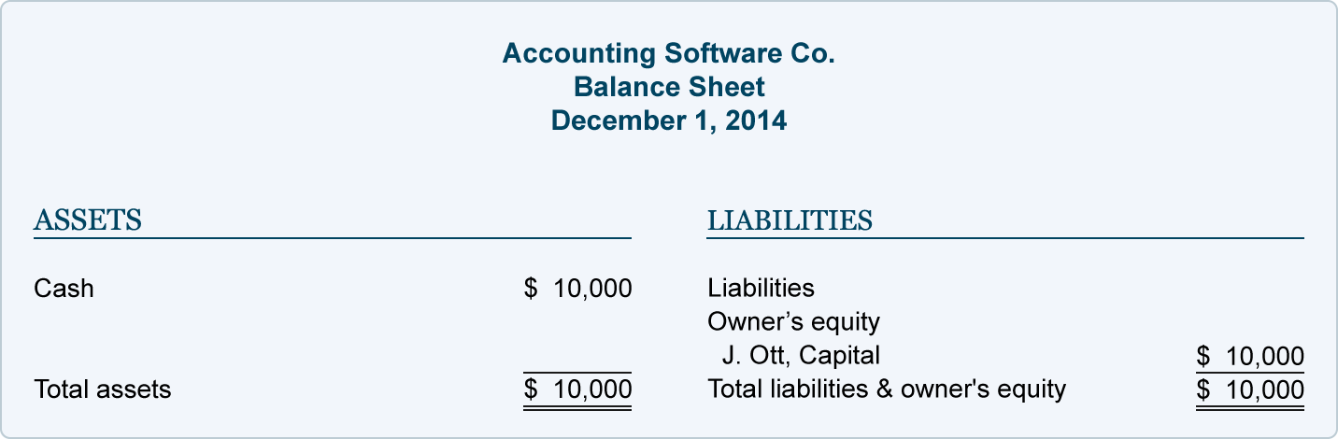

The purpose of an income statement is to report revenues and expenses. Since ASC has not yet earned any revenues nor incurred any expenses there are no transactions to be reported on an income statement.
Sole Proprietorship Transaction #2.
On December 2 2014 J. Ott withdraws $100 of cash from the business for his personal use. The effect of this transaction on ASC's accounting equation is:
Assets = Liabilities + Owners Equity
-$ 100 = No Effect + -$ 100
The accounting equation remains in balance since ASC's assets have been reduced by $100 and so has the owner's equity.
This transaction is recorded in the asset account Cash and the owner's equity account J. Ott, Drawing. The general journal entry to record the transactions in these accounts is:

Student Name: Shakeel Ahmed
Student ID# 1507, Assessment # 5,
Page No:19
Since the transactions of December 1 and 2 were each in balance the sum of both transactions should also be in balance:
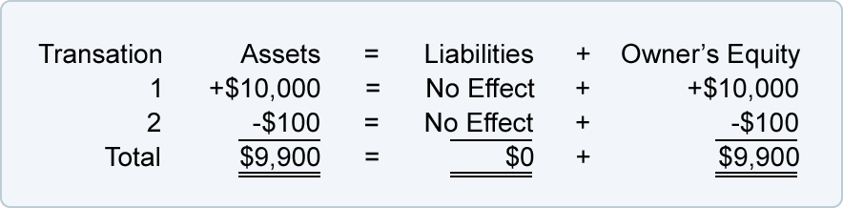
The totals indicate that ASC has assets of $9,900 and the source of those assets is the owner of the company. You can also conclude that the company has assets or resources of $9,900 and the only claim against those resources is the owner's claim.

The December 2 balance sheet will communicate the company's financial position as of midnight on December 2:
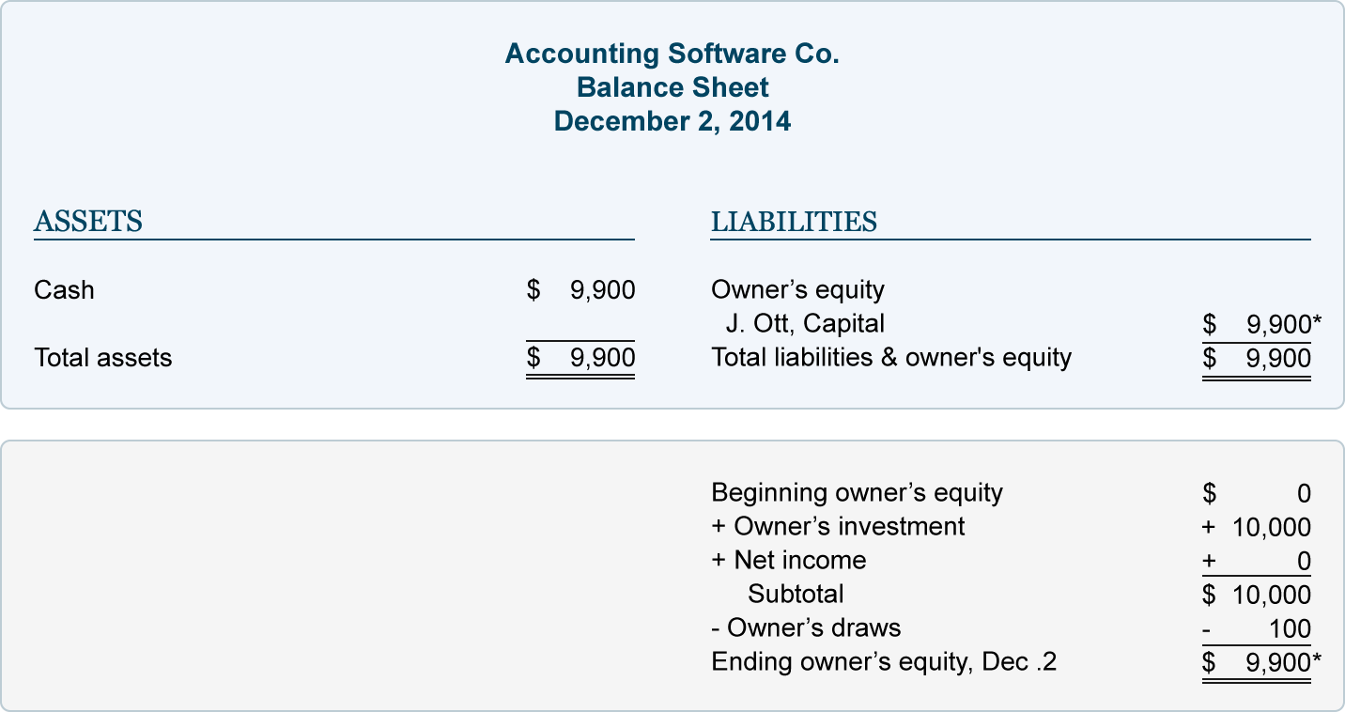
Student Name: Shakeel Ahmed
Student ID# 1507, Assessment # 5,
Page No:20
Withdrawals of company assets by the owner for the owner's personal use are known as (draws). Since draws are not expenses the transaction is not reported on the company's income statement.
The accounting equation (or basic accounting equation) for a corporation is:
Assets = Liabilities + Stockholders Equity
In my examples below, I will show how a given transaction affects the accounting equation for a corporation. I will also show how the same transaction will be recorded in the company's general ledger accounts.
Below examples will also show the effect of each transaction on the balance sheet and income statement. For all of my examples I assume that the accrual basis of accounting is being followed.
In the examples that follow I will use the following accounts:
- Cash
- Accounts Receivable
- Equipment
- Notes Payable
- Accounts Payable
- Common Stock
- Retained Earnings
- Treasury Stock
- Service Revenues
- Advertising Expense
- Temp Service Expense
Student Name: Shakeel Ahmed
Student ID# 1507, Assessment # 5,
Page No:21
I also assume that the corporation is a Subchapter S corporation in order to avoid the income tax accounting that would occur with a "C" corporation. (In a Subchapter S corporation the owners are responsible for the income taxes instead of the corporation.)
Corporation Transaction C1
Let's assume that members of the Ott family form a corporation called Accounting Software, Inc. (ASI). On December 1, 2014, several members of the Ott family invest a total of $10,000 to start ASI. In exchange the corporation issues a total of 1,000 shares of common stock. (The stock has no par value and no stated value.) The effect on the corporation's accounting equation is:
Assets = Liabilities + Stockholders Equity
+ $10,000 = No Effect + +$10, 000
As you see ASI's assets increase by $10,000 and stockholders' equity increases by the same amount. As a result the accounting equation will be in balance.
The accounting equation tells us that ASI has assets of $10,000 and the source of those assets was the stockholders. Alternatively the accounting equation tells us that the corporation has assets of $10,000 and the only claim to the assets is from the stockholders (owners).
This transaction is recorded in the asset account Cash and in the stockholders' equity account Common Stock. The general journal entry to record the transaction is:

After the journal entry is recorded in the accounts, a balance sheet can be prepared to show ASI's financial position at the end of December 1, 2014:
Student Name: Shakeel Ahmed
Student ID# 1507, Assessment # 5,
Page No:22
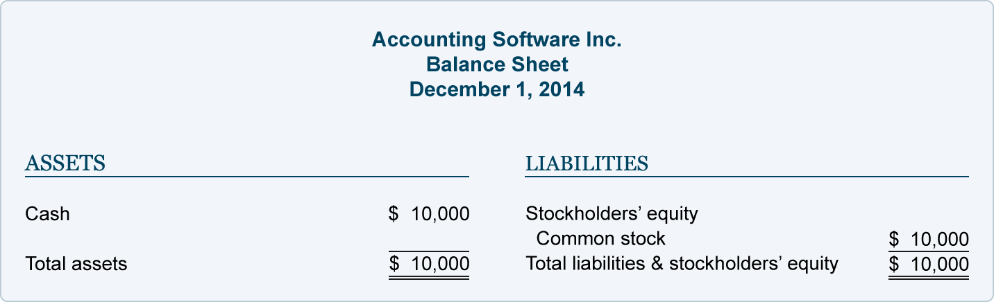
The purpose of an income statement is to report revenues and expenses. Since ASI has not yet earned any revenues nor incurred any expenses there are no transactions to be reported on an income statement.
Corporation Transaction C2.
On December 2, 2014 ASI purchases $100 of its stock from one of its stockholders. The stock will be held by the corporation as Treasury Stock. The effect of the accounting equation is:
Assets = Liabilities + Stockholders Equity
-$100 = No Effect + -$100

The purchase of its own stock for cash meant that ASI's assets decrease by $100 and its stockholders' equity decreases by $100.
This transaction is recorded in the asset account Cash and in the stockholders equity account Treasury Stock. The accounting entry in general journal form is:

Student Name: Shakeel Ahmed
Student ID# 1507, Assessment # 5,
Page No:23
Since the transactions of December 1 and 2 were each in balance the sum of both transactions should also be in balance:

Transaction Assets = Liabilities + Stockholders Equity
C1 + +$10,000 = No Effect + +$10,000
C2 -$100 = No Effect + -$100
Totals $9,900 = No Effect + $9,900

The totals indicate that ASI has assets of $9,900 and the source of those assets is the stockholders. The accounting equation also shows that the corporation has assets of $9,900 and the only claim against those resources is the stockholders claim.
The December 2 balance sheet will communicate the corporation's financial position as of midnight on December 2:
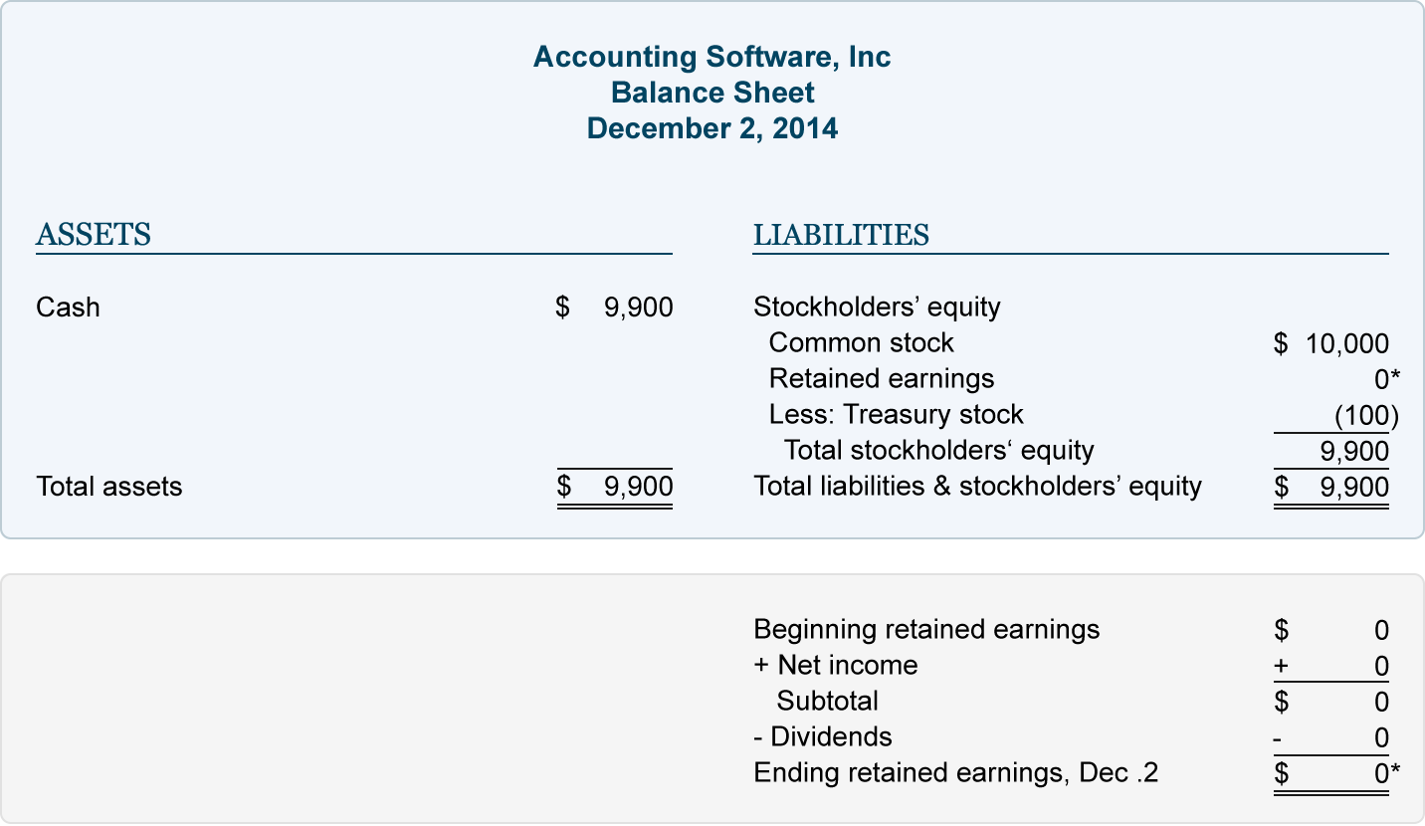
Student Name: Shakeel Ahmed
Student ID# 1507, Assessment # 5,
Page No:24
The purchase of a corporation's own stock will never result in an amount to be reported on the income statement.
Q:3)
- Realization Concept (Revenue Recognition Principle)
Realization concept in accounting:
- Definition
- Explanation
- Example
- Importance
- MCQ
1. Definition
Realization concept in accounting also known as revenue recognition principle refers to the application of accruals concept towards the recognition of revenue (income)
Under this principle revenue is recognized by the seller when it is earned irrespective of whether cash from the transaction has been received or not.
2. Explanation
In case of sale of goods revenue must be recognized when the seller transfers the risks and rewards associated with the ownership of the goods to the buyer. This is generally deemed to occur when the goods are actually transferred to the buyer. Where goods are sold on credit terms revenue is recognized along with a corresponding receivable which is subsequently settled upon the receipt of the due amount from the customer.
In case of the rendering of services revenue is recognized on the basis of stage of completion of the services specified in the contract. Any receipts from the customer in
Student Name: Shakeel Ahmed
Student ID# 1507, Assessment # 5,
Page No:25
excess or short of the revenue recognized in accordance with the stage of completion are accounted for as prepaid income or accrued income as appropriate.
3. Example
Motors PLC is a car dealer. It receives orders from customers in advance against 20% down payment. Motors PLC delivers the cars to the respective customers within 30 days upon which it receives the remaining 80% of the list price.
In accordance with the revenue realization principle Motors PLC must not recognize any revenue until the cars are delivered to the respective customers as that is the point when the risks and rewards incidental to the ownership of the cars are transferred to the buyers.
4. Importance
Application of the realization principle ensures that the reported performance of an entity, as evidenced from the income statement reflects the true extent of revenue earned during a period rather than the cash inflows generated during a period which can otherwise be gauged from the cash flow statement. Recognition of revenue on cash basis may not present a consistent basis for evaluating the performance of a company over several accounting periods due to the potential volatility in cash flows.

Revenue. It’s the top line on financial statements and arguably the most important. But revenue is not always comparable between companies since the amount reported depends on when the company recognizes the revenue as earned not when it’s received. What constitutes “when” can lead to significant debate. Improvements in accounting rules have been announced but advisors will have to wait two years before seeing their full impact.
Student Name: Shakeel Ahmed
Student ID# 1507, Assessment # 5,
Page No:26

The Current Challenges:
Any company can use the new rules on a voluntary basis. Investors need to look for early adopters while also remaining vigilant of the shortfalls in the current rules. How companies transition to the new rules will also significantly impact trend analysis and any quant-based models or systems.
Revenue recognition rules have traditionally had two problem areas: multi-year projects and multi-component transactions.
1. Projects that stretch over multiple years
For instance long-term infrastructure projects can have fixed or variable costs, multiple deadlines and uneven cash receipts and expense payments. They can also provide a mix of both goods and services. These factors make it difficult to estimate when revenue should be recorded and in what amounts.
Construction programs such as those for new aircraft can take decades to design test and deliver. Sometimes design costs can be shared across various programs. Similarly entertainment projects can involve shared costs from both production and marketing perspectives.
2. Products and services with multiple deliverables
A prime example of multiple deliverables can be seen in technology companies that provide a combination of hardware, software, consulting, servicing, support, upgrades and warranties sometimes all in one. These products and services can be interdependent so it’s difficult to measure the revenue that they earn every quarter over an extended period.

Student Name: Shakeel Ahmed
Student ID# 1507, Assessment # 5,
Page No:27

While these descriptions only scratch the surface one of accounting’s guidelines has always been that revenues should be matched to expenses. For this to occur the costs need to be known and measurable. This often results in cash payments being timed differently from when revenue is recorded.
WHAT THE NEW RULES ADDRESS
The new rules were finalized last year so the upcoming slate of annual reports will be the first opportunity companies will have to disclose the rules potential impact on their financial statements. Not all industries or companies will be affected some might not see any impact.
For instance the new rules only alter the accounting for specific situations and more complicated scenarios. Even companies in the same industry can be different in substance and product offering so investors will need to focus on the corporate level to avoid making analytical and comparability mistakes when it comes to valuation. Some companies will see their revenue and topline figures altered significantly and others not at all.
Apple Inc. has changed its revenue recognition policies in the past few years since it provides software upgrades to customers for free after they’ve made purchases. As they started to do so the company began to defer an increasing proportion of revenue related to each device sold. This was a forward-looking voluntary change that impacted reported revenue growth and profit margin both key factors monitored closely by the market.
Another industry expected to see major impacts from the changes is the telecom space. Currently cell phone providers sign many customers to contracts that are tied to new handsets. There are cost subsidies involved and some phones are sold for free (no money down, in actuality).
Student Name: Shakeel Ahmed
Student ID# 1507, Assessment # 5,
Page No:28

Previously companies generally broke down revenue based on the price of the phone as opposed to its actual value. While this seems like a subtle difference the impact will be significant unless the industry reduces the subsidies handed out to customers.

Under the new rules their accounting would have to break the bundled contract into deliverable parts so the fulfillment of providing the phone to the customer would constitute revenue generation in the amount of the estimated value of the handset. Companies would end up reporting significantly more revenue up front not later when the customer actually pays for the phone in installments. This may seem counterintuitive and could be regarded as a significant drawback to achieving the stated goal of greater accounting harmonization. Telecom providers, in particular, lobbied hard against the accounting changes (indicating the quantum of the disruptive impact the rules will bring).
While the new rules improve IFRS and harmonize reporting with U.S. guidelines there will still be significant challenges regarding implementation. There will be debates over who the actual customer is in certain situations.
Other transactions will be bogged down by details like whether something constitutes a product warranty or a service warranty. So these issues will need to be resolved with significant estimations and judgment calls by management likely degrading some of the comparability that was the primary aim of the decade-long accounting project.

- Matching Principle & Concept

Matching Principle - topic contents
Student Name: Shakeel Ahmed
Student ID# 1507, Assessment # 5,
Page No:29
- Definition
- Explanation
- Examples
- Matching Vs Accruals Vs Cash Basis
1. Definition
Matching Principle requires that expenses incurred by an organization must be charged to the income statement in the accounting period in which the revenue to which those expenses relate is earned.
2. Explanation
Prior to the application of the matching principle expenses were charged to the income statement in the accounting period in which they were paid irrespective of whether they relate to the revenue earned during that period. This resulted in non-recognition of expenses incurred but not paid for during an accounting period (accrued expenses) and the charge to income statement of expenses paid in respect of future periods (prepaid expenses). Application of matching principle results in the deferral of prepaid expenses in order to match them with the revenue earned in future periods. Similarly accrued expenses are charged in the income statement in which they are incurred to match them with the current period's revenue.
A major development from the application of matching principle is the use of depreciation in the accounting for noncurrent assets. Depreciation results in a systematic charge of the cost of a fixed asset to the income statement over several accounting periods spanning the asset's useful life during which it is expected to generate economic benefits for the entity. Depreciation ensures that the cost of fixed assets is not charged to the profit & loss at once but is matched against economic benefits (revenue or cost savings) earned from the asset's use over several accounting periods.
Student Name: Shakeel Ahmed
Student ID# 1507, Assessment # 5,
Page No:30
Matching principle therefore results in the presentation of a more balanced and consistent view of the financial performance of an organization than would result from the use of cash basis of accounting.
3. Examples
Examples of the use of matching principle in IFRS and GAAP include the following:
- Deferred Taxation
IAS 12 Income Taxes and FAS 109 Accounting for Income Taxes require the accounting for taxable and deductible temporary differences arising in the calculation of income tax in a manner that results in the matching of tax expense with the accounting profit earned during a period.
- Cost of Goods sold
the cost incurred in the manufacture or procurement of inventory is charged to the income statement of the accounting period in which the inventory is sold. Therefore any inventory remaining unsold at the end of an accounting period is excluded from the computation of cost of goods sold.
- Government Grants
IAS 20 Accounting for Government Grants and Disclosure of Government Assistance requires the recognition of grants as income over the accounting periods in which the related costs (that were intended to be compensated by the grant) are incurred by the entity.
4. Matching Vs Accruals Vs Cash Basis
In the accounting community the expressions matching principle and accruals basis of accounting are often used interchangeably. Accruals basis of accounting requires recognition of income and expenses in the accounting periods to which they relate rather than on cash basis. Accruals basis of accounting is therefore similar to the matching principle in that both tend to dissolve the use of cash basis of accounting.
Student Name: Shakeel Ahmed
Student ID# 1507, Assessment # 5,
Page No:31
However the matching principle is a further refinement of the accruals concept. For example accruals basis of accounting requires the recognition of the estimated tax expense in the current accounting period even though the actual settlement of the provision may occur in the subsequent period. However matching principle would also necessitate the recognition of deferred tax in the accounting periods in which the temporary differences arise so as to match the accounting profits with the tax charge recognized in the accounting period to the extent of the temporary differences.

Maturity matching approach has various advantages and disadvantages. The biggest advantages are that it maintains optimum level of funds, saves interest cost, no refinancing risk and interest rate fluctuation risk. The main disadvantage is its difficulty in implementation. Maturity matching or hedging approach of working capital financing is an idealistic approach. It is based on the basic principle of finance that long term assets should be financed with long term sources of finance such as equity, term loan, debentures etc. and short term assets should be financed with short term sources of finance such as short term loans, current liabilities, cash credit, bank overdraft, other working capital loans etc.

Advantages and Disadvantages of Maturity Matching or Hedging Approach to Working Capital Financing Advantages of Matching Maturity Approach

- Optimum Level of Funds (Liquidity): The funds remain on the balance sheet only till they are in use. As soon as they are not needed they are paid. This is how the interest cost is optimized in this strategy. Interest is paid only for the amount and time for which money is used. There are no unutilized cash lying idle with the business.

- Savings on Interest Costs: When short term requirements are not funded with long term finances the firm saves interest rate difference between long term and short
Student Name: Shakeel Ahmed
Student ID# 1507, Assessment # 5,
Page No:32
term interest rates. It is already known that long term interest rates are comparatively higher due to the concept of risk premium.

- No Risk of Refinancing and Interest Rate Fluctuations during Refinancing: Since the fundamental principal of finance is followed here i.e. long term asset to long term finance and short term assets to short term finance there are no risk of refinancing and the interest rate fluctuations during refinancing. This means that while renewing a loan if the market scenario changes the rate of interest may also adversely change. Here there is no problem of frequent refinancing.

Disadvantages of Matching Maturity Approach

- Difficult to Implement: It is one of the best strategies or ideal strategy but it is very difficult to implement. Exactly matching maturity of assets with their source of finance is practically not possible. There is quite a lot of uncertainty on current asset’s side. One cannot exactly predict at what time the debtor will pay or what time the sales will occur. Once the credit is extended the ball goes in the court of debtor.
- Risks Still Persists: After adopting this strategy and planning everything in accordance with it, if the assets are not realized on time it will not be possible to extend the loan due dates unreasonably. In that situation the strategy moves either towards conservative or aggressive approach. Once that happens the analytics and risks of those strategies will apply. The risks which are avoided with this strategy again come into play.

………………………………….. END …………………………………….

Student Statement:

By submitting this assignment, I confirm that this is my own work.

Student Signature | SHAKEEL AHMED | Date | 10/10/2015

For Tutor / Assessor Use Only
Total Marks
Marks Obtained
Percentage / Grade

