
Assignment Cover Sheet

Student Name: | Sumbal Jamil
Student Number: | 1149
Course: | Fashion Design
Assignment NO: | 8

Student Statement:

By submitting this assignment, I confirm that this is my own work.

Student Signature | Sumbal Jamil | Date | 14-2-2014

For Tutor / Assessor Use Only
Total Marks
Marks Obtained
Percentage / Grade

Short Answers:
1. What is meant by ‘binary colours’?
Answer: Colour made by mixing two colours is binary colours. The main binary colours are green, orange and purple. These colours are obtained by mixing two of the primary colours. Orange is a mixture of red and yellow; Purple is the mixture of red and blue and green is the mixture of yellow and blue.
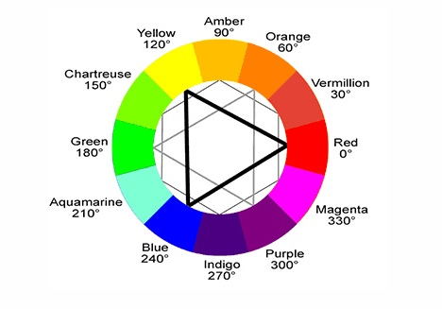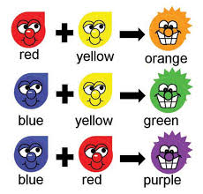
Colour wheel Binary colours

2. Grey colour is formed when black is mixed with white. Is it a warm or cool colour what do you think and how best it can be used in creating an attractive colour scheme?
Answer: Grey is a neutral colour, it is an intermediate colour between black and white. Grey absorb less heat then black but more than white. Equal parts black and white is the standard mixture for grey, whiter for lighter grey and less white for darker. Grey is a colour which can go with any colour without any problem but it goes best with colours like navy blue, purple, bright blue, red, white and black. Grey has a warm and cool variation. Some of the variations of grey are given below:
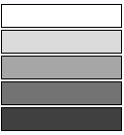

Variations of Grey:
a. Ash Grey: It is a cool grey shade and represents the colour of ash.
b. Charcoal: It is a cool dark grey shade and represents the colour of burnt wood.
c. Cool Grey: It is a grey and blue mixed together.
d. Slate grey: It is cool grey tone; we can have a slate grey by mixing grey with small amount of azure.
e. Timber wolf: It is warm grey tone.
f. Silver: I t is a metallic grey shade.
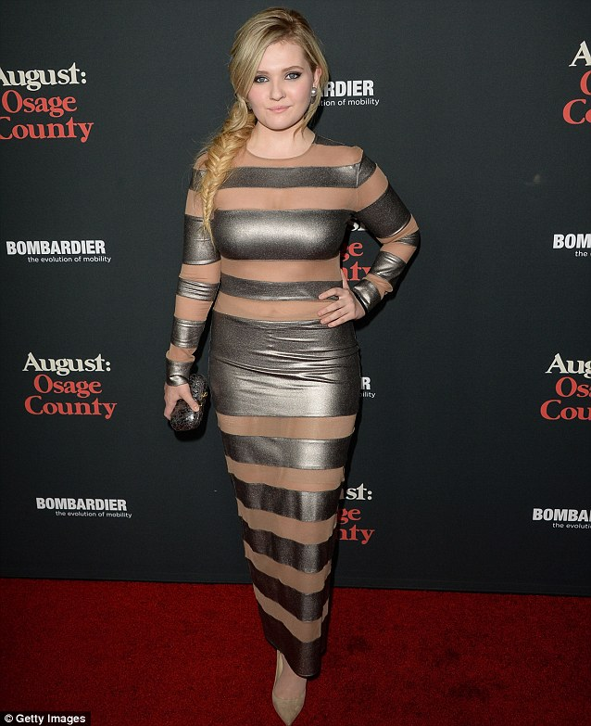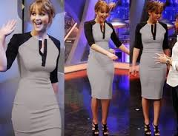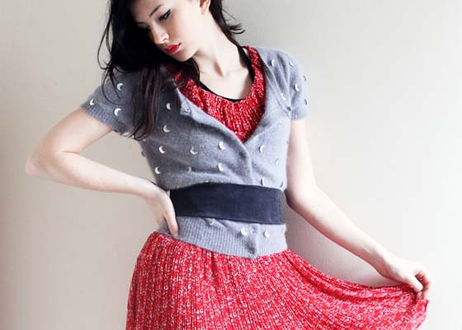

3. Which of the following colours should a stout person wear? Dark or light. And why?
Answer: Colour is the first thing most people notice about an outfit. The colour, cut and pattern we wear can draw people’s eye towards or away from our figure. One good idea for stout person is to wear clothes in dark shades only. The darker the colour, the better the look. Some of the best colours to be worn are black and dark blue. All light and bright colours can made the look of stout person broad and curvy so stout person should avoid light and bright colours. Black is very slimming colour. The secret behind the slimming power of dark colours is their ability to absorb light. Dark neutral colours are simply more appropriate for more occasions and have adapted bonus of being very easy to dress up with accessories. Dark colours hide while light colours highlight so I think dark colours are best to wear for stout person.
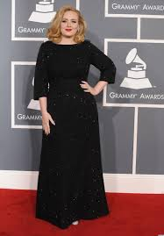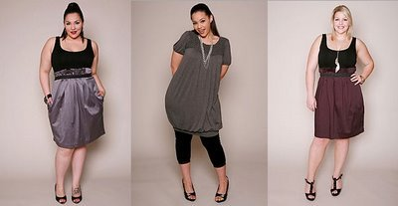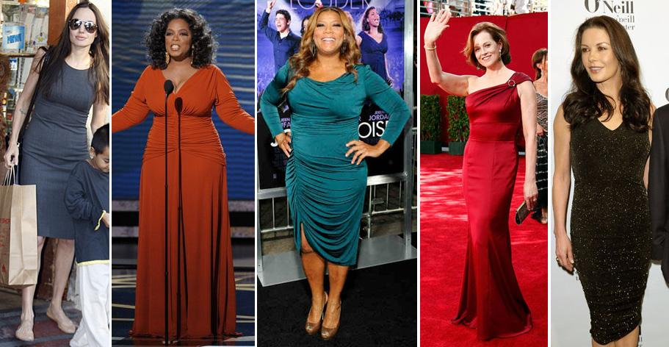4. If you want to create an illusion of height and slimness using colour, how would you do it?
Answer: It is wise to wear clothing in colours that trick other to believe that we are thin. Colour is the first thing most people notice about an outfit. Dressing in on colour produces a strong unbroken vertical line that elongates the body. Every piece of clothing we put on our body is made up of four basic design element: proportion, line, colour and texture. To look slimmest and tallest, each of these has to be right on target and perfectly in sync with our body. If the garments we wish to wear are in two pieces then we should wear both the pieces in same colour. This creates a feeling of continuity in the viewer’s mind thus making our look slimmer and taller. Black is very slimming colour. Dark colours are best to create an illusion because dark colours hide while light colours highlights and if we are using stripes then vertical stripes will go best to create illusion.
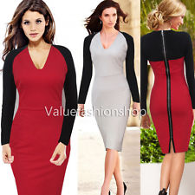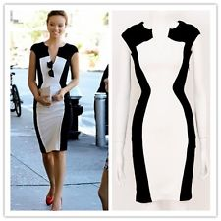
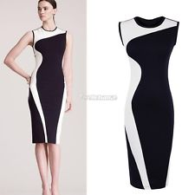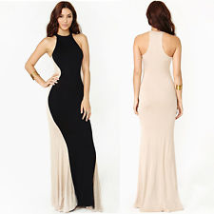

5. Wearing black for a grey haired lady is the most suitable choice. But how should she wear this in best possible way?
Answer: It is important to have clear understanding of what colour clothing works and what does not with grey hair Colour is one of the most important element of fashion, and if we can use it well we will create a complete look that always works. Grey hair colour affects everything else we are wearing and make overall look different. Red is grey’s best friend .The two colours naturally work together to create beautiful contrast. From bold ruby red to deep crimson, red goes beautifully with grey hair colour Grey haired person should expand colour palette by creating a basic wardrobe in white and black. These colours will contrast gorgeously against grey hair colour. Purple looks great with grey in just about any shade from rich berry purple to light lavender. Greens and yellows may makes grey hair colour look greenish or yellowish in tone, particularly in sunlight so grey haired person should stay away from filling wardrobe with these shades.
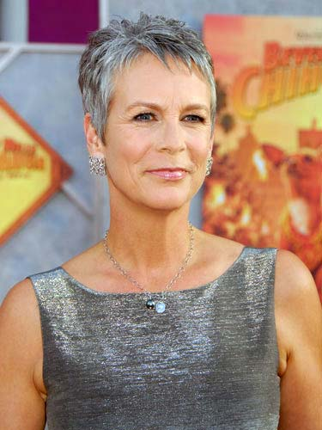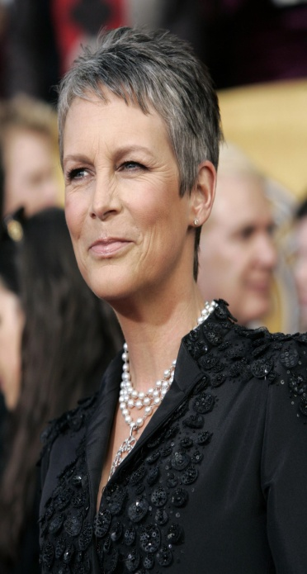

6. For a person of sallow complexion which type of colour is best choice? and why?

Answer: A person having sallow complexion should wear neutral colours as it is currently a prominent style and best choice. Nude and Ivory coloured clothing is being torn off the rack. Sallow complexion person should dare to wear blue, black, brown and green. If a person likes a neutral look, a light brown or tan is very flattering against sallow complexion with very dark hairs, wearing a lot of black can wash outlook. With redhead, a person having sallow complexion should stay away from colours similar to hair. Instead look for colours opposite of your hair such as green, blue and purple. Pastels look gorgeous against sallow complexion. A person having sallow complexion should aware of certain shades of yellow, it can makes the look sick.

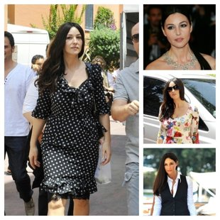
Monica Bellucci Nicole Kidman
7. Which types of colour would be more suitable for a blonde person’s dress?
Answer: Blonde hair can either be classified as cool or warm:
1. Warm Blondes:
a. Best colour for warm blonde: warm blondes look hottest in jewel tones and colours that have an orange or red undertone. Turquoise and aqua are better blue options for warm blonde than dusty, pastel shades. Warm blondes also look extra sunshiny in lemony shades of yellow, peach or coral and deeper purple like amethyst.
b. Cooler colours for warm blonde: Mint or olive green when worn by someone with warm blonde hair can grey the skin and make highlights look yellow and brassy. The same goes for hues such as pale shades of blue, pink, and yellow as well as reds that have a blue undertone.
c. Neutrals for warm blonde: warm neutrals like lovely’s Ivory gown work well for golden blondes. Ivory has more of a warm undertone that ties in with the warmth of golden hair and evens out of skin tone.
d. Bleach neutrals for warm blonde: Taupe (cool neutral colour)is horrible on a warm blonde because it makes hair look kind of green
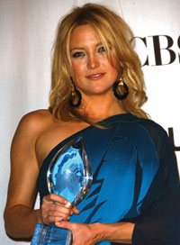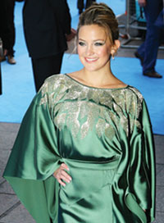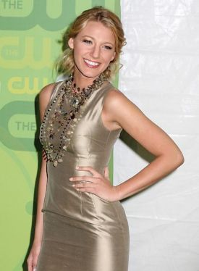
a. Best colour b Cool colour c. Neutral colour d. Bleach neutral colour
(Colours for warm blondes)
2. Cool Blondes
a. Best Colour for cool blondes: Pale blonde babes look totally sexy in pastels and colours with a blue or grey undertone. Taylor swift’s ash blonde hair and porcelain white skin are totally glowing in blue-based red gown. Platinum, pale blondes can also rock pastels like mint green and baby blue. Dusty shades of pink and lavender are also great for cool blonde hair colour.
b. Gag-me colours for cool blondes:-Grey toned colours are great for cool blondes which mean colours at the opposite end of the spectrum that have a red or warm undertone are terrible. Warm colour clothing especially shades of orange; rose and turquoise will create too big contrast with pale blond hair hues like beige, ash and platinum.
c. Surprisingly sexy neutrals for cool blondes: Taupe has a greyish base that highlights the salt tones found in cool blonde hair. Winter white also have a cool undertone that works well for women who have cool shades of blonde framing their face.
d. Sickly-looking neutrals for cool hair: ash and platinum blondes can look pallid when wearing clothing colours with a yellow undertone, like Ivory, camel and gold can also create a sickly look when worn by pale blondes.
Skinny on black for blondes: Blondes can keep black clothing from wearing them by choosing the right accessories and shades of makeup. Blondes can look hot in black or they can be totally overpowered and lost in it.
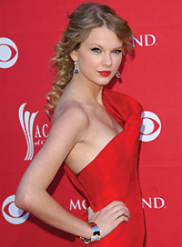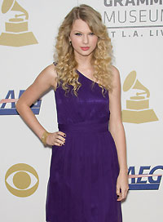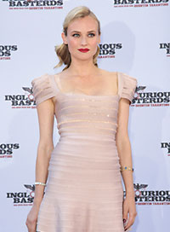 a. Best colour b. Gag-me colour c. sexy neutral colour d. sickly looking neutral
(Colours for Cool blondes)
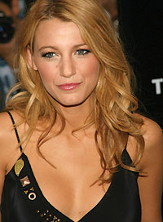
Black colour for blonde

Activity
Collect fabric swatches for different colour harmonies. Also name the colour scheme.

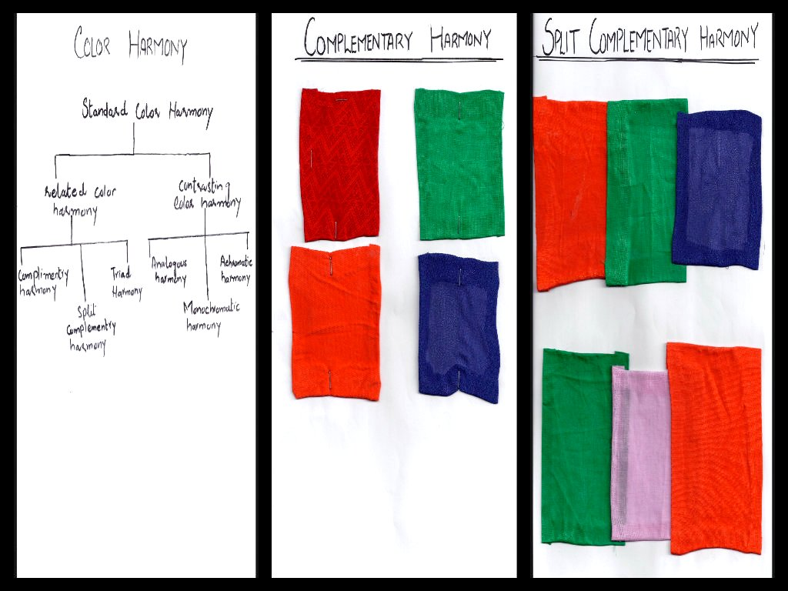
Colour harmony chart Complimentary harmony Split Complimentary harmony
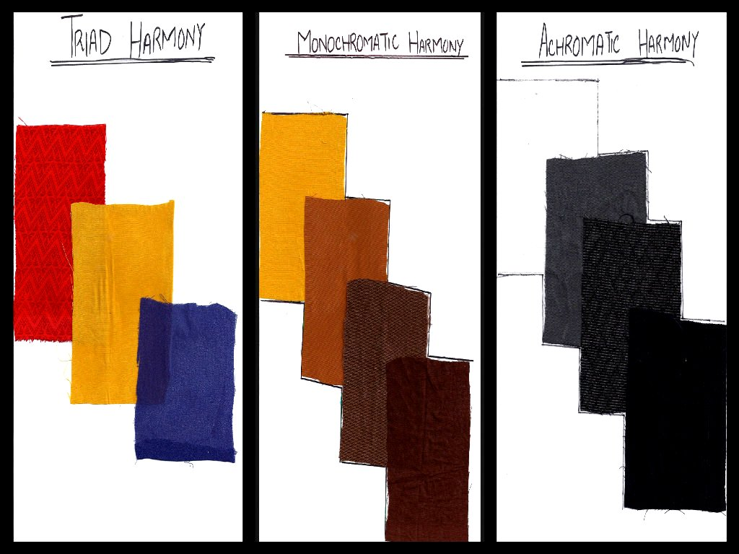
Triad Harmony Monochromatic Harmony Achromatic Harmony

Create a contrasting colour harmony using at least three colours.
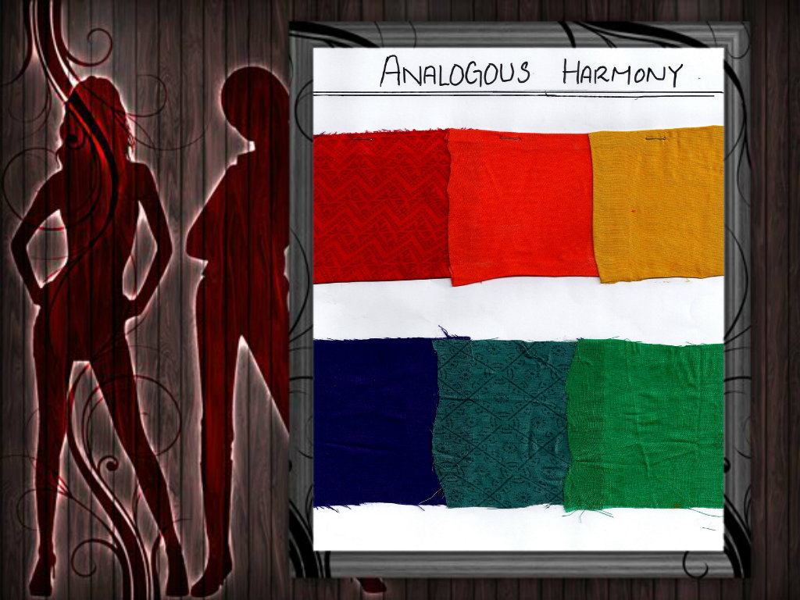
Design a Fabric using at least three colours.
