
Assignment Cover Sheet

Student Name: | Sumbal Jamil
Student Number: | 1149
Course: | Fashion design
Assignment NO: | 3

Student Statement:

By submitting this assignment, I confirm that this is my own work.

Student Signature | Sumbal jamil | Date | 11-4-2013

For Tutor / Assessor Use Only
Total Marks
Marks Obtained
Percentage / Grade

Sumbal Jamil
Student no: 1149
Assignment no: 3
Course: Fashion design
Sumbal.jamil94@yahoo.com

1. Short Answers.
a. Income groups greatly influence fashion because people having high incomes and high jobs and living in a sophisticated environment will accept fashion change more quickly than others. Mostly fashion leaders are members of high income groups and they greatly affect the fashion because quality high fashion is expensive and they can afford high expensive fashion. Income groups also affect the fashion because of fashion followers. Because of low income of fashion followers, most members of fashion industry are copyist or adapters and they make mass production successful.
b. Empowered by the internet and television, global trends are moving at an accelerating pace. The life-span of a trend is now about five months instead of a year to determine the acceptability of fashion, awareness of fashion forecasting is important to both for the designers and buyers. For retail buyers, it is becoming a huge challenge to figure out which trends will become fashion basics, like Capri’s and which are only fads, such as pony prints. Buyers have to become very flexible in their buying patterns. If the market becomes flooded with a new trend, consumers may react negatively to the overexposure. That’s why awareness of fashion forecasting is important to buyers. It is important for the designers should be aware of colour forecast because colour dictates the mood and attitude of the season. On-trend colour is directly linked to consumer’s mood and aspirations, and getting shades right can increase the sales considerably.
c. Fashion trends are the styling ideas that major collections have in common. They indicate the direction in which fashion is moving. Fashion forecasters look for styles they think are a prophetic, idea that capture the mood of the times and signals a new fashion trend.
d. There are many factors that affect fashion trends. Some of them are:
- Color is very important factor that affect fashion trend because people greatly respond to color. People related very personally to color, usually selecting or rejecting a fashion due to color does or does not appeal to them or flatter their own coloring.
- Texture also affects the fashion trend because consumers relate to texture duo to it sensuous appeal.
- Price is most important factor because average consumers evaluate the price.

3. Definitions

a. Classics: When a fashion is constant or long lasting, such as T-shirts and skirts, it is called basic or Classic. It is similar to a standard music. Classics are the outfits which stays in the fashion scene for a long period of time that is from past to present and even in future it stands.
b. Fads: Fad is short lived fashion, it stays for a very short period, because they are very costly and every one cannot afford to buy it .A fad is something which can either make a designers life more interesting or tenser.
c. Interrupted cycles: sometimes the normal progress of a fashion cycle is prolonged by social upheaval, economic depression or war. The new look will be a radical change because the old cycle had been unnaturally prolonged. This period is called interrupted cycle.
d. Recurring cycles: After a fashion dies, it may resurface. When a style reappears years later, it reinterpreted for a new time, a silhouette or proportion may recur, but it is interpreted with a change in fabric and detail. This period is called recurring cycle.
e. Adaptation of fashion: It depends on a particular group of people who area potential consumers. Sources of influence and methods of adaptation vary with the consumer’s age range, income level, lifestyles and fashion preference.
f. Traditional Fashion adoption: Traditional fashion adaption is based on the fact that most high fashion is expensive and therefore affordable to only a few people. As the new fashions are worn by publicized fashion leaders or shown in fashion publications, most consumers are exposed to the new looks and some will desire to have it for themselves. To appeal to this broader group of consumers, manufacturers produce less expensive versions of high fashion.
g. Reverse Adoption: Most fashion filters down from high priced designer clothes, fashion occasionally begins with the consumers, For example, in the 1960s and early 1970s young people in London and San Francisco influenced the whole fashion industry by creating unique combination of old, new and handcrafted clothes.
h. Mass Dissemination: Missy market styling is generally adapted from designer fashion through the traditional process .styling ideas for active sportswear and denim wear are usually inspired by the consumer, through the reverse process. Junior fashions might be mass-disseminated, since the original ideas are often produced precisely for the youthful market.

Answer no 2:

There are three variations of the trend adoption process: traditional adoption, reverse adoption and mass dissemination. The adoption of trend depends on the particular group of people who are potential consumers. Sources of influence and methods of adoption vary with the consumer’s age range income level, lifestyles and fashion preference. The timing of fashion trend adoption depends on the geographical location of potential consumers. Designers from Paris and Italy are quickly accepted worldwide by those whose incomes and lifestyles afford them the opportunity to wear European fashion. Otherwise, it usually takes one or two years for the ideas put forth in Europe to be accepted by Americans. New York designers fashion is accepted more readily and widely in America because they are specially designed for the country’s needs. Manufacturers and retailers naturally adjust their trend prediction accordingly.
- Traditional fashion adaption is based on the fact that most high fashion is expensive and therefore affordable to only a few people. As the new fashions are worn by publicized fashion leaders or shown in fashion publications, most consumers are exposed to the new looks and some will desire to have it for themselves. To appeal to this broader group of consumers, manufacturers produce less expensive versions of high fashion. Innovative designers have the courage and confidence to try new looks. At first the looks seem outrageous to many people, until it is seen how they can adapted by the customers. Not every extreme design is accepted by the general public. To cause attention and change direction even moderately, high fashion often seeks to be extreme.

- Most fashion filters down from high priced designer clothes, fashion occasionally begins with the consumers, For example, in the 1960s and early 1970s young people in London and San Francisco influenced the whole fashion industry by creating unique combination of old, new and handcrafted clothes.

- Missy market styling is generally adapted from designer fashion through the traditional process .styling ideas for active sportswear and denim wear are usually inspired by the consumer, through the reverse process. Junior fashions might be mass-disseminated, since the original ideas are often produced precisely for the youthful market

Activity
Fashion direction for the future:
- Color trend
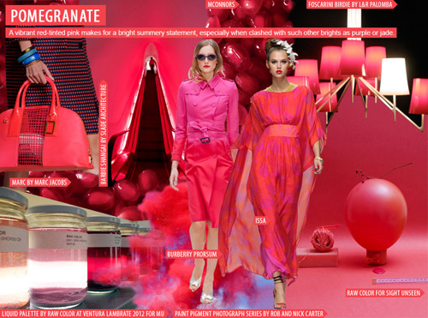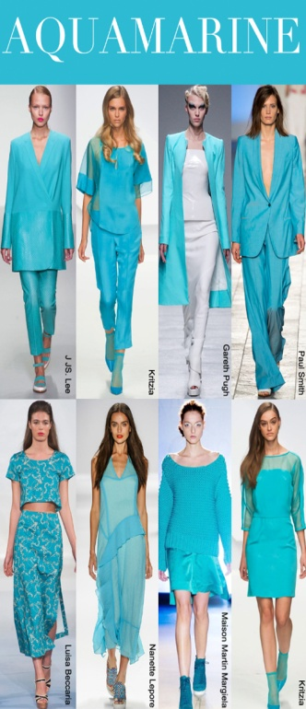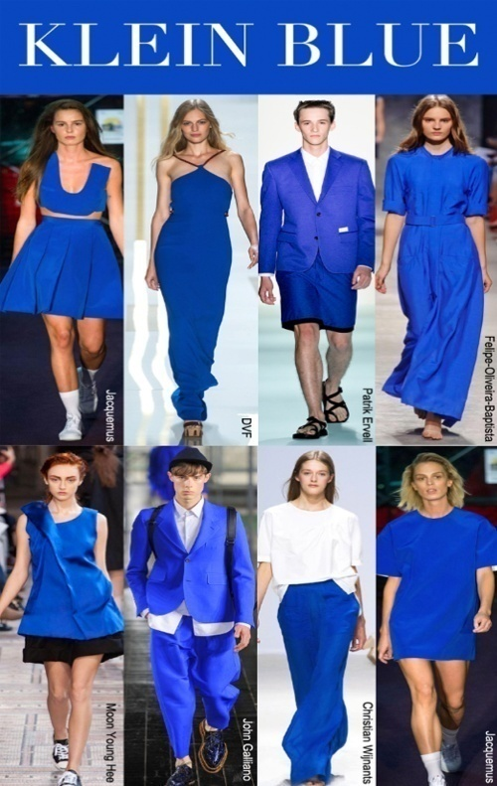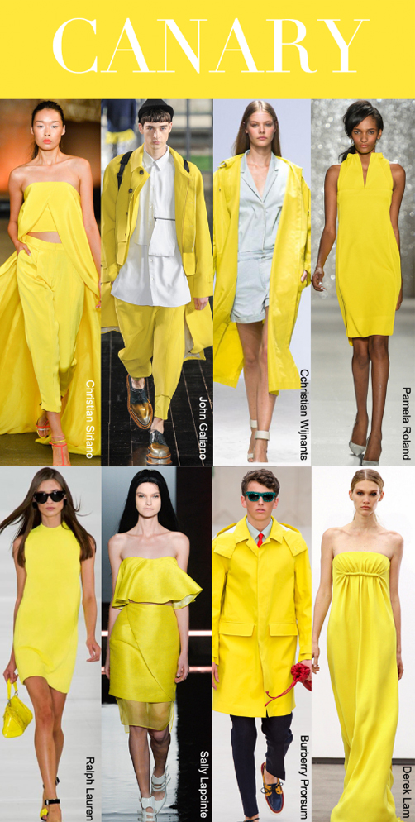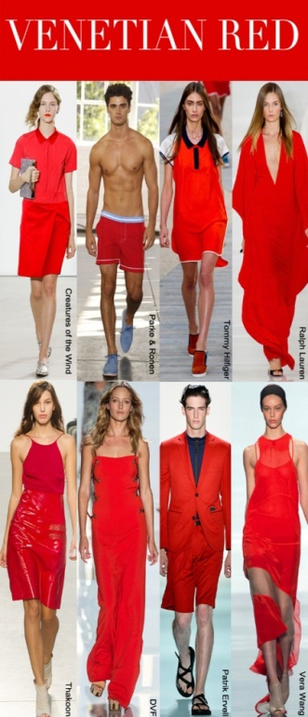

- Textile print trends
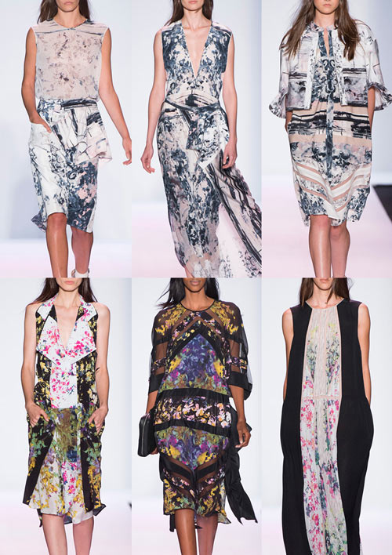
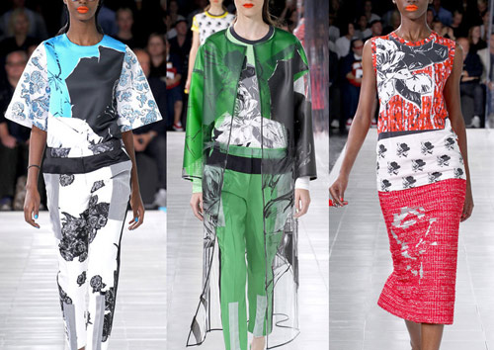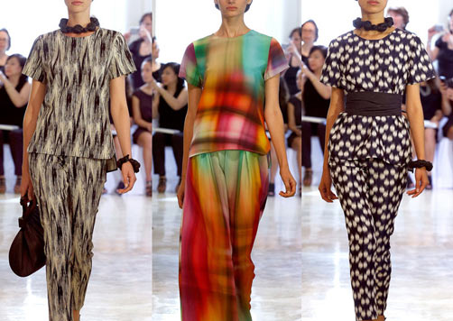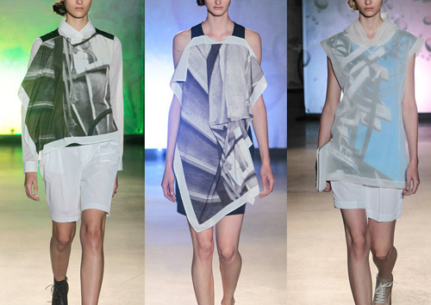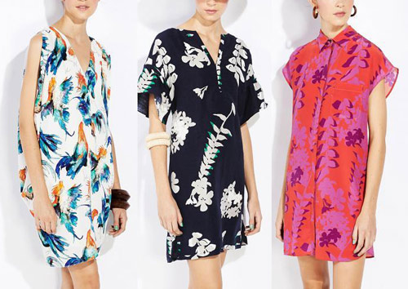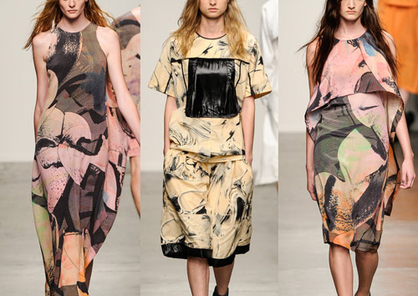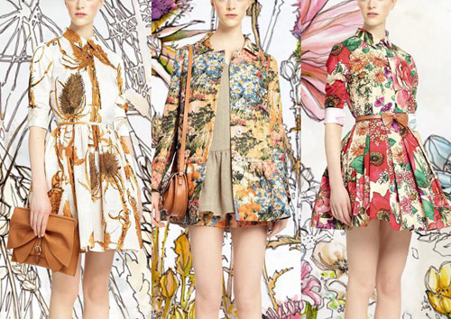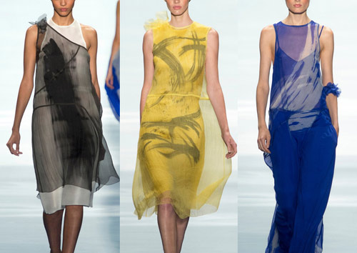
Runway trends
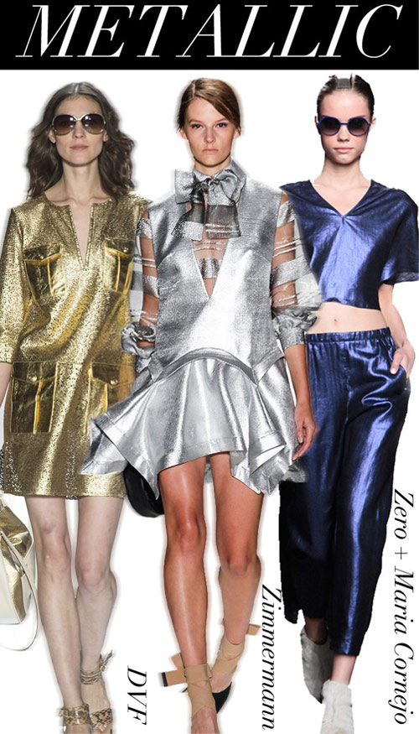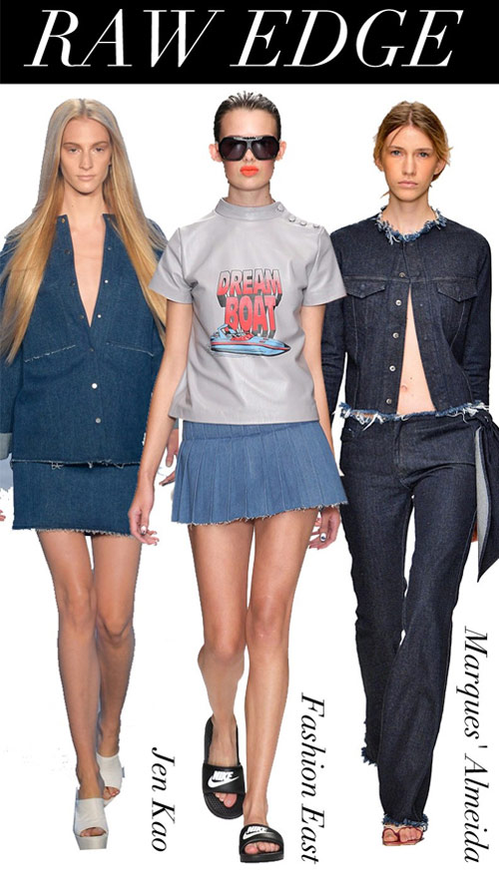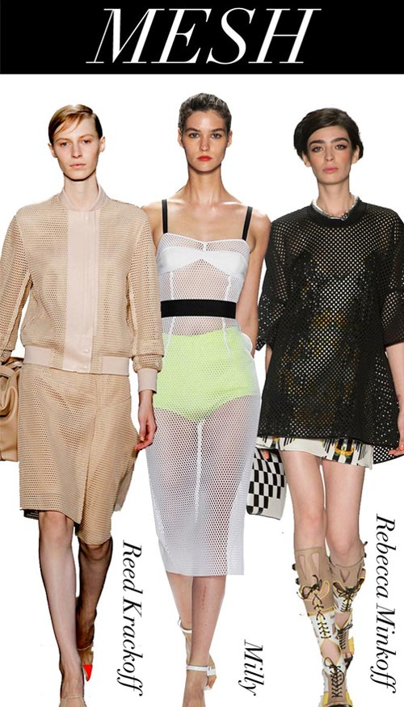
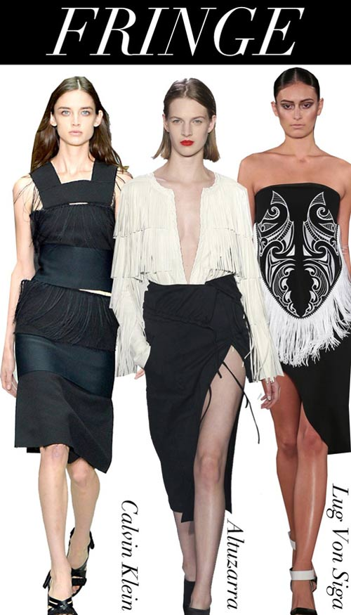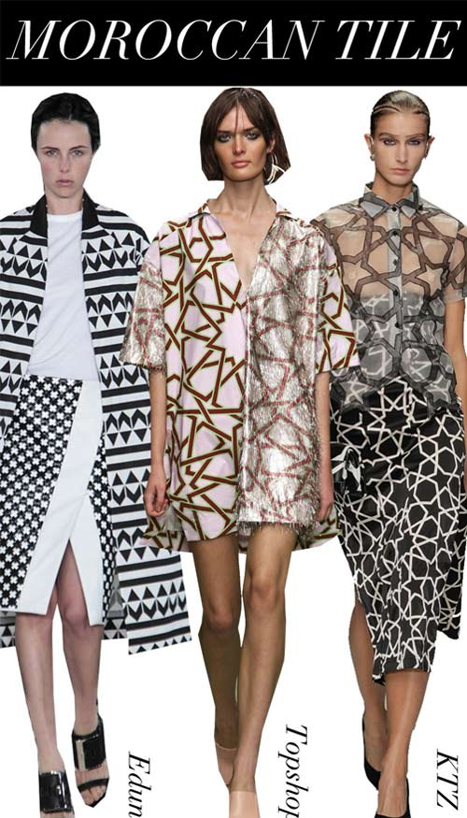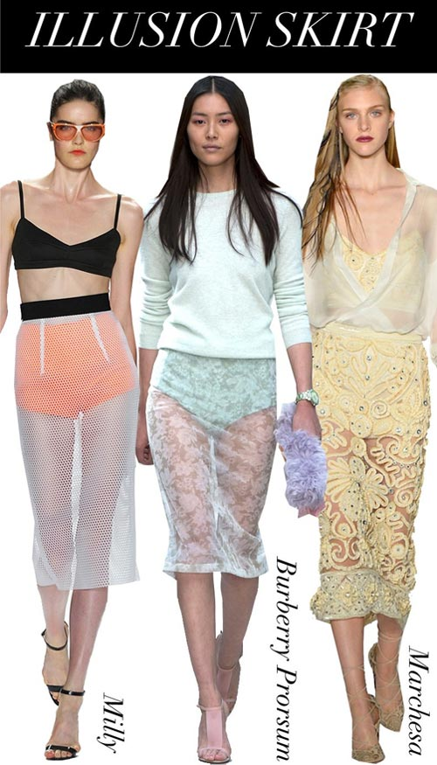

Key denim trends
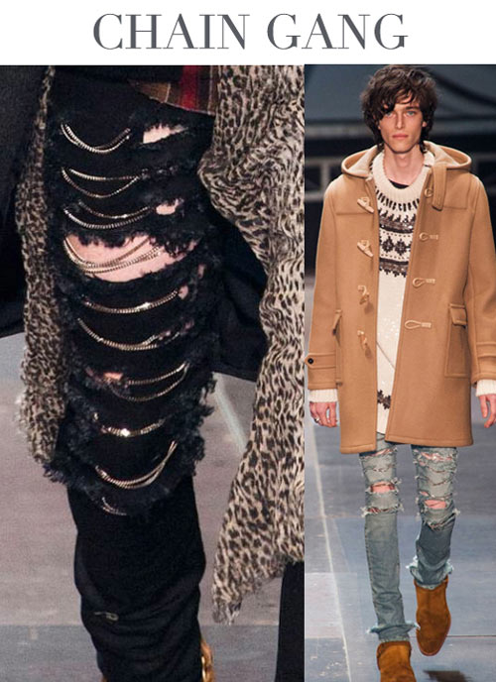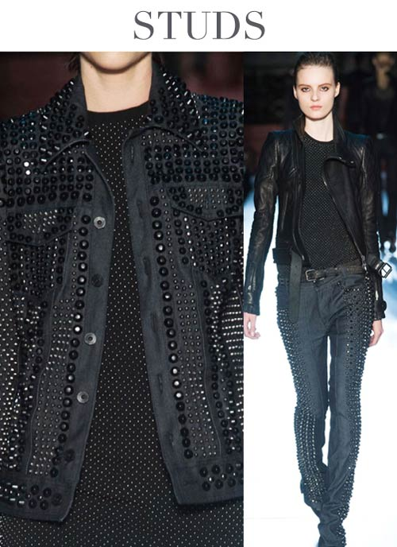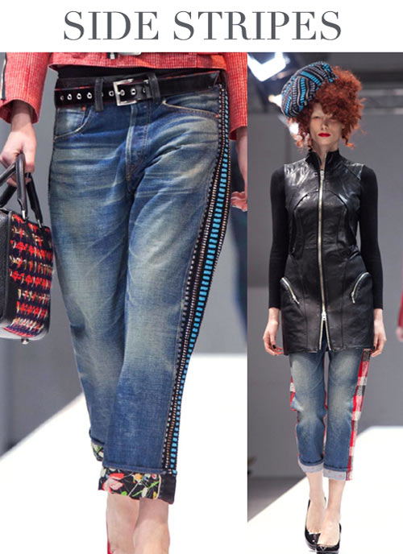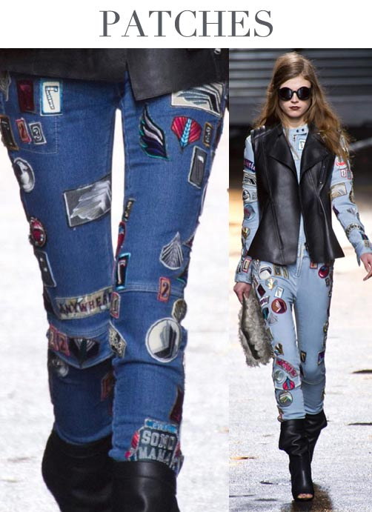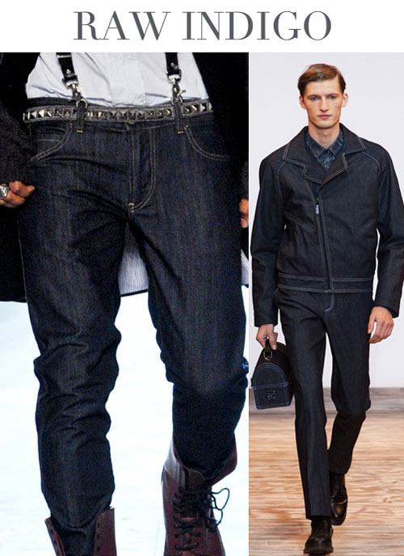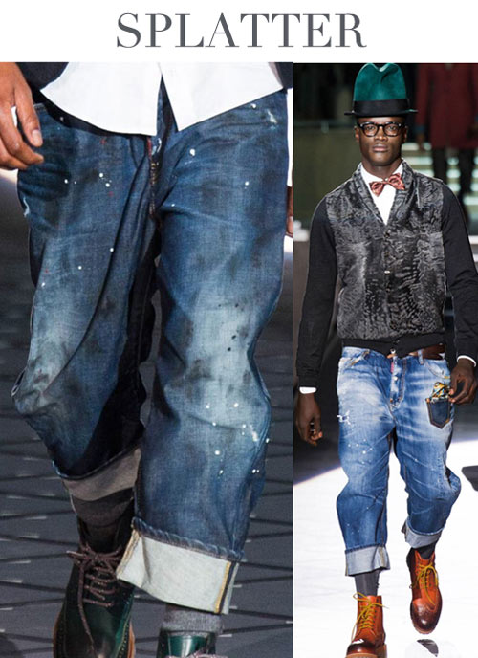

Examples:
High fashion:
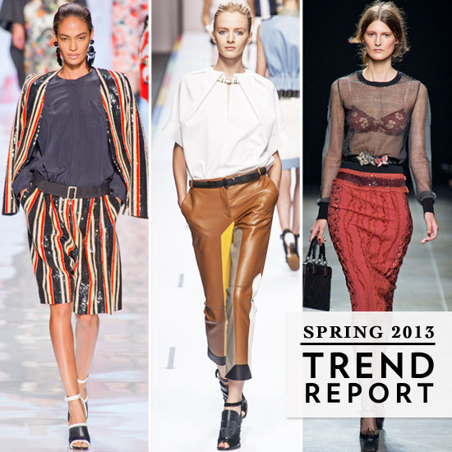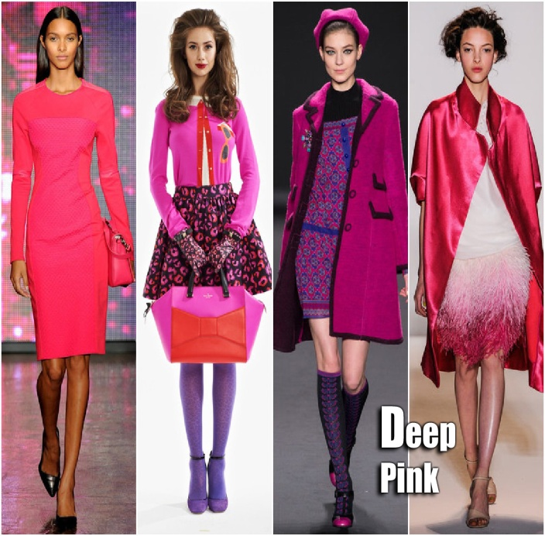
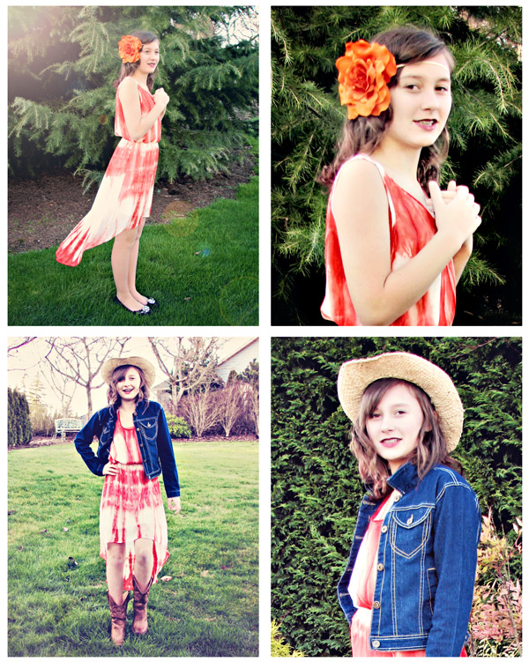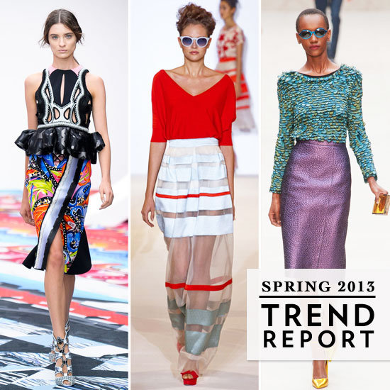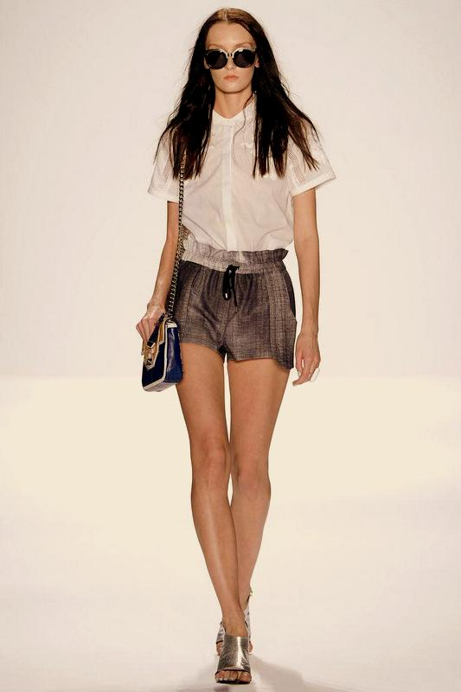
Mass Fashion:
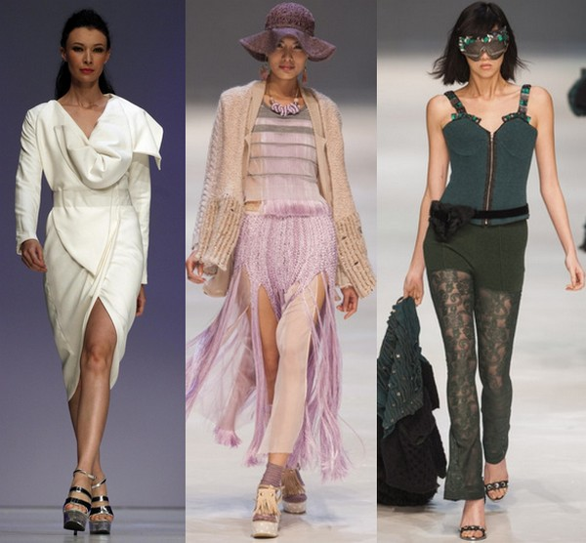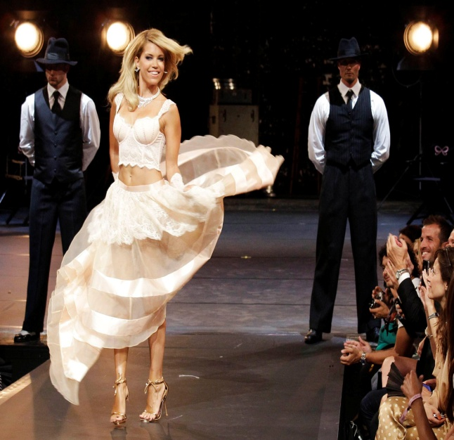
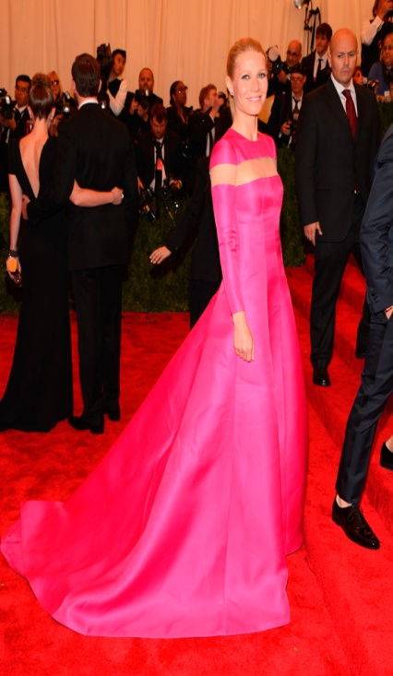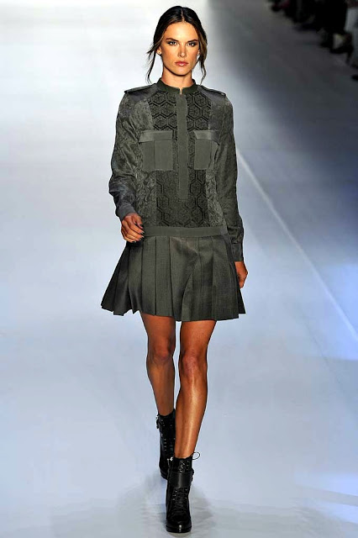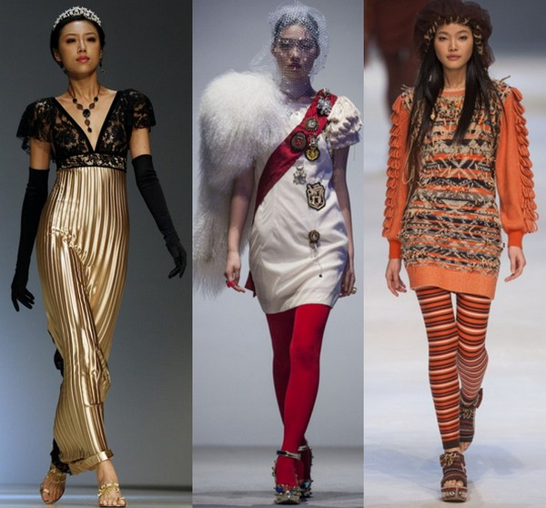

Classic fashion:
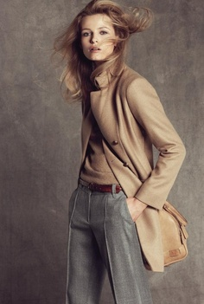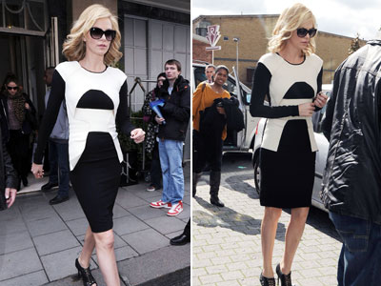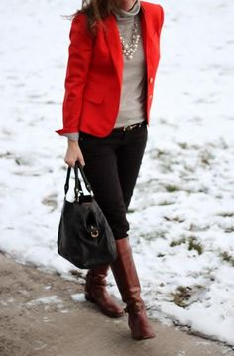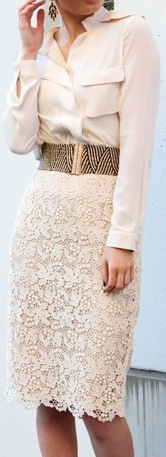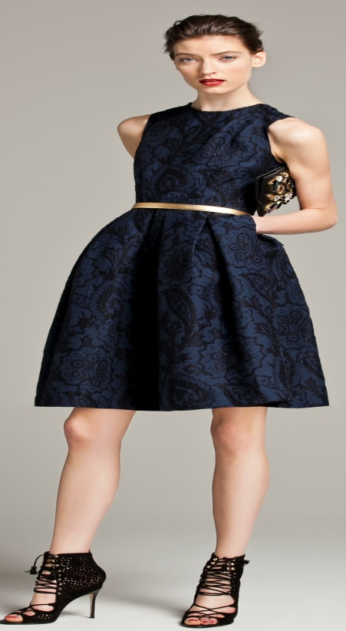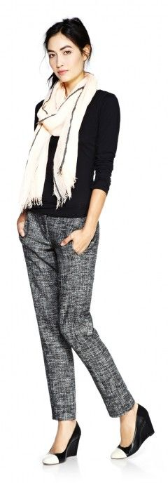
Fad fashion:
